# CCM User Manual

**Welcome to the i-transport Integrated Workstation Command Control Module (CCM) User Help File.**

The i-transport integrated workstation CCM (command control module) user help file is the essential reference for operators, with details introduction of the operating method for CCM, including documentation, graphics to facilitate the usage.

## Overview of CCM

The CCM main environment consists of:

* [A menu](#_The_menu_bar)
* [Two beacons](#_The_beacons)
* [Tool bar](#_The_toolbar)
* [Status bar](#_The_status_bar)
* [Four basic window lists](#_Four_Major_Window)

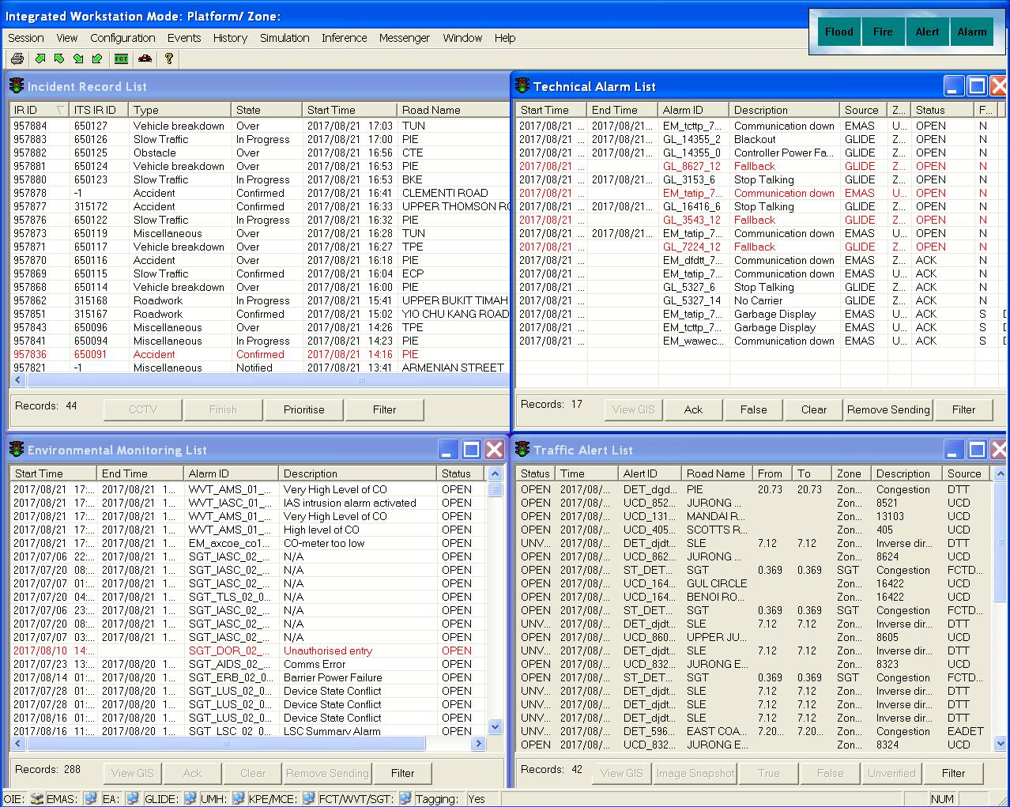

Figure 1 - IW CCM Main Environment

### The toolbar

|  |  |
| --- | --- |
| The tool toolbar allows you to perform strategy ventilation control for tunnel and launch simulation. | |
|  | |
| Description: c:\_temp\iw help\toolbar.jpg | |

|  |  |  |  |  |  |  |  |  |  |  |  |  |  |  |  |  |  |  |
| --- | --- | --- | --- | --- | --- | --- | --- | --- | --- | --- | --- | --- | --- | --- | --- | --- | --- | --- |
| |  |  | | --- | --- | |  |  | | **Print** | print current screen | | **North East Tunnel Strategy Ventilation Control** | Strategy Ventilation Control for North East Tunnel | | **North West Tunnel Strategy Ventilation Control** | Strategy Ventilation Control for North West Tunnel | | **South East Tunnel Strategy Ventilation Control** | Strategy Ventilation Control for South East Tunnel | | **South West Tunnel Strategy Ventilation Control** | Strategy Ventilation Control for South West Tunnel | | **FCT Jet Fan Group Control** | To control all  FCT's Jet Fans as a group (Automatic and Manual Mode) | | **Launch Simulation** | Launch simulation | | **About** | Show version and copyright | |

### The menu bar

|  |
| --- |
| Description: c:\_temp\iw help\The me1.gif |

The menu bar provides access to most of the functionalities available in the CCM. The functionalities are organized and grouped into 9 menus.

•        The Session menu

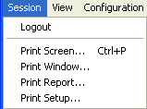

|  |  |
| --- | --- |
| **Logout** | Logout from IW. |
| **Print Screen... Ctrl+P** | Print the whole screen**.** |
| **Print Window...** | Print the active window. |
| **Print Report...** | Print the list contents in the active window. |
| **Print Setup…** | Set up printer and layout settings. |

•       The View menu

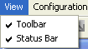

|  |  |
| --- | --- |
| **Toolbar** | Show / hide toolbar on the CCM main environment. |
| **Status Bar** | Show / hide status bar on the CCM main environment. |

•       The Configuration menu

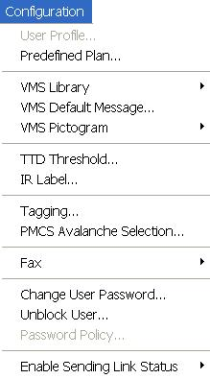

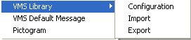

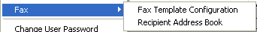

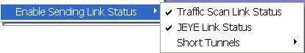

|  |  |
| --- | --- |
| **User Profile** | Add / modify / delete users and profiles. |
| **Predefined Plan** | Create / modify / duplicate / delete predefined plans, including fire plan. |
| **VMS Library** | Add / modify /delete VMS messages in the library. |
| **VMS Default Message** | Modify default messages in the library. |
| **VMS Pictogram** | Add / modify / delete pictograms used in the VMS messages (EMAS and FCT). |
| **TTD Threshold** | Configure the average travel time to adjust the threshold, for alerting operators. |
| **IR Label** | Define options for labels in the IR windows. |
| **Tagging** | Modify tagging mode for PMCS equipment and Fire detection system. |
| **PMCS Avalanche Selection** | To filter technical alarms coming from PMCS equipment. |
| **Fax** | Define fax templates and recipients list and so on. |
| **Change User Password** | Change user password for the current logged in user. |
| **Unblock User** | Unblock users in blocked status. |
| **Password Policy** | Configure the policy of user password. |
| **Enable Sending Link Status** | Auto send out Traffic Scan, JEye and FCT link down message. |

•       The Events menu

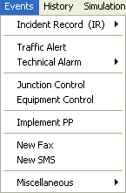

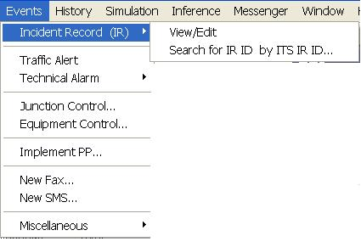

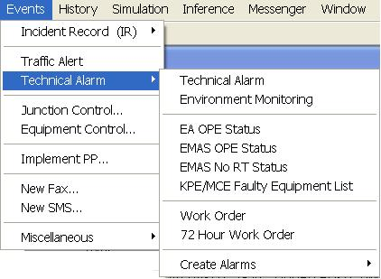

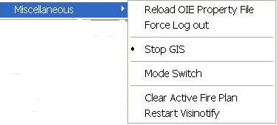

|  |  |
| --- | --- |
| **Incident Record (IR)** | Create / view / edit IR for expressways and arterial roads. |
| **Traffic Alert** | Show and focus the current list of Traffic alert detected. |
| **Technical Alarm** | Show and focus the current list of Technical Alarm List / Environment Monitoring List/ EMAS OPE Status List/ EMAS No RT Status List/ KPE/MCE Faulty Equipment List/ Work Order List/ 72 hour Work Order List and Create Alarms – manually create alarm after received fault from public call in. |
| **Junction Control** | Remote control for junctions traffic lights. |
| **Equipment Control** | Remote control of the various ITS equipment such as VMS, cameras, LUS, PMCS equipment and strategy. |
| **Implement PP** | Implement or release of predefined plan, that includes activation / deactivation of fire plans. |
| **New Fax** | Send a fax for IR or Technical alarm to internal/external parties. |
| **New SMS** | Send a message to mobile phones (SMS). |
| **Miscellaneous** | Reload property file - Once System Administrator modifies the files, the property files must be reloaded so that the new settings can be applied to all IWs.  Force users logout – To do a manual logout for users.  Stop/Start GIS – To switch on/off GIS.  Mode Switch – Switch between platform mode and fallback mode. |

•       The History menu

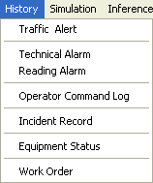

|  |  |
| --- | --- |
| **Traffic Alert** | Search and retrieve past traffic alerts. |
| **Technical Alarm** | Search and retrieve past technical alarms. |
| **Reading Alarm** | Search and retrieve past reading alarms. |
| **Operator Command Log** | Search and retrieve past commands sent by operators. |
| **Incident Record** | Search and retrieve past incident records. |
| **Equipment Status** | Search and retrieve past equipment status. |
| **Work Order** | Search and retrieve closed/ cancelled work order. |

•       The Simulation menu

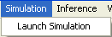

|  |  |
| --- | --- |
| **Launch Simulation** | This function is used to start Simulation application. |

•        The Inference menu

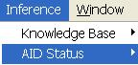

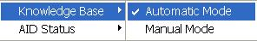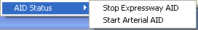

|  |  |
| --- | --- |
| **Knowledge Base** | Indicates if the inference module is currently in automatic / manual mode with a ✓. |
| **AID Status** | Start/Stop Expressway AID, if Expressway AID is running, the menu shows Stop Expressway AID; if Expressway AID is not running, the menu shows Start Expressway AID; |

•       The Window menu

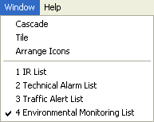

|  |  |
| --- | --- |
| **Cascade** | Arrange the list windows in cascade layout. |
| **Tile** | Arrange the list windows in tile layout. |
| **Arrange Icons** | Re-arrange the list windows using the selected layout. |
| **1 IR List** | Show / hide IR list. |
| **2 Technical Alarm List** | Show / hide Technical alarm list. |
| **3 Traffic Alert List** | Show / hide Traffic alert list. |
| **4 Environmental Monitoring List** | Show / hide Environment Monitoring list |

•       The Help menu

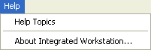

|  |  |
| --- | --- |
| **Help Topics** | Show Help window. |
| **About Integrated Workstation...** | Show version and copyright information. |

### The beacons

Beacons are small signals on the screen that allow users to monitor for important events. The beacons will change their status when:

* There are new equipment faults, measurement exceeding threshold values and fire alarms that require immediate attention, acknowledgement and action.
* There are new traffic alerts that require immediate attention, acknowledgement and response.

Flood, Fire, alert and alarm beacons

This set of beacons will appear on the top right hand corner of both CCM and GIS.

|  |  |
| --- | --- |
| normal state  red blinking state |  |

The Flood beacon changes to red blinking beacon when flood is detected in the tunnel. The flood alarm will be displayed in the [Environment Monitoring List](file:///C:\Users\Brenda%20Seah\Desktop\chm\Events\Environment%20monitoring%20list.htm) so that users can acknowledge them.

The Fire beacon changes to red blinking beacon when fires are detected in the tunnel. The fire alarm will be displayed in the [Environment Monitoring List](file:///C:\Users\Brenda%20Seah\Desktop\chm\Events\Environment%20monitoring%20list.htm) so that users can acknowledge them.

The Alert beacon changes to red blinking beacon when new traffic alerts are detected by the various ITS. These alerts will then be displayed in the [Traffic Alert List](file:///C:\Users\Brenda%20Seah\Desktop\chm\Events\Traffic%20Alert%20List.htm) so that users can acknowledge them.

The Alarm beacon changes to red blinking beacon when there are equipment faults. These alarms will then be displayed in the:

* [Environment Monitoring List](file:///C:\Users\Brenda%20Seah\Desktop\chm\Events\Environment%20monitoring%20list.htm) for PMCS measurement alarms and fire alarms in the tunnel, and TTD threshold alarms.
* [Technical Alarm List](file:///C:\Users\Brenda%20Seah\Desktop\chm\Events\Technical%20alarm%20list.htm)  for EMAS, GLIDE, FCT/WVT/SGT and other ITS faults.

Once the new alerts and alarms are acknowledged and there are no more new items in the list, the beacons will stop blinking and resume to their normal state.

### The status bar

•    Connection Status  

|  |  |
| --- | --- |
| Description: c:\_temp\iw help\status8.jpg | IW is connected to Operation Interface Engine. |
| Description: c:\_temp\iw help\status9.jpg | IW cannot connect to Operation Interface Engine. |

If  IW disconnect to Operation Interface Engine, system will try to do failover to recover the connection within 2 minutes. If connection cannot be recovered, a message will prompt in IW.

•    Fire plan status bar

|  |  |
| --- | --- |
| Description: c:\_temp\iw help\status10.jpg | Blank state; Fire plan is not activated. |
| Description: c:\_temp\iw help\status11.jpg | Fire plan has been activated; Equipment are still in fire mode. |

A fire activation plan consists of plant plan and traffic plan. When you implement the plant plan of a fire activation plan for a fire zone, this bar will show message to inform all users. The message will be “Fire Zone xxx Plan Activated”, it means the plant plan has been activated and the PMCS equipment are in fire mode in fire zone xxx.

When the fire is over and the deactivation plans are all implemented. The message will resume to blank.

•    Link status bar

There are 5 link status beacons indicate if the link from i-transport system to EMAS, GLIDE, UMH, KPE/MCE and FCT/WVT/SGT are up or down. When the link is down, the beacon of this link changes to deactivate with a red cross.

If the link status is not ok, you may view the system health diagram from GIS for details on which links are down.

|  |
| --- |
| EMAS link status |
| Description: c:\_temp\iw help\status14.jpg EMAS link is up |
| Description: c:\_temp\iw help\status15.jpg EMAS link is down |
| GLIDE link status | |
| Description: c:\_temp\iw help\status16.jpg GLIDE link is up | |
| Description: c:\_temp\iw help\status17.jpg GLIDE link is down | |

|  |
| --- |
| UMH link status |
| Description: c:\_temp\iw help\status22.jpg UMH link is up |
| Description: c:\_temp\iw help\status23.jpg UMH link is down |
| KPE/MCE link status |
| KPE/MCE link is up |
| C:\Users\BRENDA~1\AppData\Local\Temp\_TSA266.tmp\_TS3DB.tmp\kpemceup.JPG KPE/MCE link is down |

|  |
| --- |
| FCT/WVT/SGT link status |
| FCT/WVT/SGT link is up |
| FCT/WVT/SGT link is down |

•    Tagging mode status bar

|  |  |
| --- | --- |
| Description: c:\_temp\iw help\status18.jpg | PMCS equipment tagging mode are mode 1 |
| Description: c:\_temp\iw help\status19.jpg | PMCS equipment tagging mode are either mode 2 or mode 3 (FCT/WVT/SGT has only tagging mode 3) |

|  |  |
| --- | --- |
| **Mode** | **Description** |
| 1 | The equipment is able to be monitored and controlled remotely |
| 2 | The equipment is able to be monitored and unable to be controlled remotely. |
| 3 | The equipment is unable to be monitored and controlled remotely. |

The Tagging mode beacon changes to “Yes” when one of the PMCS equipment tagging mode is 2 or 3.

•   Others status bar

|  |  |
| --- | --- |
| Description: c:\_temp\iw help\status20.jpg | Blank state; none of the locks is on. |
| Description: c:\_temp\iw help\status21.jpg | CAP: Caps Lock is on. NUM: Num Lock is on. SCRL: Scroll Lock is on. To unlock, use the appropriate keys on your keyboard. |

### Four Major Window Lists

The CCM main display area consists of four major window lists:

* [Technical alarm list](#_Technical_alarm_list)
* [Environment monitoring list](#_Environment_monitoring_list)
* [Traffic alert list](#_Traffic_Alert_List)
* [Incident Record (IR) list](#_IR_List)

## Configurations

Provide configuration for:

|  |
| --- |
| •        [**User  profiles**](#_User_profiles)  Management (create/ modify/ delete) of user accounts and user profiles. Every user will have one user account that enables the user to login to IW. Every user account belongs to a profile. The user profile will determine the functions that the user is authorize to access.  •         [**Predefined plan**](#_Predefined_plan)  Management (create/ modify/ delete) of predefined plans. A predefined plan consists of a set of control commands for the traffic and plant equipment that can be implemented at predefined schedules. The commands will be applied to the equipment when the plan is activated, e.g. congestion on the tunnel exits will requires congestion message to be displayed in the relevant VMS. The predefined schedules will allow the system to prompt users for activation when the schedule is up. Predefined plans also consist of fire plans, for implementation in the event of fire in the tunnel.  •        [**VMS library**](#_VMS_library)  Management (create/ modify/ delete) of VMS messages on Expressways and tunnel.  •        [**VMS default library**](#_VMS_default_librarys)  Management (create/ modify/ delete) of VMS default messages on Expressways and tunnel.  •        [**TTD threshold**](#_TTD_threshold)  Management (create/ modify/ delete) of TTD destinations/threshold. TTD Threshold is the upper (+50%) and lower (-50%) limits of the average travelling time for each destination as displayed on the TTD.  •         [**IR label**](#_IR_label)  Management (create/ modify/ delete) of field options in the IR forms. This configuration allows users to customize what options are available for the fields during IR creation.  •         [**Pictogram**](#_Pictogram)  Management (create/ modify/ delete) of graphic icons for the VMS messages. These graphic icons are for TMD, TID, TSD, FCT\_AVMS, FCT\_TMD WVT\_EVMS, WVT\_AVMS, SGT\_EVMS and SGT\_AVMS that can display graphics.  •        [**Tagging**](#_Tagging)  Tagging function for PMCS and Fire Detection System to disable the remote control for these equipment. Tagging is to determine if equipment can be remotely controlled.  •         [**PMCS Avalanche Selection**](#_PMCS_Avalanche_Selection)  Also known as Avalanche Filtering. Filter for technical alarms to be received by the i-Transport system.  •         [**Fax**](#_Fax)  Configuration for fax templates and recipient address book. Fax templates will determine what information are contained in the IR/Technical Alarm fax message. Recipient address book contain all the fax numbers and mobile phone numbers of internal/external parties.  •         [**Change User password**](#_Change_user_password)  Allow users to change password.  •        [**Unblock User**](#_Unblock_user)  If a user log in with wrong password for a few times (specified in the password policy), this user will be blocked. Use this menu function to unblock the user.  •         [**Password Policy**](#_Password_policy)  Use this menu to change the password valid period, the password grace period and failed log in times for blocking the user.  •         [**Enable Sending Link Status**](#_Sending_link_status)  Specify if the link status should be sent out. |

### User profiles

The user profile control the functions the user is authorize to use under Platform Control Mode (PCM) or Fall back Control Mode (FCM).

|  |  |  |  |  |  |  |
| --- | --- | --- | --- | --- | --- | --- |
| **User profile** | | | | | **Operation mode** | |
| DO | Operator | FC | ITSC | Supervisor | PCM | FCM |
| ✓ | ✓ | ✓ | ✓ | ✓ | ✓ | ✓ |

Provide management of user accounts and user profiles.

•        Each user will have one user account.

•        Each user will belong to one user profile.

Features:

•      The profile will determine the functions that are available.

•      Create / modify / delete user accounts.

•      Create / modify / delete user profiles.

•       Define control modes, functions available etc. for each profile.

Go to **Configuration** menu > **User Profile**. You will see a list of current user accounts and user profiles.

|  |
| --- |
|  |
| Figure 2 - A user profile window example |

User Profile configuration has the following special settings:

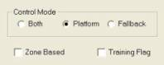

Control Mode – If Control Mode is “Both”, the users with this type of profile can login to both Platform mode and Fallback mode. If “Platform” is selected, the user can only login to Platform mode and so on.

Zoned based – If Zone Based option is checked, the profile will be restricted by zone(s) selected while login. For example, if operator login to zone 1, he can only create IR, handle technical alarm, etc. that are in zone 1. If Zone Based option is not checked, the user will be a super user. For example, DO can have this profile so that he can do anything for any zone.

Training flag – When system is live, training may still need to be conducted. Profile created with training flag checked is suitable for training because the users under this profile can perform all functions but not changing anything on the live system and equipment.

#### Create new user

   Click on **New** button.

     A User Configuration window appears.

   Type values in User ID, User Name, Password, Re-Password and Description textboxes.

     The password are case-sensitive and must have at least 12 characters but not more than 20 characters, and at least one lower letter, one upper letter, one number and one special character.

The password cannot be the same as the User ID / User Name.

  Click on Profile ID dropdown arrow, and click a profile.

   Click on **OK** button to close the window and save this user account.

|  |
| --- |
| Figure 3 - Create New User window |

|  |  |  |
| --- | --- | --- |
| **Error** | | |
| Message | Cause | Possible solution |
| Password cannot be the same as the User ID / User Name, please choose a new one! | New password entered is the same as the User ID / User Name. | Choose password different from User ID / User Name. |
| The password must have at least 12 characters but not more than 20 characters, and at least one lower letter, one upper letter, one number and one special character. Please choose a new one! | New password does not have at least 12 characters but not more than 20 characters, and at least one lower letter, one upper letter, one number and one special character. | Choose password that has at least 12 characters but not more than 20 characters, and at least one lower letter, one upper letter, one number and one special character. |
| The repeated password is not correct! | Password in Re-Password field is different from Password field. | Ensure passwords at both Re-Password field and Password field are the same. |

#### Modify user

   Click on a user in the User Configuration list.

     The selected user will be highlighted in blue background. The **Modify** button will be enabled.

   Click on **Modify** button.

     The User Configuration window appears with the details of the selected user loaded.

   Make the necessary amendments.

   Click on **OK** button.

|  |
| --- |
| Figure 4 - Modify User window |
|  |

|  |  |  |
| --- | --- | --- |
| **Error** | | |
| Message | Cause | Possible solution |
| Password cannot be the same as the User ID / User Name, please choose a new one! | New password entered is the same as the User ID / User Name. | Choose password different from User ID / User Name. |
| The password must have at least 12 characters but not more than 20 characters, and at least one lower letter, one upper , one number and one special character. Please choose a new one! | New password does not have at least 12 characters but not more than 20 characters, and at least one lower letter, one upper letter, one number and one special character. | Choose password that has at least 12 characters but not more than 20 characters, and at least one lower letter, one upper letter, one number and one special character. |
| The repeated password is not correct! | Password in Re-Password field is different from Password field. | Ensure passwords at both Re-Password field and Password field are the same. |

#### Delete user

   Click on a user in the User Configuration list.

    The selected user will be highlighted in blue background. The **Delete** button will be enabled.

   Click on **Delete** button.

     A confirmation window appears. Click on **Yes** button to confirm deletion of user, click **No** button to cancel.

|  |
| --- |
| Description: c:\_temp\iw help\configuration\user profiles\Delete33.jpg  Figure 5 - Deleting User Confirmation Window |
|  |

#### Create new profile

   Click on **New** button.

     A Profile Configuration window appears (see pic).

    Type values in Profile ID and Description textboxes.

   Click on a Control Mode that this profile is allowed to operate.

   Click on Zone Based if this profile is to operate according to zones.

    Click on Training if this profile requires training.

    In the Function list, click on the checkbox beside the function if this profile can perform the function.

   Click on **OK** button to close the window and save this user profile.

|  |
| --- |
| Description: c:\_temp\iw help\configuration\user profiles\create_pro.JPG  Figure 6 - Create New Profile window |
|  |

Here, all Function list is as follows:

|  |  |
| --- | --- |
| Function ID | Function Description |
| AVALANCHE\_FILTER | Avalanche filtering |
| CONFIG\_FAX\_TEMPL | Configure FAX template |
| CONFIG\_IR\_LABEL | Configure IR labels |
| CONFIG\_IW\_USER | Configure IW User |
| CONFIG\_PARTNER | Configure incident management partners |
| CONFIG\_PP | Create, modify, delete predefined plan |
| CONFIG\_RPP | Create, modify, delete response predefined plan |
| CONFIG\_SEND\_STATUS | Configure sending status of external link |
| CONFIG\_TTD\_THRESHOLD | Configure TTD thresholds |
| CONFIG\_VMS\_DEF\_MSG | Configure VMS default messages |
| CONFIG\_VMS\_PICCODE | Configure VMS graphic code |
| CTRL\_EMAS\_AIRCON | Control EMAS Airconditioning |
| CTRL\_EMAS\_DOOR | Control EMAS Door and Staircases |
| CTRL\_EMAS\_DRAINAGE | Control EMAS Drainage |
| CTRL\_EMAS\_LIGHTING | Control EMAS Lighting |
| CTRL\_EMAS\_LUS | Control EMAS LUS |
| CTRL\_EMAS\_POWER | Control EMAS Power |
| CTRL\_EMAS\_VENT | Control EMAS Ventilation |
| CTRL\_EMAS\_VIDEO | Control EMAS Video |
| CTRL\_EMAS\_VMS | Control EMAS VMS |
| CTRL\_GLIDE\_SIGNAL | Control GLIDE signal |
| CTRL\_GLIDE\_SKIP\_PHASE | Skip phase in junction control |
| CTRL\_JE\_VIDEO | Control JE Video |
| CTRL\_MONITOR | Control CCTV monitor |
| DISABLE\_CAMERA\_CTRL | Disable camera control |
| EXTRACT\_CMD\_LOG | To extract operation command log into a txt file |
| FORCE\_LOGOUT | Force a user to logout |
| GIS\_SELECT\_LAYER | Select GIS layer |
| GIS\_VIEW\_HIST\_DATA | View historical IR/technical alarm/speed from GIS |
| IMPLEMENT\_PP | View, implement predefined plan |
| IMPLEMENT\_RPP | View, implement response predefined plan |
| IMP\_EXP\_VMS\_LIB | Import/export VMS library |
| MANAGE\_IR | Manage IR |
| MANAGE\_READING\_ALARM | Manage current environment monitoring list |
| MANAGE\_TECH\_ALARM | Manage current technical alarm list |
| MANAGE\_TRAFFIC\_ALERT | Manage traffic alerts on own zone |
| MODIFY\_HIST\_IR | Modify any fields of historical IR |
| RELOAD\_OIE\_PROP | Reload OIE property file |
| REMOVE\_UMH\_SEND | Remove UMH Alarms from buffer |
| REMOVE\_WEB\_IR | Remove IR from Web |
| SEND\_IR\_FAX\_PAGING | Send fax, paging for IR |
| SEND\_TA\_FAX\_PAGING | Send fax, paging for technical alarm |
| SIM\_PREDICT | Request predicted speed, volume, etc |
| SIM\_SIMULATE\_AT\_DIW | Request for simulation at DIW |
| START\_FCS | Start EMAS fallback control service |
| SWITCH\_AID | Turn on/off AID |
| SWITCH\_GIS | Switch on/off GIS application |
| SWITCH\_IFM | Turn on/off inference plan |
| TAGGING | EMAS equipment tagging |
| UNBLOCK\_IW\_USER | Unblock IW User |
| UPDATE\_VMS\_LIB | Add, modify, delete messages into/from VMS library |
| UPDATE\_VMS\_LIB\_CATE | Create, rename, delete VMS category |
| VIEW\_48HR\_LIST | View 48 hour closed TSM fault list |
| VIEW\_72HR\_LIST | View 72 Hour Work Order List |
| VIEW\_EQT\_STATUS | View equipment status |
| VIEW\_EXT\_SYS\_STATUS | View external system status |
| VIEW\_HIST\_IR | View historical IR/IP |
| VIEW\_HIST\_READING\_ALARM | View historical environment monitoring list |
| VIEW\_HIST\_TECH\_ALARM | View historical technical alarms |
| VIEW\_HIST\_TRAFFIC\_ALERT | View historical traffic alerts |
| VIEW\_HIST\_WO | View Historical Work Order |
| VIEW\_IR | View IR from IR list |
| VIEW\_IR\_CCTV | Select CCTV view for IR |
| VIEW\_OPE\_STATUS | View Operational Status List |
| VIEW\_OPTR\_CMD\_LOG | View operator command log |
| VIEW\_READING\_ALARM | View current environment monitoring list |
| VIEW\_TECH\_ALARM | View current technical alarms |
| VIEW\_TRAFFIC\_ALERT | View traffic alerts |
| VIEW\_VMS\_LIB | View VMS library |
| VIEW\_WO | View Work Order |

#### Modify profile

   Click on a profile in the Profile Configuration list.

     The selected profile will be highlighted in blue background. The functions usable by this profile appear in the function list. The **Modify** button will be enabled.

    Click on **Modify** button.

     The Profile Configuration window appears with the details of the selected profile loaded.

   Make the necessary amendments.

   Click on **OK** button.

|  |
| --- |
| Description: c:\_temp\iw help\configuration\user profiles\modify_pro.JPG  Figure 7 - Modify Profile Window |
|  |

#### Delete profile

   Click on a profile in the Profile Configuration list.

     The selected profile will be highlighted in blue background. The functions usable by this profile appear in the function list. The **Delete** button will be enabled.

   Click on **Delete** button.

     A confirmation window appears. Click on **Yes** button to confirm deletion of profile, click **No** button to cancel.

|  |
| --- |
| Description: c:\_temp\iw help\configuration\user profiles\Delete35.jpg  Figure 8 - Deleting Profile Confirmation Window |
|  |

### Predefined plan

The user profile control the functions the user is authorize to use under Platform Control Mode (PCM) or Fall back Control Mode (FCM). Every user will have one user account that enables the user to login to IW. Every user account belongs to a profile.

|  |  |  |  |  |  |  |
| --- | --- | --- | --- | --- | --- | --- |
| **User profile** | | | | | **Operation mode** | |
| DO | Operator | FC | ITSC | Supervisor | PCM | FCM |
| ✓ | ✓ | ✓ | ✓ | ✓ | ✓ | ✓ |

Provide management (create/ modify/ delete) of predefined plans. A predefined plan consists of a set control commands for the traffic and plant equipment that can be implemented at predefined schedules. The commands will be applied to the equipment when the plan is activated, e.g. congestion on the tunnel exits will requires congestion message to be displayed in the relevant VMS. The predefined schedules will allow the system to prompt users for activation when the schedule is up. Predefined plans also consist of fire plans, for implementation in the event of fire in the tunnel.

Equipment that can be included in a PP are as follow:

•      VMS

•      Tunnel LUS

•       Traffic Surveillance Cameras

•       Video Monitor

•       Tunnel PMCS equipment

•        Junction Traffic Controller

•       Tunnel Traffic Signal

Features:

•      Search for plans.

•       Inhibit / activate plans.

•       Add / edit / delete commands for EMAS, GLIDE and FCT/WVT/SGT equipment.

•       Add / edit / delete schedules for plans.

•      View simulation of plans.

•       Create / modify / duplicate / delete plans.

Go to **Configuration menu** > **Predefined Plan**.

|  |
| --- |
| Description: c:\_temp\iw help\configuration\predefined plan\Predefined plan.JPG  Figure 9 - PP Configuration window with Commands |
|  |

#### Search for Plans

  Click on **Search Plan** button.

     The Search Plan window appears.

   Click on **PP Type** dropdown arrow and select a type, Click on **PP Zone** dropdown arrow and select a zone.

   In the Fire Mode Option panel, select an option.

   In the Activation Option panel, select an option.

   Click **OK** button.

     The window closes and the search results appear in the list.

|  |
| --- |
| Description: c:\_temp\iw help\configuration\predefined plan\Search_pp.jpg  Figure 10 - Search Plan Window |
|  |

#### Create Plan

   Click on **Create Plan** button

     The plan details panel is enabled.

   Click on **PP Type** dropdown arrow, and click a type.

   Type plan name in the Description textbox.

   In Fire Mode panel, click on **Yes/No** to indicate if the plan is for fire.

     In Inhibition panel, click on **Yes** to disable the plan.

   In Activation panel, click on **Yes/No** to activate or de-activate the plan.

   Click on **Save** button.

     A message window saying “New plan … saved successfully” appears.

|  |
| --- |
| Description: c:\_temp\iw help\configuration\predefined plan\Create plan.jpg  Figure 11 - Create Plan Window with enabled details |
|  |

|  |  |  |
| --- | --- | --- |
| **Error** | | |
| Message | Cause | Possible solution(s) |
| You have selected some EMAS controls for a GLIDE plan. Please revise accordingly! | The plan is a GLIDE plan (PP Type: = GLIDE), but you have added commands to control EMAS equipment. | •   Change the PP Type to EMAS / MIXED.  •   Delete the EMAS commands and add GLIDE commands. |
| You have selected a GLIDE control for a EMAS plan! | The plan is a EMAS plan (PP Type: = EMAS), but you have added commands to control GLIDE equipment. | •   Change the PP Type to GLIDE / MIXED.  •   Delete the GLIDE commands and add EMAS commands. |
| You have selected some EMAS controls for a FCT/WVT/SGT plan. Please revise accordingly! | The plan is a FCT/WVT/SGT plan (PP Type: = FCT/WVT), but you have added commands to control EMAS equipment. | •   Change the PP Type to EMAS / MIXED.  •   Delete the EMAS commands and add FCT/WVT/SGT commands. |
| You have selected a GLIDE control for a FCT/WVT/SGT plan! | The plan is a FCT/WVT/SGT plan (PP Type: = FCT/WVT), but you have added commands to control GLIDE equipment. | •   Change the PP Type to GLIDE.  •   Delete the GLIDE commands and add FCT/WVT/SGT commands. |
| You have selected some FCT/WVT/SGT controls for a GLIDE plan. Please revise accordingly! | The plan is a GLIDE plan (PP Type: = GLIDE), but you have added commands to control FCT/WVT/SGT equipment. | •   Change the PP Type to FCT/WVT/SGT  •   Delete the FCT/WVT/SGT commands and add GLIDE commands. |
| You have selected a FCT/WVT/SGT control for a EMAS plan! | The plan is a EMAS plan (PP Type: = EMAS), but you have added commands to control FCT/WVT/SGT equipment. | •   Change the PP Type to FCT/WVT/SGT / MIXED.  •   Delete the FCT/WVT/SGT commands and add EMAS commands. |
| ne or more options are not correctly configured! Please check again. | Some required fields are empty. | You must fill in Description, Fire Mode, Inhibition and DeActivation fields. |

#### Modify Plan

   Click on a plan from the list. If the list is empty, search for plans to retrieve plans first.

    The selected plan will be highlighted in blue background. The current settings for the selected plan appear at the bottom of the list.

   Click on **Modify Plan** button.

   Make the necessary amendments.

   Click on **Save** button.

#### Duplicate Plan

   Click on a plan from the list. If the list is empty, search for plans to retrieve plans first.

     The selected plan will be highlighted in blue background. The current settings for the selected plan appear at the bottom of the list.

   Click on **Duplicate Plan** button.

   Make the necessary amendments.

   Click on **Save** button.

#### Delete Plan

  Click on a plan from the list. If the list is empty, search for plans to retrieve plans first.

The selected plan will be highlighted in blue background. The current settings for the selected plan appear at the bottom of the list.

     Click on **Delete Plan** button.

A window will pop up asking for confirmation to delete. Click **Yes** to delete plan, click **No** to cancel.

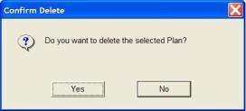

#### Add Command

   Click on a plan from the list. If the list is empty, search for plans to retrieve plans first.

     The selected plan will be highlighted in blue background. The current settings for the selected plan appear at the bottom of the list.

   Click on **Modify Plan** button.

   Click on Command tab if this tab is inactive.

     The existing commands (if any) are loaded.

|  |
| --- |
| Description: c:\_temp\iw help\configuration\predefined plan\Add Co2.jpg  Figure 12 - All Commands of selected Plan |
|  |

    In Choose Item To Add panel, click on an item type.

   Click on **Add** button.

|  |
| --- |
| Figure 13 – Control Type Window |
|  |

    If the selected Item To Add is DELAY, a Add a Delay window will appear, type seconds in the delay value textbox (If the command is a Short Tunnels Delay check the checkbox of Delay for FCT/WVT/SGT), and click **Apply** button.

|  |
| --- |
| Figure 14 - Add Delay Window |
|  |

   If the selected Item To Add is EMAS CONTROL, a Add Equipment Control To PP window will appear. Please refer to [Equipment control](#_Equipment_control), on how to set control settings for the equipment. Finally, click **Add** button to add the equipment to Command List.

   If the selected Item To Add is GLIDE CONTROL, a Junction Control window will appear. Please refer to [Junction Control](#_Junction_Control), on how to set control settings for the junctions. Finally, click **Apply** button to add the junction to Command List.

9.  If the selected Item To Add is Short Tunnels CONTROL, a Add Equipment Control To PP window will appear. Please refer to [Equipment control](#_Equipment_control), on how to set control settings for the equipment. Finally, click **Add** button to add the equipment to Command List.

.    Click **Save** button to save the PP.

|  |  |
| --- | --- |
| **Item** | **Description** |
| Delay | This type of command will not control any equipment but is used as delay before first command / in between commands / after last command. |
| EMAS Control | This type of command controls EMAS equipment. |
| Short Tunnels Control | This type of command controls FCT/WVT/SGT equipment. |
| GLIDE Control  EA Control  PGS Control | This type of command controls junctions.  This type of command controls EA equipment.  This type of command controls PGS equipment. |

#### Modify Command

   Click on a plan from the list. If the list is empty, search for plans to retrieve plans first.

     The selected plan will be highlighted in blue background. The current settings for the selected plan appear at the bottom of the list.

   Click on **Modify Plan** button.

   Click on Command tab if this tab is inactive.

     The existing commands (if any) are loaded.

|  |
| --- |
| Description: c:\_temp\iw help\configuration\predefined plan\Modify44.jpg |
|  |

  Click on a command from the list. The selected plan will be highlighted in blue background.

   Click on **Edit/View** button.

If the command is of DELAY type, an Add a Delay window will appear, enter the new delay seconds and click **Apply** button.

If the command is of EMAS CONTROL type, an Edit Equipment Parameter window will appear. Please refer to Equipment control on how to set control settings for the equipment. Finally, click **Modify** button.

If the command is of GLIDE CONTROL type, a Junction Control window will appear. Please refer to Junction Control on how to set control settings for the junctions. Finally, click **Apply** button.

If the command is of Short Tunnels CONTROL type, an Edit Equipment Parameter window will appear. Please refer to Equipment control on how to set control settings for the equipment. Finally, click **Modify** button.

If the command is of EA CONTROL type, an Edit Equipment Parameter window will appear. Please refer to Equipment control on how to set control settings for the equipment. Finally, click **Modify** button.

If the command is of PGS CONTROL type, an Edit Equipment Parameter window will appear. Please refer to Equipment control on how to set control settings for the equipment. Finally, click **Modify** button.

  Click on **Save** button to save the PP.

#### Delete Command

   Click on a plan from the list. If the list is empty, search for plans to retrieve plans first.

     The selected plan will be highlighted in blue background. The current settings for the selected plan appear at the bottom of the list.

   Click on **Modify Plan** button.

   Click on Command tab if this tab is inactive.

     The existing commands (if any) are loaded.

|  |
| --- |
| Description: c:\_temp\iw help\configuration\predefined plan\Delete45.jpg |
|  |

   Click on a command from the list. The selected command will be highlighted in blue background.

  Click on **Delete** button. A window will pop up asking for confirmation to delete. Click **Yes** to delete command, click **No** to cancel.

  Click on **Save** button.

#### Add Schedule

  Click on a plan from the list. If the list is empty, search for plans to retrieve plans first.

     The selected plan will be highlighted in blue background. The current settings for the selected plan appear at the bottom of the list.

  Click on **Modify Plan** button.

  Click on Schedule tab.

     The existing schedules (if any) are loaded.

|  |
| --- |
| Description: c:\_temp\iw help\configuration\predefined plan\Add Sc1.jpg  Figure 15 - Existing Schedules for selected Plan |
|  |

   Click on **Add** button.

     A Schedule window appears, and the current time is updated in the Start Time textbox.

|  |
| --- |
| Figure 16 - Add Schedule Window |
|  |

   In the Frequency Selection panel, click on a frequency.

•       One Time – the system will prompt user for plan activation one time only on the Start Time.

•       Minute – the system will prompt user for plan activation every X minute(s) after the Start Time

•       Hour – the system will prompt user for plan activation every X hour(s) after the Start Time.

•       Day – the system will prompt user for plan activation every X day(s) after the Start Time.

•       Weekdays – the system will prompt user for plan activation on weekdays only.

•       Saturday – the system will prompt user for plan activation on Saturday only.

•       Sunday – the system will prompt user for plan activation on Sunday only.

  Click on **Apply** button. The schedule is added to the Schedule list.

  Click on **Save** button to save the new schedule.

#### Modify Schedule

  Click on a plan from the list. If the list is empty, search for plans to retrieve plans first.

     The selected plan will be highlighted in blue background. The current settings for the selected plan appear at the bottom of the list.

   Click on **Modify Plan** button.

   Click on Schedule tab. The existing schedules (if any) are loaded.

|  |
| --- |
| Description: c:\_temp\iw help\configuration\predefined plan\Modify47.jpg |
| Display theExisting Schedules for selected Plan |

  Click on **Edit/View** button. A Schedule window appears, and the details of the selected schedule appear.

|  |
| --- |
|  |
| Figure 17 - Edit/View Schedule Window |

    Make the necessary amendments.

   Click on **Apply** button. The schedule is updated.

   Click on **Save** button to save the changes.

#### Delete Schedule

    Click on a plan from the list. If the list is empty, search for plans to retrieve plans first.

The selected plan will be highlighted in blue background. The current settings for the selected plan appear at the bottom of the list.

    Click on **Modify Plan** button.

    Click on Schedule tab. The existing schedules (if any) are loaded.

|  |
| --- |
| Description: c:\_temp\iw help\configuration\predefined plan\Delete2.jpg |
| Figure 18 - Existing Schedules for selected Plan |

   Click on a schedule from the list. The selected schedule will be highlighted in blue background.

  Click on **Delete** button. A confirmation window appears. Click on **Yes** button to confirm deletion of schedule, click **No** button to cancel.

|  |
| --- |
| Description: c:\_temp\iw help\configuration\predefined plan\Delete1.jpg  Figure 19 - Delete a Schedule Confirmation Window |
|  |

    Click on **Save** button to save the changes.

#### Start Simulation for Plan

   Click on a EMAS or Short Tunnels plan from the list. If the list is empty, search for plans to retrieve plans first.

The selected plan will be highlighted in blue background. The current settings for the selected plan appear at the bottom of the list.

|  |
| --- |
| Description: c:\_temp\iw help\configuration\predefined plan\simulate PP.JPG  Figure 20 - Display Selected Plan Window |
|  |

   Click on **Start Simulation** button.

     The GIS on the right changes view and the equipment start changing status according to the commands in the plan.

|  |
| --- |
| **Note** |
| This function is only available for EMAS and FCT/WVT/SGT plan.  During simulation, GIS will only simulate LUS commands and tunnel EMAS VMS (TMD, TED and TTD), EMAS VMS Full Graphic (TIP/TEP/TTP/TSP/TIC) or FCT/WVT/SGT VMS (TMD, EVMS and AVMS) commands. |

### VMS library

Provide management of VMS messages on Expressways and tunnel. The library consists of messages for different VMS equipment, categories and expressways; it is also for quick selection of message during remote control.

Equipment include:

•        TIP (EMAS Full Graphic)

•        TEP (EMAS Full Graphic)

•        TTP (EMAS Full Graphic)

•        TSP (EMAS Full Graphic)

•        TIC (EMAS Full Graphic)

•        FCT\_TMD (FCT)

•        FCT\_AVMS (FCT)

•        WVT\_AVMS (WVT)

•        WVT\_EVMS (WVT)

•        SGT\_AVMS (SGT)

•        SGT\_EVMS (SGT)

 Features:

•      VMS Message Library configuration

•      Batch update library by importing file.

•      Export library to file.

#### Configuration

The user profile control the functions the user is authorize to use under Platform Control Mode (PCM) or Fall back Control Mode (FCM). Every user will have one user account that enables the user to login to IW. Every user account belongs to a profile.

|  |  |  |  |  |  |  |
| --- | --- | --- | --- | --- | --- | --- |
| **User profile** | | | | | **Operation mode** | |
| DO | Operator | FC | ITSC | Supervisor | PCM | FCM |
| ✓ | ✓ | ✓ | ✓ | ✓ | ✓ | ✓ |

Provide management of VMS messages.

Features:

•      Search for messages.

•        Inhibit messages.

•       Add / modify / delete messages.

•        Add / modify / delete message categories.

•        Flash messages.

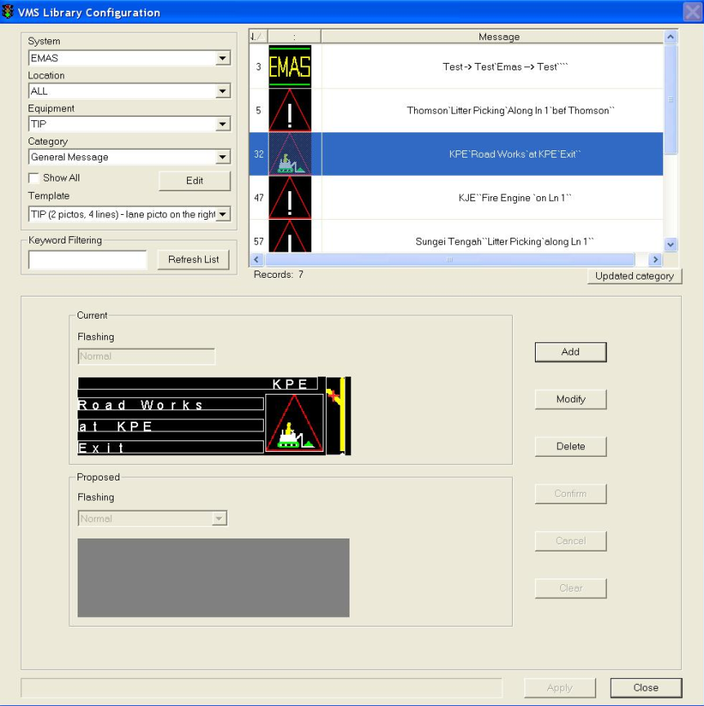

|  |
| --- |
| Figure 21 - An EMAS VMS Library window example |
|  |

|  |
| --- |
| Description: c:\_temp\iw help\configuration\vms library\Config3.jpg  Figure 22 - A FCT VMS Library window example |
|  |

##### Search for Messages

   On VMS Library window, click on Equipment dropdown arrow, and click on an equipment.

    Click on Expressway dropdown arrow, and click on an expressway.

   Click on Category dropdown arrow, and click on a message category.

     The messages for the selected criteria appear on the right.

   Filter message: Enter some characters in Edit Box and click "Refresh List ", messages will be filtered.

|  |
| --- |
| Figure 23 - Display VMS Library Window with selected Criteria |

##### Add Message

   On VMS Library window, click on Equipment dropdown arrow, and click on an equipment.

    Click on Expressway dropdown arrow, and click on an expressway.

   Click on Category dropdown arrow, and click on a message category.

     The messages for the selected criteria appear on the right. The **Add** button is enabled.

|  |
| --- |
| Figure 24 - The EMAS VMS Library Window with selected Criteria |
| Description: c:\_temp\iw help\configuration\vms library\FCT_VMS.JPG  Figure 25 - The FCT VMS Library Window with selected Criteria |

    Click on **Add** button, the Proposed panel is enabled.

If it is EMAS VMS message,

   In the Proposed panel, click on a Graphic Icon for the message.

    Type message in text line boxes.

    Click on Inhibition if the message is not ready for operator usage.

   Click on Flashing if the message’s flashing mode is yes.

If it is a FCT/WVT VMS message,

   In the Proposed panel, click on a "Page Type" button to change message type.

    Make some necessary amendments,

If type is Graphic, click on Graphic icon for the message

If type is Text, type message in Line1, Line2 and line3 textboxes.

If type is Mixed, click on Graphic icon and type message in Line1, Line2 and line3 textboxes

     Click on Inhibition if the message is not ready for operator usage.

     Select Flashing flag from drop down list.

If it is SGT VMS message,

   Select Page Type from drop down list.

2. If there is graphic icon, click the icon to select picto.

3. If there is text line boxes, type in messages.

     Click on Inhibition if the message is not ready for operator usage.

     Select Flashing flag from drop down list.

6. Click on **Apply Page** button.

.    Click on **Confirm** button.

The message will be added to top of the message arrow.

.    Click on **Apply** button to save the new message.

|  |
| --- |
| **Note** |
| To insert the new message on top of an existing message, click on an existing message on the list. E.g.  Description: c:\_temp\iw help\configuration\vms library\Add Me4.jpg  The new message will be added above the selected existing message. |

|  |  |  |
| --- | --- | --- |
| **Error** | | |
| Message | Possible cause (s) | Possible solution (s) |
| Data has been changed, do you want to save them before closing the window? | You have created the new message but you have not click on Add button to save it. If you close the window, the message will not be saved. | Click on Add button to save the new message before closing the window. |

##### Modify Message

  On VMS Library window, click on Equipment dropdown arrow, and click on an equipment.

   Click on Expressway dropdown arrow, and click on an expressway.

  Click on Category dropdown arrow, and click on a message category.

     The messages for the selected criteria appear on the right. The **Modify** button is enabled.

    Click on a message in the list.

    The selected message will be highlighted in blue background.

   Click on **Modify** button, the Proposed panel is enabled. The details for selected message appear.

   Make the necessary amendments.

   Click on **Confirm** button. The message will be updated on the message list.

   Click on **Apply** button to save the changes.

|  |
| --- |
| Description: c:\_temp\iw help\configuration\vms library\Modify2.jpg  Figure 26 - The Proposed panel with details for selected EMAS message |
| Description: c:\_temp\iw help\configuration\vms library\Modify2_1.jpg  Figure 27 - The Proposed panel with details for selected FCT message |

##### Delete Message

  On VMS Library window, click on Equipment dropdown arrow, and click on an equipment.

   Click on Expressway dropdown arrow, and click on an expressway.

  Click on Category dropdown arrow, and click on a message category.

     The messages for the selected criteria appear on the right. The Delete button is enabled.

    Click on a message in the list.

    The selected message will be highlighted in blue background.

   Click on **Delete** button.

    The message will be removed on the message list.

   Click on **Apply** button to save the changes.

##### Add Message Category

  On VMS Library window, click on **Edit** button.

     The Category Name window appears.

   Click on **Add** button.

    Type new category name in the Input New Category textbox.

   Click **OK** button

|  |
| --- |
| Description: c:\_temp\iw help\configuration\vms library\add1.JPG  Figure 28 - The VMS Library Category Editor Window with The Category Name Window |

|  |  |  |
| --- | --- | --- |
| **Error** | | |
| Message | Possible Cause(s) | Possible solution(s) |
| Category name already exists ! | The new category’s name is the name of another category. | Enter another category name. |

##### Modify Message Category

  On VMS Library window, click on Edit button.

     The VMS Library Category Editor window appears.

   Click on Name dropdown arrow, and click a name.

   Click on **Modify** button.

     The Category Name window appears.

    Type new category name in the Modify Existing Category textbox.

     Click **OK** button

|  |  |  |
| --- | --- | --- |
| **Error** | | |
| Message | Possible Cause(s) | Possible solution |
| Category name already exists ! | The new name of the category is the name of another category. | Enter another category name. |

##### Delete Message Category

  On VMS Library window, click on **Edit** button.

     The VMS Library Category Editor window appears.

   Click on Name dropdown arrow, and click a name.

    Click on **Delete** button.

     A message will ask for confirmation to delete.

    Click **Yes** to confirm delete, **No** to cancel.

|  |
| --- |
| **Note** |
| Deletion of category will cause all message(s) under the category to be deleted too. |

#### Import

The user profile control the functions the user is authorize to use under Platform Control Mode (PCM) or Fall back Control Mode (FCM). Every user will have one user account that enables the user to login to IW. Every user account belongs to a profile.

|  |  |  |  |  |  |  |
| --- | --- | --- | --- | --- | --- | --- |
| **User profile** | | | | | **Operation mode** | |
| DO | Operator | FC | ITSC | Supervisor | PCM | FCM |
| ✓ | ✓ | ✓ | ✓ | ✓ | ✓ | ✓ |

Provide batch update of VMS library by uploading of text file. The text file containing VMS messages that will be imported to i-transport VMS library has the following format:

•        Each line represents a message;

•        Each line format:

* EMAS - "<Eqt Type> | <E-way Code> | <Category Label> | <Sequence No.> | <Message> | <Inhibition>"
* FCT/WVT/SGT     - "<Eqt Type> | <E-way Code> | <Category Label> | <Sequence No.> | <Message> | <Inhibition> | <Message Type> |<Flashing>"

  Features:

•        Browse and upload text file.

Go to **Configuration** menu > **VMS Library** > **Import**.

Click on Load File button.

A Open file window appears, browse for the text file and click on **Open** button.

|  |
| --- |
| Description: c:\_temp\iw help\configuration\vms library\Import7.jpg  Figure 29 - Open File Window with Browse Window |

#### Export

The user profile control the functions the user is authorize to use under Platform Control Mode (PCM) or Fall back Control Mode (FCM). Every user will have one user account that enables the user to login to IW. Every user account belongs to a profile.

|  |  |  |  |  |  |  |
| --- | --- | --- | --- | --- | --- | --- |
| **User profile** | | | | | **Operation mode** | |
| DO | Operator | FC | ITSC | Supervisor | PCM | FCM |
| ✓ | ✓ | ✓ | ✓ | ✓ | ✓ | ✓ |

Provide exportation of VMS library to a text file.  When IW CCM exports the messages from VMS library, it shall also follow the same format defined in imported file, refer to [here](#_Import).

  Features:

•        Export library to a text file.

Go to **Configuration** menu > **VMS Library** > **Export**.

       A Save file window appears when you click on the Export menu.

       Save the file into the desired location.

|  |
| --- |
| VMS|-1|1|72|47,0,ACCIDENT/AVOID LN 2 4, |0  VMS|-1|1|73|47,0,ACCIDENT AHEAD/ON LN 2 4, |1  VMS|-1|1|74|47,0,ACCIDENT AHEAD/AVOID LN 2 4, |0  VMS|-1|1|75|47,0,ACCIDENT AHEAD/ACCIDENT AHEAD,AT/AVOID LN 2 4|0  VMS|-1|1|76|47,0,ACCIDENT AHEAD/ACCIDENT AHEAD,AFT/AVOID LN 2 4|0  VMS|-1|1|77|46,0,ACCIDENT/ON LN 1 2 4, |1  VMS|-1|1|78|46,0,ACCIDENT/AVOID LN 1 2 4, |0  VMS|-1|1|79|46,0,ACCIDENT AHEAD/ON LN 1 2 4, |1  VMS|-1|1|80|46,0,ACCIDENT AHEAD/AVOID LN 1 2 4, |0  VMS|-1|1|81|46,0,ACCIDENT AHEAD/ACCIDENT AHEAD,AT/AVOID LN 1 2 4|0 |

An extract of the exported EMAS text file

### VMS default library

The user profile control the functions the user is authorize to use under Platform Control Mode (PCM) or Fall back Control Mode (FCM). Every user will have one user account that enables the user to login to IW. Every user account belongs to a profile.

|  |  |  |  |  |  |  |
| --- | --- | --- | --- | --- | --- | --- |
| **User profile** | | | | | **Operation mode** | |
| DO | Operator | FC | ITSC | Supervisor | PCM | FCM |
| ✓ | ✓ | ✓ | ✓ | ✓ | ✓ | ✓ |

Provide management of VMS default messages on Expressways and tunnel. Every VMS can have a default message so that during remote control, the VMS message can be selected to switch to the default message quickly. Also, when IR is closed, the Inference Module will recommend the VMS equipment to revert to their default messages base on this library.

Equipment include:

•        TIP (EMAS Full Graphic)

•        TEP (EMAS Full Graphic)

•        TTP (EMAS Full Graphic)

•        TSP (EMAS Full Graphic)

•        TIC (EMAS Full Graphic)

•        FCT\_AVMS (FCT)

•        FCT\_TMD (FCT)

•        WVT\_AVMS (WVT)

•        WVT\_EVMS (WVT)

•        SGT\_AVMS (SGT)

•        SGT\_EVMS (SGT)

Features:

•      Search for messages.

•       Modify messages.

Go to **Configuration** menu > **VMS Default Message**

|  |
| --- |
| Figure 30 - VMS Default Message Window |
|  |

#### Search for Messages

  On VMS Default Message window, click on Equipment dropdown arrow, and click on an equipment.

2.   Click on Expressway dropdown arrow, and click on an expressway.

The messages for the selected criteria appear on the right. If no message appears, that means the selected equipment does not exist on the selected expressway.

|  |
| --- |
| Figure 31 - VMS Default Message Window with selected Criteria |

#### Modify Message

  On VMS Default Message window, click on Equipment dropdown arrow, and click on an equipment.

2.   Click on Expressway dropdown arrow, and click on an expressway.

The messages for the selected criteria appear on the right. If no message appears, that means the selected equipment does not exist on the selected expressway.

  Click on a message and click on **Modify** buttonThe selected message will be highlighted in blue background. The Proposed panel is enabled.

|  |
| --- |
| Figure 32 - The VMS Default Message Window with enabled Proposed panel |

Make the necessary amendments

5.   Click on **Confirm** button.

The message is updated on the message list.

6.   Click on **Apply** button to save the changes.

### TTD threshold

The user profile control the functions the user is authorize to use under Platform Control Mode (PCM) or Fall back Control Mode (FCM). Every user will have one user account that enables the user to login to IW. Every user account belongs to a profile.

|  |  |  |  |  |  |  |
| --- | --- | --- | --- | --- | --- | --- |
| **User profile** | | | | | **Operation mode** | |
| DO | Operator | FC | ITSC | Supervisor | PCM | FCM |
| ✓ | ✓ | ✓ | ✓ | ✓ | ✓ | ✓ |

Provide management of TTD destinations’ threshold.

Equipment include:

TTD

Feature:

Modify the average traveling time for each destination of TTD. This is to set the threshold values with which the system will generate a TTD threshold alarm when the threshold values (above 50% or below 50% of the set average time) are reached.

Go to **Configuration** menu > **TTD Threshold**.

|  |
| --- |
| Description: c:\_temp\iw help\configuration\ttd threshold\TTD th1.jpg  Figure 33 - TTD Threshold Window |
|  |

#### Modify Threshold

   Click on a TTD from the list.

    The selected TTD will be highlighted in blue background. The current settings for the selected TTD appear at the bottom of the list.

|  |
| --- |
| Description: c:\_temp\iw help\configuration\ttd threshold\Modify1.jpg  Figure 34 - TTD Threshold Window After Click on a TTD |

   Make the necessary amendments.

   Click on **Apply** button.

### IR label

The user profile control the functions the user is authorize to use under Platform Control Mode (PCM) or Fall back Control Mode (FCM). Every user will have one user account that enables the user to login to IW. Every user account belongs to a profile.

|  |  |  |  |  |  |  |
| --- | --- | --- | --- | --- | --- | --- |
| **User profile** | | | | | **Operation mode** | |
| DO | Operator | FC | ITSC | Supervisor | PCM | FCM |
| ✓ | ✓ | ✓ | ✓ | ✓ | ✓ | ✓ |

This configuration allows users to customize the options that will be available for the fields during IR creation. E.g. if there is a new option for the “Breakdown Type” field, you may use this to add to the field, so that it’s available for selection in future during IR creation.

IR labels that are configurable include:

•        Source

•        Accident Type

•        Road State

•        Towing Type

•        Danger Type

•        Partner Type

•        Roadwork Type

•        Obstacle Type

•        Traffic State

•        Breakdown Type

•        Visibility

•        Opinion

•        Weather Event

•        Weather Detail

•        Vehicle Category

Features:

Add / edit / delete options in each IR field.

Go to **Configuration** menu > **IR Label**.

|  |
| --- |
| Description: c:\_temp\iw help\configuration\ir label\IR_label.jpg  Figure 35 - A IR label window example |
|  |

#### Add Field Option

   On IR Label Configuration window, click on SelectIR Label Type dropdown arrow, and click a label.

     The current options for the selected label appear at the right side.

   Click on **Add** button.

The Labels panel is enabled with a form

|  |
| --- |
| Description: c:\_temp\iw help\configuration\ir label\IR_Label_add.jpg  Figure 36 - The IR Label Configuration Window with enabled form |

   Type name in the Description textbox.

   Click **Apply** button.

The new option is added to the list on the right.

#### Edit Field Option

   On IR Label Configuration window, click on SelectIR Label Type dropdown arrow, and click a label.

The current options for the selected label appear at the right side.

   Click on an option.

The selected option will be highlighted in blue background.

   Click **Edit** button.

The details of selected option appear in the Labels panel.

|  |
| --- |
| Description: c:\_temp\iw help\configuration\ir label\IR_label_edit.jpg  Figure 37 - The IR Label Configuration window with Label details |

   Change the Description, or change the display order using Move Up or Move Down button.

   Click **Apply** button.

The option is updated on the list.

#### Delete Field Option

   On IR Label Configuration window, click on **SelectIR Label Type** dropdown arrow, and click a label.

The current options for the selected label appear at the right side.

   Click on an option.

The selected option will be highlighted in blue background.

|  |
| --- |
| Description: c:\_temp\iw help\configuration\ir label\IR_Label.jpg  Figure 38 - The IR Label Configuration Window |

   Click **Delete** button. The Confirm Delete window appears.

   Click **Yes** button to permanently delete the option.

The option is removed from the list.

|  |
| --- |
| Description: c:\_temp\iw help\configuration\ir label\Delete2.jpg  Figure 39 - The Confirm Delete IR Label option window |

### Pictogram

The user profile control the functions the user is authorize to use under Platform Control Mode (PCM) or Fall back Control Mode (FCM). Every user will have one user account that enables the user to login to IW. Every user account belongs to a profile.

|  |  |  |  |  |  |  |
| --- | --- | --- | --- | --- | --- | --- |
| **User profile** | | | | | **Operation mode** | |
| DO | Operator | FC | ITSC | Supervisor | PCM | FCM |
| ✓ | ✓ | ✓ | ✓ | ✓ | ✓ | ✓ |

Provide management of graphic icons for the VMS messages. These graphic icons are for TMD, TID, TSD, FCT\_TMD, FCT\_AVMS, WVT\_AVMS, WVT\_EVMS, SGT\_AVMS and SGT\_EVMS that can display graphics.

Features:

Add / Edit / Delete graphic icons.

Go to **Configuration** menu > **VMS Pictogram** > EMAS...

|  |
| --- |
| Description: c:\_temp\iw help\configuration\pictogram\Pictogram_EMAS.JPG  Figure 40 - A EMAS Pictogram window example |
| Go to **Configuration** menu > **VMS Pictogram** > FCT > FCT\_AVMS... or FCT\_TMD... |

|  |
| --- |
| Description: c:\_temp\iw help\configuration\pictogram\Pictog_fct.jpg  Figure 41 - A FCT Pictogram window example |
|  |

#### Add Graphic Icon

   On Pictogram window, type a number in ID textbox.

Type description in Description textbox.

|  |
| --- |
| Description: c:\_temp\iw help\configuration\pictogram\Pictogram_EMAS_ADD.JPG  Figure 42 - The Pictogram Window |

   Click on **Add** button.

   Click on Load Picture to load the icon (BMP format).

A file browser will appear for you to browse for the BMP file.

   Click on **Confirm** button to add the new icon.

|  |
| --- |
| **Note** |
| The graphic icon will have to be   * EMAS: 60 x 60 pixels. * FCT AVMS: 32 x 72 pixels * FCT TMD: 32 x 32 or 64 x 144 pixels * WVT/SGT EVMS 40 x 40 pixels or 64 x 144 pixels * SGT AVMS 64 x 144 pixels |

#### Edit Graphic Icon

   On Pictogram window, click on an icon on the list.

The selected icon will be highlighted in blue background, and the details appear on the right.

   Click on **Modify** button.

|  |
| --- |
| Description: c:\_temp\iw help\configuration\pictogram\Pictogram_EMAS_EDIT.JPG  Figure 43 - The Pictogram Window after Modify button is pressed |

   Make the necessary amendment.

   Click on **Confirm** button to edit the icon.

A message window will ask you if you want to replace the icon, click **Yes**.

|  |
| --- |
| Description: c:\_temp\iw help\configuration\pictogram\Edit G2.jpg  Figure 44 - A message window for editing icon |

#### Delete Graphic Icon

   On Pictogram window, click on an icon on the list.

The selected icon will be highlighted in blue background, and the details appear on the right.

   Click on **Delete** button to delete the icon.

A message window will ask for confirmation to delete, click **Yes**. The icon will be removed from the list.

|  |
| --- |
| Description: c:\_temp\iw help\configuration\pictogram\Delete1.jpg  Figure 45 - A message window for deleting icon |

### Tagging

The user profile control the functions the user is authorize to use under Platform Control Mode (PCM) or Fall back Control Mode (FCM). Every user will have one user account that enables the user to login to IW. Every user account belongs to a profile.

|  |  |  |  |  |  |  |
| --- | --- | --- | --- | --- | --- | --- |
| **User profile** | | | | | **Operation mode** | |
| DO | Operator | FC | ITSC | Supervisor | PCM | FCM |
| ✓ | ✓ | ✓ | ✓ | ✓ | ✓ | ✓ |

The tagging is to determine if an equipment can be remotely controlled from the IW. By default, all the equipment will be tagged as mode 1. Once a particular equipment is tagged to mode 2 or mode 3, the user will not be able to implement a control of the equipment using the equipment control (335for details on Equipment Control) or activate a command of the equipment in PP (refer to [here](#_Implement_Predefined_Plan) for details on Predefined Plan Implementation). Tagging function is provided for PMCS equipment and Fire Detection System listed below:

Equipment include:

•       Ventilation (PMCS)

•        Air Con (PMCS)

•        Lighting (PMCS)

•        Drainage (PMCS)

•        Doors and Staircases (PMCS)

•        Power (PMCS)

•        Communication (PMCS)

•        Strobe Light (PMCS)

•        Fire Area Alarm (Fire Detection System)

Go to **Configuration** menu > **Tagging.**

|  |
| --- |
| Figure 46 - A tagging window example |
|  |

#### Modify Tagging Mode

   In the equipment list, click on + sign besides the equipment type, until the list cannot be further expand.

   Click on an equipment type.

The list of equipment for the selected type appears on the right

   On equipment list, click on an equipment.

The selected equipment will be highlighted in blue background. The tagging Mode panel is enabled, and the current mode of the selected equipment is selected.

   Click on a new mode.

   Click on **Apply** button.

|  |
| --- |
| Figure 47 - Equipment Tagging Window after Apply button is pressed |

#### View Tagged Equipment List

On the Equipment Tagging window, click on Tagged Equipment button. The Tagged Equipment List window (see pic) will show and if there’s any equipment tagged (in mode 2 or 3), the equipment will appear on the list.

|  |
| --- |
| Description: c:\_temp\iw help\configuration\tagging\Tagging_view.jpg  Figure 48 - The Tagged Equipment List Window |

### PMCS Avalanche Selection

The user profile control the functions the user is authorize to use under Platform Control Mode (PCM) or Fall back Control Mode (FCM). Every user will have one user account that enables the user to login to IW. Every user account belongs to a profile.

|  |  |  |  |  |  |  |
| --- | --- | --- | --- | --- | --- | --- |
| **User profile** | | | | | **Operation mode** | |
| DO | Operator | FC | ITSC | Supervisor | PCM | FCM |
| ✓ | ✓ | ✓ | ✓ | ✓ | ✓ | ✓ |

Provide filter for PMCS technical alarms, that is, alarms that belong to the selected equipment types, will be totally blocked and not received by IW. These alarms will not be displayed to the users on IW and will not be stored in the database.

Equipment include:

•        Ventilation (PMCS)

•        Air Con (PMCS)

•        Lighting (PMCS)

•        Drainage (PMCS)

•        Doors and Staircases (PMCS)

•        Power (PMCS)

•        Communication (PMCS)

Feature:

Select equipment types to be filtered.

Go to **Configuration** menu > **PMCS Avalanche Selection**.

|  |
| --- |
| Description: c:\_temp\iw help\configuration\pmcs avalanche selection\PMCS A19.jpg  Figure 49 - A PMCS Avalanche Selection window example |
|  |

#### Filter

    In the PMCS Avalanche Selection window, click on an equipment type.

Click more than one type if you want to filter off alarms for multiple types.

   Click on **Apply** button.

|  |
| --- |
| Description: c:\_temp\iw help\configuration\pmcs avalanche selection\Filter20.jpg  Figure 50 - A Filter example |

### Fax

Provide configuration for fax templates and recipient address book.

•       [Fax Template Configuration](#_Fax_Template_Configuration)

•        [Recipient address book](#_Recipient_Address_Book)

Go to **Configuration** menu > **Fax.**

|  |
| --- |
| Description: c:\_temp\iw help\configuration\fax\fax.JPG  Figure 51 - Fax Sub-Menu in Configuration Menu |
|  |

#### Fax Template Configuration

|  |  |  |  |  |  |  |
| --- | --- | --- | --- | --- | --- | --- |
| **User profile** | | | | | **Operation mode** | |
| DO | Operator | FC | ITSC | Supervisor | PCM | FCM |
| ✓ | ✓ | ✓ | ✓ | ✓ | ✓ | ✓ |

You can configure the templates used by IR and technical alarm, these templates will control the information shown on the fax document when a fax is being sent from any fax function on CCM.

Features:

•       View fax templates

•        Add/ Edit/ Remove field

Go to **Configuration** menu > **Fax** > **Fax Template Configuration**

|  |
| --- |
| Description: c:\_temp\iw help\configuration\fax\Fax_template.jpg  Figure 52 - A Fax template window example |

##### View Fax Template

In the Fax Template Configuration window, click on type of template in Label Type Selection panel.

The event names for the selected template type appear on the right. On the left, there’s a list of events that has not yet to be added to the template events.

|  |
| --- |
| Description: c:\_temp\iw help\configuration\fax\Fax_template.jpg  Figure 53 - Fax Template Configuration Window with selected Type |
|  |

##### Add Field

   Click on an event name on IR Event Name list.

    The selected event will be highlighted in blue background.

  Click on **>** button.

The selected event will be highlighted in blue background.

   Click on **Save** button to save.

##### Edit Field

  Click on an event in the template events list.

    The selected event will be highlighted in blue background. The existing label (if any) will appear at the bottom in the Event Label textbox.

   Type a new label in the Event Label textbox.

    Click **Apply** button.

   Click on **Save** button to save.

##### Remove Field

  Click on an event name on template events list.

   The selected event will be highlighted in blue background.

  Click on **<** button.

   The selected event will move to the left, this event will not appear the fax document.

  Click on **Save** button to save.

#### Recipient Address Book

|  |  |  |  |  |  |  |
| --- | --- | --- | --- | --- | --- | --- |
| **User profile** | | | | | **Operation mode** | |
| DO | Operator | FC | ITSC | Supervisor | PCM | FCM |
| ✓ | ✓ | ✓ | ✓ | ✓ | ✓ | ✓ |

You can configure the recipient details like the name of recipient, the hand phone no., fax no etc. The fax no. information will be used when you send a fax and the hand phone no. will be used when you send a SMS from any FAX/SMS function on CCM.

Features:

•      View Recipient List

•      Add/ Edit/ Remove Recipient

•       View Group List

•       Add/ Edit/ Remove Group

Go to **Configuration** menu > **Fax** > **Recipient Address Books**.

|  |
| --- |
| Description: c:\_temp\iw help\configuration\fax\Recipient Address Book.jpg  Figure 54 - A Recipient Address Book example |
|  |

##### View Recipient List

In the Recipients Address Book window, click on View button, and click on By Contact.

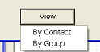

If the view is currently in Group list, the Group list will be unloaded and the Recipient list appears.

##### New Recipient

    In the Recipients Address Book window, click on **New** button, and click on **New Contact**.

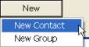

    The Contact Properties window appears.

|  |
| --- |
| Description: c:\_temp\iw help\configuration\fax\contact properties.jpg  Figure 55 - The Contact Properties Window |
|  |

    Type name in the Name textbox.

   Type salutation in the Salutation textbox.

   Type designation in the Designation textbox.

   Type company name in the Organization textbox.

   Click on **OK** button to save the new recipient.

The window closes and the new recipient is being added to the list.

##### Edit Recipient

  In the recipient list, click on a recipient.

    The selected recipient will be highlighted in blue background.

  Click on **Edit** button.

    The Contact Properties window appears with the details of the selected recipient.

  Make the necessary amendments.

  Click **OK** button to save the changes.

    The window closes and the recipient is updated on the list.

##### Remove Recipient

  In the recipient list, click on a recipient.

    The selected recipient will be highlighted in blue background.

  Click on **Remove** button.

    A window appears to ask for confirmation to remove the selected recipient.

  Click **Yes** to permanently remove the recipient, **No** to cancel.

The window closes and the recipient is removed from the list.

|  |  |  |
| --- | --- | --- |
| **Error** | | |
| Message | Cause | Possible solution |
| Please fill in the field for Name. | Name field is empty. | A new recipient record must at least have Name, fill in and try again. |

##### View Group List

In the Recipients Address Book window, click on View button, and click on By Group.



    Click View Button

If the view is currently in Recipient list, the Recipient list will be unloaded and the Group list appears.

##### New Group

    In the Recipients Address Book window, click on **New** button, and click on **New Group**.

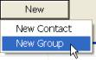

    The Contact Group Properties window appears.

|  |
| --- |
| Description: c:\_temp\iw help\configuration\fax\contact group properties.jpg  Figure 56 - The Contact Group Properties Window |
|  |

  Type group name in the **Name** textbox.

  Type group description in the **Description** textbox.

  In the Group Members Selection, click on a recipient in the Recipient list.

    The selected recipient will be highlighted in blue.

  Click on **>** button to add the selected recipient to the group.

   Repeat step 4 – 5 until all recipients are added.

  Click on **OK** button to save the new group.

     The window closes and the new group is being added to the list.

##### Edit Group

  In the group list, click on a group.

    The selected group will be highlighted in blue background.

  Click on **Edit** button.

    The Contact Group Properties window appears with the details of the selected group.

   Make the necessary amendments.

  Click **OK** button to save the changes.

     The window closes and the group is updated on the list.

##### Remove Group

   In the group list, click on a group.

    The selected group will be highlighted in blue background.

  Click on **Remove** button.

    A window appears to ask for confirmation to remove the selected group.

  Click **Yes** to permanently remove the group, **No** to cancel.

The window closes and the group is removed from the list.

|  |
| --- |
| **Note** |
| Remove the group will not remove the recipients in the group. |

### Change user password

The user profile control the functions the user is authorize to use under Platform Control Mode (PCM) or Fall back Control Mode (FCM). Every user will have one user account that enables the user to login to IW. Every user account belongs to a profile.

|  |  |  |  |  |  |  |
| --- | --- | --- | --- | --- | --- | --- |
| **User profile** | | | | | **Operation mode** | |
| DO | Operator | FC | ITSC | Supervisor | PCM | FCM |
| ✓ | ✓ | ✓ | ✓ | ✓ | ✓ | ✓ |

Allow users to change password. Each password can only be used for a specific period of time. After which, they need to be change for security reasons. The users will be prompted to change their password when the password is due to expire.

Features:

•      Prevent reuse of past password – system will keep record of past passwords and disallow user to reuse the past passwords.

•        Verify old password.

•         Create new password

Go to **Configuration** menu > **Change User Password**

|  |
| --- |
| Figure 57 - The Change password window |
|  |

#### Change password

   In the Change User Password window, type your old password in Old Password textbox.

   Type your new password in the New Password textbox.

  Type your new password in the Re-key New Password textbox to reconfirm it.

    Click on **OK** button.

|  |
| --- |
| Figure 58 - Change User Password Window |
|  |

|  |  |  |
| --- | --- | --- |
| **Error** | | |
| Message | Cause | Possible solution |
| Old password is not correct! | Old password does not match to the one in the database. | Passwords are case sensitive, ensure the password entered is of the correct case. |
| Password cannot be the same as the User ID / User Name, please choose a new one! | New password entered is the same as the User ID / User Name. | Choose password different from User ID / User Name. |
| The password must have at least 12 characters but not more than 20 characters, and at least one lower letter, one upper letter, one number and one special character. Please choose a new one! | New password does not have at least 12 characters but not more than 20 characters, and at least one lower letter, one upper letter, one number and one special character. | Choose password that has at least 12 characters but not more than 20 characters, and at least one lower letter, one upper letter, one number and one special character. |
| The repeated password is not correct! | Password in Re-key New Password field is different from New Password field. | Ensure passwords at both Re-key New Password field and New Password field are the same. |

### Unblock user

The user profile control the functions the user is authorize to use under Platform Control  
Mode (PCM) or Fall back Control Mode (FCM). Every user will have one user account  
that enables the user to login to IW. Every user account belongs to a profile.

|  |  |  |  |  |  |  |
| --- | --- | --- | --- | --- | --- | --- |
| **User profile** | | | | | **Operation mode** | |
| DO | Operator | FC | ITSC | Supervisor | PCM | FCM |
| ✓ | ✓ | ✓ |  |  | ✓ | ✓ |

This configuration only allows DO to unblock user.

1. Go to **Configuration** menu>**Unblock User,** the Unblock User window display as following:

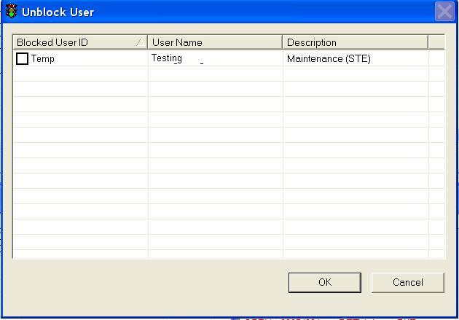

2. Uncheck the user ID, and click on the **OK** button, this user is unblcoked.

### Password policy

The user profile control the functions the user is authorize to use under Platform Control  
Mode (PCM) or Fall back Control Mode (FCM). Every user will have one user account  
that enables the user to login to IW. Every user account belongs to a profile.

|  |  |  |  |  |  |  |
| --- | --- | --- | --- | --- | --- | --- |
| **User profile** | | | | | **Operation mode** | |
| DO | Operator | FC | ITSC | Supervisor | PCM | FCM |
| ✓ | ✓ | ✓ | ✓ | ✓ | ✓ | ✓ |

This configuration only allows DO, ITSC and Supervisor to change the password policy.

1. Go to **Configuration** menu>**Password Policy,** the Password Policy window display as following:

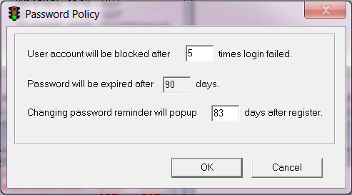

2. Change the times for login failed, change the password valid duration or change the reminder days before the password expiry, and click on the **OK** button, the password policy is changed accordingly.

### Sending link status

The user profile control the functions the user is authorize to use under Platform Control  
Mode (PCM) or Fall back Control Mode (FCM). Every user will have one user account  
that enables the user to login to IW. Every user account belongs to a profile.

|  |  |  |  |  |  |  |
| --- | --- | --- | --- | --- | --- | --- |
| **User profile** | | | | | **Operation mode** | |
| DO | Operator | FC | ITSC | Supervisor | PCM | FCM |
| ✓ | ✓ | ✓ | ✓ | ✓ | ✓ | ✓ |

This configuration only allows DO to change the sending status.

1. Go to **Configuration** menu>**Enable Sending Link Status**, then the link

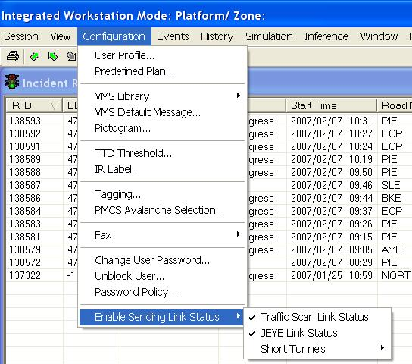

Note: If there is "√" beside the link, meaning that currently this link status will be sent to UMH it will be unchecked if you select it again. This is a toggle selection.

## Events

•     [**Incident Record (IR)**](#_Incident_Record_(IR)) - record of an event / incident

•        Create expressway IR (both open and tunnel)

•         Create arterial road IR

•         View / edit  IR

•     [**IR List**](#_IR_List)

•        View all existing unfinished IR details

•       Provide filtering function

•        View CCTV

•         Finish IR

•     [**Traffic Alert List**](#_Traffic_Alert_List)

•        View and monitor all new and current traffic alerts

•         Filter on the list

•        Alert acknowledgement

•        View equipment of the selected alert on GIS

•     [**Technical Alarm List**](#_Technical_alarm_list)

•        View and monitor all new and current Technical Alarm details

•        Filter on the list

•        Alarm acknowledgement

•        View equipment of the selected alarm on GIS

•     [**Environment Monitoring List**](#_Environment_monitoring_list)

•       Monitor all reading alarms

•        View equipment of the selected alarm on GIS

•        Alarm acknowledgement

•        Filter on the list

•     [**EMAS Equipment Operation Status List**](#_EA_equipment_operation)

•       Monitor all EMAS equipment operation status

•        Search on the list

•        Filter on the list

•        Reset the selected item

•     [**Work Order and 72 Hour Work Order**](#_Work_Order_Handling)

•       View current work order

•        View work order closed within 72 hours

•    [**Junction Control**](#_Junction_Control) – remote control of junction traffic lights

•        Remote control of GLIDE junctions, setting of Cycle Time**,** Split Plan, offset plan, link plan, phase, marriage and divorce

•     [**Equipment Control**](#_Equipment_control) – remote control of EMAS equipment

•      Remote control of VMS / LUS / PMCS / cameras equipment and strategy classes

•     [**Implement Predefined Plan (PP**](#_Implement_Predefined_Plan)**)** – a plan that consists of commands for equipment control

•      Implement or release Predefined Plans

•     [**Next Fax**](#_New_fax)

•      Create and send new fax

•     [**New SMS**](#_New_SMS)

•      Create and send new message (sms)

•     [**Miscellaneous**](#_Miscellaneous)

•      Reload system property files

•      Force users to logout

•        Switch on/off GIS

•     Switching of operational modes

### Incident Record (IR)

You can create a Tunnel or Expressway IR using the “create expressway IR” menu or right click mouse on GIS (**Error! Bookmark not defined.**). Likewise, an arterial IR can be created using the “create Arterial IR” menu. The types of IR are:

|  |  |
| --- | --- |
| Icons | Type Description |
| Description: c:\_temp\iw help\events\Incide1.jpg | Accident |
| Description: c:\_temp\iw help\events\Incide5.jpg | Obstacle |
| Description: c:\_temp\iw help\events\Incide9.jpg | Heavy Traffic |
| Description: c:\_temp\iw help\events\Incide2.jpg | Road works |
| Description: c:\_temp\iw help\events\Incide6.jpg | Road block |
| Description: c:\_temp\iw help\events\Incide10.jpg | Weather |
| Description: c:\_temp\iw help\events\Incide3.jpg | Unattended vehicle |
| Description: c:\_temp\iw help\events\Incide7.jpg | Diversion |
| Description: c:\_temp\iw help\events\Incide4.jpg | Vehicle breakdown |
| Description: c:\_temp\iw help\events\Incide8.jpg | Miscellaneous |

There flow for IR handling is as follows:

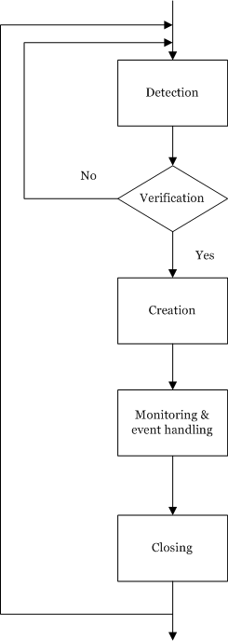

•        Detection

Events are detected by various means which include through PTZ or detection cameras, reported by towing crews or public and from public call-ins.

•        Verification

Detected events can be verified using CCTV or by sending crew to the site.

•        Creation

After confirming that the events are true, operator will proceed to IR creation. You may create an IR event if you do not have much detail. However, you can create event with certain essential details first and save the IR. The system will not allow you to save the IR if the essential details are missing. The essential details are State, Start Time, Location information, Source, Lane Blockage and Type. When you get more details for the IR, you can update the IR to input the rest of the details. You must also decide if you would like to get partners involvement or send recovery crew and to propose/ implement event action plan.

The system has 20 different templates to cater for various type of IR. A template is made up of an event form, a response form, a monitor form and an event handling form. The event form for each type of IR may vary slightly, the response, monitor and event handling forms are similar.

•        Monitoring & event handling

After IR is created, you have to constantly monitor the event situation to update the system of any change. E.g. to record the arrival time of informed partner(s), to enter congestion information caused by IR and end time of IR etc. You may also need to inform more partners or implement more event action plans.

•        Closing

After the event has ended, you may close the IR. This will end the IR handling process.

An Incident Record consists of 4 tabs to cater for creation & monitoring phases of IR handling:

•       Event tab – IRdetails, duration, location, type and source.

•       Response tab –Partners (TP, SCDF, Ambulance, ENV, Police) and vehicles (Incident, Tow) involved.

•       Monitor tab –Congestion time and location caused by the incident.

•       Event Handling tab – Implement / recommended action plans involving traffic equipment (VMS, LUS and junctions). It also allow for faxing of the IR details to the various partners.

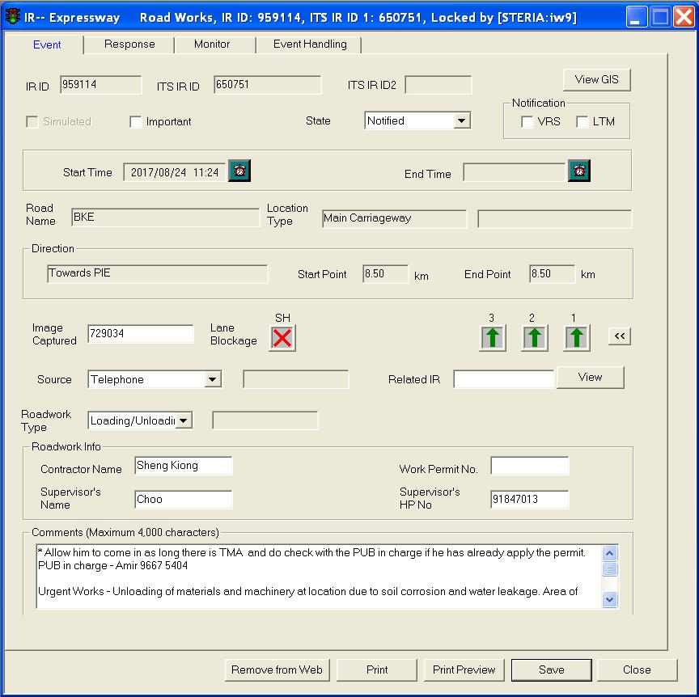

Figure 59 - An example expressway / tunnel IR window

|  |  |
| --- | --- |
| **Field** | **Description** |
| IR ID | ID assigned to this IR by the system, it will appear when the system successfully save the IR. If the IR is simulated IR, the IR will be a negative ID, e.g. -1000. |
| ITS IR ID | ID of the original ITS given by EMAS/Short Tunnels when I-Transport system stores the IR to EMAS/Short Tunnels database. This ID is not available for arterial road IR. |
| ITS IR ID2 | ID of the congestion ITS given by EMAS/Short Tunnels when I-Transport system stores the congestion part of the IR to EMAS/Short Tunnels database. This ID is not available for congestion of arterial road IR. |
| View GIS | Could only be used when IR is saved. To view the location of the incident on the GIS. |
| State | |  |  | | --- | --- | | Notified | Received notification from source (CCTV, crew or public) but not confirmed. | | Confirmed | The event is confirmed by verification through CCTV or tow crew. | | Anticipated | For scheduled events, only available for Road Works and Road Blocks types. | | In Progress | The event is still ongoing and has not over yet / the congestion caused by the event has not been cleared. | | Over | The event has over and congestion (if any) cleared. | |
| Lane Blockage | For expressway IR, the lane blockage will display the actual numbers of lanes on site, based on Start Point.  For arterial road IR, the number of lanes displayed on the IR will be fixed and is the maximum no. of available lanes on Singapore arterial roads.   |  |  | | --- | --- | | SH | Shoulder (expressway). | | LS1 and LS2 | Left storage lanes (arterial rd). | | RS1 and RS2 | Right storage lanes (arterial rd). | | Description: c:\_temp\iw help\events\lb_nor.JPG | Normal state | | Description: c:\_temp\iw help\events\lb_loc.JPG | Location of the event | | Description: c:\_temp\iw help\events\lb_clane.JPG | Closed lane (due to LTA action) | | Description: c:\_temp\iw help\events\lb_cleven.JPG | Closed lane at the location of event | |

Creation of an IR will involve both CCM and GIS. CCM is used for entering most of the IR details, while GIS is used for selecting the start and end points of event and congestion end point locations. Creation of IR can start from CCM or GIS, but finally, monitoring and closing of IR will always be performed on CCM.

#### Create Expressway/EA/ST IR

The user profile control the functions the user is authorize to use under Platform Control Mode (PCM) or Fall back Control Mode (FCM). Every user will have one user account that enables the user to login to IW. Every user account belongs to a profile.

|  |  |  |  |  |  |  |
| --- | --- | --- | --- | --- | --- | --- |
| **User profile** | | | | | **Operation mode** | |
| DO | Operator | FC | ITSC | Supervisor | PCM | FCM |
| ✓ | ✓ | ✓ | ✓ | ✓ | ✓ | ✓ |

To create IR, you can right click mouse on GIS to create an Expressway IR.

An IR generally consists of the following information:

•      Verification state (notified, confirmed, anticipated, in progress and over).

•      Starting date and time.

•      Ending date and time.

•       GIS location (Road Name, Location Type, Direction, Start Point and End Point.

•       Source of event detection.

•       Reference to the IR that cause this event.

•       Type of event.

•       Whether the IR is simulated or real.

Other information is depended on the IR type.

##### Accident

•    Create event

Click on **Event** tab.

The Event form is shown.

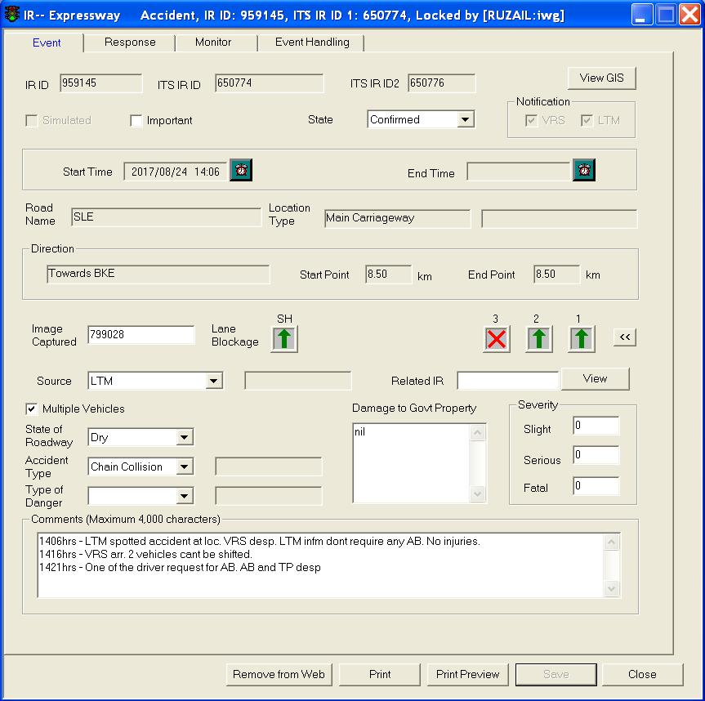

 Click the Simulated checkbox if the IR is meant as a simulated one.

 Click the State dropdown arrow, and click a state.

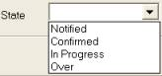.

   Set the Start Time by clicking on the Clock button to set time as the current date and time. To manually set date and time, click on the textbox, a Date and Time window will appear.

   If the IR’s state is “Over”, you can set the End Time.

   Click on Start Point textbox.

   Move your mouse to GIS and create start point.

For more information on how to create start point on GIS, refer to Create Start Point , expressway, tunnel or FCT/WVT/SGT.

Road Name, Location Type, Direction, Start Point and End Point will be automatically updated after selection of the start point on the GIS.

   Click on End Point textbox.

For more information on how to create end point on GIS, refer to Create End Point , expressway, tunnel or FCT/WVT/SGT.

End Point will be automatically updated.

   Type value in the Image Captured textbox.

   Click the Source dropdown arrow, and click a source.

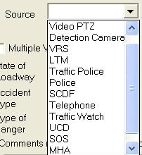

These IR labels may change because they are configurable.

 Click the State of IR dropdown arrow, and click a state.

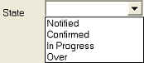

 Click the Accident Type dropdown arrow, and click a type.

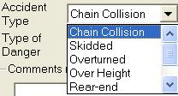

 Click the Type of Danger dropdown arrow, and click a type.

 Click the Lane Blockage graphic of each affected lane, and click a new graphic.

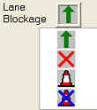

 Click the Related IR dropdown arrow, and select a related IR.

 Type description in the Damage to Government Property textbox.

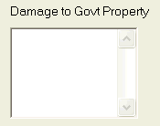

 Type no. of people in the Slight, Serious, Fatal textboxes, e.g. if 2 people are seriously injured, type 2 in Serious textbox. Number must be in the integer format.

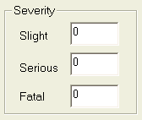

 Type comments in the Comments textbox if there is any additional information.

 Click **Save** button to save the IR when all these details are entered. The IR ID field will then returned a ID number associated to this  IR.

•    Define Response, Monitor and Event Handling

Please refer to [Update Event Response Tab](#_Update_Event_Response), [Update Monitor](#_Update_Monitor), [Update Event Handling](#_Update_Event_Handling).

|  |  |  |
| --- | --- | --- |
| **Error** | | |
| Message | Cause | Possible solution |
| Please Select Verification State. | The State in Event form is not defined. | Click on Event tab, select the State in the event form and try again. |

##### Road Works

•    Create event

   Click on **Event** tab.

      The Event form is shown.

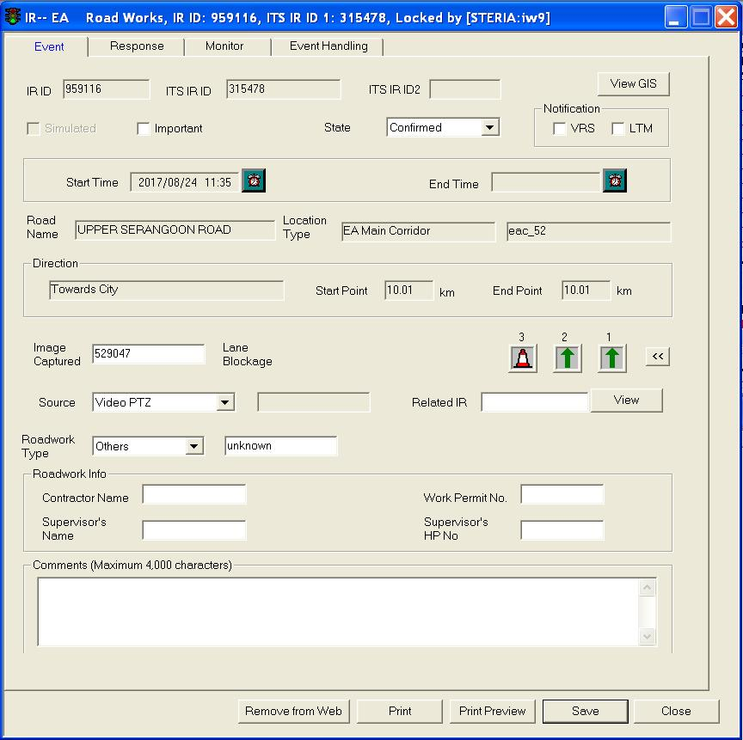

2  Click the Simulated checkbox if the IR is meant as a simulated one.

3  Click the State dropdown arrow, and click a state.



   Set the Start Time by clicking on the Clock button to set time as the current date and time. To manually set date and time, click on the textbox, a Date and Time window will appear.

5  If the IR’s state is “Over" you can set the End Time.

6  Click on Start Point textbox.

7  Move your mouse to GIS and create start point.

For more information on how to create start point on GIS, refer to Create Start Point , expressway, tunnel or FCT/WVT/SGT.

Road Name, Location Type, Direction, Start Point and End Point will be automatically updated after selection of the start point on the GIS.

8  Click on End Point textbox.

For more information on how to create end point on GIS, refer to Create End Point, expressway, tunnel or FCT/WVT/SGT.

End Point will be automatically updated.

9  Type value in the Image Captured textbox.

10 Click the Source dropdown arrow, and click a source.



These IR labels may change because they are configurable

11 Click the Roadwork Type dropdown arrow, and click a type.

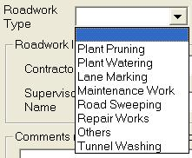

12 Click the Lane Blockage graphic of each affected lane, and click a new graphic.

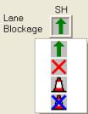

13 Click the Related IR dropdown arrow, and click a related IR.

  In the Roadwork Info panel, type name in the Contractor Name , Supervisor’s Name textboxes.

  Type no. in the Work Permit No. textbox.

  Type hp no. in the Supervisor’s HP No. textbox.

  Type comments in the Comments textbox.

  Type comments in the Comments textbox if there is any additional information.

19  Click **Save** button to save the IR when all these details are entered. The IR ID field will then returned a ID number associated to this IR.

•    Define Response, Monitor and Event Handling

Please refer to [Update Event Response Tab](#_Update_Event_Response), [Update Monitor](#_Update_Monitor), [Update Event Handling](#_Update_Event_Handling).

|  |  |  |
| --- | --- | --- |
| **Error** | | |
| Message | Cause | Possible solution |
| Please Select Verification State. | The State in Event form is not defined. | Click on Event tab, select the State in the event form and try again. |

##### Unattended vehicle

•    Create event

  Click on **Event** tab.

      The Event form is shown.

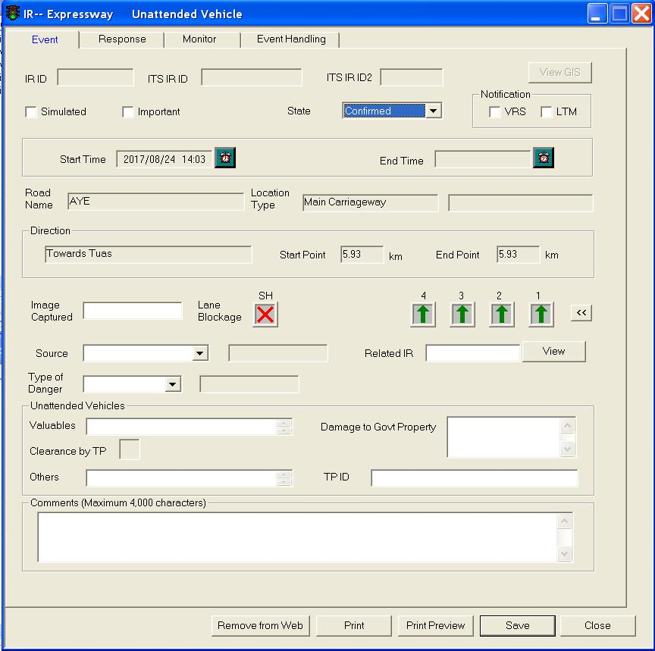

  Click the Simulated checkbox if the IR is meant as a simulated one.

  Click the State dropdown arrow, and click a state.



   Set the Start Time by clicking on the Clock button to set time as the current date and time. To manually set date and time, click on the textbox, a Date and Time window will appear.

    If the IR’s state is “Over”, you can set the End Time.

    Click on Start Point textbox.

    Move your mouse to GIS and create start point.

For more information on how to create start point on GIS, refer to Create Start Point, expressway, tunnel or FCT/WVT/SGT.

Road Name, Location Type, Direction, Start Point and End Point will be automatically updated after selection of the start point on the GIS.

    Click on End Point textbox.

For more information on how to create end point on GIS, refer to Create End Point, expressway, tunnel or FCT/WVT/SGT.

End Point will be automatically updated.

    Type value in the Image Captured textbox.

 Click the Source dropdown arrow, and click a source.



These IR labels may change because they are configurable.

  Click the Type of Danger dropdown arrow, and click a type.

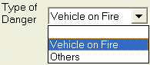

 Click the Type of Danger dropdown arrow, and click a type.



  Click the Related IR dropdown arrow, and click a related IR.

  In the Unattended Vehicles panel, type description in the Valuables textbox.

  Type description in the Damage to Govt Property textbox.

  Click on Clearance by TP button.

  Type values in the Others textbox.

  Type ID in the TP ID textbox.

  Type comments in the Comments textbox if there is any additional information.

  Click **Save** button to save the IR when all these details are entered. The IR ID field will then returned a ID number associated to this IR.

•    Define Response, Monitor and Event Handling

Please refer to [Update Event Response Tab](#_Update_Event_Response), [Update Monitor](#_Update_Monitor), [Update Event Handling](#_Update_Event_Handling).

|  |  |  |
| --- | --- | --- |
| **Error** | | |
| Message | Cause | Possible solution |
| Please Select Verification State. | The State in Event form is not defined. | Click on Event tab, select the State in the event form and try again. |

##### Vehicle breakdown

•    Create event

  Click on **Event** tab.

The Event form is shown.

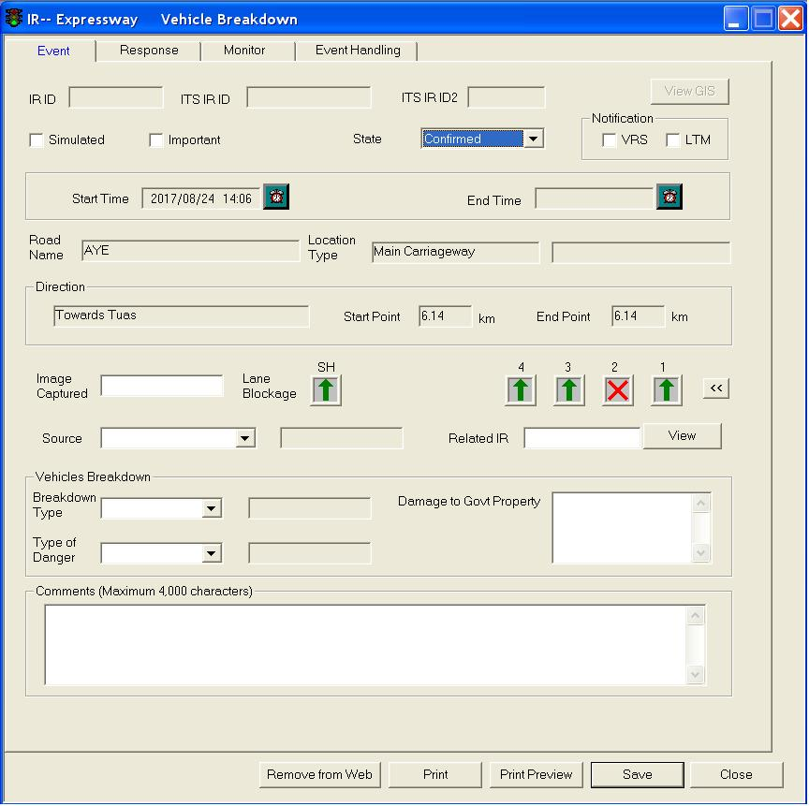

  Click the Simulated checkbox if the IR is meant as a simulated one.

  Click the State dropdown arrow, and click a state.



  Set the Start Time by clicking on the Clock button to set time as the current date and time. To manually set date and time, click on the textbox, a Date and Time window will appear.

  If the IR’s state is “Over" you can set the End Time.

  Click on Start Point textbox.

  Move your mouse to GIS and create start point.

For more information on how to create start point on GIS, refer to Create Start Point , expressway, tunnel or FCT/WVT/SGT.

Road Name, Location Type, Direction, Start Point and End Point will be automatically updated after selection of the start point on the GIS.

  Click on End Point textbox.

For more information on how to create end point on GIS, refer to Create End Point , expressway, tunnel or FCT/WVT/SGT.

End Point will be automatically updated.

  Click the Source dropdown arrow, and click a source.

  Click the Source dropdown arrow, and click a source.



These IR labels may change because they are configurable.

  Click the Breakdown Type dropdown arrow, and click a type.

  Click the Type of Danger dropdown arrow, and click a type



 Click the Lane Blockage graphic of each affected lane, and click a new graphic.



 Click the Related IR dropdown arrow, and click a related IR.

 Type description in the Damage to Government Property textbox.

 Type comments in the Comments textbox if there is any additional information.

 Click **Save** button to save the IR when all these details are entered. The IR ID field will then returned a ID number associated to this IR.

•    Define Response, Monitor and Event Handling

Please refer to [Update Event Response Tab](#_Update_Event_Response), [Update Monitor](#_Update_Monitor), [Update Event Handling](#_Update_Event_Handling).

|  |  |  |
| --- | --- | --- |
| **Error** | | |
| Message | Cause | Possible solution |
| Please Select Verification State. | The State in Event form is not defined. | Click on Event tab, select the State in the event form and try again. |

##### Obstacle

•    Create event

 Click on **Event** tab.

The Event form is shown.

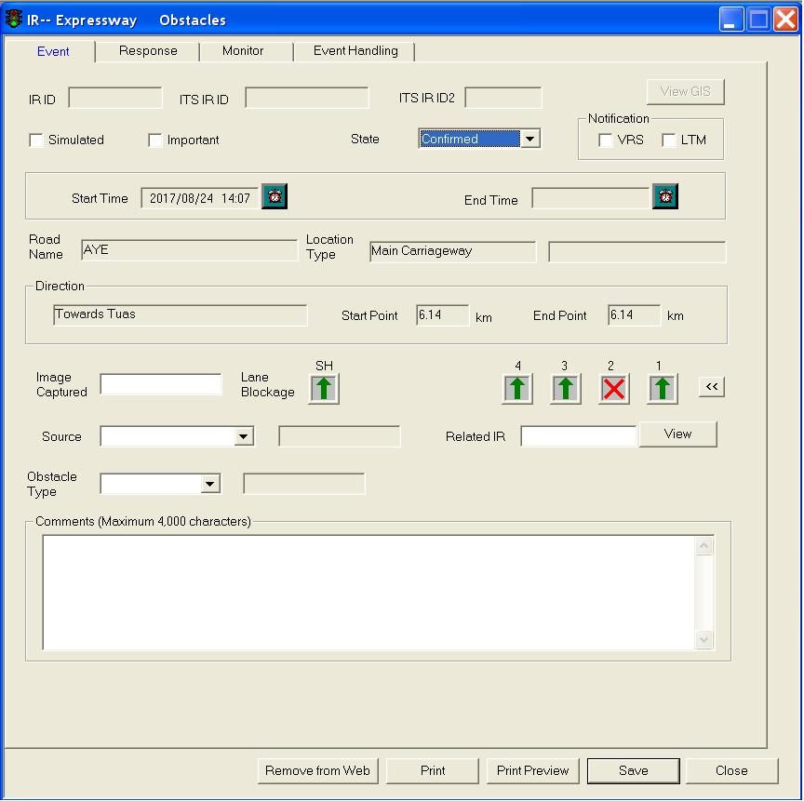

 Click the Simulated checkbox if the IR is meant as a simulated one.

 Click the State dropdown arrow, and click a state.



 Set the Start Time by clicking on the Clock button to set time as the current date and time. To manually set date and time, click on the textbox, a Date and Time window will appear.

 If the IR’s state is “Over”, you can set the End Time.

 Click on Start Point textbox.

 Move your mouse to GIS and create start point.

For more information on how to create start point on GIS, refer to Create Start Point , expressway, tunnel or FCT/WVT/SGT.

Road Name, Location Type, Direction, Start Point and End Point will be automatically updated after selection of the start point on the GIS.

 Click on End Point textbox.

For more information on how to create end point on GIS, refer to Create End Point , expressway, tunnel or FCT/WVT/SGT.

End Point will be automatically updated.

 Type value in the Image Captured textbox.

 Click the Source dropdown arrow, and click a source.

+

These IR labels may change because they are configurable.

 Click the Obstacle Type dropdown arrow, and click a type.

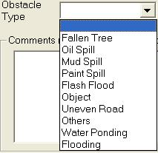

 Click the Lane Blockage graphic of each affected lane, and click a new graphic.



 Click the Related IR dropdown arrow, and click a related IR.

 Type comments in the Comments textbox if there is any additional information.

 Click **Save** button to save the IR when all these details are entered. The IR ID field will then returned a ID number associated to this IR.

•    Define Response, Monitor and Event Handling

Please refer to [Update Event Response Tab](#_Update_Event_Response), [Update Monitor](#_Update_Monitor), [Update Event Handling](#_Update_Event_Handling).

|  |  |  |
| --- | --- | --- |
| **Error** | | |
| Message | Cause | Possible solution |
| Please Select Verification State. | The State in Event form is not defined. | Click on Event tab, select the State in the event form and try again. |

##### Road block

•    Create event

  Click on **Event** tab.

The Event form is shown.

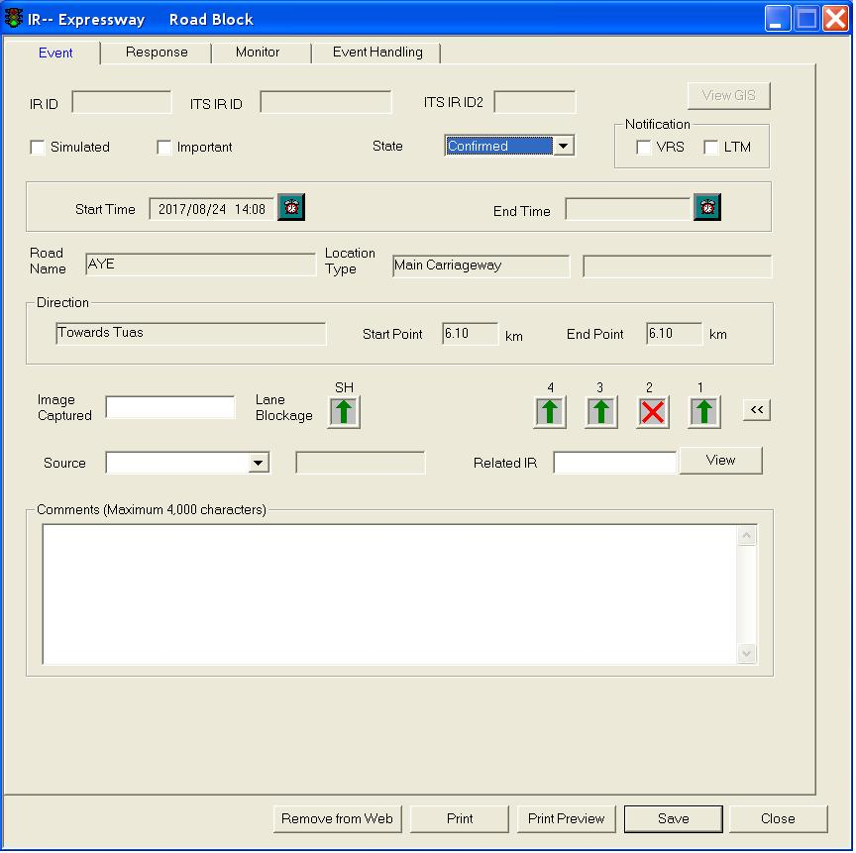

  Click the Simulated checkbox if the IR is meant as a simulated one.

  Click the State dropdown arrow, and click a state.



   Set the Start Time by clicking on the Clock button to set time as the current date and time. To manually set date and time, click on the textbox, a Date and Time window will appear.

   If the IR’s state is “Over”, you can set the End Time.

   Click on Start Point textbox.

   Move your mouse to GIS and create start point.

For more information on how to create start point on GIS, refer to Create Start Point , expressway, tunnel or FCT/WVT/SGT.

Road Name, Location Type, Direction, Start Point and End Point will be automatically updated after selection of the start point on the GIS.

   Click on End Point textbox.

For more information on how to create end point on GIS, refer to Create End Point , expressway, tunnel or FCT/WVT/SGT.

End Point will be automatically updated.

   Type value in the Image Captured textbox.

 Click the Source dropdown arrow, and click a source.



These IR labels may change because they are configurable.

 Click the Lane Blockage graphic of each affected lane, and click a new graphic.



 Click the Related IR dropdown arrow, and click a related IR.

 Type comments in the Comments textbox if there is any additional information.

 Click **Save** button to save the IR when all these details are entered. The IR ID field will then returned a ID number associated to this IR.

•    Define Response, Monitor and Event Handling

Please refer to [Update Event Response Tab](#_Update_Event_Response), [Update Monitor](#_Update_Monitor), [Update Event Handling](#_Update_Event_Handling).

|  |  |  |
| --- | --- | --- |
| **Error** | | |
| Message | Cause | Possible solution |
| Please Select Verification State. | The State in Event form is not defined. | Click on Event tab, select the State in the event form and try again. |

##### Diversion

•    Create event

  Click on **Event** tab.

The Event form is shown.

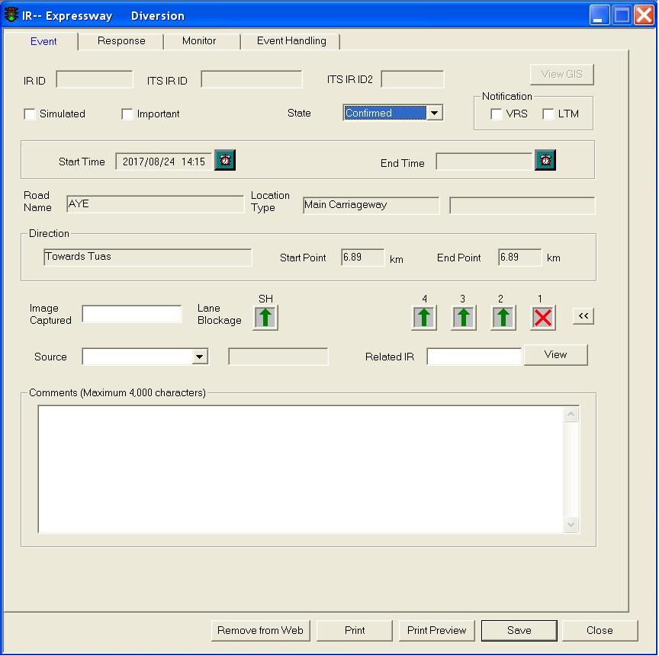

  Click the Simulated checkbox if the IR is meant as a simulated one.

  Click the State dropdown arrow, and click a state.



   Set the Start Time by clicking on the Clock button to set time as the current date and time. To manually set date and time, click on the textbox, a Date and Time window will appear.

   If the IR’s state is “Over”, you can set the End Time.

   Click on Start Point textbox.

   Move your mouse to GIS and create start point.

For more information on how to create start point on GIS, refer to Create Start Point , expressway, tunnel or FCT/WVT/SGT.

Road Name, Location Type, Direction, Start Point and End Point will be automatically updated after selection of the start point on the GIS.

   Click on End Point textbox.

For more information on how to create end point on GIS, refer to Create End Point , expressway, tunnel or FCT/WVT/SGT.

End Point will be automatically updated.

   Type value in the Image Captured textbox.

 Click the Source dropdown arrow, and click a source.



These IR labels may change because they are configurable.

 Click the Lane Blockage graphic of each affected lane, and click a new graphic.



 Click the Related IR dropdown arrow, and click a related IR.

 Type comments in the Comments textbox if there is any additional information.

 Click **Save** button to save the IR when all these details are entered. The IR ID field will then returned a ID number associated to this IR.

•    Define Response, Monitor and Event Handling

Please refer to [Update Event Response Tab](#_Update_Event_Response), [Update Monitor](#_Update_Monitor), [Update Event Handling](#_Update_Event_Handling).

|  |  |  |
| --- | --- | --- |
| **Error** | | |
| Message | Cause | Possible solution |
| Please Select Verification State. | The State in Event form is not defined. | Click on Event tab, select the State in the event form and try again. |

##### Miscellaneous

•    Create event

  Click on **Event** tab.

The Event form is shown.

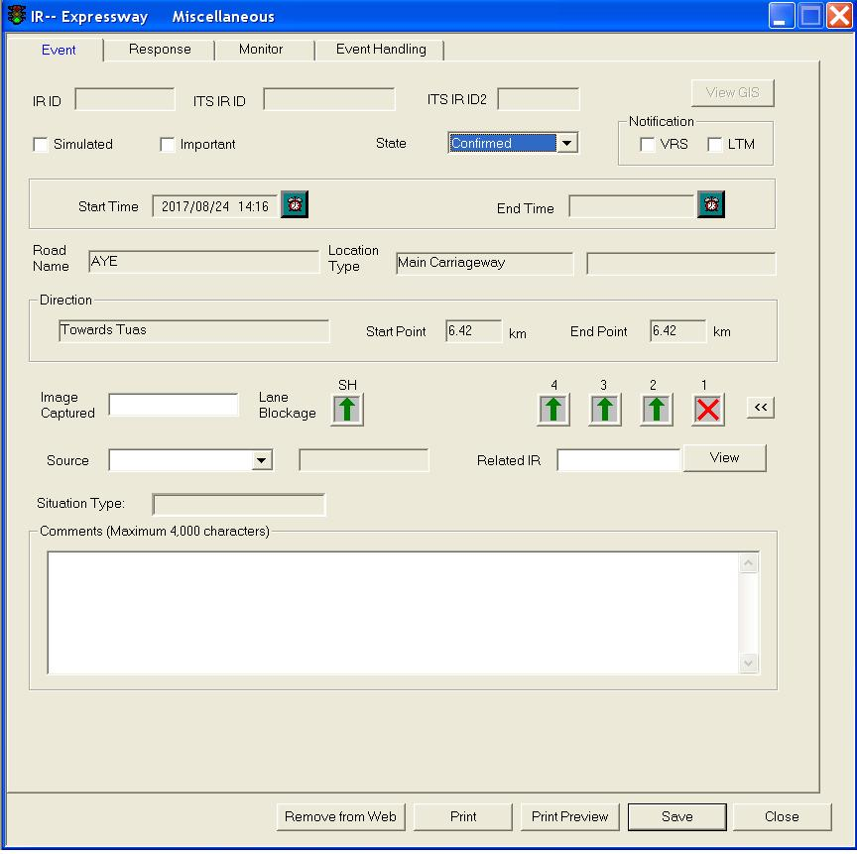

  Click the Simulated checkbox if the IR is meant as a simulated one.

  Click the State dropdown arrow, and click a state.



   Set the Start Time by clicking on the Clock button to set time as the current date and time. To manually set date and time, click on the textbox, a Date and Time window will appear.

   If the IR’s state is “Over”, you can set the End Time.

   Click on Start Point textbox.

   Move your mouse to GIS and create start point.

For more information on how to create start point on GIS, refer to Create Start Point , expressway, tunnel or FCT/WVT/SGT.

Road Name, Location Type, Direction, Start Point and End Point will be automatically updated after selection of the start point on the GIS.

   Click on End Point textbox.

For more information on how to create end point on GIS, refer to Create End Point , expressway, tunnel or FCT/WVT/SGT.

End Point will be automatically updated.

   Type value in the Image Captured textbox.

 Click the Source dropdown arrow, and click a source.



These IR labels may change because they are configurable.

 Click the Lane Blockage graphic of each affected lane, and click a new graphic.



 Click the Related IR dropdown arrow, and click a related IR.

  Type comments in the Comments textbox if there is any additional information.

 Click **Save** button to save the IR when all these details are entered. The IR ID field will then returned a ID number associated to this IR.

•    Define Response, Monitor and Event Handling

Please refer to [Update Event Response Tab](#_Update_Event_Response), [Update Monitor](#_Update_Monitor), [Update Event Handling](#_Update_Event_Handling).

|  |  |  |
| --- | --- | --- |
| **Error** | | |
| Message | Cause | Possible solution |
| Please Select Verification State. | The State in Event form is not defined. | Click on Event tab, select the State in the event form and try again. |

##### Heavy Traffic

•    Create event

   Click on **Event** tab.

The Event form is shown.

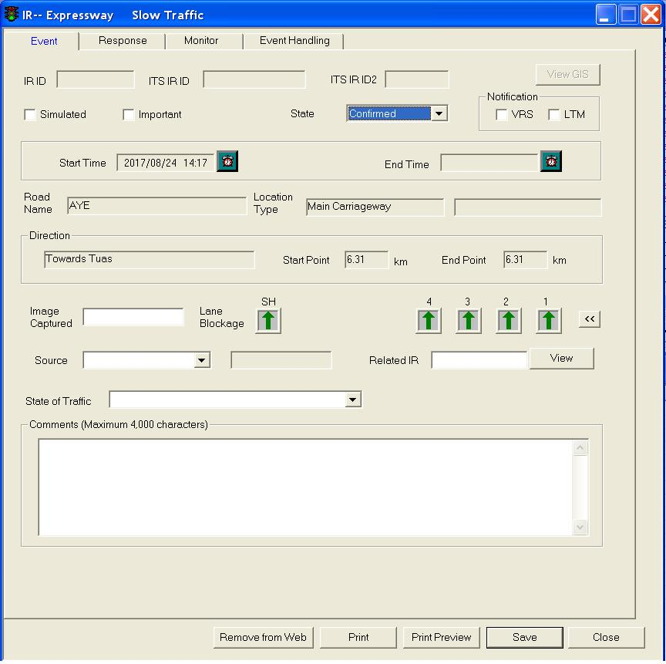

   Click the Simulated checkbox if the IR is meant as a simulated one.

   Click the State dropdown arrow, and click a state.



   Set the Start Time by clicking on the Clock button to set time as the current date and time. To manually set date and time, click on the textbox, a Date and Time window will appear.

   If the IR’s state is “Over" you can set the End Time.

   Click on Start Point textbox.

   Move your mouse to GIS and create start point.

For more information on how to create start point on GIS, refer to Create Start Point, expressway, tunnel or FCT/WVT/SGT.

Road Name, Location Type, Direction, Start Point and End Point will be automatically updated after selection of the start point on the GIS.

   Click on End Point textbox.

For more information on how to create end point on GIS, refer to Create End Point, expressway, tunnel or FCT/WVT/SGT.

End Point will be automatically updated.

   Type value in the Image Captured textbox.

 Click the Source dropdown arrow, and click a source.



These IR labels may change because they are configurable.

 Click the State of Traffic dropdown arrow, and click a state.

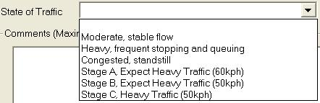

 Click the Lane Blockage graphic of each affected lane, and click a new graphic (optional for this type of IR).



 Click the Related IR dropdown arrow, and click a related IR.

 Type comments in the Comments textbox if there is any additional information.

 Click **Save** button to save the IR when all these details are entered. The IR ID field will then returned a ID number associated to this IR.

•    Define Response, Monitor and Event Handling

Please refer to [Update Event Response Tab](#_Update_Event_Response), [Update Monitor](#_Update_Monitor), [Update Event Handling](#_Update_Event_Handling).

|  |  |  |
| --- | --- | --- |
| **Error** | | |
| Message | Cause | Possible solution |
| Please Select Verification State. | The State in Event form is not defined. | Click on Event tab, select the State in the event form and try again. |

|  |
| --- |
| **Note** |
| Please note that for Heavy Traffic IR, congestion details (in Monitor tab) is not required as slow traffic itself is congestion. |

##### Weather

•    Create event

   Click on **Event** tab.

The Event form is shown.

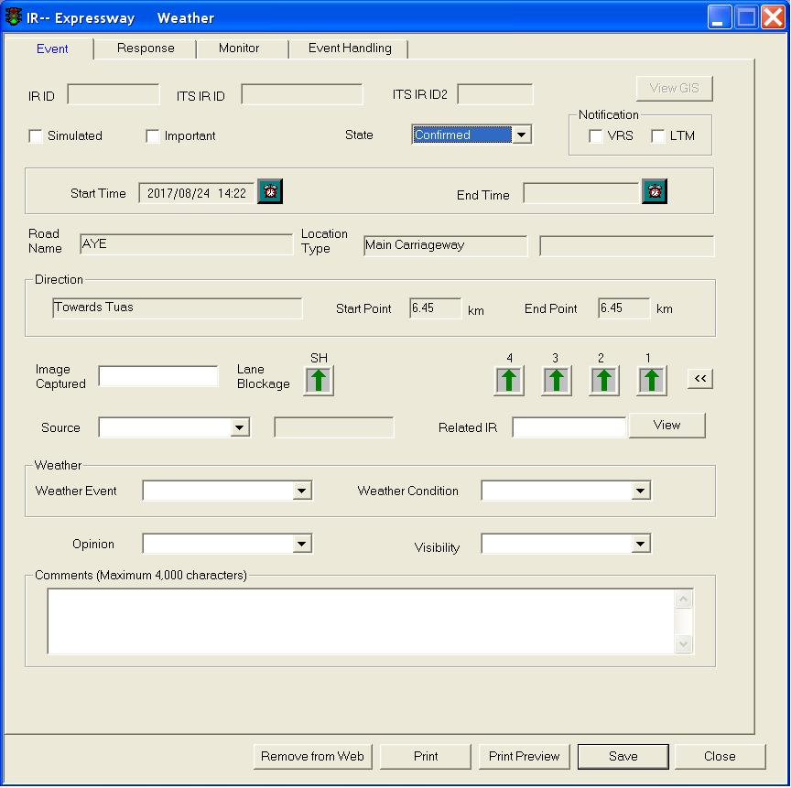

   Click the **Simulated** checkbox if the IR is meant as a simulated one.

   Click the **State** dropdown arrow, and click a state.

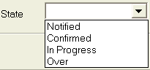

   Set the Start Time by clicking on the Clock button to set time as the current date and time. To manually set date and time, click on the textbox, a Date and Time window will appear.

   If the IR’s state is “Over”, you can set the End Time.

  Click on **Start Point** textbox.

   Move your mouse to GIS and create start point.

For more information on how to create start point on GIS, refer to Create Start Point , expressway, tunnel or FCT/WVT/SGT.

Road Name, Location Type, Direction, Start Point and End Point will be automatically updated after selection of the start point on the GIS.

  Click on **End Point** textbox.

For more information on how to create end point on GIS, refer to Create End Point , expressway, tunnel or FCT/WVT/SGT.

End Point will be automatically updated.

  Type value in the Image Captured textbox.

 Click the **Source** dropdown arrow, and click a source.



These IR labels may change because they are configurable.

 Click the **Lane Blockage** graphic of each affected lane, and click a new graphic.

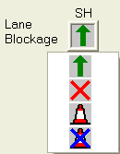

 Click the **Related IR** dropdown arrow, and click a related IR.

 In the Weather panel, click the Weather Event dropdown arrow, and click an event.

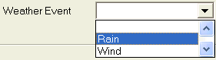

 Click the **Weather Condition** dropdown arrow, and click a condition.

 Click the **Opinion** dropdown arrow, and click an opinion.

 Click the **Visibility** dropdown arrow, and click a visibility.

 Type comments in the Comments textbox if there is any additional information.

 Click **Save** button to save the IR when all these details are entered. The IR ID field will then returned a ID number associated to this IR.

•    Define Response, Monitor and Event Handling

Please refer to [Update Event Response Tab](#_Update_Event_Response), [Update Monitor](#_Update_Monitor), [Update Event Handling](#_Update_Event_Handling).

|  |  |  |
| --- | --- | --- |
| **Error** | | |
| Message | Cause | Possible solution |
| Please Select Verification State. | The State in Event form is not defined. | Click on Event tab, select the State in the event form and try again. |

#### Create KPE/MCE IR

Operators are not allowed to create KPE/MCE IR through CCM.

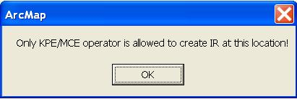

Authorized operators can validate if the KPE/MCE IR is valid or not.

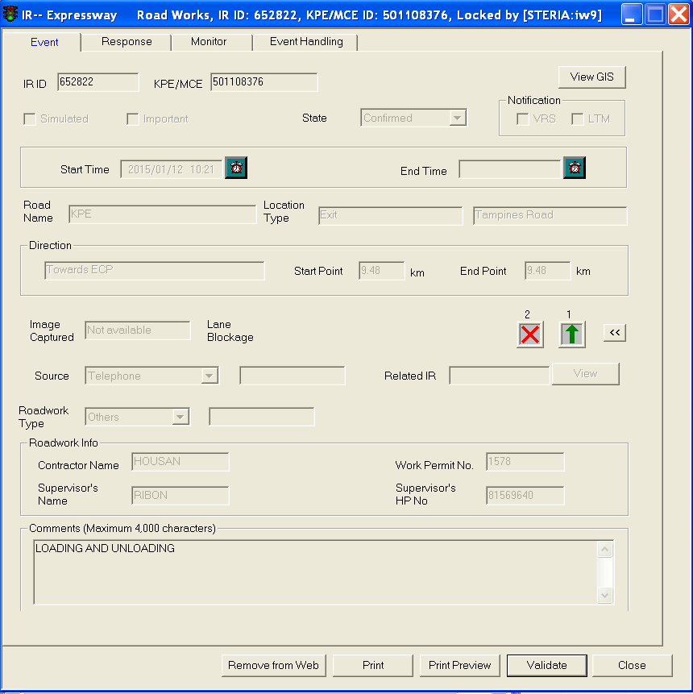

#### Create Arterial Road IR

The user profile control the functions the user is authorize to use under Platform Control Mode (PCM) or Fall back Control Mode (FCM). Every user will have one user account that enables the user to login to IW. Every user account belongs to a profile.

|  |  |  |  |  |  |  |
| --- | --- | --- | --- | --- | --- | --- |
| **User profile** | | | | | **Operation mode** | |
| DO | Operator | FC | ITSC | Supervisor | PCM | FCM |
| ✓ | ✓ | ✓ | ✓ | ✓ | ✓ | ✓ |

To create IR, you can right click mouse on GIS to create an Arterial Road IR.

An IR generally consists of the following information:

•       Verification state (notified, confirmed, anticipated, in progress and over).

•      Starting date and time.

•       Ending date and time.

•      GIS location (Up Site Id, Up Node Distance, Road Name, Up Node description, Down Site Id and Down Node description).

•        Source of event detection.

•       Reference to the IR that cause this event.

•       Type of event

•      Whether the IR is simulated or real.

Other information is depended on the IR type.

##### Accident

•    Create event

  Click on **Event** tab.

The Event form is shown.

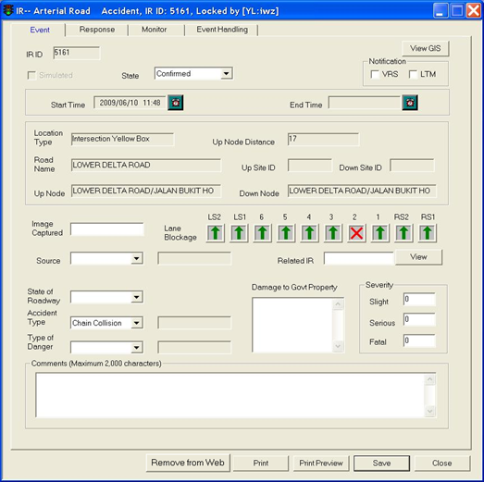

  Click the **Simulated** checkbox if the IR is meant as a simulated one.

  Click the **State** dropdown arrow, and click a state.



   Set the Start Time by clicking on the **Clock** button to set time as the current date and time. To manually set date and time, click on the textbox, a Date and Time window will appear.

   If the IR’s state is “Over”, you can set the End Time.

   Move your mouse to GIS and create start point.

For more information on how to create start point on GIS, refer to [Create Start Point](#_Create_Start_Point)

Up Site Id, Up Node Distance, Road Name and Up Node will be automatically updated.

   Move your mouse to GIS and create end point.

For more information on how to create end point on GIS, refer to [Create End Point](#_Create_End_Point)

Down Site Id and Down Node will be automatically updated.

   Type value in the **Image Captured** textbox.

   Click the **Lane Blockage** graphic of each affected lane, and click a new graphic.



 Click the **Source** dropdown arrow, and click a source.



These IR labels may change because they are configurable.

 Click the **Related IR** dropdown arrow, and click a related IR.

 Click the **State of Roadway** dropdown arrow, and click a state.

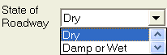

 Click the **Accident** Type dropdown arrow, and click a type.



 Click the **Type of Danger** dropdown arrow, and click a type.

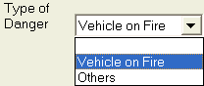

 Type description in the Damage to Govt Property textbox.

 Type no. of people in the **Slight, Serious, Fatal** textboxes, e.g. if 2 people are seriously injured, type 2 in Serious textbox.

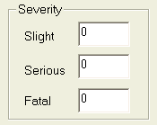

 Type comments in the **Comments** textbox if there is any additional information.

 Click **Save** button to save the IR when all these details are entered. The IR ID field will then returned a ID number associated to this IR.

•    Define Response, Monitor and Event Handling

Please refer to [Update Event Response Tab](#_Update_Event_Response), [Update Monitor](#_Update_Monitor), [Update Event Handling](#_Update_Event_Handling).

|  |  |  |
| --- | --- | --- |
| **Error** | | |
| Message | Cause | Possible solution |
| Please Select Verification State. | The State in Event form is not defined. | Click on Event tab, select the State in the event form and try again. |

##### Road works

•    Create event

  Click on **Event** tab.

The Event form is shown.

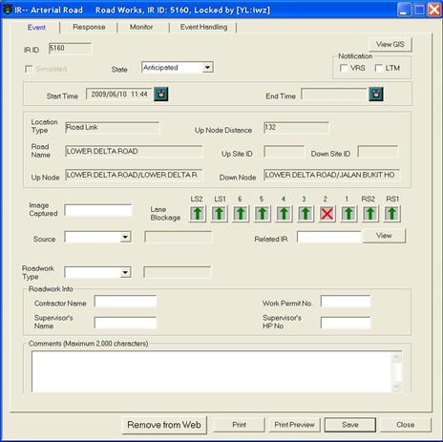

  Click the **Simulated** checkbox if the IR is meant as a simulated one.

  Click the **State** dropdown arrow, and click a state.



  Set the Start Time by clicking on the **Clock** button to set time as the current date and time. To manually set date and time, click on the textbox, a Date and Time window will appear.

  If the IR’s state is “Over”, you can set the End Time.

  Move your mouse to GIS and create start point.

For more information on how to create start point on GIS, refer to [Create Start Point](#_Create_Start_Point)

Up Site Id, Up Node Distance, Road Name and Up Node will be automatically updated.

  Move your mouse to GIS and create end point.

For more information on how to create end point on GIS, refer to [Create End Point](#_Create_End_Point)

Down Site Id and Down Node will be automatically updated.

  Type value in the I**mage Captured** textbox.

  Click the **Source** dropdown arrow, and click a source.



These IR labels may change because they are configurable.

  Click the **Roadwork** Type dropdown arrow, and click a type.



  Click the **Lane Blockage** graphic of each affected lane, and click a new graphic.



  Click the **Related IR** dropdown arrow, and click a related IR.

  In the **Roadwork Info** panel, type name in the Contractor Name, Supervisor’s Name textboxes.

  Type no. in the **Work Permit No.** textbox.

  Type hp no. in the **Supervisor’s HP No.** textbox.

  Type comments in the **Comments** textbox if there is any additional information.

  Click **Save** button to save the IR when all these details are entered. The IR ID field will then returned a ID number associated to this IR.

•    Define Response, Monitor and Event Handling

Please refer to [Update Event Response Tab](#_Update_Event_Response), [Update Monitor](#_Update_Monitor), [Update Event Handling](#_Update_Event_Handling).

|  |  |  |
| --- | --- | --- |
| **Error** | | |
| Message | Cause | Possible solution |
| Please Select Verification State. | The State in Event form is not defined. | Click on Event tab, select the State in the event form and try again. |

##### Unattended vehicle

•    Create event

  Click on **Event** tab.

The Event form is shown.

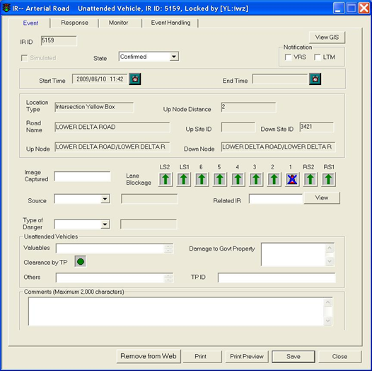

  Click the **Simulated** checkbox if the IR is meant as a simulated one.

  Click the **State** dropdown arrow, and click a state.



   Set the Start Time by clicking on the **Clock** button to set time as the current date and time. To manually set date and time, click on the textbox, a Date and Time window will appear.

   If the IR’s state is “Over”, you can set the End Time.

  Move your mouse to GIS and create start point.

For more information on how to create start point on GIS, refer to [Create Start Point](#_Create_Start_Point)

Up Site Id, Up Node Distance, Road Name and Up Node will be automatically updated.

  Move your mouse to GIS and create end point.

For more information on how to create end point on GIS, refer to [Create End Point](#_Create_End_Point)

Down Site Id and Down Node will be automatically updated.

   Type value in the **Image Captured** textbox.

   Click the **Source** dropdown arrow, and click a source.



These IR labels may change because they are configurable.

 Click the **Type of Danger** dropdown arrow, and click a type.

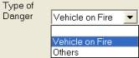

 Click the **Lane Blockage** graphic of each affected lane, and click a new graphic.



 Click the **Related IR** dropdown arrow, and click a related IR.

 In the **Unattended Vehicles** panel, type description in the Valuables textbox.

 Type description in the **Damage to Government Property** textbox.

 Click on Clearance by **TP** button.

 Type values in the Others textbox.

 Type ID in the **TP ID** textbox.

 Type comments in the **Comments** textbox if there is any additional information.

 Click **Save** button to save the IR when all these details are entered. The IR ID field will then returned a ID number associated to this IR.

•    Define Response, Monitor and Event Handling

Please refer to [Update Event Response Tab](#_Update_Event_Response), [Update Monitor](#_Update_Monitor), [Update Event Handling](#_Update_Event_Handling).

|  |  |  |
| --- | --- | --- |
| **Error** | | |
| Message | Cause | Possible solution |
| Please Select Verification State. | The State in Event form is not defined. | Click on Event tab, select the State in the event form and try again. |

##### Vehicle breakdown

•    Create event

  Click on **Event** tab.

The Event form is shown.

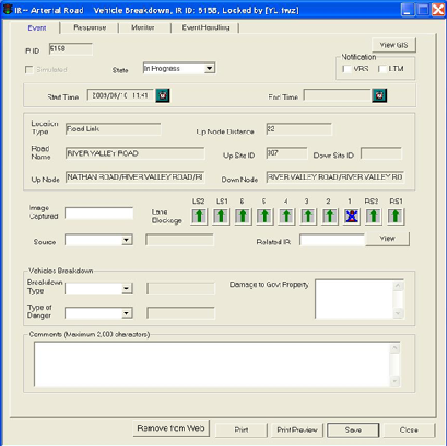

  Click the **Simulated** checkbox if the IR is meant as a simulated one.

  Click the **State** dropdown arrow, and click a state.



   Set the Start Time by clicking on the **Clock** button to set time as the current date and time. To manually set date and time, click on the textbox, a Date and Time window will appear.

   If the IR’s state is “Over”, you can set the End Time.

  Move your mouse to GIS and create start point.

For more information on how to create start point on GIS, refer to [Create Start Point](#_Create_Start_Point)

Up Site Id, Up Node Distance, Road Name and Up Node will be automatically updated.

  Move your mouse to GIS and create end point.

For more information on how to create end point on GIS, refer to [Create End Point](#_Create_End_Point)

Down Site Id and Down Node will be automatically updated.

    Type value in the **Image Captured** textbox.

    Click the **Source** dropdown arrow, and click a source.



These IR labels may change because they are configurable.

 Click the **Breakdown Type** dropdown arrow, and click a type.

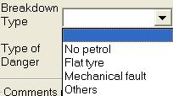

 Click the **Type of Danger** dropdown arrow, and click a type.



 Click the **Lane Blockage** graphic of each affected lane, and click a new graphic.



 Click the **Related IR** dropdown arrow, and click a related IR.

 Type description in the **Damage to Government Property** textbox.

 Type comments in the **Comments** textbox if there is any additional information.

 Click **Save** button to save the IR when all these details are entered. The IR ID field will then returned a ID number associated to this IR.

•    Define Response, Monitor and Event Handling

Please refer to [Update Event Response Tab](#_Update_Event_Response), [Update Monitor](#_Update_Monitor), [Update Event Handling](#_Update_Event_Handling).

|  |  |  |
| --- | --- | --- |
| **Error** | | |
| Message | Cause | Possible solution |
| Please Select Verification State. | The State in Event form is not defined. | Click on Event tab, select the State in the event form and try again. |

##### Obstacle

•    Create event

  Click on **Event** tab.

The Event form is shown.

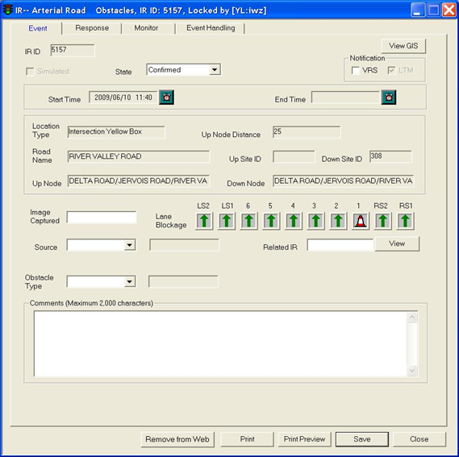

  Click the **Simulated** checkbox if the IR is meant as a simulated one.

  Click the **State** dropdown arrow, and click a state.



   Set the Start Time by clicking on the **Clock** button to set time as the current date and time. To manually set date and time, click on the textbox, a Date and Time window will appear.

   If the IR’s state is “Over”, you can set the End Time.

  Move your mouse to GIS and create start point.

For more information on how to create start point on GIS, refer to [Create Start Point](#_Create_Start_Point)

Up Site Id, Up Node Distance, Road Name and Up Node will be automatically updated.

  Move your mouse to GIS and create end point.

For more information on how to create end point on GIS, refer to [Create End Point](#_Create_End_Point)

Down Site Id and Down Node will be automatically updated.

   Type value in the **Image Captured** textbox.

   Click the **Source** dropdown arrow, and click a source.



These IR labels may change because they are configurable.

  Click the **Obstacle** Type dropdown arrow, and click a type.



  Click the **Lane Blockage** graphic of each affected lane, and click a new graphic.



  Click the **Related IR** dropdown arrow, and click a related IR.

  Type comments in the **Comments** textbox if there is any additional information.

  Click **Save** button to save the IR when all these details are entered. The IR ID field will then returned a ID number associated to this IR.

•    Define Response, Monitor and Event Handling

Please refer to [Update Event Response Tab](#_Update_Event_Response), [Update Monitor](#_Update_Monitor), [Update Event Handling](#_Update_Event_Handling).

|  |  |  |
| --- | --- | --- |
| **Error** | | |
| Message | Cause | Possible solution |
| Please Select Verification State. | The State in Event form is not defined. | Click on Event tab, select the State in the event form and try again. |

##### Road block

•    Create event

  Click on **Event** tab.

The Event form is shown.

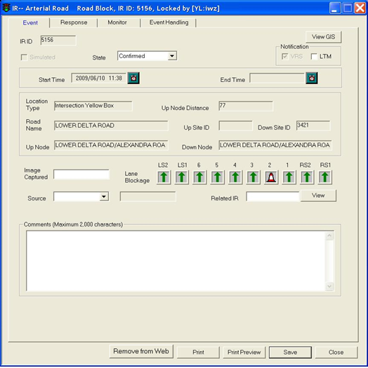

  Click the **Simulated** checkbox if the IR is meant as a simulated one.

  Click the State dropdown arrow, and click a state.



  Set the Start Time by clicking on the **Clock** button to set time as the current date and time. To manually set date and time, click on the textbox, a Date and Time window will appear.

  If the IR’s state is “Over”, you can set the End Time.

  Move your mouse to GIS and create start point.

For more information on how to create start point on GIS, refer to [Create Start Point](#_Create_Start_Point)

Up Site Id, Up Node Distance, Road Name and Up Node will be automatically updated.

  Move your mouse to GIS and create end point.

For more information on how to create end point on GIS, refer to [Create End Point](#_Create_End_Point)

Down Site Id and Down Node will be automatically updated.

  Type value in the **Image Captured** textbox.

  Click the **Source** dropdown arrow, and click a source.



These IR labels may change because they are configurable.

  Click the **Lane Blockage** graphic of each affected lane, and click a new graphic.



  Click the **Related IR** dropdown arrow, and click a related IR.

  Type comments in the **Comments** textbox if there is any additional information.

 Click **Save** button to save the IR when all these details are entered. The IR ID field will then returned a ID number associated to this IR.

•    Define Response, Monitor and Event Handling

Please refer to [Update Event Response Tab](#_Update_Event_Response), [Update Monitor](#_Update_Monitor), [Update Event Handling](#_Update_Event_Handling).

|  |  |  |
| --- | --- | --- |
| **Error** | | |
| Message | Cause | Possible solution |
| Please Select Verification State. | The State in Event form is not defined. | Click on Event tab, select the State in the event form and try again. |

##### Diversion

•    Create event

  Click on **Event** tab.

The Event form is shown.

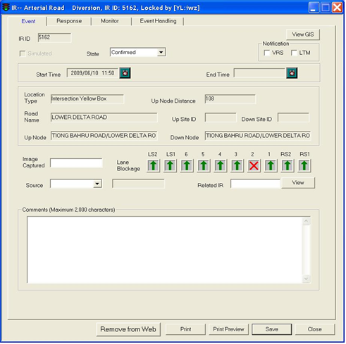

  Click the **Simulated** checkbox if the IR is meant as a simulated one.

  Click the **State** dropdown arrow, and click a state.



  Set the Start Time by clicking on the **Clock** button to set time as the current date and time. To manually set date and time, click on the textbox, a Date and Time window will appear.

  If the IR’s state is “Over”, you can set the End Time.

  Move your mouse to GIS and create start point.

For more information on how to create start point on GIS, refer to [Create Start Point](#_Create_Start_Point)

Up Site Id, Up Node Distance, Road Name and Up Node will be automatically updated.

  Move your mouse to GIS and create end point.

For more information on how to create end point on GIS, refer to [Create End Point](#_Create_End_Point)

Down Site Id and Down Node will be automatically updated.

  Type value in the **Image Captured** textbox.

  Click the **Source** dropdown arrow, and click a source.



These IR labels may change because they are configurable.

  Click the **Lane Blockage** graphic of each affected lane, and click a new graphic.



  Click the **Related IR** dropdown arrow, and click a related IR.

  Type comments in the **Comments** textbox if there is any additional information.

 Click **Save** button to save the IR when all these details are entered. The IR ID field will then returned a ID number associated to this IR.

•    Define Response, Monitor and Event Handling

Please refer to [Update Event Response Tab](#_Update_Event_Response), [Update Monitor](#_Update_Monitor), [Update Event Handling](#_Update_Event_Handling).

|  |  |  |
| --- | --- | --- |
| **Error** | | |
| Message | Cause | Possible solution |
| Please Select Verification State. | The State in Event form is not defined. | Click on Event tab, select the State in the event form and try again. |

##### Miscellaneous

•    Create event

  Click on **Event** tab.

The Event form is shown.

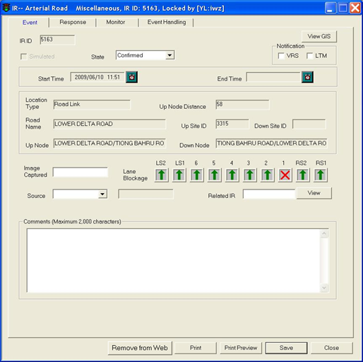

  Click the **Simulated** checkbox if the IR is meant as a simulated one.

   Click the **State** dropdown arrow, and click a state.



  Set the Start Time by clicking on the **Clock** button to set time as the current date and time. To manually set date and time, click on the textbox, a Date and Time window will appear.

   If the IR’s state is “Over”, you can set the End Time.

  Move your mouse to GIS and create start point.

For more information on how to create start point on GIS, refer to [Create Start Point](#_Create_Start_Point)

Up Site Id, Up Node Distance, Road Name and Up Node will be automatically updated.

  Move your mouse to GIS and create end point.

For more information on how to create end point on GIS, refer to [Create End Point](#_Create_End_Point)

Down Site Id and Down Node will be automatically updated.

   Type value in the **Image Captured** textbox.

   Click the Source dropdown arrow, and click a source.



These IR labels may change because they are configurable.

 Click the **Lane Blockage** graphic of each affected lane, and click a new graphic.



 Click the **Related IR** dropdown arrow, and click a related IR.

 Type comments in the **Comments** textbox if there is any additional information.

 Click **Save** button to save the IR when all these details are entered. The IR ID field will then returned a ID number associated to this IR.

•   Define Response, Monitor and Event Handling

Please refer to [Update Event Response Tab](#_Update_Event_Response), [Update Monitor](#_Update_Monitor), [Update Event Handling](#_Update_Event_Handling).

|  |  |  |
| --- | --- | --- |
| **Error** | | |
| Message | Cause | Possible solution |
| Please Select Verification State. | The State in Event form is not defined. | Click on Event tab, select the State in the event form and try again. |

##### Heavy Traffic

•    Create event

 Click on **Event** tab.

The Event form is shown.

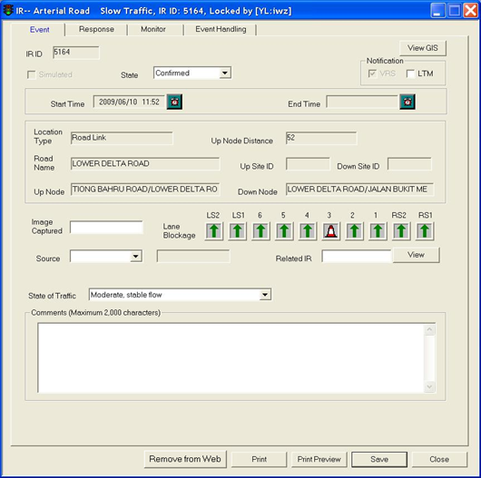

  Click the **Simulated** checkbox if the IR is meant as a simulated one.

  Click the **State** dropdown arrow, and click a state.



   Set the Start Time by clicking on the **Clock** button to set time as the current date and time. To manually set date and time, click on the textbox, a Date and Time window will appear.

   If the IR’s state is “Over”, you can set the End Time.

  Move your mouse to GIS and create start point.

For more information on how to create start point on GIS, refer to [Create Start Point](#_Create_Start_Point)

Up Site Id, Up Node Distance, Road Name and Up Node will be automatically updated.

  Move your mouse to GIS and create end point.

For more information on how to create end point on GIS, refer to [Create End Point](#_Create_End_Point)

Down Site Id and Down Node will be automatically updated.

   Type value in the **Image Captured** textbox.

   Click the **Source** dropdown arrow, and click a source.



These IR labels may change because they are configurable.

 Click the **State of Traffic** dropdown arrow, and click a state.



 Click the **Lane Blockage** graphic of each affected lane, and click a new graphic (optional for this type of IR).



 Click the Related IR dropdown arrow, and click a related IR.

 Type comments in the Comments textbox if there is any additional information.

 Click **Save** button to save the IR when all these details are entered. The IR ID field will then returned a ID number associated to this IR.

•    Define Response, Monitor and Event Handling

Please refer to [Update Event Response Tab](#_Update_Event_Response), [Update Monitor](#_Update_Monitor), [Update Event Handling](#_Update_Event_Handling).

|  |  |  |
| --- | --- | --- |
| **Error** | | |
| Message | Cause | Possible solution |
| Please Select Verification State. | The State in Event form is not defined. | Click on Event tab, select the State in the event form and try again. |

|  |
| --- |
| Note |
| Please note that for Heavy Traffic IR, congestion details (in Monitor tab) is not required as slow traffic itself is congestion. |

##### Weather

•    Create event

    Click on **Event** tab.

The Event form is shown.

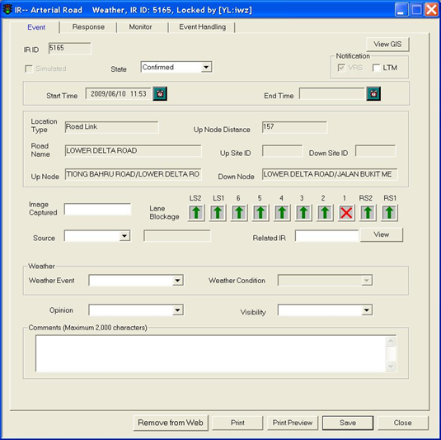

    Click the **Simulated** checkbox if the IR is meant as a simulated one.

    Click the **State** dropdown arrow, and click a state.



    Set the Start Time by clicking on the **Clock** button to set time as the current date and time. To manually set date and time, click on the textbox, a Date and Time window will appear.

    If the IR’s state is “Over? you can set the End Time.

  Move your mouse to GIS and create start point.

For more information on how to create start point on GIS, refer to [Create Start Point](#_Create_Start_Point)

Up Site Id, Up Node Distance, Road Name and Up Node will be automatically updated.

  Move your mouse to GIS and create end point.

For more information on how to create end point on GIS, refer to [Create End Point](#_Create_End_Point)

Down Site Id and Down Node will be automatically updated.

   Type value in the **Image Captured** textbox.

   Click the **Source** dropdown arrow, and click a source.



These IR labels may change because they are configurable.

 Click the **Lane Blockage** graphic of each affected lane, and click a new graphic.



 Click the **Related IR** dropdown arrow, and click a related IR.

 In the **Weather** panel, click the **Weather Event** dropdown arrow, and click an event.

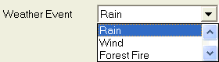

 Click the **Weather Condition** dropdown arrow, and click a condition.

 Click the **Opinion** dropdown arrow, and click an opinion.

 Click the **Visibility** dropdown arrow, and click a visibility.

 Type comments in the **Comments** textbox if there is any additional information.

 Click **Save** button to save the IR when all these details are entered. The IR ID field will then returned a ID number associated to this IR.

•    Define Response, Monitor and Event Handling

Please refer to [Update Event Response Tab](#_Update_Event_Response), [Update Monitor](#_Update_Monitor), [Update Event Handling](#_Update_Event_Handling).

|  |  |  |
| --- | --- | --- |
| **Error** | | |
| Message | Cause | Possible solution |
| Please Select Verification State. | The State in Event form is not defined. | Click on Event tab, select the State in the event form and try again. |

#### Update Event Response Tab

The user profile control the functions the user is authorize to use under Platform Control Mode (PCM) or Fall back Control Mode (FCM). Every user will have one user account that enables the user to login to IW. Every user account belongs to a profile.

|  |  |  |  |  |  |  |
| --- | --- | --- | --- | --- | --- | --- |
| **User profile** | | | | | **Operation mode** | |
| DO | Operator | FC | ITSC | Supervisor | PCM | FCM |
| ✓ | ✓ | ✓ | ✓ | ✓ | ✓ | ✓ \* |

\* Only expressway/ tunnel IR is available

Operators need to continuously update the – Partners (TP, SCDF, Ambulance, ENV, Police) and vehicles (Incident, Tow) details in this tab.

Click on **Response** tab.

The Response form is shown with Partners Intervention list and Vehicles Involved list.

|  |
| --- |
| Description: c:\_temp\iw help\events\ir\ir_response.jpg  Figure 60 - The Response form |
|  |

##### Add a Partner

   Click on **Add** button in the Partners Intervention list.

The Partner Intervention window appears.

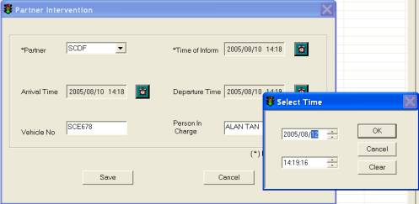

   Click the Partner dropdown arrow, and click a partner.

   Set Time of Inform, Arrival Time and Departure Time, click on the **Clock** button to set time as the current time. To manually set date and time, click on the textbox, a Date and Time window will appear.

   Type vehicle no. in Vehicle No. textbox.

    Type name in Person in Charge textbox.

   Click **Save** button to save the partner details.

   The information will then be updated in the list of partners’ intervention for this particular IR event.

|  |
| --- |
| **Note** |
| During the actual operation, the fields for the Partner type and Time of Inform are mandatory to be filled up. The rest of the details can be filled up later when the information is available. |

    Click on the **Save** button when all of the partners details or whenever a new partner’s details are added.

##### Edit / View Partner details

   Select a partner from the list.

   Click on **Edit/View** button.

The Partner Intervention window appears with details filled.

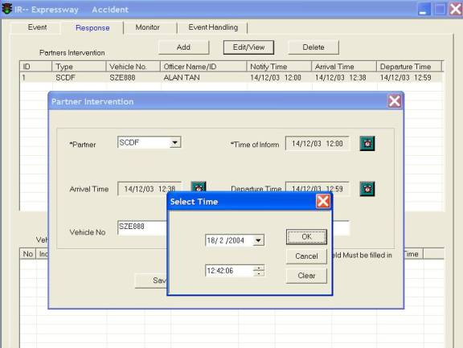

    If editing details, edit the details and click on **Save** button.

The details will be saved and window will be closed.

   If viewing details, click on **Cancel** button.

The window will be closed.

   Click **Save** button to save the IR.

|  |
| --- |
|  |

##### Delete a Partner

   Select a partner from the list.

   Click on **Delete** button.

A window will pop up asking for confirmation to delete, click on **Yes** button to confirm deletion, **No** button to do nothing and close the window.

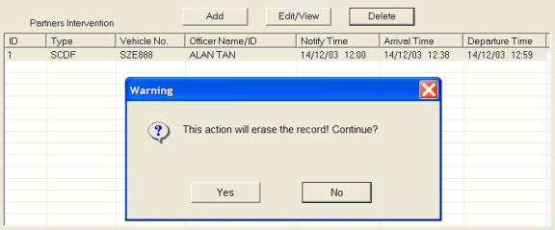

   Click **Save** button to save the IR.

|  |  |
| --- | --- |
|  |  |

##### Add a Vehicle

   Click on **Add** button in the Vehicles Involved list.

The Tow and Accident Vehicle Info window appears.

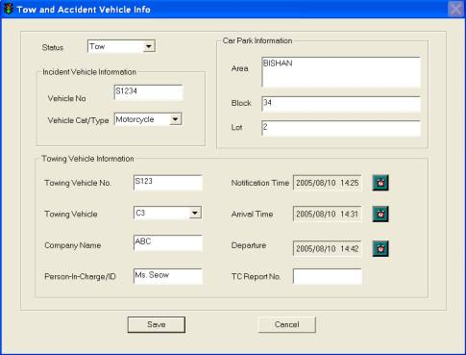

   Click the Status dropdown arrow, and click a status.

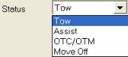

   On the Incident Vehicle Info panel, type vehicle no. in Vehicle No. textbox.

   Click the Vehicle Car/Type, and click a type.

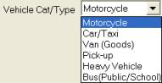

These IR labels may change because they are configurable.

   On the Car Park Info panel, type description in Area textbox.

   Type block no. in Block textbox.

   Type lot no. in Lot textbox.

   On the Towing Vehicle Info panel, type vehicle no. in Towing Vehicle No. textbox.

   Click the Towing Vehicle dropdown arrow, and click a no. of towing vehicle(s). You may also manually type the number.

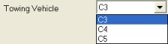

 Click the Company Name dropdown arrow, and click a company name. You may also manually type the company name.

 Type name in Person-in-Charge/ID textbox.

 Type report no. in TC Report No. textbox.

 Click **Save** button to save the details of the towing and incident vehicles.

|  |
| --- |
|  |

##### Edit / View Vehicle details

   Select a vehicle from the list in the IR response tab.

   Click on **Edit/View** button.

The Tow and Accident Vehicle Info window appears with details filled.

   If editing details, edit the details and click on **Save** button.

The details will be saved and window will be closed.

    If viewing details, click on **Cancel** button.

The window will be closed.

    Click **Save** button to save the IR.

##### Delete Vehicle

   Select a vehicle from the list in the IR response tab.

   Click on **Delete** button.

A window will pop up asking for confirmation to delete, click on **Yes** button to confirm deletion, **No** button to do nothing and close the window.

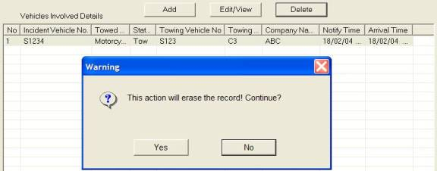

   Click **Save** button to save the IR.

|  |  |
| --- | --- |
|  |  |

#### Update Monitor

The user profile control the functions the user is authorize to use under Platform Control Mode (PCM) or Fall back Control Mode (FCM). Every user will have one user account that enables the user to login to IW. Every user account belongs to a profile.

|  |  |  |  |  |  |  |
| --- | --- | --- | --- | --- | --- | --- |
| **User profile** | | | | | **Operation mode** | |
| DO | Operator | FC | ITSC | Supervisor | PCM | FCM |
| ✓ | ✓ | ✓ | ✓ | ✓ | ✓ | ✓ \* |

\* Only expressway/ tunnel IR is available

Operators need to continuously update the IR monitor tab when a vehicle is moved to the road shoulder or when a traffic congestion is resulted due to the event (accident, road block, etc). The congestion information is applicable for all types of IR except Slow Traffic IR.

   Click on IR **Monitor** tab.

The Monitor form is shown.

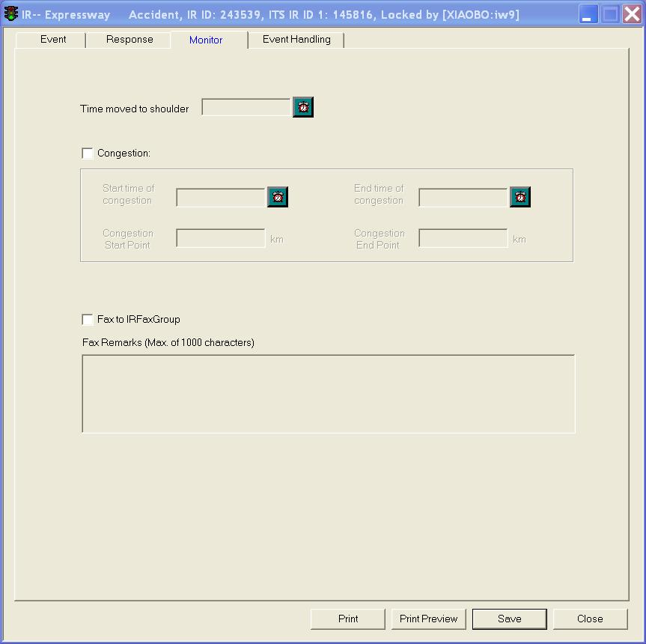

  If an accident vehicle is moved to the shoulder on site, the operator needs to click on the Clock button to set time that the vehicle was shifted. To manually set date and time, click on the textbox, a Date and Time window will appear.

   If congestion was resulted due to the event, operator needs to click on the congestion checkbox.

   Click the Congestion checkbox.

The Congestion Start Point km is automatically updated. Since the start point of congestion is normally taken as the end point of the incident.

   During the Platform automatic control mode, the operators need to update the congestion end point and congestion end date/time at time intervals for the system to recommend a set of recommended traffic action plans in the “event handling” tab.

   Set End time of congestion, click on the Clock button to set time as the current time. To manually set date and time, click on the textbox, a Date and Time window will appear.

   Click on Congestion End Point.

   Move your mouse to GIS to select the end point of congestion. For more information on how to select the end point of congestion, refer to [expressway](#_Create_Congestion_End) or [tunnel](#_Create_Congestion_End_1).

Road Name, Location Code, Direction and Start Point will be automatically updated.

   Click **Save** button to save the IR.

|  |
| --- |
| **NOTE** |
| The Congestion Start Point cannot be modified because the start point of congestion is taken as the end point of the incident. If you modify End Point, Congestion Start Point will also be automatically updated |

#### Update Event Handling

Click on **Event Handling** tab.

The Event Handling form is shown with a list of event action plans.

|  |
| --- |
| Figure 61 - The Event Handling form |
|  |

##### ****Overview****

|  |  |  |  |  |  |  |
| --- | --- | --- | --- | --- | --- | --- |
| **User profile** | | | | | **Operation mode** | |
| DO | Operator | FC | ITSC | Supervisor | PCM | FCM |
| ✓ | ✓ | ✓ | ✓ | ✓ | ✓ | ✓ \* |

\* Only expressway/ tunnel IR is available

   Click on **Event Handling** tab.

   The Event Handling form is shown with the list of inference plans proposed by Inference Engine for the operator to confirm and implement. The default setting for the IP shown on Event Handling is shown in the below figure.

   When click **Simulation** button, IP simulation will be started in current inference plan.

|  |
| --- |
| Figure 62 - The Event Handling form with the list of IP |

##### Description of IP and commands

The commands in IP are described, as shown in the table below.

|  |  |  |  |  |  |  |  |  |  |  |  |  |  |  |  |  |  |  |
| --- | --- | --- | --- | --- | --- | --- | --- | --- | --- | --- | --- | --- | --- | --- | --- | --- | --- | --- |
| |  |  | | --- | --- | | **Fields In IP List** | **Description** | | IP ID | For each IP proposed by IFM, IFM gives running order ID to the IP | | System | Different systems for the equipment  •        **EM**: EMAS  •        **GL**: GLIDE  •        **DL**: DELAY (applied to EMAS/GLIDE). It specifies a delay time of the commands following after the Delay Command  •        **DLY**: DELAY (/FCT commands) It specifies a delay time of the commands following after the Delay Command  •        **ST**: Short Tunnel (FCT/WVT/SGT) | | Type | Different Equipment Control Types  For EMAS: **LUS, TIP, TEP, TTP, TSP, TIC**  For GLIDE: **LP Lock, CL Lock, APS, SP Lock**  For FCT/WVT/SGT: **TMD, AVMS, LUS, EVMS** | | Equip ID | Equipment ID, e.g.  EMAS: amvms\_123  GLIDE: GLIDE Site 405  FCT: AVMS\_00\_00001 | | Command | Individual EMAS, GLIDE or FCT/WVT/SGT command parameters (e.g. pic code| flashing mode | message) | | Action | **Reject** (Default): User to reject a command such that it will not be implemented on site  **Accept**: User to accept a command such that it will be implemented  **No Action**: Proposed by IFM when it detects that the proposed command is same as that implemented on site, or when system link or equipment is down | | Result | Implementation Result of individual Commands  **OK**: Command in IP is implemented successfully for the associated equipment  **Timeout**: Command in IP is not implemented successfully for the associated equipment or system is slow in response but actually implemented on site. | | Status | Command Status  **O**: Original. The command is same as originally proposed by IFM  **M**: Modified. The user has edited the command and is now different from original state  **N**: New. The user has newly inserted this equipment command into original IP | |
| Figure 63 - Description table of IP and commands |

##### IP status

The status in Event handling specify the event handling states, which is same as the status for the associated IR in IR list, as shown in the Figure below.

|  |
| --- |
| Figure 64 - IP Status in Event handling and IR list |
|  |

|  |
| --- |
| Description: c:\_temp\iw help\events\ir\ueventhanding\IP sta1.gif  Figure 65 - Description table of IP Status |
|  |

##### Color of commands in IP

The different colors of commands specify the different means:

|  |  |
| --- | --- |
| Black: | Normal command in IP proposed by IFM |
| Red: | The equipment in command is uncontrollable due to system fault. |
| Blue: | The equipment is uncontrollable due to individual equipment technical fault or equipment OPE status is not operational |
| Pink: | The equipment has alarms |

##### Sorting of commands

For the integrated plan, the IP list display the EMAS command controls first, EA command controls, then the GLIDE command controls.

##### Sorting of EMAS control commands in IFM plans

|  |  |  |
| --- | --- | --- |
| Sort by: | Command /Equipment type | LUS  TMD  TIP  TEP  TTP  TSP |

If equipment type is “LUS”, LUSs are sorted by:

|  |  |  |
| --- | --- | --- |
| Sort by: | Pictogram | Red cross  Amber  Green arrow |
| Then by: | Lane | Ascending |
| Then by: | Km mark | From downstream to upstream |

If equipment type is TMD, TIP, TEP, TTP, TSP they are sorted respectively by:

|  |  |  |
| --- | --- | --- |
| Sort by: | Expressway name | From main expressway to adjacent expressway |
| Then by: | Km mark | From downstream to upstream |

##### Sorting of EA control commands in IFM plans

|  |  |  |
| --- | --- | --- |
| Sort by: | Command /Equipment type | RVMS  CVMS  VMS1  VMS2 |

If equipment type is “LUS”, LUSs are sorted by:

|  |  |  |
| --- | --- | --- |
| Sort by: | Pictogram | Red cross  Amber  Green arrow |
| Then by: | Lane | Ascending |
| Then by: | Km mark | From downstream to upstream |

If equipment type is RVMS, CVMS, VMS1 or VMS2 they are sorted respectively by:

|  |  |  |
| --- | --- | --- |
| Sort by: | Expressway name | From main expressway to adjacent expressway |
| Then by: | Km mark | From downstream to upstream |

##### Sorting of GLIDE control commands in IFM plans

The sorting of GLIDE control command in IFM plans as follows.

|  |  |  |
| --- | --- | --- |
| **Criteria** | **Manner** | |
| Sort by: | Site ID | Ascending |
| Then by: | Plan type | Lock link plan |
| Lock cycle length |
| Lock split plan |
| Lock active phase split |

##### Sorting of ST control commands in IFM plans

The sorting of ST control command in IFM plans as follows.

|  |  |  |
| --- | --- | --- |
| Sort by: | Command /Equipment type | LUS  EVMS  AVMS |

If equipment type is “LUS”, LUSs are sorted by:

|  |  |  |
| --- | --- | --- |
| Sort by: | Pictogram | Red cross  Amber  Green arrow |
| Then by: | Lane | Ascending |
| Then by: | Km mark | From downstream to upstream |

If equipment type is LUS, EVMS or AVMS, they are sorted respectively by:

|  |  |  |
| --- | --- | --- |
| Sort by: | Expressway name | From main expressway to adjacent expressway |
| Then by: | Km mark | From downstream to upstream |

##### Add Delay

Click on command in IP List. The new command will be inserted in front of this highlighted command

Select DELAY

Click on **Add**

 Add a Delay dialog window will pop up for Operator to enter the delay value (from 1 to 999 seconds). As shown in the figure, the glide command will be implemented after a delay of 3 (If it is a FCT/WVT/SGT delay, click on the checkbox of delay for FCT/WVT/SGT)

 Enter the value and click on **Apply**

 This value is the time to delay the implementation of subsequent commands in IP.

 Delay command will be inserted above the highlighted and selected command. If none of command is selected, the Delay command is put at the bottom of IP list by default.

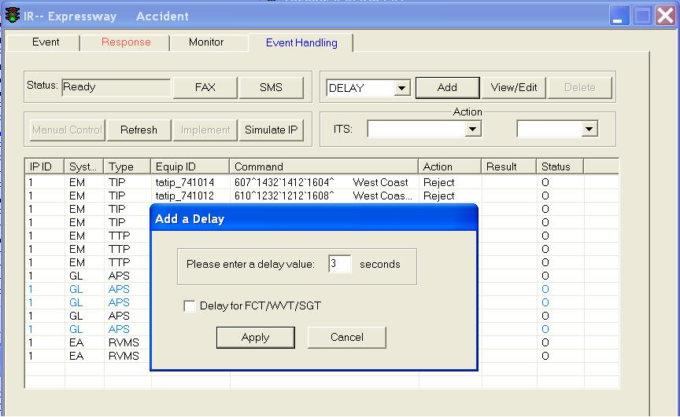

##### Add EMAS Plan

Before traffic controller has never highlighted any command in the IP list to insert a new EMAS control, the default status for the Add EMAS CONTROL is shown in the below figure. If none of command is highlighted, the added command is put at the bottom of IP list by default.

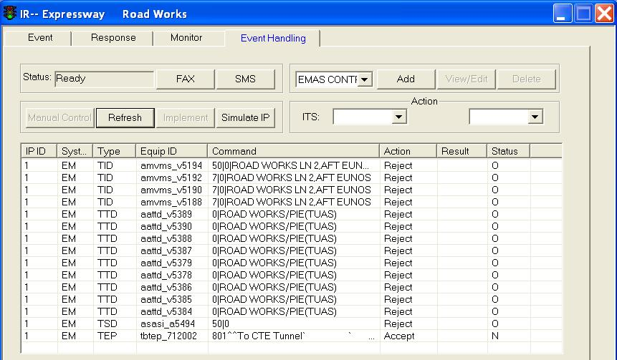

After traffic controller has highlighted a command in the IP list to insert a new EMAS control, the status for the Add EMAS CONTROL is shown in the below figure. Later the added new command will be put above the highlighted command.

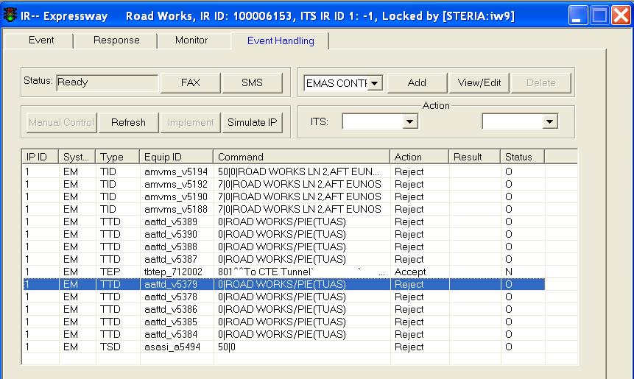

Select EMAS CONTROL from drop down box and click on **Add** button, an Insert Control to IR window appears. You may then define the new plan.

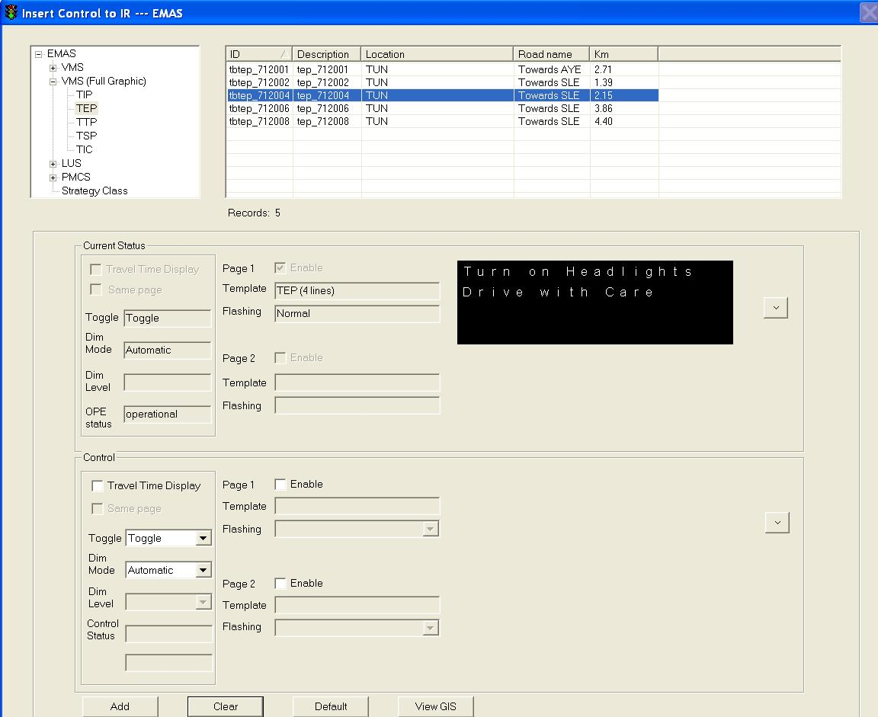

##### Add GLIDE Plan

Before traffic controller has never highlighted any command in the IP list to insert a new GLIDE control, the default status for the Add GLIDE CONTROL is shown in the below figure. If none of command is highlighted, the added command is put at the bottom of IP list by default.

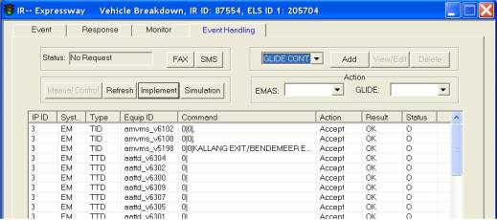

After traffic controller has highlighted a command in the IP list to insert a new GLIDE control, the status for the Add GLIDE CONTROL is shown in the below figure. Later the added new command will be put above the highlighted command.

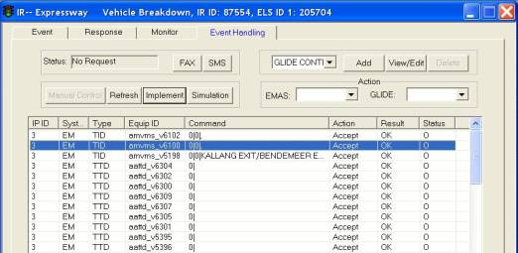

Select GLIDE CONTROL from drop down box and click on **Add** button, an Insert Control to IR window appears. You may then define the new plan.

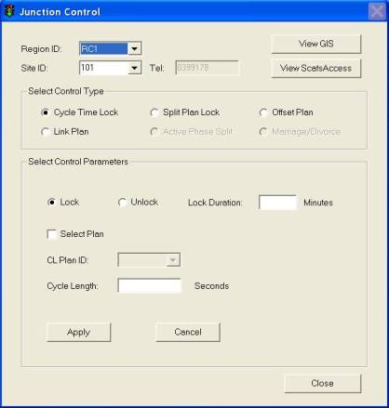

##### Add ST Plan

Before traffic controller has never highlighted any command in the IP list to insert a new ST control, the default status for the Add ST CONTROL is shown in the below figure. If none of command is highlighted, the added command is put at the bottom of IP list by default.

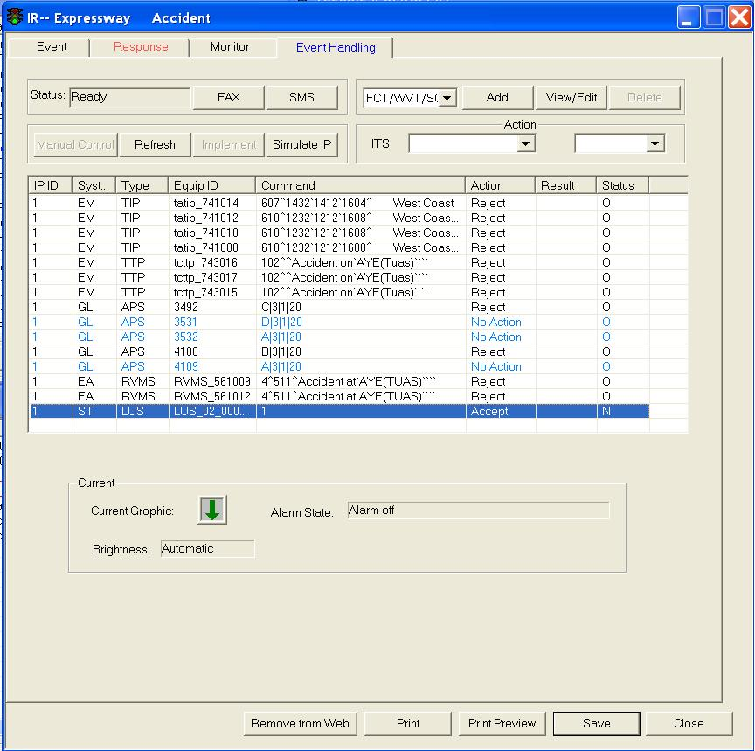

After traffic controller has highlighted a command in the IP list to insert a new ST control, the status for the Add ST CONTROL is shown in the below figure. Later the added new command will be put above the highlighted command.

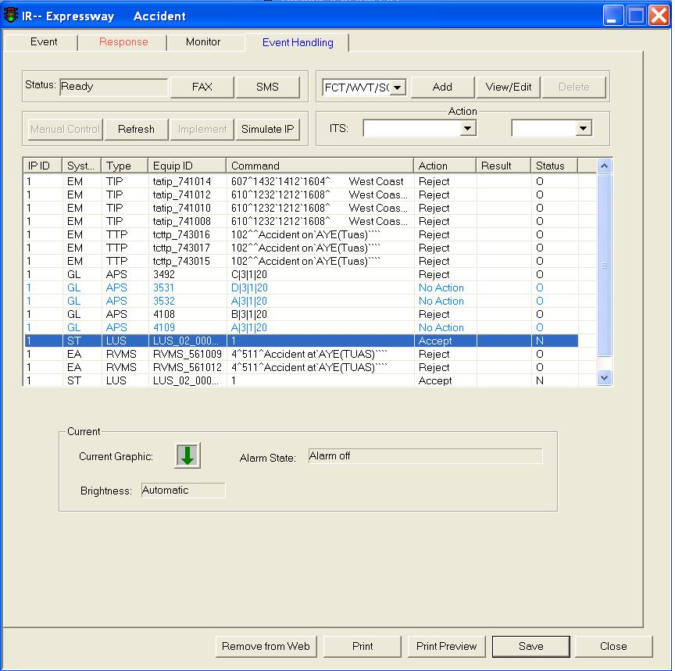

Select ST CONTROL from drop down box and click on **Add** button, an Insert Control to IR window appears. You may then define the new plan.

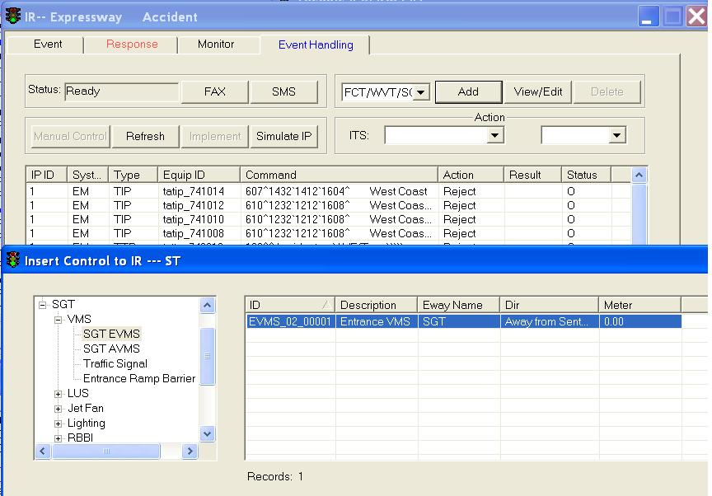

##### Add KPE/MCE Plan

Instead of adding KPE/MCE plan directly, operator can only key in recommended actions and send the request to the party who is in charge of KPE/MCE.

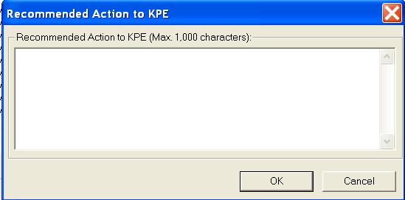

##### Add EA Plan

Before traffic controller has never highlighted any command in the IP list to insert a new EA control, the default status for the Add EA CONTROL is shown in the below figure. If none of command is highlighted, the added command is put at the bottom of IP list by default.

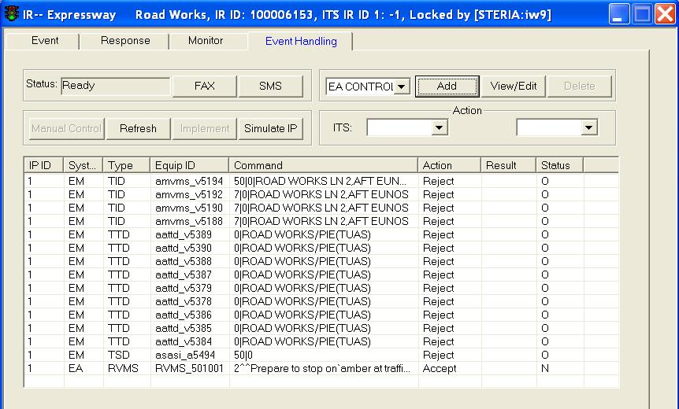

After traffic controller has highlighted a command in the IP list to insert a new EA control, the status for the Add EA CONTROL is shown in the below figure. Later the added new command will be put above the highlighted command.

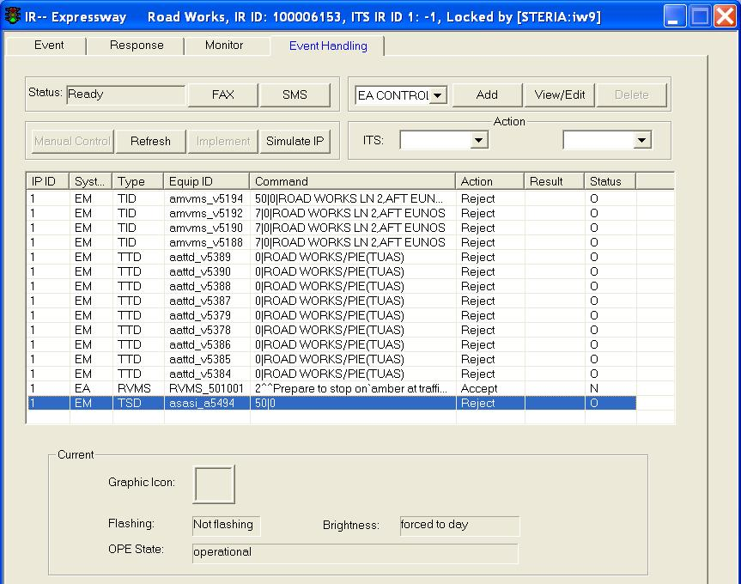

Select EA CONTROL from drop down box and click on **Add** button, an Insert Control to IR window appears. You may then define the new plan.

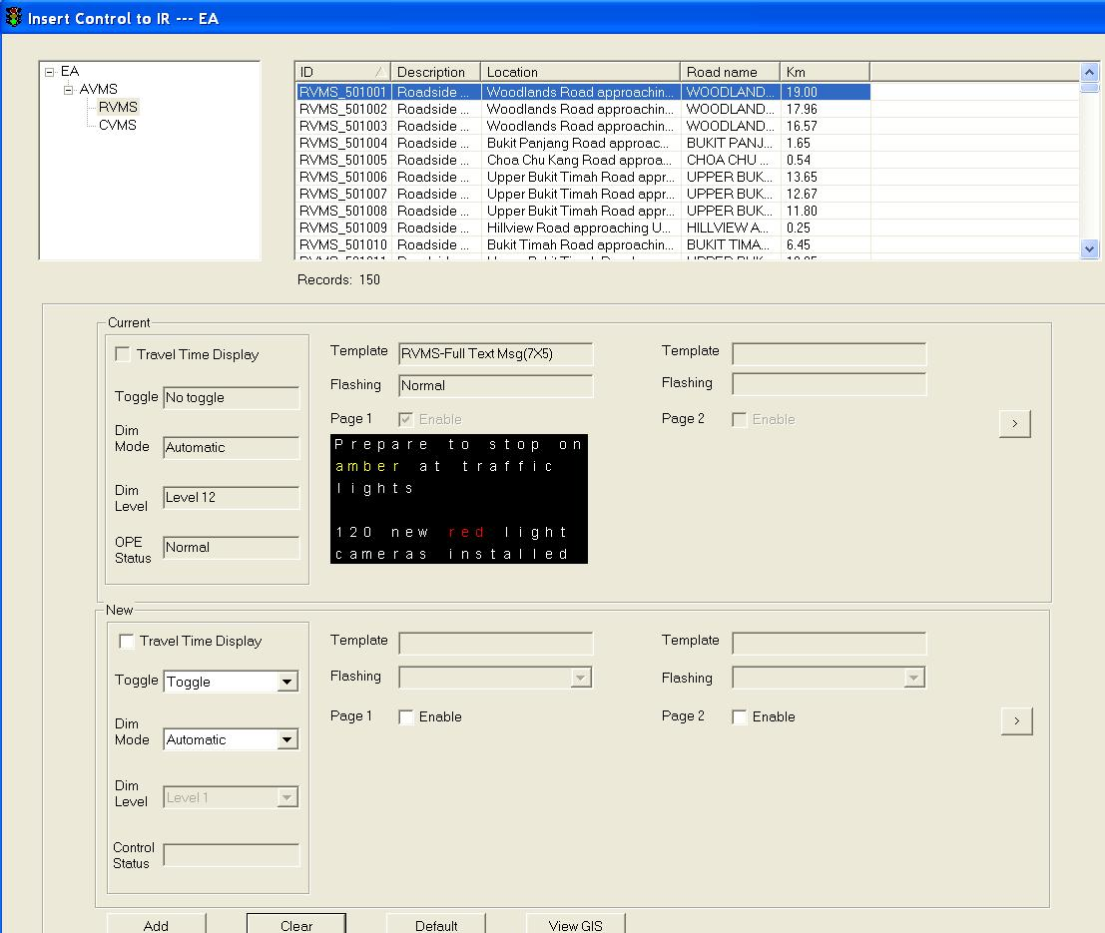

##### View/Edit Plan

 Click on a plan in the list to select it, the selected plan will be highlighted in blue background.

 The current panel beneath the Plan list will show the current settings for the equipment of the selected plan.

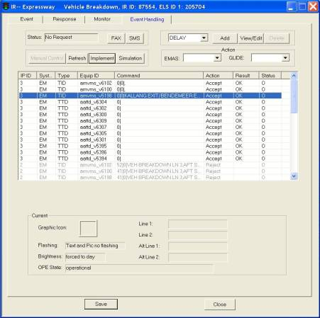

  Click on **View/Edit** button.

 The Edit Equipment Parameter window will show. In the New panel, input the new settings. Please refer to IW User Manual on how to edit settings for each type of equipment.

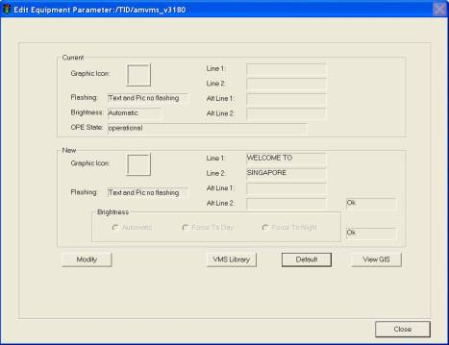

 Click on **Modify** button to the save the settings.

 Click **Save** button to save the IR.

If the equipment is in non-operational mode (such as TID 4101 in the right figure) or when link is down, traffic controller will be allowed to view/edit the relevant command. An error message will be popup as shown as below figure.

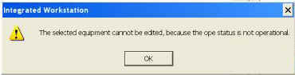

##### Delete a Plan

Only the commands manually added can be deleted and removed from IP.

 Click and highlight a New Command in the IP list. Note that only commands inserted by Operators can be deleted.

 Click on **Delete** button.

 The command will be removed from the IP list.

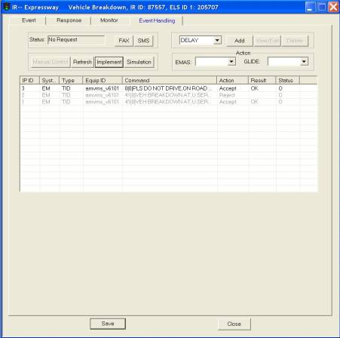

|  |  |
| --- | --- |
|  |  |

##### Manual Control

Only Duty Officer (DO) is able to switch current mode (auto/manual) from CCM and only can do it when IFM is running at the moment.

CCM will gray off current mode setting when IFM is down.

During platform mode, the menu for KB mode will be changed by DO.

•   When DO setting IFM Auto Mode, system will pop up a window to inform that IFM is now available for use.

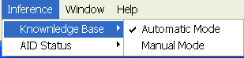

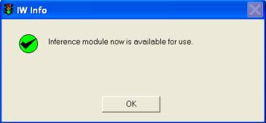

•   When DO setting Manual Mode, system will pop up a window to inform that IFM is disabled and no IP is available for IR.

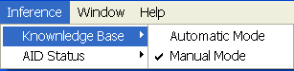

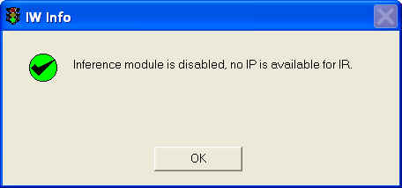

The IP states are shown according to the following scenarios:

|  |  |  |
| --- | --- | --- |
| IFM Status | Current Mode (Set by DO) | IP status (shown in IR list) |
| OK | Auto | (Other states except for “Not Available”) |
| OK | Manual | Not Available |
| Down | Auto/Manual | Not Available |

##### IP with GLIDE control

If the list of inference plans contains the Glide Control Commands, IP will be proposed with updated plans at every 15 minutes. According to request by DO, **Manual Control** button can be used to inform Inference not to propose any inference plans until the IR is updated.

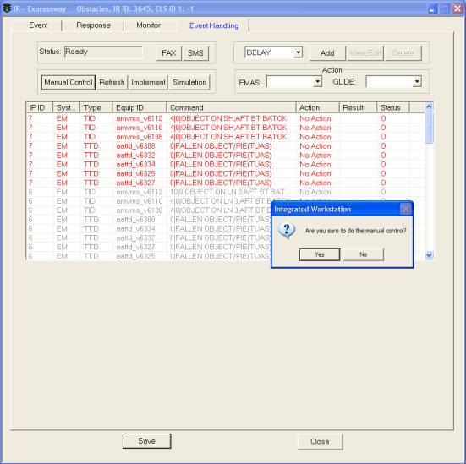

Note: The alert for the different set of coming GLIDE IP will be presented in IR List window at IW.

|  |  |
| --- | --- |
|  |  |

##### Refresh

 Click on **Refresh** button to reload the current IP and display on the Event tab again.

 Equipment health status will be refreshed and reflected in Action field and command colour.

 To check or to re-implement the command(s) that is(are) not implemented earlier due to individual equipment technical fault or system faulty, user can click **Refresh** button to reload the IP and display the latest status.

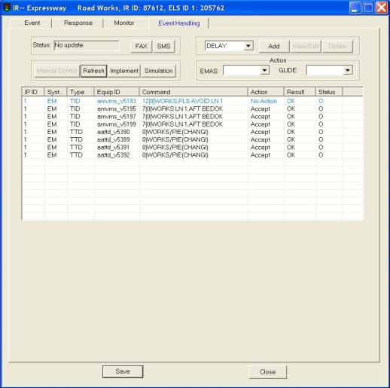

##### Implement plans

Click on **Implement** button to activate the system to implement the event action plan on the field equipment. Once you activates to implement the plan, the system shall send the plan to various ITS.

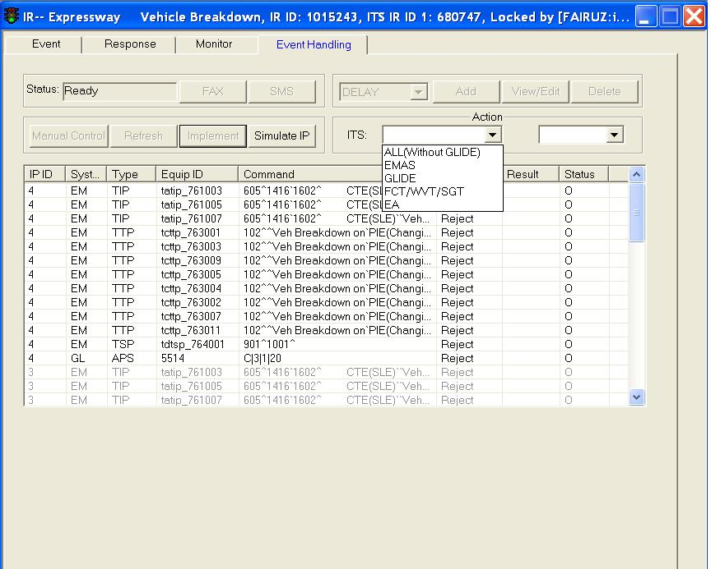

Figure 66 - The Event Action Plan

Before implementation of IP, user can select actions for individual commands or for all commands:

•       Accept

•       Reject

•       No Action

•       Accept All

•       Reject All

•       No Action All

Operator cannot select actions if command is uncontrollable.

1.     Click on **Implement** button

2.     CCM prompts user to confirm if wants to implement equipment commands

3.     If yes, system sends commands with “Accept” status to the field equipment.

4.     Implementation result is shown in “Result” in Event handling tab when subsystem returns acknowledgement

5.     OK – A command in IP is implemented successfully on the associated equipment

6.     Timeout – A command IP may not be implemented successfully to the associated equipment, or system may be slow in response but the command is actually implemented to site. Traffic operators are strong encouraged to check the equipment status through the use of camera or GIS, etc.

7.     When IP Status=Executed, the **Add/View/Delete/Implement** buttons are enabled again. This is to allow the Operator to implement an IP multiple times, especially for Timeout Commands

##### IP for Linked IR

To obtain the integrated IP for the multiple events, user can link 2 or 3 IRs on IW. The detailed rules and logic for linking IRs are referring to Knowledge Base Requirement Specification.

User moves mouse on the field of Related IR in IR window, keys in the related or linked IR ID. It means this IR will be linked to the related IR, therefore, user obtains the IFM integrated plan in Event handling tab after clicking the “save” button.

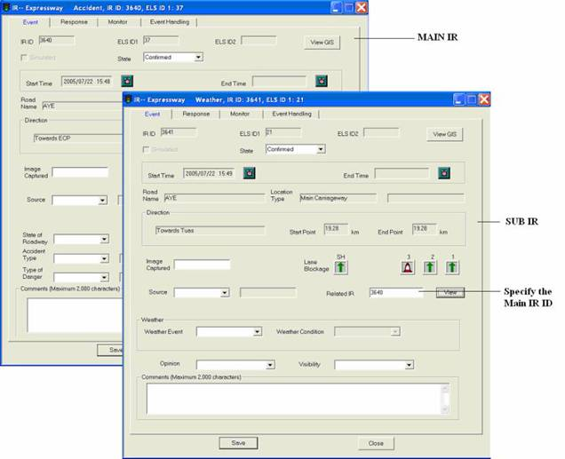

##### Send Fax

   Fax Template consists of Reference No, Event Status textboxes, List of Available Recipients panel, List of Selected Fax Recipients panel and Event panel and also Send, **Preview** and **Cancel** buttons.

|  |
| --- |
| Description: c:\_temp\iw help\events\ir\ueventhanding\Fax IR15.jpg  Figure 67 - The Fax Template Window |
|  |

   Select the Recipient in the List of Available Recipients panel.

  The selected recipient will be highlighted in blue background.

   Click on > button.

  The recipient details will be added into the List of Selected Fax Recipients panel. To add more recipients, repeat steps 2-3.

   Click Incident Record or Technical Alarm for Label Type Selection.

  Type remark in the Remark textbox.

  Click **Preview** button to preview the fax as shown.

|  |
| --- |
| Description: c:\_temp\iw help\events\ir\ueventhanding\Fax IR16.jpg  Figure 68 - Preview the fax sheet |
|  |

   Click **Send** button to send the fax to the selected Fax Recipients.

##### Send SMS

 SMS Service form consists, List of Available Recipients panel, List of Selected SMS Recipients panel and Message Content Text Area.

|  |
| --- |
| Description: c:\_temp\iw help\events\ir\ueventhanding\SMS IR5.jpg  Figure 69 - The SMS Service Form |
|  |

 Select the Recipient in the List of Available Recipients panel, The selected recipient will be highlighted in blue background.

 Click on > button.

 The recipient details will be added into the List of Selected SMS Recipients panel. To add more recipients, repeat steps 2-3.

 Incident Type, Date and Time of Incident, Start Point, Road Name, etc will be filled by the system automatically, Operator can enter additional info if needed.

 Click **Send** button to send SMS to the selected Recipients.

### IR List

The user profile control the functions the user is authorize to use under Platform Control Mode (PCM) or Fall back Control Mode (FCM). Every user will have one user account that enables the user to login to IW. Every user account belongs to a profile.

|  |  |  |  |  |  |  |
| --- | --- | --- | --- | --- | --- | --- |
| **User profile** | | | | | **Operation mode** | |
| DO | Operator | FC | ITSC | Supervisor | PCM | FCM |
| ✓ | ✓ | ✓ | ✓ | ✓ | ✓ | ✓ \* |

\* Only expressway/ tunnel IR is available

This list contains all existing unfinished IR which include:

•        Real incident on roads, anticipated road works and simulated incidents.

•        Expressway, tunnel and arterial road IR.

•        Accident, Vehicle breakdown, Unattended vehicle, Road Works, Obstacles, Slow Traffic, Weather, Road Block, Miscellaneous and Diversion type.

Features:

•        Real-time update - when there is new or expired IR, they will be added/removed from the list automatically.

•        Provide field sorting on the list - you can choose to sort the list in ascending or descending alphabetical order of the alerts or by the latest or the earliest date/time when they click at the top to of the list.

•        View CCTV for the selected incident (available only the incident is viewable by surveillance cameras, the nearest surveillance camera will be selected by the system automatically).

•        Finish IR (available for IRs that are “Over”).

•        Provide IR sorting on the list – the IR are sorted according to location type (Tunnel / Expressway / Arterial road), location code (Main carriageway / Exit / Entrance), lane blockage ratio (no. of lanes closed against total no. of lanes) and start time.

•        Provide filtering on the list.

•         View IR details (through double click).

•         Send IR through fax or SMS (through context menu).

 You can view/edit all incident records by opening the IR List window.

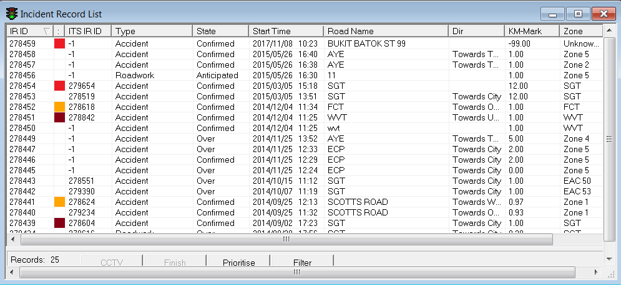

Figure 70 – CCM IR List

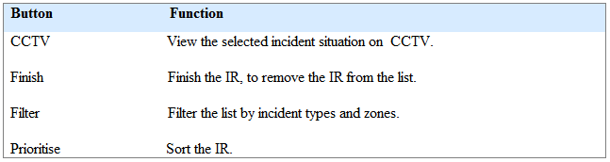

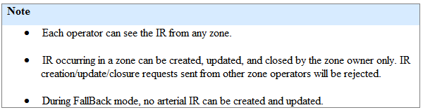

|  |
| --- |
| **IR Speed Colour Code** |
| Each IR has a speed colour code attached to it. The colour code and its corresponding speed range are as follow:   |  |  |  |  | | --- | --- | --- | --- | | **Colour Code** | **Lower Speed (Km/h)** | **Higher Speed (Km/h)** | **IR Type** | | White | 40 | 999 | EA | | Orange | 20 | 40 | EA | | Red | 10 | 20 | EA | | Dark Red | 0 | 10 | EA | |  |  |  |  | | White | 60 | 999 | EMAS | | Orange | 40 | 60 | EMAS | | Red | 20 | 40 | EMAS | | Dark Red | 0 | 20 | EMAS | |  |  |  |  | | White | 30 | 999 | Others | | Orange | 20 | 30 | Others | | Red | 10 | 20 | Others | | Dark Red | 0 | 10 | Others | |

#### Filter the list

  Click on **Filter** button to show IR List Filter window.

  Select Incident Type(s).

Select more than one type if you want to view IR of multiple types.

   Select Zone(s).

       Select more than one zone if you want to view IR for multiple zones.

  Select EAC Corridor(s).

  Click on **Apply** button.

The window closes and the list refreshes and displays the list according to the selected filtered IR types and/or zones and/or EAC Corridors.

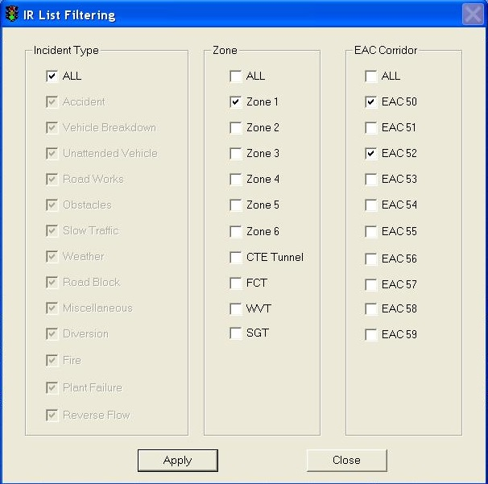

#### Sort the list (field)

Click on Field header to sort the field.

At any one time, only one field can be sorted. First click will sort the field in ascending order, second click will sort the field in descending order.

ascending order

descending order

#### View / Edit IR details

  Double click on an IR on the list.

The IR Detail window is shown with the details.

  You may then edit the details as usual.

|  |
| --- |
|  |
| The IR Detail Window |

|  |
| --- |
| Note |
| •   For IR that are “Over”, only Comments field will be enabled for editing.  •   The **Save** button will be enabled if the IR belongs to your zone(s) since you can only create/edit/finish IR that are in your zone(s). You can see the zone of the IR on the IR list.  •    The **Save** button will be disabled if someone else has open your IR for editing. This is to avoid conflict of information. |

#### View CCTV

  Select an IR on the list.

  Click on **CCTV** button.

A monitor list is shown.

  Select a monitor from the list.

The monitor will show the view of the nearest PTZ to the IR.

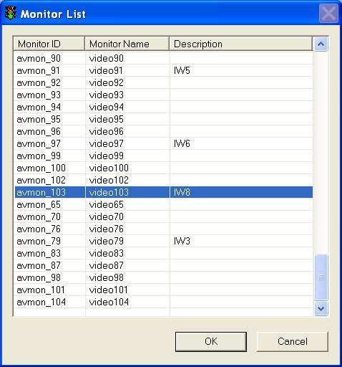

#### Send IR through Fax or SMS

Right click on an IR on the list.

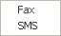 A context menu appears.

•   To fax

Click on **Fax.**

A Fax Template window appears. For more information on how to send a fax, refer to 583.

|  |
| --- |
| Description: c:\_temp\iw help\events\ir list\IR fax.jpg |

Figure 71 - A Fax template

•   To SMS

Click on **SMS.**

A SMS Service window appears. For more information on how to send a SMS, refer to [here](#_Send_Fax).

|  |
| --- |
| Description: c:\_temp\iw help\events\ir list\IR SMS.jpg |

Figure 72 - A SMS template

The SMS message format:

*"<type of event>,<start/end time>,<location of event>"*

#### IR Handling in IR List

To Finish an IR:

  Click on an IR on the list.

The selected IR will be highlighted in blue background. The Finish button will be enabled.

   Click on **Finish** button.

The IR will be removed from the list.

|  |
| --- |
| Description: c:\_temp\iw help\events\ir list\IR list.jpg |

Figure 73 - IR List Window

|  |
| --- |
| **Note** |
| •   When events are over and the IR windows are saved and closed, the IR will still remain in the IR List. You need to manually remove the item from the IR List by selecting the Finish button.  •   You can finish an IR only is that State is “Over”. |

#### Prioritising of IR

  Click on the **Prioritise** button.

The list will be sorted accordingly with the highest priority IR at the top of the list.

|  |
| --- |
| **Note** |
| The sorting is done by evaluating:     Location type (Tunnel / Expressway / Arterial road), tunnel IR has highest priority while Arterial road IR has the lowest. If 2 or more IRs are found to have the same location type, the system will look at the location code.     Location code (Main carriageway / Exit / Entrance), main carriageway has the highest priority while entrance has the lowest. If 2 or more IRs are found to have same location type and same location code, the system will look at the lane blockage ratio.     Lane blockage ratio (no. of lanes closed against total no. of lanes). The higher the ratio, the higher the priority. If 2 or more IRs are found to have same location type, same location code and same ratio, the system will look at the start time.    Start time. The more recent incident will have higher priority. |

### Traffic Alert List

The user profile control the functions the user is authorize to use under Platform Control Mode (PCM) or Fall back Control Mode (FCM). Every user will have one user account that enables the user to login to IW. Every user account belongs to a profile.

|  |  |  |  |  |  |  |
| --- | --- | --- | --- | --- | --- | --- |
| **User profile** | | | | | **Operation mode** | |
| DO | Operator | FC | ITSC | Supervisor | PCM | FCM |
| ✓ | ✓ | ✓ | ✓ | ✓ | ✓ | ✓ |

 This list contains all traffic alerts coming from various sources include:

•       Expressway SOS phone calls reception (from EMAS).

•       Expressway traffic measure detection systems (from EMAS).

•       FAX reception.

•       Central Level Automatic Incident Detection based on traffic data analysis (CLAID) (from EMAS).

•        Junction unusual congestion data (from GLIDE).

•        Short tunnel traffic measure detection camera (from short tunnel).

•       Traffic alerts generated by the System inference module.

   Features:

•       Real-time update - when there are new or expired traffic alerts, they will be added/removed from the list automatically.

•       When there are new alerts, the alerts are highlighted in red and the Alert beacon changes its status.

•       Provide field sorting on the list - you can choose to sort the list in ascending or descending alphabetical order of the alerts or by the latest or the earliest date/time when they click at the top to of the list.

•       Provide filtering on the list - by zones and sources (EMAS, GLIDE, SOS, FCT etc.).

•      View location of the selected alert on GIS.

•        Provide Acknowledgement on the alerts.

•       View CCTV for the selected alert (available only if the alert is viewable by surveillance cameras, the nearest surveillance camera will be selected by the system automatically).

You can monitor all traffic alerts by opening the Traffic Alert List window.

Go to Events > Traffic Alert menu.

|  |
| --- |
| Description: c:\_temp\iw help\events\traffic alert list.jpg |

Figure 74 - CCM Traffic alert list

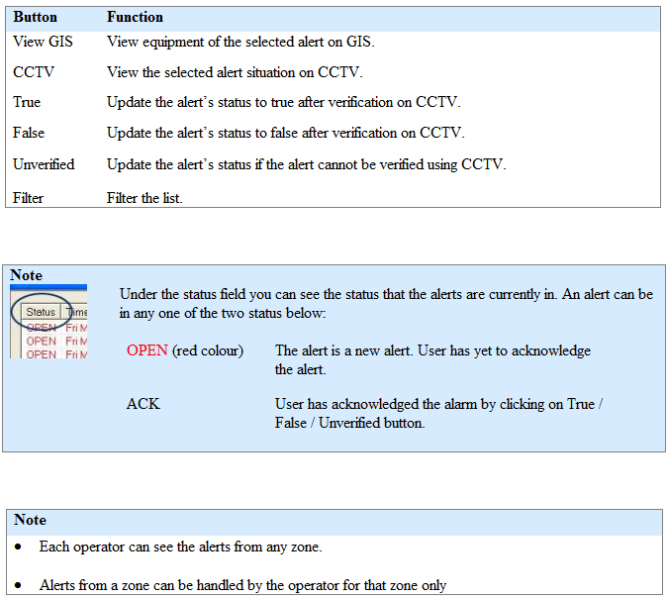

#### Filter the list

  Click on **Filter** button to show Traffic Alert Configuration window.

  Select a Source.

 Select more than one source if you want to view alerts from multiple sources.

  Select a Zone.

 Select more than one zone/EAC Corridor if you want to view alerts for multiple zones/EAC Corridors.

4.  Click on **Apply** button.

The window closes and the list refreshes.

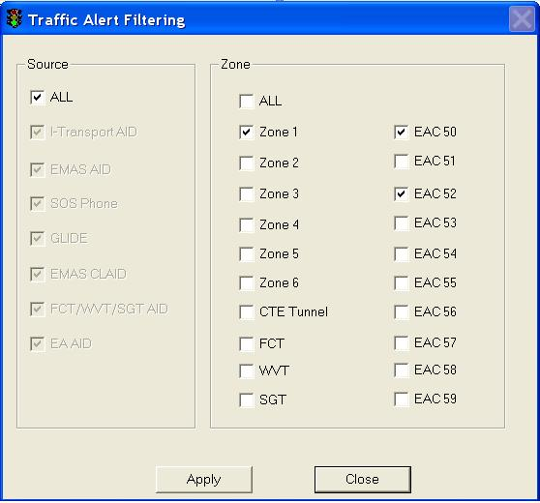

#### Sort the list (field)

Click on Field header to sort the field.

At any one time, only one field can be sorted. First click will sort the field in ascending order, second click will sort the field in descending order.

       ascending order

      descending order

#### View GIS

  Select an alert on the list.

  Click on **View GIS** button.

  The GIS changes its view and the selected location of the alert is highlighted in the GIS.

|  |
| --- |
| Description: c:\_temp\iw help\events\traffic alert list\View G10.jpg |

Figure 75 - A UCD/CLAID alert example

|  |
| --- |
| Description: c:\_temp\iw help\events\traffic alert list\View G11.jpg |
|  |

|  |
| --- |
| **Note** |
| You can clear the light blue color highlight with the Clear Selection Description: c:\_temp\iw help\events\traffic alert list\View G9.jpg tool on GIS toolbar. |

Figure 76 - A SOS/Detection alert example

#### View CCTV

  Select an alert on the list.

  Click on **CCTV** button.

A monitor list is shown.

  Select a monitor from the list.

The monitor will show the view of the nearest PTZ to the traffic alert.



#### Alert Handling

To acknowledge a traffic alert:

Select the new alert (highlighted in red and belongs to your zone) on the Traffic Alert List.

|  |
| --- |
|  |
| Figure 77 - Traffic Alert List Window |

•    If the alert is verified as true

Click on the **True** button. The alert changes to black color and the status changes to ACK.

•    If the alert is a false alert

Click on **False** button. The status changes to ACK.

•    If the alert cannot be verified on site

Click on the **Unverified** button. The status changes to ACK.

Click **Image Snapshot** to view the snapshot image captured on EA and certain Expressway. For alerts on other locations (KPE/MCE, FCT/WVT and GLIDE), the **Image Snapshot** button will be grey out.

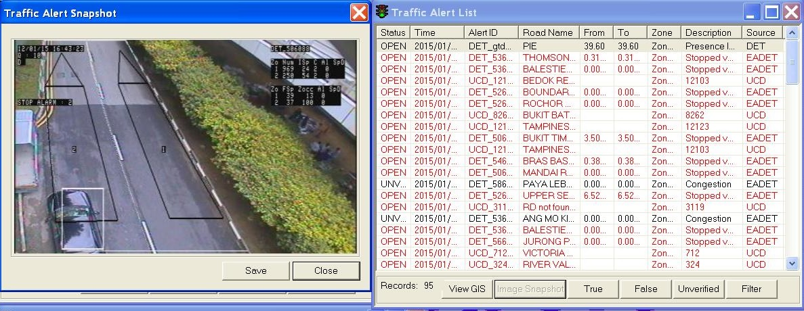

Figure 78 - Snapshot image of traffic alert

### Technical alarm list

The user profile control the functions the user is authorize to use under Platform Control Mode (PCM) or Fall back Control Mode (FCM). Every user will have one user account that enables the user to login to IW. Every user account belongs to a profile.

|  |  |  |  |  |  |  |
| --- | --- | --- | --- | --- | --- | --- |
| **User profile** | | | | | **Operation mode** | |
| DO | Operator | FC | ITSC | Supervisor | PCM | FCM |
| ✓ | ✓ | ✓ | ✓ | ✓ | ✓ | ✓ \* |

\* TSM related function will not be available

This list contains all the equipment defects and faults reported by EMAS, GLIDE, FCT, RIMS TLMT and public.

Features:

•       Real-time update - when there are new or expired technical alarms, they will be added/removed from the list automatically.

•       When there are new alarms, the alarms are highlighted in red in the list and the Alarm beacon changes its status.

•       Provide field sorting on the list - you can choose to sort the list in ascending or descending alphabetical order of the alerts or by the latest or the earliest date/time when they click at the top to of the list.

•       Provide filtering on the list - by zones, sources (EMAS, GLIDE, FCT/WVT/SGT, TSM etc.) and equipment (VMS, LUS, PMCS etc.).

•       View equipment of the selected alarm on GIS.

•       View alarm details.

•       Provide Acknowledgement on the alarms. After acknowledgement, the system will automatically clear the alarm (by default) or you can manually clear them.

•       Send alarm through fax or SMS – through context menu.

•       Send alarm to RIMS TSM – through context menu.

You can monitor all technical alarm by opening the Technical Alarm List window.

Go to Events > Technical Alarm > Technical menu.

|  |
| --- |
| Description: c:\_temp\iw help\events\Techni8.jpg |

Figure 79 - CCM Technical alarm list

|  |  |
| --- | --- |
| **Button** | **Function** |
| View GIS | View equipment of the selected alarm on GIS. |
| Ack | Acknowledge the alarms. |
| False | Remove the alarm from the list if the alarm is a false alarm. |
| Remove Sending | Cancel sending to UMH action. |
| Clear | Close the alarm. |
| Filter | Filter the list by zones, ITS sources (EMAS, Glide etc.) and equipment (VMS, LUS, PMCS etc.) |

|  |  |
| --- | --- |
| **Note** |  |
| Description: c:\_temp\iw help\events\tech_status.JPG | Under the status field you can see the status that the alarms are currently in. An alarm can be in any one of the five status below:   |  |  | | --- | --- | | OPEN (red color) | The alarm is a new alarm. User has yet to acknowledge the alarm. | | OPEN | The alarm is a new alarm. User has not yet  acknowledge the alarm but other ITS systems has detected that the alarm is rectified and closed. The End Time is updated. | | ACK | User has acknowledged the alarm by clicking on Ack button. | | CLOSED | The alarm closed. The End Time will be set automatically once the alarm is closed. | |

|  |  |
| --- | --- |
| **Note** |  |
| Description: c:\_temp\iw help\events\tech_flag.JPG | Under the Flag field you can see the UMH flag for call-in alarm. A call-in alarm can be in any one of the four flags below:   |  |  |  | | --- | --- | --- | | N | NO\_ACTION | Operator had not clicked on "Send\_to\_UMH". | | W | WAITING\_SEND | Re-send to UMH when link is up or link is restarted | | E | EXCEPTION | Already sent to UMH but exception encountered | | S | SENT\_TO\_UMH | Successfully send to UNH and receive the positive reply from UMH | |

|  |  |  |
| --- | --- | --- |
| **Alarm Handling** | | |
| **Type** | **Source** |  |
|  | GLIDE EMAS JEYE | You can acknowledge the alarm, “false” or manually close the alarm. send the alarm to UMH by using Send To UMH function (select alarm and right click button). If you send the alarm to UMH, the Flag will turn from “N” to "S”. You can also fax/ sms the alarm details.   EMAS alarm with the codes: daa, dab, dac, das and daz will be closed manually by users, others will be closed by the system.  FCT alarm with code "FCT\_FCT\_IT\_CLNK\_FCT\_LNK" will be closed by system automatically |

|  |
| --- |
| **Note** |
| •   Technical alarms generated by the CTE Tunnel equipment (PMCS, LUS, TMD, and outside the tunnel TMD) can be handled by Tunnel operator.  •   Technical alarms generated by the FCT/WVT/SGT equipment can be handled by FCT/WVT/SGT operator.  •   Each operator can see the alarms from any zone.  •   All technical alarms occurring on open expressway or alarms from GLIDE will be handled by the FC. |

#### Filter the list

  Click on **Filter** button to show Technical Alarm List Filtering window.

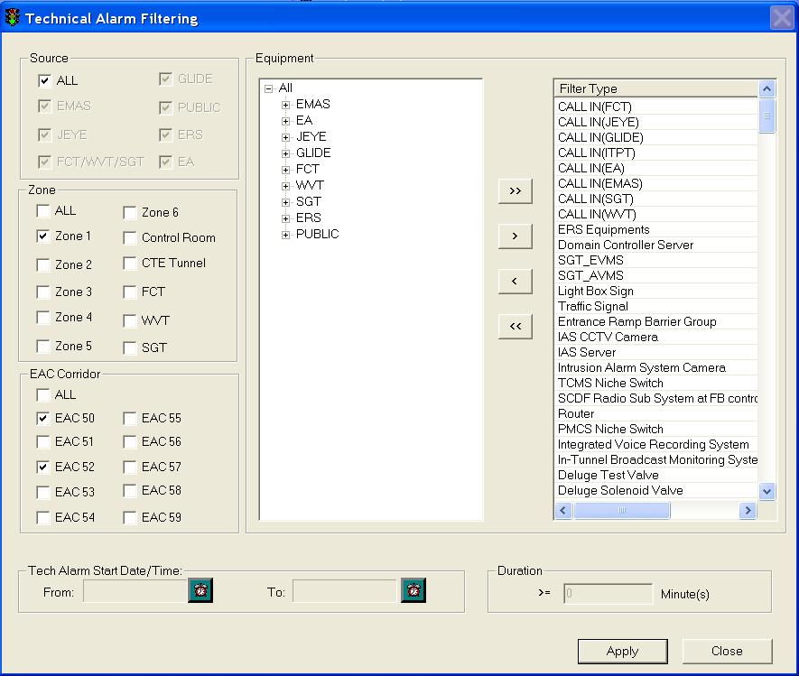

  Select a Source.

Select more than one source if you want to view alarms from multiple sources.

  Select a Zone/EAC Corridor.

Select more than one zone/EAC Corridor if you want to view alarms for multiple zones/EAC Corridors.

  Select equipment from Equipment list into Filter Type list. To add all equipment without making any selection, proceed to step 5. To add equipment by selection, proceed to step 6.

  Click on >> button. Proceed to step 9.

  Click on + in the Equipment list to expand the list.

   Select an equipment type.

    Click on > button to add the selected equipment to Filter Type list. To add another equipment, repeat steps 7 – 8.

    Click on **Apply** button.

The window closes and the list refreshes.

#### Sort the list (field)

Click on Field header to sort the field.

At any one time, only one field can be sorted. First click will sort the field in ascending order, second click will sort the field in descending order.

 ascending order

 descending order

#### View GIS

   Select an alarm on the list.

  Click on **View GIS** button.

The GIS changes its view and the selected equipment in the Technical Alarm List is highlighted on the GIS with light blue color. The equipment will also have a red cross **X**.

|  |
| --- |
| Description: c:\_temp\iw help\events\technical alarm list\View G19.jpg |

Figure 80 - View a Technical Alarm on GIS

|  |
| --- |
| **Note** |
| You can clear the light blue color highlight with the Clear Selection Description: c:\_temp\iw help\events\technical alarm list\View G18.jpg tool on GIS toolbar. |

#### View alarm details

Double click on an alarm on the list.

The Technical Alarm Detail window is shown with the details.

|  |
| --- |
| Description: c:\_temp\iw help\events\technical alarm list\EMAS Alarm.jpg |

Figure 81 - A EMAS alarm detail window

|  |
| --- |
| Description: c:\_temp\iw help\events\technical alarm list\GLIDE alarm.jpg |

Figure 82 - A Glide alarm detail window

|  |
| --- |
| Description: c:\_temp\iw help\events\technical alarm list\JEYE alarm.jpg |

Figure 83 - A JEYE alarm detail window

|  |
| --- |
| Description: c:\_temp\iw help\events\technical alarm list\FCT alarm.jpg |

Figure 84 - A FCT alarm detail window

|  |
| --- |
| Description: c:\_temp\iw help\events\technical alarm list\ERS alarm.jpg |

Figure 85 - A ERS alarm detail window

#### Technical Alarm Handling

•    To acknowledge an alarm:

  Click on an unacknowledged alarm (status is “OPEN” and belongs to your zone) on the list.

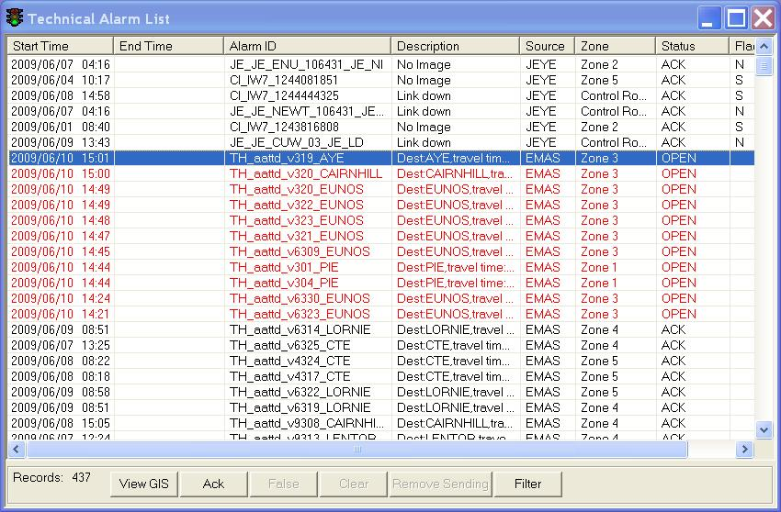

The selected alarm will be highlighted in blue background. The **Ack** button will be enabled.

  Click on the **Ack** button.

The **False** and **Clear** button will then be enabled and the alarm’s status changes to “ACK”. An acknowledged alarm will stay on the list forever until you update the alarm to false or close the alarm.

•    If the alarm is a false alarm

  Click on an acknowledged alarm (status is “ACK”) on the list. The selected alarm will be highlighted in blue background.

  Click on False button. The alarm will be removed from the list.

•    To Clear an alarm

  Click on an acknowledged alarm (status is “ACK”) on the list. The selected alarm will be highlighted in blue background.

  Click on **Clear** button.The status will become “CLOSED”. The alarm will be closed and removed from the list 1 hour later.

|  |
| --- |
| **Note** |
| You can only handle technical alarm if the alarm occurs in your zone, e.g. If you are Zone 1 operator, you can handle alarms from Zone 1 as well as tunnel (FCT/WVT/SGT and CTE). However you will be able to see all alarms including those that occur in other zones. |

#### Create Call in Alarm

  After receiving public call-in with details of the defect site, you will manually create the alarm because this is not a system-detected alarm.

2.   Go to **Events** > **Technical Alarm** > **Create Alarms** menu.

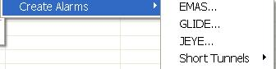

3.   Select a ITS system. after that select Equipment.

EMAS:

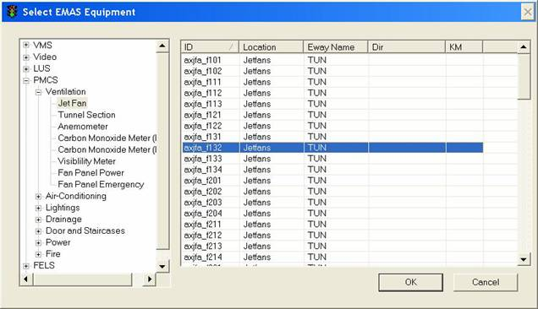

GLIDE:

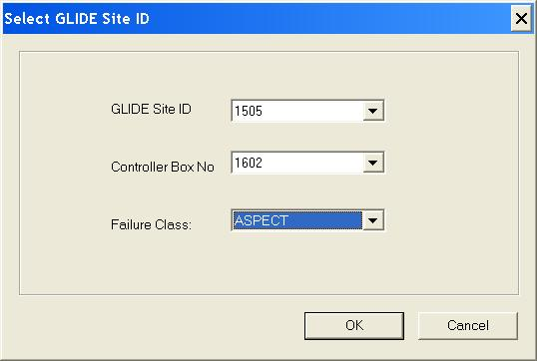

JEYE:

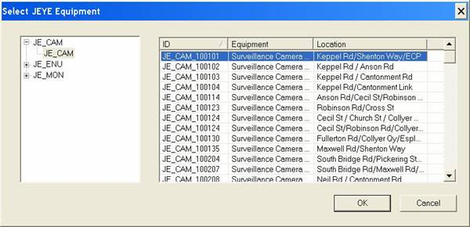

FCT:

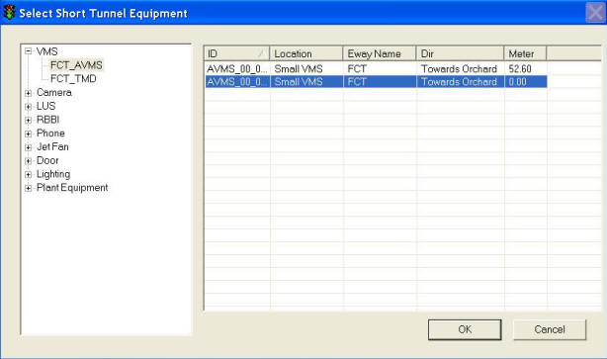

 EA/PGS:

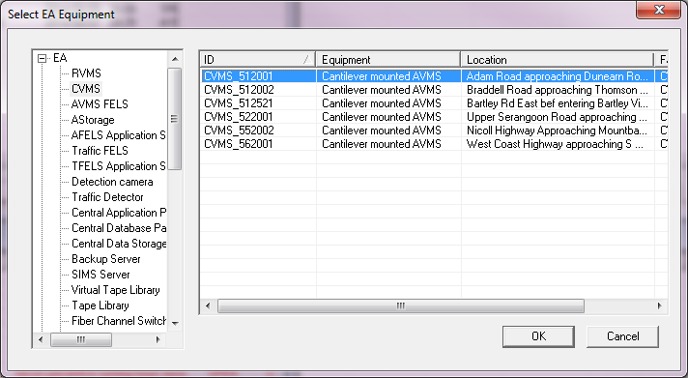

I-transport:

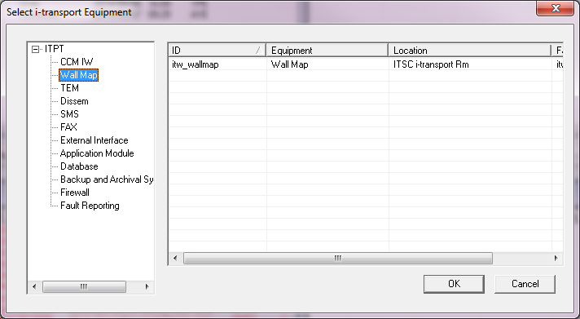

  4.  A Technical Alarm Detail window will appear.

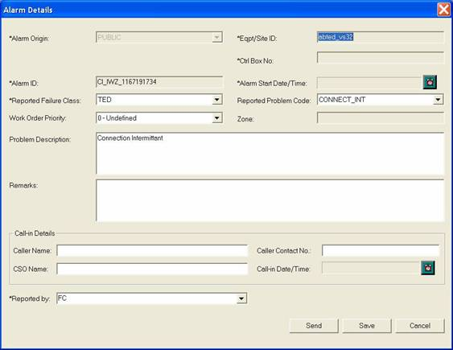

   Set the Start Date/Time by clicking on the Clock button to set time as the current date and time. To manually set date and time, click on the textbox, a Select Time window will appear.

6.      Enter remarks if you want to.

   Click on **Send** button. The alarm will be added to the Technical Alarm List as a new alarm and you will handle it the same way as system-detected alarm.

|  |
| --- |
| **Note** |
| You will just need to enter eitherGLIDE Site ID / Controller Box No. If the no. entered is valid, the corresponding Controller Box No. / GLIDE Site ID will be retrieved automatically. |

#### Send Technical Alarm Details (Fax, SMS or UMH)

Right click on a Technical Alarm (status is “ACK” and belongs to your zone) on the list.

A context menu appears.

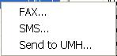

•   To fax

   Click on **Fax.**

A Fax Template window appears. For more information on how to send a fax, refer to 583.

|  |
| --- |
| Description: c:\_temp\iw help\events\technical alarm list\alarm fax.jpg |

Figure 86 - A Fax template

•   To SMS

    Click on **SMS**.

A SMS Service window appears. For more information on how to send a SMS, refer to [here](#_Send_Message).

|  |
| --- |
| Description: c:\_temp\iw help\events\technical alarm list\alarm SMS.jpg |

Figure 87 - A SMS template

The SMS message format:

*"Call ITSC: <phone number>; Alarm ID: <Technical alarm ID>"*

•   To send to UMH

  Click on **Send** to UMH.

Technical Alarm window appears.

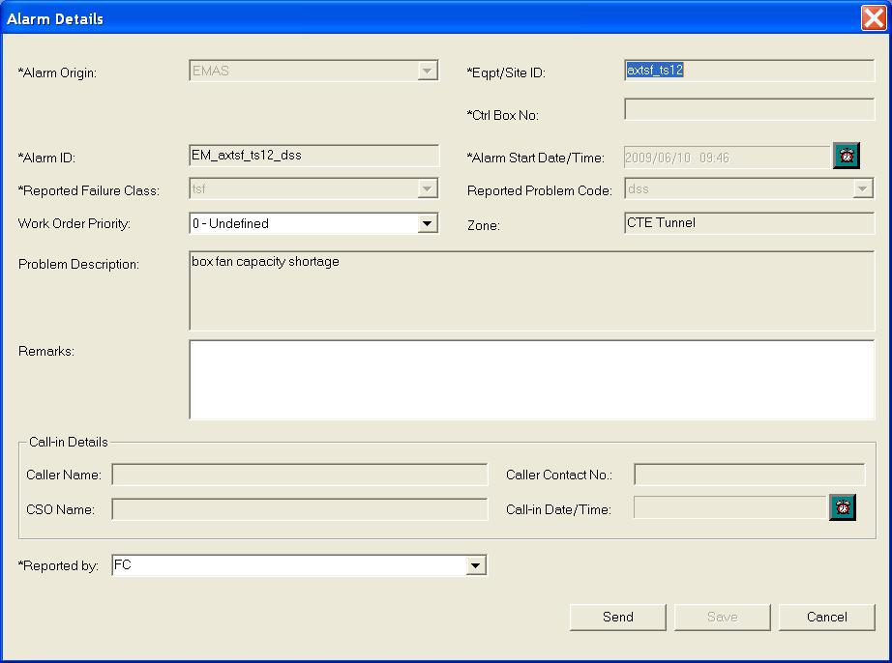

2.  Type comments in the remarks textbox.

3.  Click on **Send** button to send alarm to UMH.

### Environment monitoring list

The user profile control the functions the user is authorize to use under Platform Control Mode (PCM) or Fall back Control Mode (FCM). Every user will have one user account that enables the user to login to IW. Every user account belongs to a profile.

|  |  |  |  |  |  |  |
| --- | --- | --- | --- | --- | --- | --- |
| **User profile** | | | | | **Operation mode** | |
| DO | Operator | FC | ITSC | Supervisor | PCM | FCM |
| ✓ | ✓ \* | ✓ | ✓ | ✓ | ✓ | ✓ |

          \* Restricted to Tunnel and Zone 1 operator only

This list contains all PMCS measuring alarms and TTD threshold warning that exceed the threshold values. Fire alarms will also be contained in this list.

Features:

•       Real-time update - when there are new or expired reading measures alarms, they will be added/removed from the list automatically.

•       When there are new alarms, the alarms are highlighted in red and the Alarm beacon changes it’s status.

•    Provide field sorting on the list - you can choose to sort the list in ascending or descending alphabetical order of the alerts or by the       latest or the earliest date/time when they click at the top to of the list.

•       View equipment of the selected alarm on GIS.

•       Send alarm through fax or SMS (through context menu).

•        Provide Acknowledgement on the alarms. After acknowledgement, the system will automatically clear the alarm (by default) or you can manually clear them.

You can monitor all reading alarms by opening Environment Monitoring List window.

Go to Events > Technical Alarm > Environment Monitoring menu.

|  |
| --- |
| Description: c:\_temp\iw help\events\Environment monitoring list.jpg |

Figure 88 - CCM Environment monitoring list

|  |  |  |
| --- | --- | --- |
| **Button                     Function** | | |
| **View  GIS**View equipment of the selected alarm on GIS.  **Ack**Acknowledge the alarms.  **Clear**Close the alarm.  **Remove Sending**Cancel sending to UMH action.  **Filter**Filter the list by PMCS equipment (Fan, doors, pumps, light etc.) | | |
| **Note** |  | |
| Description: c:\_temp\iw help\enviro4.jpg | Under the status field you can see the status that the alarms are currently in. An alarm can be in any one of the five status below:   |  |  | | --- | --- | | OPEN (red colour) | The alarm is a new alarm. User has yet to acknowledge the alarm. | | OPEN | The alarm is a new alarm. User has yet to acknowledge the alarm but EMAS/FCT/WVT/SGT has closed the alarm. The End Time is updated. | | ACK | User has acknowledged the alarm by clicking on Ack button. | | CLOSED | EMAS/FCT has closed the alarm because the measurement has returned to the normal range. The End Time will be set automatically once the alarm is closed. | | |

|  |
| --- |
| **Note** |
| •   Tunnel PMCS equipment alarms PMCS can be handled by Tunnel operator and Zone 1 operator only.  •    Fire alarms can be handled by Tunnel operator and Zone 1 operator only.  •   FCT/WVT/SGT PMCS equipment alarms PMCS can be handled by FCT/WVT/SGT operator and Zone 1 operator only.  •   TTD threshold alarms can be handled by the zone operators.  •    Each operator can see the alarms from any zone. |

#### Filter the list

   Click on Filter button to show Environment Monitoring Configuration window.

   Click + to expand the equipment list (EMAS/FCT/WVT/SGT).

   Select a equipment from Equipment list into Filter Type list.

   Click on > button.

Repeat step 3 – 4 to add more equipment to the Filter Type list.

   Click on Apply button.

The window closes and the list refreshes.

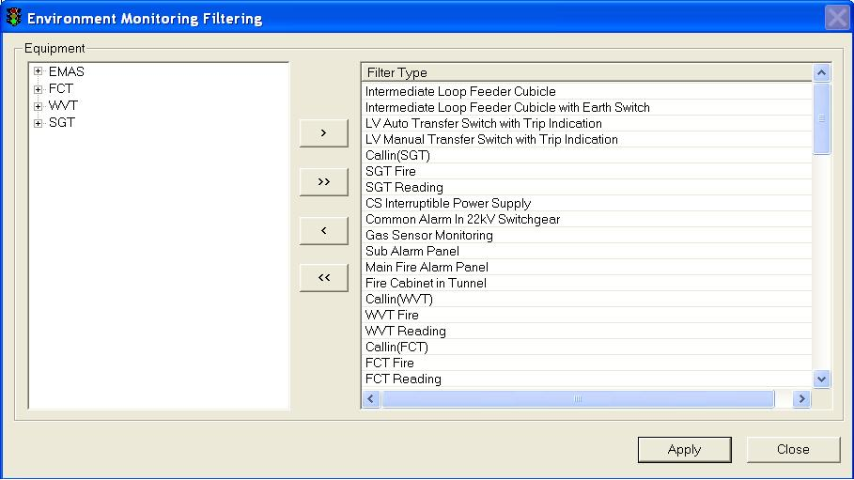

Figure 89 - Environment Monitoring Filtering Window

#### Sort the list (field)

Click on Field header to sort the field.

At any one time, only one field can be sorted. First click will sort the field in ascending order, second click will sort the field in descending order.

ascending order

descending order

#### View GIS

1.      Select an alarm on the list.

2.      Click on View GIS button.

The GIS changes its view and the selected equipment in the Environment Monitoring list is highlighted in the GIS. The equipment will also have a red cross **X**.

|  |
| --- |
| Description: c:\_temp\iw help\events\environment monitoring list\View G37.jpg |
| This picture shows a LUS alarm |

|  |
| --- |
| **Note** |
| You can clear the light blue colour highlight with the Clear Selection Description: c:\_temp\iw help\events\environment monitoring list\View G36.jpg tool on GIS toolbar. |

#### Send Reading Alarm through Fax or SMS

  Right click on a Technical Alarm (status is “ACK” and belongs to your zone) on the list.

A context menu appears.

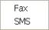

  Click on Fax to send fax.

A Fax Template window appears. For more information on how to send a fax, refer to [here](#_Send_Fax).

|  |
| --- |
| Description: c:\_temp\iw help\events\environment monitoring list\fax.jpg |

Figure 90 - A Fax window

  Click on SMS to send SMS.

A SMS Service window appears. For more information on how to send a SMS, refer to [here](#_Send_Message).

|  |
| --- |
| Description: c:\_temp\iw help\events\environment monitoring list\sms.jpg |

Figure 91 - A SMS window

The SMS message format:

*"Call ITSC: <phone number>; Alarm ID: <Reading alarm ID>"*

#### Measurement Alarm Handling

•    To acknowledge an alarm

  Click on an unacknowledged alarm (status is “OPEN” and belongs to your zone) on the list.

The selected alarm will be highlighted in blue background.

The ACK button and Clear button will be enabled.

  Click on ACK button.

The alarm changes to black color and it’s Status changes to “ACK”. The Clear button will be enabled.

•    To Clear an alarm

Click on Clear button.

|  |
| --- |
| Description: c:\_temp\iw help\events\environment monitoring list\handling.jpg |

Figure 92 - A sample alarm

### EA equipment operation status list

You can monitor all EA equipment operation status by opening EA Equipment Operation Status List window.

Go to Events > Technical Alarm > A OPE Status.

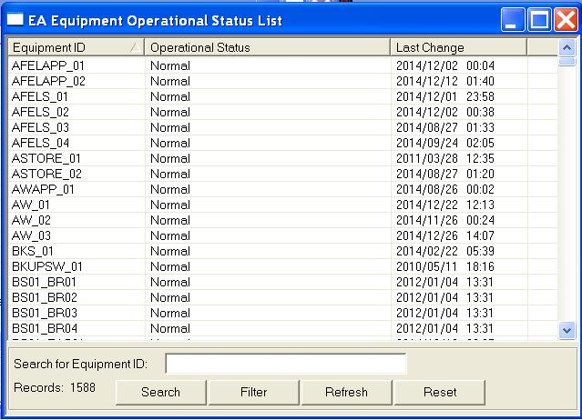

Figure 93 - CCM EA equipment operation status list

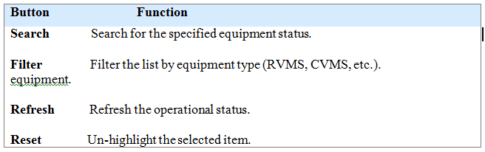

#### Search

1. Key in the equipment ID to be searched.

2. Click on the **Search** button.

3. The selected item will be highlighted.

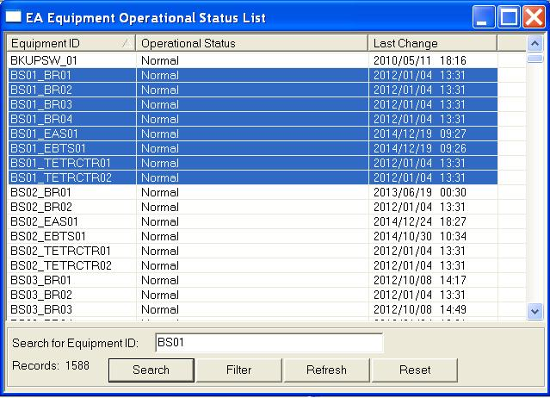

#### Filter

1. Click on the **Filter** button.

2. The filter window will be displayed as following.

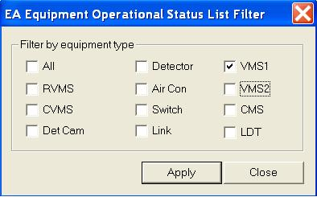

3. Select the equipment and click on **Apply** button.

4. Only the selected equipment operation status will be displayed.

#### Reset

1. If one item is selected as following:



2. Click on **Reset** button, the item will be de-selected as following:

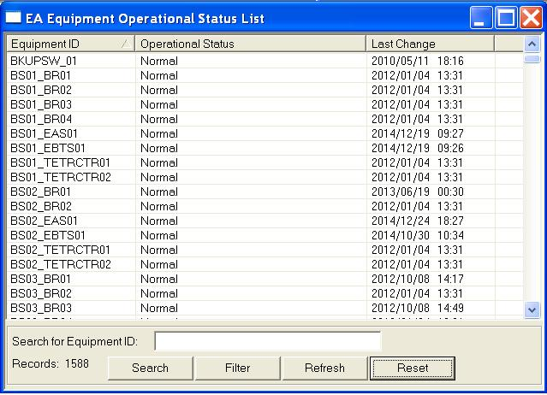

### EMAS equipment operation status list

You can monitor all EMAS equipment operation status by opening EMAS Equipment Operation Status List window.

Go to Events > Technical Alarm > EMAS OPE Status.

|  |
| --- |
| Description: c:\_temp\iw help\events\EMAS OPE Status.jpg |

Figure 94 - CCM EMAS equipment operation status list

|  |
| --- |
| **Button                           Function** |
| **Search**Search for the specified equipment status.  **Filter**Filter the list by equipment type (TTD, TED, etc.). equipment.  **Refresh**Refresh the operational status.  **Reset** Un-highlight the selected item. |

#### Search

1. Key in the equipment ID to be searched.

2. Click on the **Search** button.

3. The selected item will be highlighted.

|  |
| --- |
| Description: c:\_temp\iw help\events\emas ope status\OperationStatusSearch.JPG |
|  |

#### Filter

1. Click on the **Filter** button.

2. The filter window will be displayed as following.

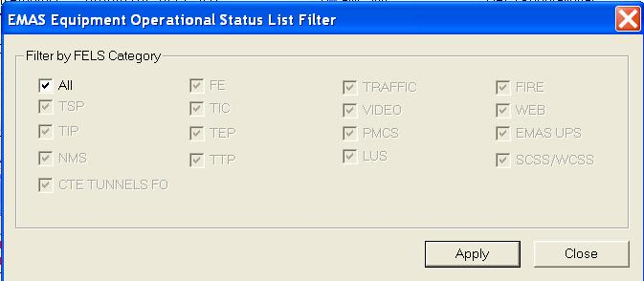

3. Select the equipment and click on **Apply** button.

4. Only the selected equipment operation status will be displayed.

|  |
| --- |
|  |
|  |

#### Reset

1. If one item is selected as following:

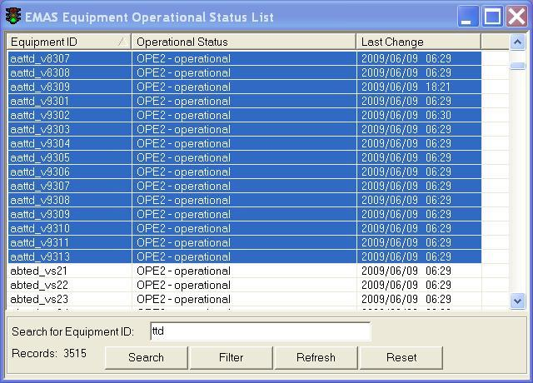

2. Click on **Reset** button, the item will be de-selected as following:

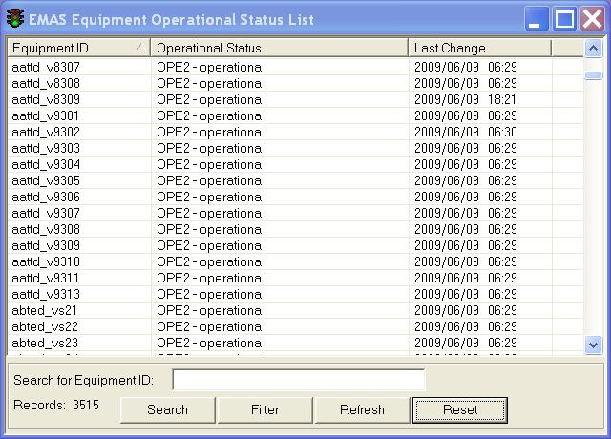

|  |
| --- |
|  |
|  |

### EMAS No RT (RealTime) Status Equipment List

You can monitor EMAS equipment which do not send back RT status to i-Transport by opening EMAS no RT status equipment list window.

Go to Events > Technical Alarm > EMAS No RT Status.

|  |
| --- |
| Description: c:\_temp\iw help\events\EMAS no RT List.jpg |

Figure 95 - EMAS No RT Status List

|  |
| --- |
| **Button                           Function** |
| **Clear** Clear the equipment from the List.  **View GIS**  Locate the equipment at GIS map  **Refresh**Refresh the operational status.  **Filter**Filter the list by equipment type (TID, TMD, etc.). equipment. |

#### Filter

1. Click on the **Filter** button.

2. The filter window will be displayed as following.

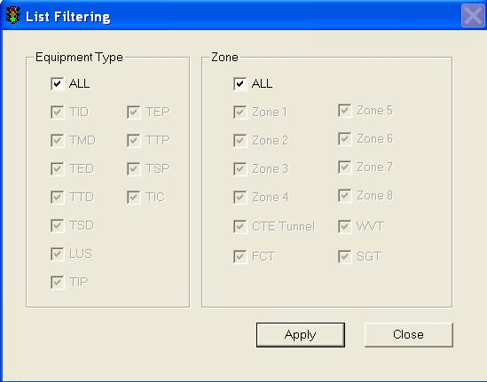

3. Select the equipment and click on **Apply** button.

4. Only the selected equipment will be displayed.

|  |
| --- |
|  |
|  |

### KPE/MCE fault equipment list

You can monitor KPE/MCE fault equipment operation status by opening KPE/MCE fault equipment list window.

Go to Events > Technical Alarm > KPE/MCE fault equipment list.

|  |
| --- |
|  |

Figure 96 – KPE/MCE fault equipment list

|  |
| --- |
| **Button                           Function** |
| **Search**Search for the specified equipment status.  **Filter**Filter the list by equipment type (TID, AVMS, etc.). equipment.  **Refresh**Refresh the operational status.  **Reset** Un-highlight the selected item. |

#### Search

1. Key in the equipment ID to be searched.

2. Click on the **Search** button.

3. The selected item will be highlighted.

|  |
| --- |
| Description: c:\_temp\iw help\events\kpe fault equipment list\OperationStatusSearch.JPG |
|  |

#### Filter

1. Click on the **Filter** button.

2. The filter window will be displayed as following.

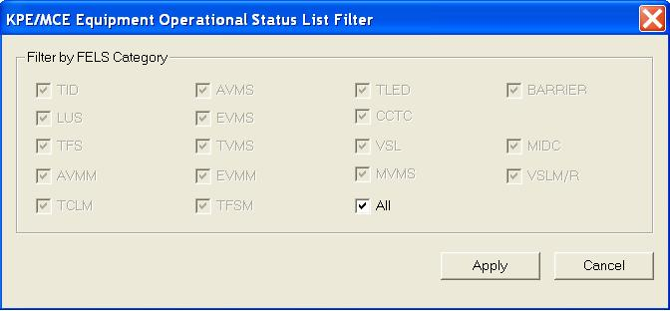

3. Select the equipment and click on **Apply** button.

4. Only the selected equipment operation status will be displayed.

|  |
| --- |
|  |
|  |

#### Reset

1. If one item is selected as following:

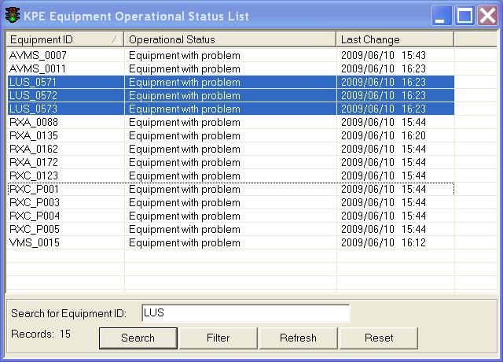

2. Click on **Reset** button, the item will be de-selected as following:

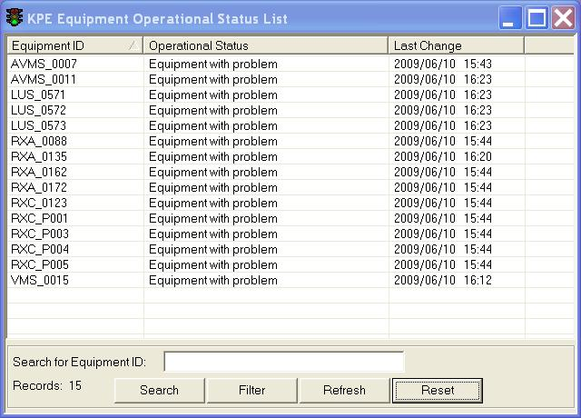

|  |
| --- |
|  |
|  |

### Work Order Handling

1.  All creation and modification of Work Orders are performed at UMH and sent to i-transport (IW). Work Orders are for viewing only at i-transport.

|  |
| --- |
| Description: c:\_temp\iw help\events\work order\Work order.jpg |

Figure 97 - Work Order List

2. Once the status becomes close or cancel, this Work Order will be moved from current Work Order list to the Historical WO list & 72 Hour List.

3. The 72 Hour List keeps a list of Work Orders that are closed or cancelled in the past 72 hours.

|  |
| --- |
| Description: c:\_temp\iw help\events\work order\Work O21.jpg |

Figure 98 - 72 Hour Closed/Cancelled Work Order List

#### Filter the list

   Click on Filter button to show Work Order List Filter window.

   Select a Fault Source in type list.

   Click on Apply button.

The window closes and the list refreshes.

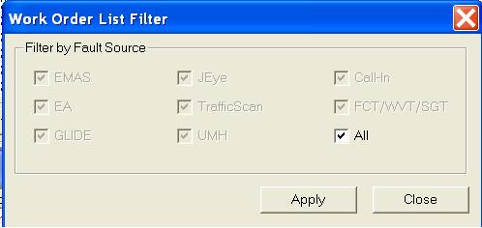

Figure 99 – Work Order Filter Window

#### Sort the list (field)

Click on Field header to sort the field.

At any one time, only one field can be sorted. First click will sort the field in ascending order, second click will sort the field in descending order.

ascending order

descending order

### Junction Control

The user profile control the functions the user is authorize to use under Platform Control Mode (PCM) or Fall back Control Mode (FCM). Every user will have one user account that enables the user to login to IW. Every user account belongs to a profile.

|  |  |  |  |  |  |  |
| --- | --- | --- | --- | --- | --- | --- |
| **User profile** | | | | | **Operation mode** | |
| DO | Operator | FC | ITSC | Supervisor | PCM | FCM |
| ✓ | ✓ | ✓ | ✓ | ✓ | ✓ | ✓ |

Go to Events menu > Junction Control menu.

The following control functions are provided:

|  |  |
| --- | --- |
| Cycle Time Lock | Link Plan |
| •    Lock/unlock  •    Specify Lock duration  •    Choose Cycle Length Plan  •    Specify Cycle Length duration | •    Lock/unlock  •    Specify Lock duration  •    Choose Link Plan  •    Choose Link Plan mode |

|  |  |
| --- | --- |
| Split Plan Lock | Active Phase Split |
| •    Lock/unlock  •    Specify Lock duration  •    Choose Split Plan | •    Lock/unlock  •    Specify Lock duration  •    Choose Phase to change  •    Skip phase  •    Choose type of change |

|  |  |
| --- | --- |
| Offset Plan | Marriage/Divorce |
| •    Lock/unlock  •    Specify Lock duration  •    Choose Offset Plan | •    Lock/unlock  •    Specify Lock duration  •    Choose marriage or divorce |

|  |  |
| --- | --- |
| Action Plan |  |
| •    Choose Action plan |  |

#### To Set Split Plan Lock

To Set Split Plan Lock:

  Click on Region ID dropdown arrow, and click an ID.

2.   Click on Site ID dropdown arrow, and click an ID.

3.   In Select Control Type panel, click on Split Plan Lock radio button.

The control settings appear in the Select Control Parameters panel.

4.   Click the Lock or Unlock radio buttons.

5.  Type no. of minutes in Lock Duration textbox.

6.  Click Select Plan if you want to select Split Plan.

7.   Split Plan ID dropdown list will be enabled.

8.   If you are selecting Split Plan. Click on Split Plan ID dropdown arrow, and click a plan ID.

9.  Click **Apply** button.

|  |
| --- |
| Description: c:\_temp\iw help\events\junction control\Split plan lock.jpg |

Figure 100 - Junction Control Window

|  |
| --- |
| **Note** |
| You will perform control from here but you can view the split plans configuration by opening ScatsAccess.  Description: c:\_temp\iw help\events\junction control\To Set45.jpg |

#### To Set Active Phase Split

To Set Active Phase Split :

  Click on Region ID dropdown arrow, and click an ID.

2.  Click on Site ID dropdown arrow, and click an ID.

3.   In Select Control Type panel, click on Active Phase Split radio button.

The control settings appear in the Select Control Parameters panel.

4.   Click the **Lock** or **Unlock** radio buttons.

5.  Type no. of minutes in Lock Duration textbox.

6.   Click the Phase to Change dropdown arrow, and click a phase.

7.  Click Skip Phase if you want to skip.

8.   Click the Change Type.

9.   Click the Change Value dropdown arrow, and click a number.

10.   Click **Apply** button.

|  |
| --- |
| Description: c:\_temp\iw help\events\junction control\Active phase split.jpg |

Figure 101 - Junction Control Window

|  |
| --- |
| **Note** |
| You will perform control from here but you can view the phases configuration by opening ScatsAccess.  Description: c:\_temp\iw help\events\junction control\To Set51.jpg |

#### To Set Cycle Time Lock

To Set Cycle Time Lock:

  Click on Region ID dropdown arrow, and click an ID.

2.  Click on Site ID dropdown arrow, and click an ID.

3.   In Select Control Type panel, click on Cycle Time Lock radio button.

The control settings appear in the Select Control Parameters panel.

4.   Click the **Lock** or **Unlock** radio buttons.

5.  Type no. of minutes in Lock Duration textbox.

6.   Type no. of seconds in Cycle Length textbox.

7.  Click **Apply** button.

|  |
| --- |
| Description: c:\_temp\iw help\events\junction control\Cycle time lock.jpg |

Figure 102 - Junction Control Window

|  |
| --- |
| **Note** |
| You will perform control from here but you can view the cycle plans configuration by opening ScatsAccess.  Description: c:\_temp\iw help\events\junction control\To Set43.jpg |

#### To Set Link Plan

To Set Link Plan:

  Click on Region ID dropdown arrow, and click an ID.

2.   Click on Site ID dropdown arrow, and click an ID.

3.   In Select Control Type panel, click on Link Plan radio button.

The control settings appear in the Select Control Parameters panel.

4.  Click the **Lock** or **Unlock** radio buttons.

5.  Type no. of minutes in Lock Duration textbox.

6.  Click Select Plan if you want to select Link Plan.

7.   Link Plan ID dropdown list will be enabled.

8.   If you are selecting Link Plan. Click on Link Plan ID dropdown arrow, and click a plan ID.

9.   In the Mode panel, click on the mode.

10.   Click **Apply** button.

|  |
| --- |
| Description: c:\_temp\iw help\events\junction control\Link plan.jpg |

Figure 103 - Junction Control Window

|  |
| --- |
| **Note** |
| You will perform control from here but you can view the link plans configuration by opening ScatsAccess.  Description: c:\_temp\iw help\events\junction control\To Set49.jpg |

#### To Set Offset Plan

To Set Offset Plan:

  Click on Region ID dropdown arrow, and click an ID.

2.   Click on Site ID dropdown arrow, and click an ID.

3.   In Select Control Type panel, click on Offset Plan radio button.

The control settings appear in the Select Control Parameters panel.

4.   Click the Lock or Unlock radio buttons.

5.  Type no. of minutes in Lock Duration textbox.

6.   Click Select Plan if you want to select Offset Plan.

7.   Offset Plan ID dropdown list will be enabled.

8.   If you are selecting Offset Plan. Click on Offset Plan ID dropdown arrow, and click a plan ID.

9.  Click **Apply** button.

|  |
| --- |
| Description: c:\_temp\iw help\events\junction control\Offset Plan.jpg |

Figure 104 - Junction Control Window

|  |
| --- |
| **Note** |
| You will perform control from here but you can view the offset plans configuration by opening ScatsAccess.  Description: c:\_temp\iw help\events\junction control\To Set47.jpg |

#### To Set Marriage/Divorce

To Set Marriage/Divorce:

  Click on Region ID dropdown arrow, and click an ID.

2.   Click on Site ID dropdown arrow, and click an ID.

3.   In Select Control Type panel, click on Marriage/Divorce radio button.

The control settings appear in the Select Control Parameters panel.

4.  Click the **Lock** or **Unlock** radio buttons.

5.   Type no. of minutes in Lock Duration textbox.

6.   In Selection panel, click on Marriage or Divorce.

7.  Click **Apply** button.

|  |
| --- |
| Description: c:\_temp\iw help\events\junction control\Marriage divorce.jpg |
|  |

Figure 105 - Junction control Window

|  |
| --- |
| **Note** |
| You will perform control from here but you can view which site is married to this site by opening ScatsAccess.  Description: c:\_temp\iw help\events\junction control\To Set53.jpg |

#### To Set Action List

To Set Marriage/Divorce:

  Click on Region ID dropdown arrow, and click an ID.

3.   In Select Control Type panel, click on Action List radio button.

    The control settings appear in the Select Control Parameters panel.

4.  Click on Select Action List dropdown arrow, and click an action list.

    The control commands of action list appear in the list box.

5.  Click **Apply** button.

|  |
| --- |
| Description: c:\_temp\iw help\events\junction control\Action List.jpg |

Figure 106 - Junction control Window

|  |
| --- |
| **Note** |
| You will perform control from here but you can view which site is married to this site by opening ScatsAccess.  Description: c:\_temp\iw help\events\junction control\To Set53.jpg |

### Equipment control

EMAS/FCT/WVT/SGT Field equipment could be controlled on the CCM, via a window for specified equipment. Also provided is the capability for user to apply a command to several equipment.

Equipment control will only be allowed when the Operational State is “operational” (EMAS equipment), Alarm state is "off" (FCT/WVT/SGT Equipment) and the Tagging Mode is “1” (For more information on tagging mode, refer to [here](#_Tagging) ). For each equipment, the current setting will be shown and the new setting can be specified. When you send a control command, the command is sent to EMAS/FCT/WVT/SGT and EMAS/FCT/WVT/SGT will reply with an acknowledgement:

•         “Ok” - The remote control is successful. This means the command is sent successfully to the site equipment.

•          “Time Out” – The remote control is unsuccessful. This means either the command is not received by EMAS/FCT/WVT/SGT or the command is received but EMAS/FCT/WVT/SGT do not send back a reply. You should try to resend the command.

•         “Not Sent” – No new setting is set for the command, hence no command is sent to EMAS/FCT/WVT/SGT.

Go to Events menu > Equipment Control

|  |
| --- |
| Description: c:\_temp\iw help\events\Equipm22.jpg |

Figure 107 - A equipment control window example

EMAS Equipment control list:

•       VMS (TIP, TEP, TTP, TSP and TIC)

•       Camera (Junction surveillance, Expressway surveillance, Expressway detection and Monitor)

•       LUS

•       PMCS

•      Ventilation (Jet fan, Tunnel section and Visibility meter)

•         Air Con

•       Lighting (Photometer, Boost lighting, Boost light group, Line lighting control north tunnel, Line lighting control south tunnel, Line lighting switching)

•      Drainage (Tunnel main pump, Tunnel main sump, De-watering pump, De-watering sump, Cleaning pump and Cleaning sump

•       Doors and Staircases (Vehicle door, Pedestrian door, Pressurization fan and ES normal fan)

•       Power (LV MDB outgoing feeder and LV diesel generator)

•            Strategy class

FCT Equipment control list:

•        VMS ( FCT\_AVMS, FCT\_TMD, MES and NLTS)

•        Camera (Surveillance)

•        LUS

•        Jet Fan (Jet Fan and Jet Fan Control Group)

•        Lighting (Beacon Light and Tunnel Lighting)

•        RBBI

•        Air Equipment (Air Con and Fresh Air Fan)

•        Power Equipment (Generator)

#### FCT

##### Variable Message Sign (VMS)

The user profile control the functions the user is authorize to use under Platform Control Mode (PCM) or Fall back Control Mode (FCM). Every user will have one user account that enables the user to login to IW. Every user account belongs to a profile.

|  |  |  |  |  |  |  |
| --- | --- | --- | --- | --- | --- | --- |
| **User profile** | | | | | **Operation mode** | |
| DO | Operator | FC | ITSC | Supervisor | PCM | FCM |
| ✓ | ✓ | ✓ | ✓ | ✓ | ✓ |  |

For each FCT VMS, you may change the following setting:

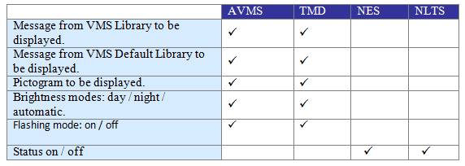

###### Search and Retrieve VMS

   In the equipment list, click on + sign besides VMS.

The list expands to show the list of VMS equipment.

   Click on VMS (FCT TMD or FCT AVMS).

A list of equipment appears on the right with ID, Description, Eway Name, Dir and Kilometer information.

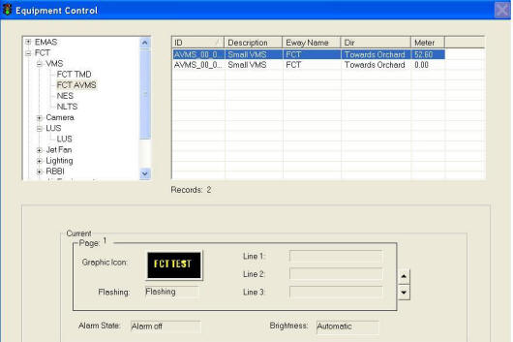

Figure 108 - FCT VMS Equipment Control window

  Click on any equipment to select it. To do multiple selection, press and hold Shift button or Ctrl button on your keyboard and click on the equipment on the list.

The selected equipment will be highlighted in blue background. The current settings for the selected equipment appear in the Current panel.

###### Remote Control FCT\_AVMS and FCT\_TMD

   Choose a new message from the [VMS Library](#_VMS_library) or use [Default message](#_VMS_default_librarys).

   In the Brightness panel, click on a setting.

   Click on Apply button to save the changes.

   Wait for the system to response.

•    If the remote control is successful, the response will show “Ok”.

•    If the system response with a “Time Out” after 30 seconds, you should try again by clicking on Apply button.

•    If the system response with “Not Sent”, it simply means that you have not set the new setting. E.g. you may have chosen a new Graphic Icon but you did not choose a new Brightness. Hence when you click on Apply button, the system immediately replies with “Not Sent” beside the Brightness panel.

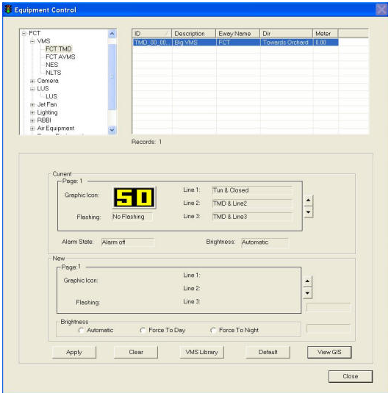

Figure 109 - This picture shows a FCT\_TMD control window

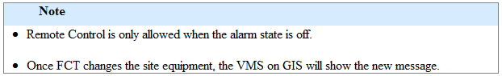

###### Remote Control NES and NLTS

   In the Control panel, click on a setting.

   Click on Apply button to save the changes.

   Wait for the system to response.

•    If the remote control is successful, the response will show “Ok”.

•    If the system response with a “Time Out” after 30 seconds, you should try again by clicking on Apply button.

 •    If the system response with “Not Sent”, it simply means that you have not set the new setting.

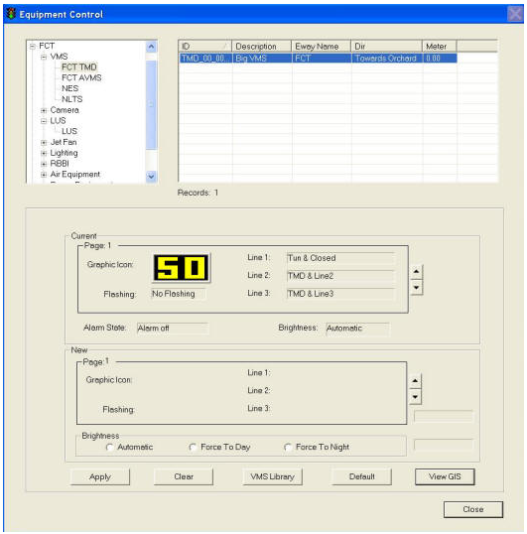

Figure 110 - This picture shows a NES control window

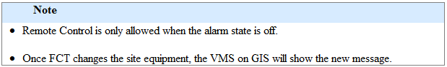

###### Choose new message from VMS Library

  Click on VMS Library button.

The VMS Library window appears.

  Click on Expressway dropdown arrow, and click on an expressway name.

  Click on Category dropdown arrow, and click on a category.

A list of messages  for the selected equipment type, expressway and category appears on the right.

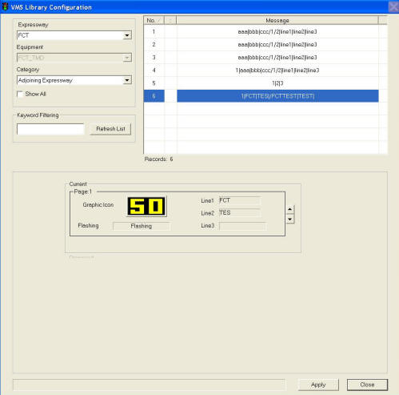

Figure 111 - FCT VMS Library Window

  Click on the desired message to select it.

The selected message will be highlighted in blue background. The current settings for the selected message appear in the Current panel.

  Click on Apply button to use this message as the new message or repeat steps 2 – 5 to choose another message.

The VMS Library window closes and the selected message settings appear in the New panel.

  In the Brightness panel, click on a setting.

  Click on Apply button to activate the new changes to the VMS on site.

 Wait for the system to response:

•    If the remote control is successful, the response will show “Ok”. This means the message is sent successfully to the site equipment.

•    If the system response with a “Time Out” after 30 seconds, you should try again by clicking on Apply button as the site equipment is not responding.

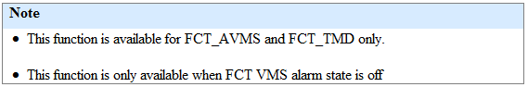

###### Set new message using messages in VMS Default Library

   Click on Default button.

The default message (from VMS Default Library) for the selected equipment appears in the New panel.

   In the Brightness panel, click on a setting.

   Click on Apply button to save the changes.

|  |
| --- |
| Description: c:\_temp\iw help\events\equipment control\Set ne65.jpg |

Figure 112 - FCT VMS New Message Setting Window

|  |
| --- |
| **Note** |
| •    This function is available for all VMS.  •   This function is only available when the FCT VMS alarm state is off. |

###### View GIS

Click on View GIS button.

The GIS changes its view and the equipment is highlighted.

|  |
| --- |
| Description: c:\_temp\iw help\events\equipment control\View G67.jpg |

Figure 113 - View VMS on GIS

##### Lane Use Signal (LUS)

The user profile control the functions the user is authorize to use under Platform Control Mode (PCM) or Fall back Control Mode (FCM). Every user will have one user account that enables the user to login to IW. Every user account belongs to a profile.

|  |  |  |  |  |  |  |
| --- | --- | --- | --- | --- | --- | --- |
| **User profile** | | | | | **Operation mode** | |
| DO | Operator | FC | ITSC | Supervisor | PCM | FCM |
| ✓ | ✓ \* | ✓ \*\* | ✓ | ✓ | ✓ | ✓ |

\* Only FCT and Zone 1 operators can control

\*\* FC can only view

You may change the graphic code – green arrow, amber cross, red cross or blank

###### Select LUS from GIS

1       Click on GIS FCT Tunnel button.

The GIS on the right switch to tunnel diagram.

2     On tunnel diagram, click on the LUS button to enable LUS.

Tunnel view with LUS are enabled.

3      Double click on one LUS icon

The selected LUS will be highlighted and LUS control panel display in the CCM

4      In the New panel, click on a new graphic icon.

5      Click on Apply button to save the changes.

Wait for the system to response.

* If the remote control is successful, the response will show “Ok”.
* If the system response with a “Time Out” after 30 secs, you should try again by clicking on Apply button.

###### Control LUS

    In the equipment list, click on + sign besides LUS.

The list expands to show the list of LUS equipment.

  Click on LUS.

A list of equipment appears on the right with ID, Description, Eway Name, Dir and Kilometer information.

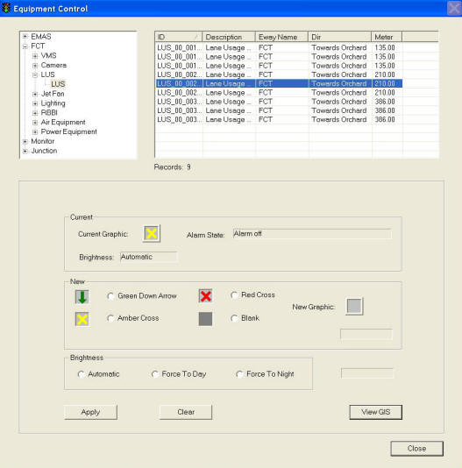

   Click on any equipment to select it. To do multiple selection, press and hold Shift button or Ctrl button on your keyboard and click on the equipment on the list.

The selected equipment will be highlighted in blue background. The current settings for the selected equipment appear in the Current panel.

   In the New panel, click on a new graphic icon.

5.  Click on one of Brightness settings (Automatic, Force To Day or Force To Night)

   Click on Apply button to save the changes.

   Wait for the system to response.

•    If the remote control is successful, the response will show “Ok”.

•   If the system response with a “Time Out” after 30 seconds, you should try again by clicking on Apply button.

|  |
| --- |
| **Note** |
| •     Remote Control is only allowed when the alarm state is off.  •    Once FCT changes the site equipment, the LUS on GIS will show the new graphic. |

###### View GIS

Click on View GIS button.

The GIS changes its view and the equipment is highlighted.

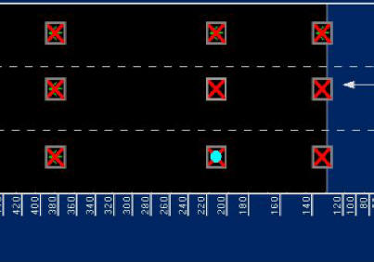

|  |
| --- |
| **Note** |
| You can clear the light blue color highlight with the Clear Selection Description: c:\_temp\iw help\events\equipment control\lus\View G76.jpg tool on GIS toolbar. |

##### Jet Fan

|  |  |  |  |  |  |  |
| --- | --- | --- | --- | --- | --- | --- |
| **User profile** | | | | | **Operation mode** | |
| DO | Operator | FC | ITSC | Supervisor | PCM | FCM |
| ✓ | ✓ \* | ✓ \*\* | ✓ | ✓ | ✓ | ✓ |

\* Only FCT and Zone 1 operators can control

\*\* Only viewing is allowed

For Jet Fan Control  in the tunnel, IW CCM  has the following features:

•    [Control Jet Fan Group](#_Control_Jet_Fan_1)

•    [Control Jet Fan](#_Control_Jet_Fan)

•    [View GIS](#_View_GIS_6)

###### Control Jet Fan

1.   In the equipment list, click on + sign besides Jet Fan.

2.   The list expands to show the Jet fan group and Jet Fan

3.   Click on Jet Fan.

A list of equipment appears on the right with ID, Description, Eway Name, Dir and Kilometer information.

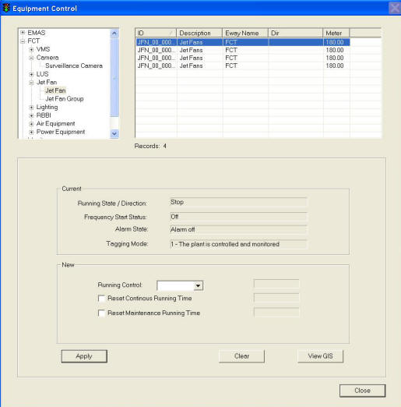

  Click on any equipment to select it. To do multiple selection, press and hold Shift button or Ctrl button on your keyboard and click on the equipment on the list.

The selected equipment will be highlighted in blue background. The current settings for the selected equipment appear in the Current panel.

5.   In the New panel, click on Start/Stop Control dropdown arrow, and click an action.

6.  Click on Reset Continous Running Time to reset the running hours to 0.

7.  Click on Reset Maintenance Running Time to reset the running hours to 0.

8.  Click on Apply button to save the changes.

9.  Wait for the system to response.

•    If the remote control is successful, the response will show “Ok”.

•    If the system response with a “Time Out” after 30 seconds, you should try again by clicking on Apply button.

•    If the system response with “Not Sent”, it simply means that you have not set the new setting.

|  |
| --- |
| **Note** |
| Remote Control is only allowed when the alarm state is off and tagging mode is 1. |

###### Control Jet Fan Group

1.   In the equipment list, click on + sign besides Jet Fan.

2.   The list expands to show the Jet fan group and Jet Fan

3.   Click on Jet Fan Group.

A list of equipment appears on the right with ID, Description, Eway Name, Dir and Kilometer information.

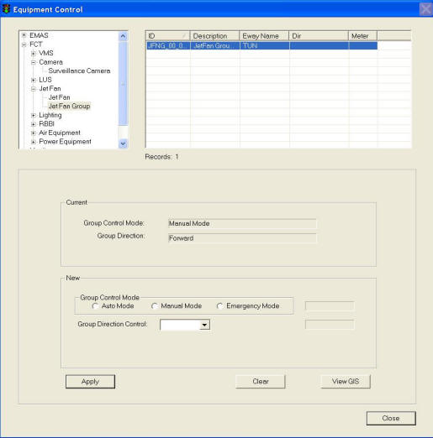

  Click on any equipment to select it.

The selected equipment will be highlighted in blue background. The current settings for the selected equipment appear in the Current panel.

5.   In the New panel, click on Group Control Mode (Auto Mode, Manual Mode and Emergency Mode).

6.  In the New panel, click on drop down arrow to change all jet fans direction (Forward and Reverse).

7.  Click on Apply button to save the changes.

8.  Wait for the system to response.

•    If the remote control is successful, the response will show “Ok”.

•    If the system response with a “Time Out” after 30 seconds, you should try again by clicking on Apply button.

•    If the system response with “Not Sent”, it simply means that you have not set the new setting.

|  |
| --- |
| **Note** |
| Remote Control is only allowed when the alarm state is off and tagging mode is 1. |

###### View GIS

Click on View GIS button.

The GIS changes its view and the equipment is highlighted.

|  |
| --- |
| Description: c:\_temp\iw help\events\equipment control\fct\jet fan\GIS.jpg |

Figure 115 - Highlighted Jet Fan

|  |
| --- |
| **Note** |
| You can clear the light blue color highlight with the Clear Selection Description: c:\_temp\iw help\events\equipment control\PMCS\View G81.jpg tool on GIS toolbar. |

##### Lighting

|  |  |  |  |  |  |  |
| --- | --- | --- | --- | --- | --- | --- |
| **User profile** | | | | | **Operation mode** | |
| DO | Operator | FC | ITSC | Supervisor | PCM | FCM |
| ✓ | ✓ \* | ✓ \*\* | ✓ | ✓ | ✓ | ✓ |

\* Only FCT and Zone 1 operators can control

\*\* Only viewing is allowed

For Lighting Control  in the tunnel, IW CCM  has the following features:

•    [Control Tunnel Lighting](#_Control_Tunnel_Lighting)

•    [Control Beacon Lighting](#_Control_Beacon_Lighting)

•    [View GIS](#_View_GIS_7)

###### Control Beacon Lighting

1.   In the equipment list, click on + sign besides Lighting.

The list expands to show the list of  Lighting equipment.

2.   Click on Beacon Lighting.

A list of equipment appears on the right with ID, Description, Eway Name, Dir and Kilometer information.

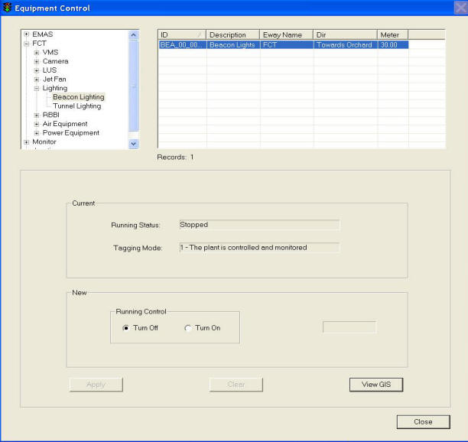

3.  Click on the beacon lighting equipment to select it.

The selected equipment will be highlighted in blue background. The current settings for the selected equipment appear in the Current panel.

4.  In the New panel, click on Turn Off or Turn On to control beacon light running status.

5.  Click on Apply button to save the changes.

6.   Wait for the system to response.

•     If the remote control is successful, the response will show “Ok”.

•     If the system response with a “Time Out” after 30 seconds, you should try again by clicking on Apply button.

•     If the system response with “Not Sent”, it simply means that you have not set the new setting.

|  |
| --- |
| **Note** |
| Remote Control is only allowed when the beacon lighting alarm is off and tagging mode is 1. |

Control Tunnel Lighting

1.   In the equipment list, click on + sign besides Lighting.

The list expands to show the list of  Lighting equipment.

2.   Click on Tunnel Lighting.

A list of equipment appears on the right with ID, Description, Eway Name, Dir and Kilometer information.

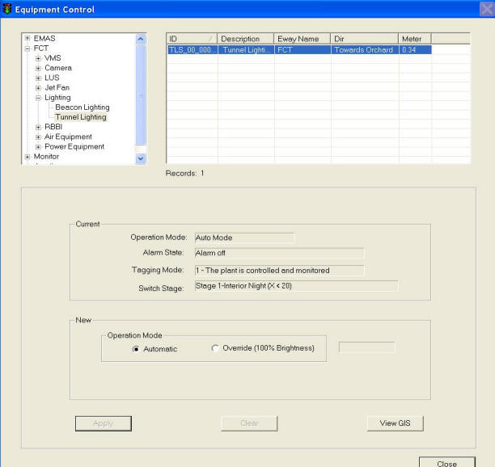

3.  Click on the  tunnel lighting equipment to select it.

The selected equipment will be highlighted in blue background. The current settings for the selected equipment appear in the Current panel.

5.  In the New panel, click on Automatic or Override mode for the Tunnel lighting operation mode control

6.  Click on Apply button to save the changes.

7.   Wait for the system to response.

•     If the remote control is successful, the response will show “Ok”.

•     If the system response with a “Time Out” after 30 seconds, you should try again by clicking on Apply button.

•     If the system response with “Not Sent”, it simply means that you have not set the new setting.

|  |
| --- |
| **Note** |
| Remote Control is only allowed when the tunnel lighting alarm is off and tagging mode is 1. |

###### View GIS

  Click on View GIS button.

The GIS changes its view and the equipment is highlighted.

|  |
| --- |
| Description: c:\_temp\iw help\events\equipment control\fct\lighting\GIS_1.JPG |

Figure 116 - Highlighted Tunnel lighting

|  |
| --- |
| Description: c:\_temp\iw help\events\equipment control\fct\lighting\GIS_2.JPG |

Figure 117 - Highlighted Beacon lighting

|  |
| --- |
| **Note** |
| You can clear the light blue color highlight with the Clear Selection Description: c:\_temp\iw help\events\equipment control\PMCS\Lighting\View G91.jpg tool on GIS toolbar. |

##### RBBI

|  |  |  |  |  |  |  |
| --- | --- | --- | --- | --- | --- | --- |
| **User profile** | | | | | **Operation mode** | |
| DO | Operator | FC | ITSC | Supervisor | PCM | FCM |
| ✓ | ✓ \* | ✓ \*\* | ✓ | ✓ | ✓ | ✓ |

\* Only FCT and Zone 1 operators can control

\*\* Only viewing is allowed

For Lighting Control  in the tunnel, IW CCM  has the following features:

•    [Control RBBI](#_Control_RBBI)

•    [View GIS](#_View_GIS_8)

###### Control RBBI

1.   In the equipment list, click on + sign besides RBBI.

The list expands to show the list of  RBBI equipment.

2.   Click on RBBI.

A list of equipment appears on the right with ID, Description, Eway Name, Dir and Kilometer information.

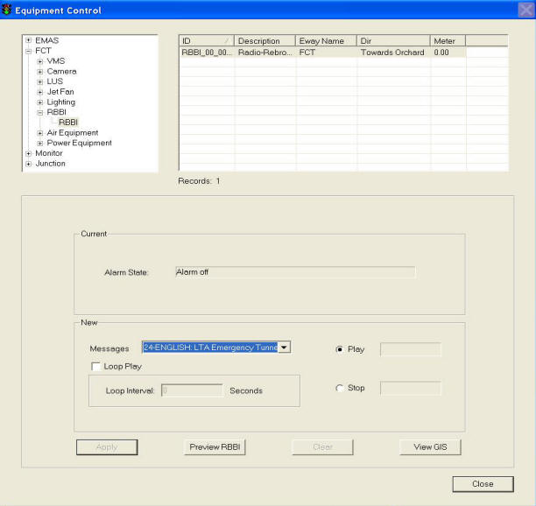

3.  Click on the  RBBI equipment to select it.

The selected equipment will be highlighted in blue background. The current settings for the selected equipment appear in the Current panel.

5.  In the New panel, click on Play or Stop to control RBBI

     If play a RBBI message, choose a message from dropdown list, click on Loop Play and set loop interval.

6.  Click on Apply button to save the changes.

7.   Wait for the system to response.

•     If the remote control is successful, the response will show “Ok”.

•     If the system response with a “Time Out” after 30 seconds, you should try again by clicking on Apply button.

•     If the system response with “Not Sent”, it simply means that you have not set the new setting.

|  |
| --- |
| **Note** |
| Remote Control is only allowed when the RBBI alarm is off and tagging mode is 1. |

###### View GIS

  Click on View GIS button.

The GIS changes its view and the equipment is highlighted.

|  |
| --- |
| Description: c:\_temp\iw help\events\equipment control\fct\rbbi\gis.JPG |
|  |

Figure 118 - Highlighted RBBI

|  |
| --- |
| **Note** |
| You can clear the light blue color highlight with the Clear Selection Description: c:\_temp\iw help\events\equipment control\PMCS\Lighting\View G91.jpg tool on GIS toolbar. |

##### Air Equipment

|  |  |  |  |  |  |  |
| --- | --- | --- | --- | --- | --- | --- |
| **User profile** | | | | | **Operation mode** | |
| DO | Operator | FC | ITSC | Supervisor | PCM | FCM |
| ✓ | ✓ \* | ✓ \*\* | ✓ | ✓ | ✓ | ✓ |

\* Only FCT and Zone 1 operators can control

\*\* Only viewing is allowed

For Air Equipment Control  in the tunnel, IW CCM  has the following features:

•         [Control Air Con](#_Control_Air_Con_1)

•         [Control Fresh Air Fan](#_Control_Fresh_Air)

•         [View GIS](#_View_GIS_9)

###### Control Air Con

    In the equipment list, click on + sign besides Air equipment.

The list expands to show the list of Air equipment.

    Click on Air Con.

A list of equipment appears on the right with ID, Description, Eway Name, Dir and Kilometer information.

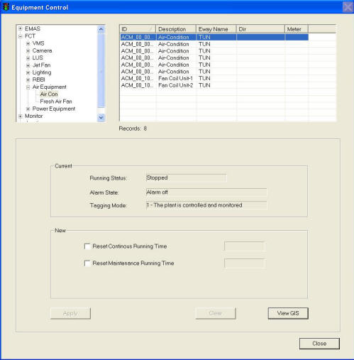

  Click on any equipment to select it. To do multiple selection, press and hold Shift button or Ctrl button on your keyboard and click on the equipment on the list.

The selected equipment will be highlighted in blue background. The current settings for the selected equipment appear in the Current panel.

   In the New panel, click on Reset Continuous Running Hours to reset running hours to 0

  Click on Reset Maintenance Running Hours to reset the running hours to 0.

   Click on Apply button to save the changes.

   Wait for the system to response.

•     If the remote control is successful, the response will show “Ok”.

•     If the system response with a “Time Out” after 30 seconds, you should try again by clicking on Apply button.

•      If the system response with “Not Sent”, it simply means that you have not set the new setting.

|  |
| --- |
| **Note** |
| Remote Control is only allowed when the air con alarm state is off and tagging mode is 1. |

###### Control Fresh Air Fan

    In the equipment list, click on + sign besides Air equipment.

The list expands to show the list of Air equipment.

    Click on Fresh Air Fan.

A list of equipment appears on the right with ID, Description, Eway Name, Dir and Kilometer information.

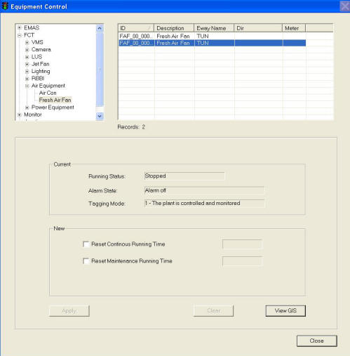

  Click on any equipment to select it. To do multiple selection, press and hold Shift button or Ctrl button on your keyboard and click on the equipment on the list.

The selected equipment will be highlighted in blue background. The current settings for the selected equipment appear in the Current panel.

   In the New panel, click on Reset Continuous Running Hours to reset running hours to 0

  Click on Reset Maintenance Running Hours to reset the running hours to 0.

   Click on Apply button to save the changes.

   Wait for the system to response.

•     If the remote control is successful, the response will show “Ok”.

•     If the system response with a “Time Out” after 30 seconds, you should try again by clicking on Apply button.

•      If the system response with “Not Sent”, it simply means that you have not set the new setting.

|  |
| --- |
| **Note** |
| Remote Control is only allowed when the fresh air fan alarm state is off and tagging mode is 1. |

###### View GIS

|  |  |  |  |  |  |  |
| --- | --- | --- | --- | --- | --- | --- |
| **User profile** | | | | | **Operation mode** | |
| DO | Operator | FC | ITSC | Supervisor | PCM | FCM |
| ✓ | ✓ | ✓ | ✓ | ✓ | ✓ | ✓ |

Click on View GIS button.

The GIS changes its view and the equipment is highlighted. Highlighted Fresh Air Fan

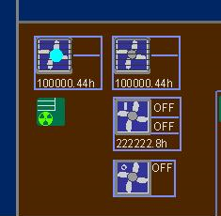

Figure 119 - Highlighted Air Con

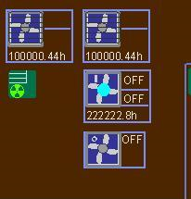

Figure 120 - Highlighted Fresh Air Fan

|  |
| --- |
| **Note** |
| You can clear the light blue color highlight with the Clear Selection Description: c:\_temp\iw help\events\equipment control\PMCS\AirCon\View G84.jpg tool on GIS toolbar. |

##### Power Equipment

|  |  |  |  |  |  |  |
| --- | --- | --- | --- | --- | --- | --- |
| **User profile** | | | | | **Operation mode** | |
| DO | Operator | FC | ITSC | Supervisor | PCM | FCM |
| ✓ | ✓ \* | ✓ \*\* | ✓ | ✓ | ✓ | ✓ |

\* Only FCT and Zone 1 operators can control

\*\* Only viewing is allowed

For Power Equipment Control  in the tunnel, IW CCM  has the following features:

•         [Control Generator](#_Control_Generator)

•         [View GIS](#_View_GIS_10)

###### Control Generator

    In the equipment list, click on + sign besides power equipment.

The list expands to show the list of power equipment.

    Click on Genreator.

A list of equipment appears on the right with ID, Description, Eway Name, Dir and Kilometer information.

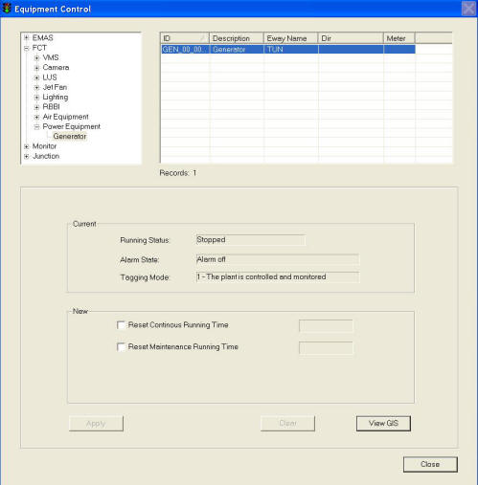

  Click on any equipment to select it.

The selected equipment will be highlighted in blue background. The current settings for the selected equipment appear in the Current panel.

   In the New panel, click on Reset Continuous Running Hours to reset running hours to 0

  Click on Reset Maintenance Running Hours to reset the running hours to 0.

   Click on Apply button to save the changes.

   Wait for the system to response.

•     If the remote control is successful, the response will show “Ok”.

•     If the system response with a “Time Out” after 30 seconds, you should try again by clicking on Apply button.

•      If the system response with “Not Sent”, it simply means that you have not set the new setting.

|  |
| --- |
| **Note** |
| Remote Control is only allowed when the generator alarm state is off and tagging mode is 1. |

###### View GIS

|  |  |  |  |  |  |  |
| --- | --- | --- | --- | --- | --- | --- |
| **User profile** | | | | | **Operation mode** | |
| DO | Operator | FC | ITSC | Supervisor | PCM | FCM |
| ✓ | ✓ | ✓ | ✓ | ✓ | ✓ | ✓ |

Click on View GIS button.

The GIS changes its view and the equipment is highlighted.

|  |
| --- |
| Description: c:\_temp\iw help\events\equipment control\fct\power equipment\gis.JPG |
| Figure 121 - Highlighted Generator |

|  |
| --- |
| **Note** |
| You can clear the light blue color highlight with the Clear Selection Description: c:\_temp\iw help\events\equipment control\PMCS\AirCon\View G84.jpg tool on GIS toolbar. |

#### WVT

##### Variable Message Sign (VMS)

The user profile control the functions the user is authorize to use under Platform Control Mode (PCM) or Fall back Control Mode (FCM). Every user will have one user account that enables the user to login to IW. Every user account belongs to a profile.

|  |  |  |  |  |  |  |
| --- | --- | --- | --- | --- | --- | --- |
| **User profile** | | | | | **Operation mode** | |
| DO | Operator | FC | ITSC | Supervisor | PCM | FCM |
| ✓ | ✓ | ✓ | ✓ | ✓ | ✓ |  |

For each WVT VMS, you may change the following setting:

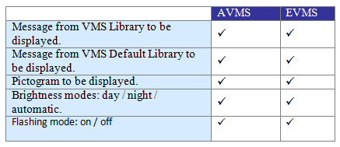

###### Search and Retrieve VMS

   In the equipment list, click on + sign besides VMS.

The list expands to show the list of VMS equipment.

   Click on VMS (WVT EVMS or WVT AVMS).

A list of equipment appears on the right with ID, Description, Eway Name, Dir and Kilometer information.

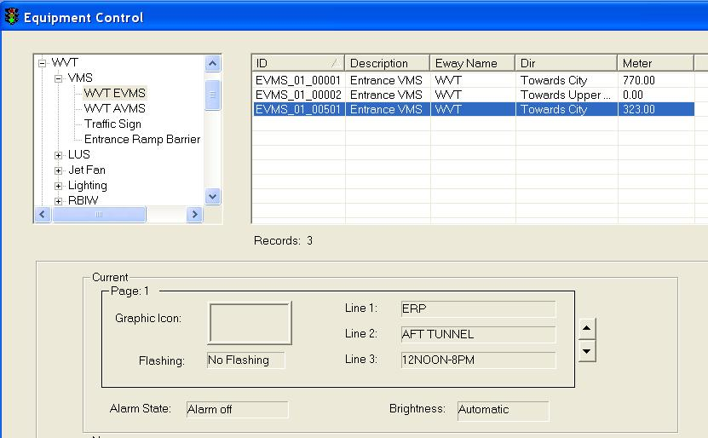

Figure 122 - WVT VMS Equipment Control window

  Click on any equipment to select it. To do multiple selection, press and hold Shift button or Ctrl button on your keyboard and click on the equipment on the list.

The selected equipment will be highlighted in blue background. The current settings for the selected equipment appear in the Current panel.

###### Remote Control WVT EVMS and WVT AVMS

   Choose a new message from the [VMS Library](#_VMS_library) or use [Default message](#_VMS_default_librarys).

   In the Brightness panel, click on a setting.

   Click on Apply button to save the changes.

   Wait for the system to response.

•    If the remote control is successful, the response will show “Ok”.

•    If the system response with a “Time Out” after 30 seconds, you should try again by clicking on Apply button.

•    If the system response with “Not Sent”, it simply means that you have not set the new setting. E.g. you may have chosen a new Graphic Icon but you did not choose a new Brightness. Hence when you click on Apply button, the system immediately replies with “Not Sent” beside the Brightness panel.

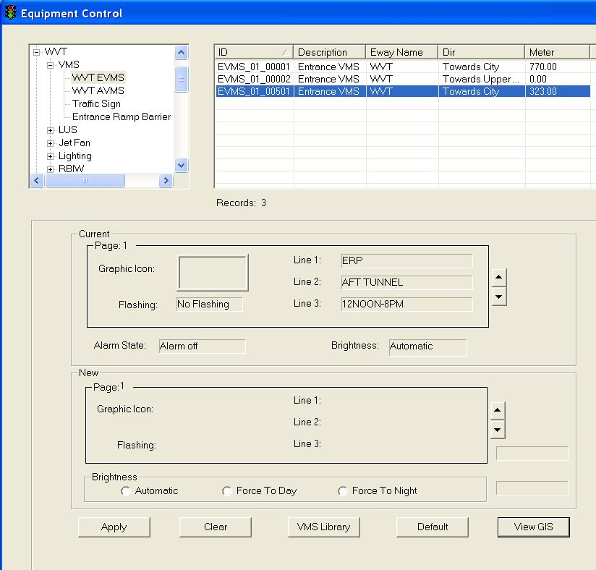

Figure 123 - This picture shows a WVT EVMS control window

###### Remote Control Traffic Sign

1.   In the equipment list, click on + sign besides VMS.

The list expands to show the list of WVT VMS.

2.   Click on Traffic Sign.

A list of equipment appears on the right with ID, Description, Eway Name, Dir and Kilometer information.

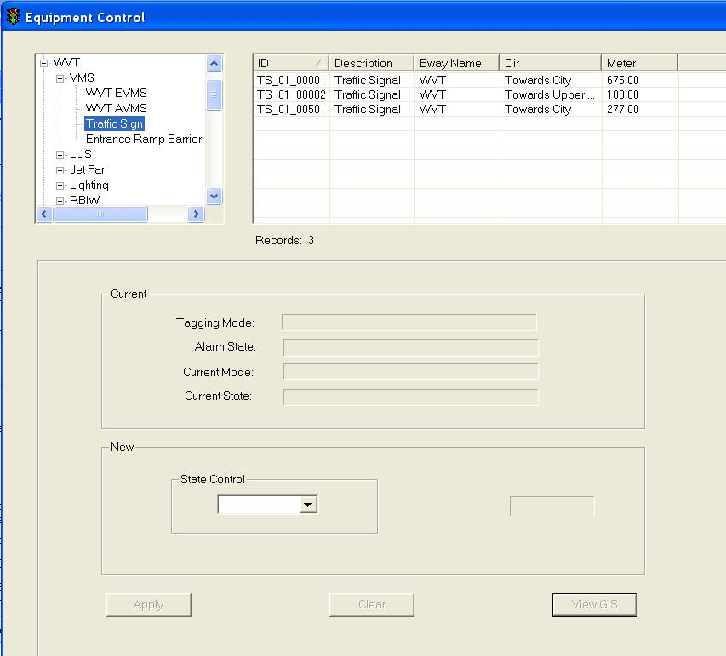

3.  Click on the Traffic Sign equipment to select it.

The selected equipment will be highlighted in blue background. The current settings for the selected equipment appear in the Current panel.

4.  In the New panel, choose a state (BLANK/GREEN/RED/AMBER) from dropdown list.

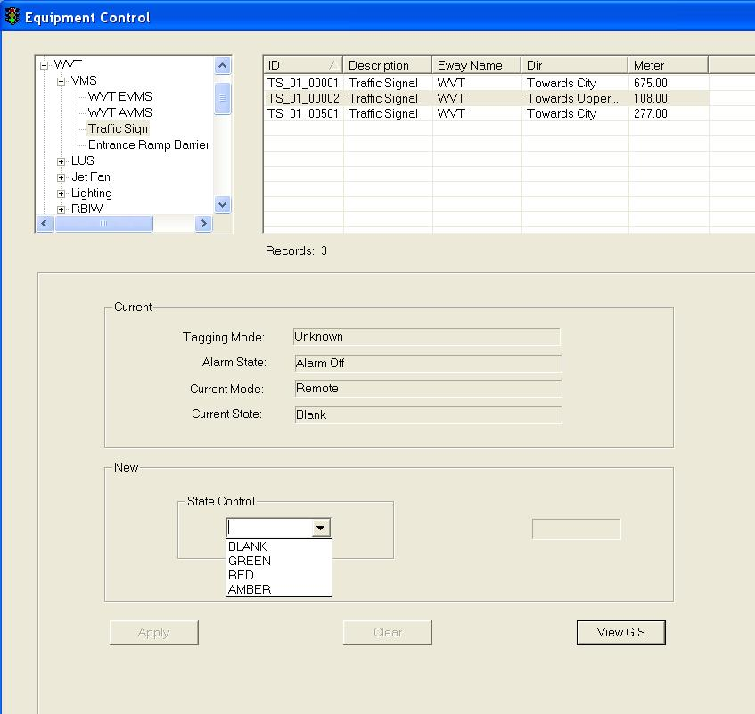

5.  Click on Apply button to save the changes.

6.   Wait for the system to response.

•     If the remote control is successful, the response will show “Ok”.

•     If the system response with a “Time Out” after 30 seconds, you should try again by clicking on Apply button.

•     If the system response with “Not Sent”, it simply means that you have not set the new setting.

###### Remote Control Entrance Ramp Barrier Group

1.   In the equipment list, click on + sign besides VMS.

The list expands to show the list of WVT VMS.

2.   Click on Entrance Ramp Barrier Group.

A list of equipment appears on the right with ID, Description, Eway Name, Dir and Kilometer information.

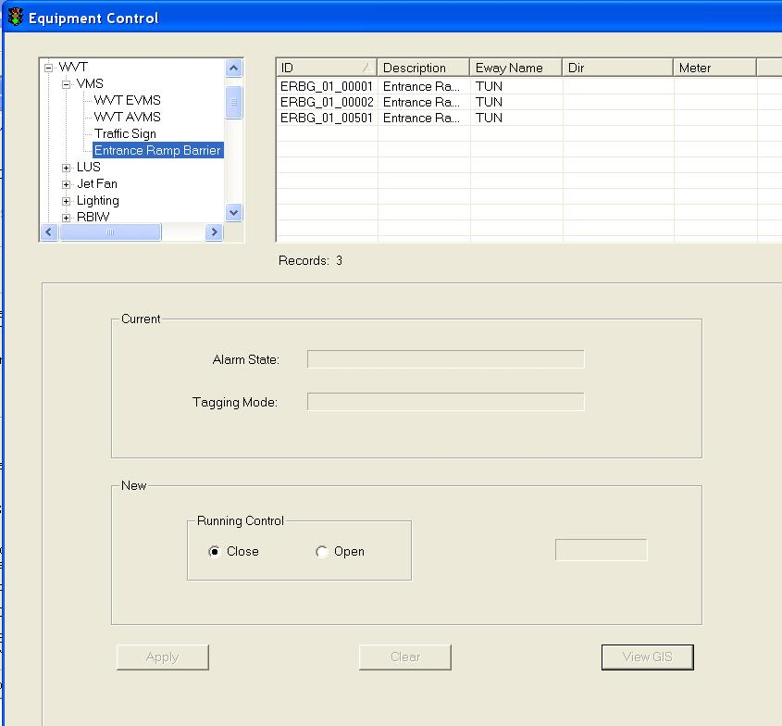

3.  Click on the Entrance Ramp Barrier Group equipment to select it.

The selected equipment will be highlighted in blue background. The current settings for the selected equipment appear in the Current panel.

4.  In the New panel, click on Close or Open to control Entrance Ramp Barrier Group running status

5.  Click on Apply button to save the changes.

6.   Wait for the system to response.

•     If the remote control is successful, the response will show “Ok”.

•     If the system response with a “Time Out” after 30 seconds, you should try again by clicking on Apply button.

•     If the system response with “Not Sent”, it simply means that you have not set the new setting.

###### Choose new message from VMS Library

  Click on VMS Library button.

The VMS Library window appears.

  Click on Expressway dropdown arrow, and click on an expressway name.

  Click on Category dropdown arrow, and click on a category.

A list of messages  for the selected equipment type, expressway and category appears on the right.

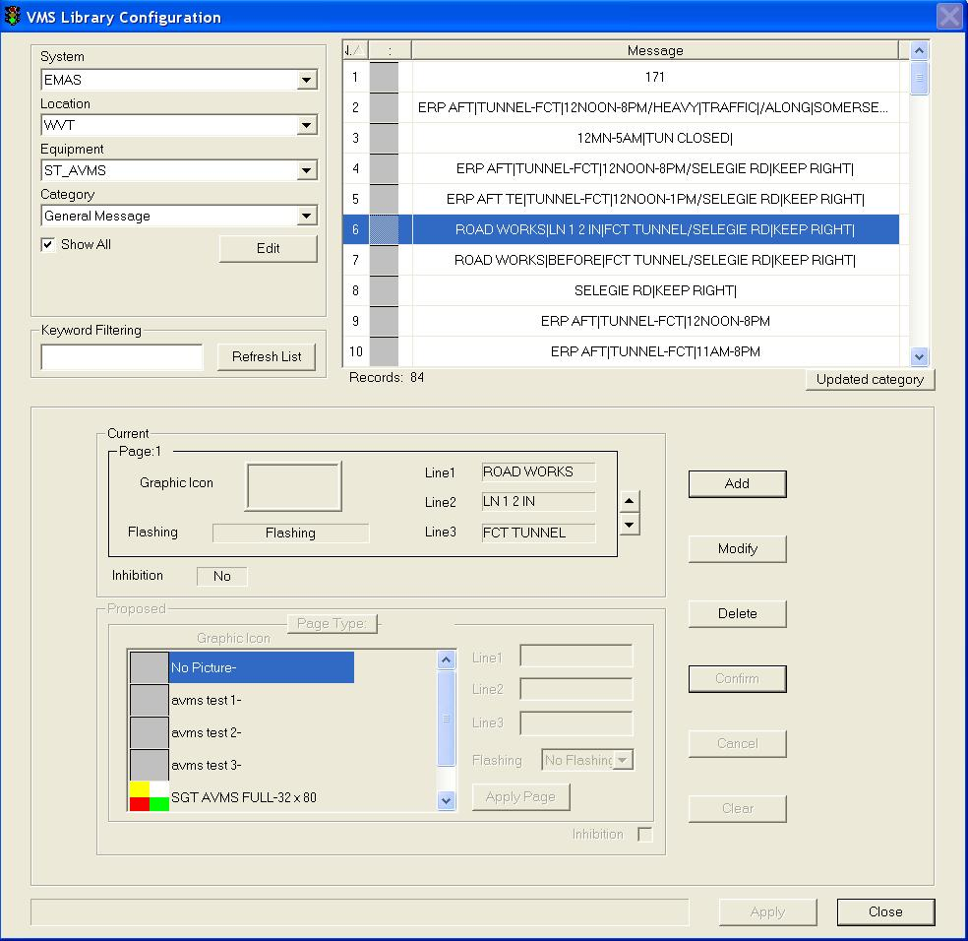

Figure 124 - WVT VMS Library Window

  Click on the desired message to select it.

The selected message will be highlighted in blue background. The current settings for the selected message appear in the Current panel.

  Click on Apply button to use this message as the new message or repeat steps 2 – 5 to choose another message.

The VMS Library window closes and the selected message settings appear in the New panel.

  In the Brightness panel, click on a setting.

  Click on Apply button to activate the new changes to the VMS on site.

 Wait for the system to response:

•    If the remote control is successful, the response will show “Ok”. This means the message is sent successfully to the site equipment.

•    If the system response with a “Time Out” after 30 seconds, you should try again by clicking on Apply button as the site equipment is not responding.

###### Set new message using messages in VMS Default Library

   Click on Default button.

The default message (from VMS Default Library) for the selected equipment appears in the New panel.

   In the Brightness panel, click on a setting.

   Click on Apply button to save the changes.

|  |
| --- |
|  |

Figure 125 - WVT VMS New Message Setting Window

###### View GIS

Click on View GIS button.

The GIS changes its view and the equipment is highlighted.

|  |
| --- |
|  |

Figure 126 - View WVT VMS on GIS

##### LUS

The user profile control the functions the user is authorize to use under Platform Control Mode (PCM) or Fall back Control Mode (FCM). Every user will have one user account that enables the user to login to IW. Every user account belongs to a profile.

|  |  |  |  |  |  |  |
| --- | --- | --- | --- | --- | --- | --- |
| **User profile** | | | | | **Operation mode** | |
| DO | Operator | FC | ITSC | Supervisor | PCM | FCM |
| ✓ | ✓ \* | ✓ \*\* | ✓ | ✓ | ✓ | ✓ |

\* Only WVT and Zone 1 operators can control

\*\* FC can only view

You may change the graphic code – green arrow, amber cross, red cross or blank

###### Select LUS from GIS

1       Click on GIS WVT Tunnel button.

The GIS on the right switch to tunnel diagram.

2     On tunnel diagram, click on the LUS button to enable LUS.

Tunnel view with LUS are enabled.

3      Double click on one LUS icon

The selected LUS will be highlighted and LUS control panel display in the CCM

4      In the New panel, click on a new graphic icon.

5      Click on Apply button to save the changes.

Wait for the system to response.

* If the remote control is successful, the response will show “Ok”.
* If the system response with a “Time Out” after 30 secs, you should try again by clicking on Apply button.

###### Control LUS

    In the equipment list, click on + sign besides LUS.

The list expands to show the list of LUS equipment.

  Click on LUS.

A list of equipment appears on the right with ID, Description, Eway Name, Dir and Kilometer information.

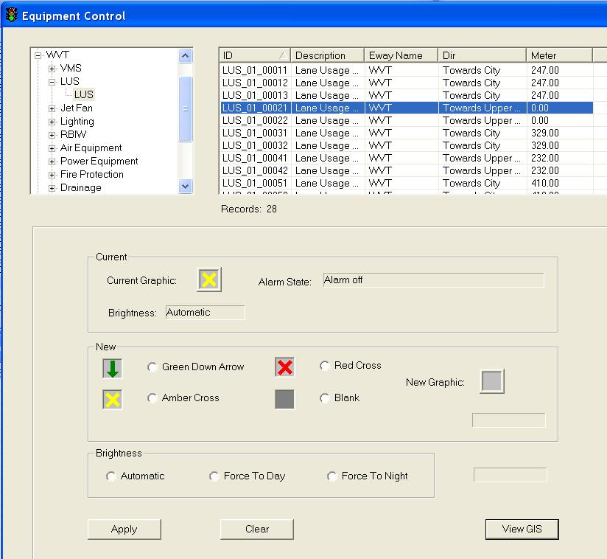

   Click on any equipment to select it. To do multiple selection, press and hold Shift button or Ctrl button on your keyboard and click on the equipment on the list.

The selected equipment will be highlighted in blue background. The current settings for the selected equipment appear in the Current panel.

   In the New panel, click on a new graphic icon.

5.  Click on one of Brightness settings (Automatic, Force To Day or Force To Night)

   Click on Apply button to save the changes.

   Wait for the system to response.

•    If the remote control is successful, the response will show “Ok”.

•   If the system response with a “Time Out” after 30 seconds, you should try again by clicking on Apply button.

|  |
| --- |
| **Note** |
| •     Remote Control is only allowed when the alarm state is off.  •    Once WVT changes the site equipment, the LUS on GIS will show the new graphic. |

###### View GIS

Click on View GIS button.

The GIS changes its view and the equipment is highlighted.

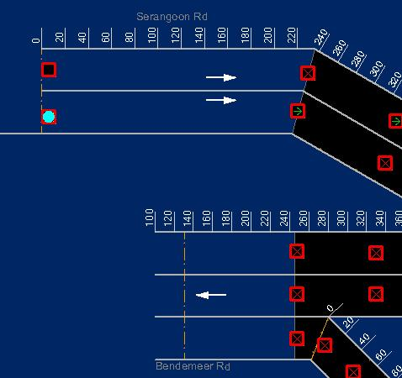

Figure 127 - View WVT LUS on GIS

|  |
| --- |
| **Note** |
| You can clear the light blue color highlight with the Clear Selection Description: c:\_temp\iw help\events\equipment control\lus\View G76.jpg tool on GIS toolbar. |

##### Jet Fan

|  |  |  |  |  |  |  |
| --- | --- | --- | --- | --- | --- | --- |
| **User profile** | | | | | **Operation mode** | |
| DO | Operator | FC | ITSC | Supervisor | PCM | FCM |
| ✓ | ✓ \* | ✓ \*\* | ✓ | ✓ | ✓ | ✓ |

\* Only WVT and Zone 1 operators can control

\*\* Only viewing is allowed

For Jet Fan Control in the tunnel, IW CCM  has the following features:

•    Control Jet Fan Group

•    Control Jet Fan

•    Control Logic Sequential Controller

•    View GIS

###### Control Jet Fan

1.   In the equipment list, click on + sign besides Jet Fan.

2.   The list expands to show the Jet fan group, Jet Fan and Logic Sequential Controller

3.   Click on Jet Fan.

A list of equipment appears on the right with ID, Description, Eway Name, Dir and Kilometer information.

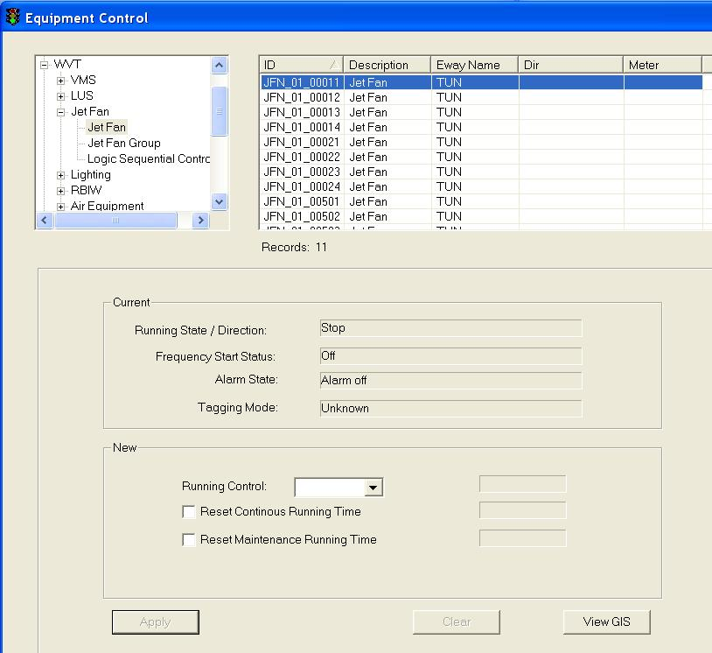

  Click on any equipment to select it. To do multiple selection, press and hold Shift button or Ctrl button on your keyboard and click on the equipment on the list.

The selected equipment will be highlighted in blue background. The current settings for the selected equipment appear in the Current panel.

5.   In the New panel, click on Start/Stop Control dropdown arrow, and click an action.

6.  Click on Reset Continous Running Time to reset the running hours to 0.

7.  Click on Reset Maintenance Running Time to reset the running hours to 0.

8.  Click on Apply button to save the changes.

9.  Wait for the system to response.

•    If the remote control is successful, the response will show “Ok”.

•    If the system response with a “Time Out” after 30 seconds, you should try again by clicking on Apply button.

•    If the system response with “Not Sent”, it simply means that you have not set the new setting.

|  |
| --- |
| **Note** |
| Remote Control is only allowed when the alarm state is off and tagging mode is 1. |

###### Control Jet Fan Group

1.   In the equipment list, click on + sign besides Jet Fan.

2.   The list expands to show the Jet fan group, Jet Fan and Logic Sequential Controller

3.   Click on Jet Fan Group.

A list of equipment appears on the right with ID, Description, Eway Name, Dir and Kilometer information.

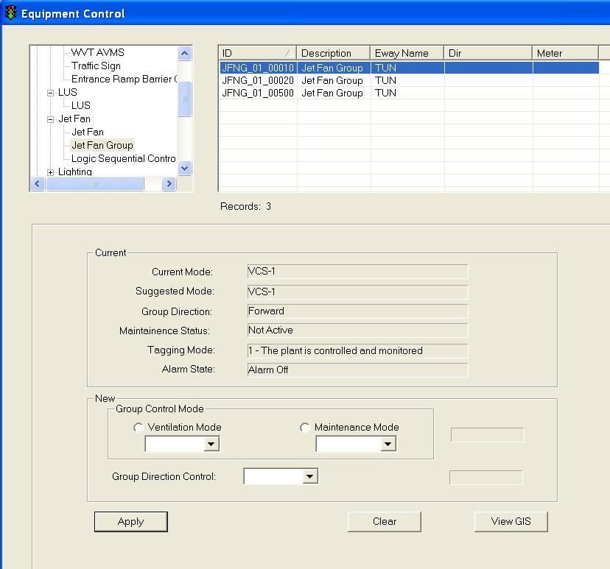

  Click on any equipment to select it.

The selected equipment will be highlighted in blue background. The current settings for the selected equipment appear in the Current panel.

5.   In the New panel, click on Group Control Mode to select either Ventilation Mode or Maintenance Mode. Then, choose one mode in the dropdown list.

6.  In the New panel, click on drop down arrow to change all jet fans direction (Forward and Reverse).

7.  Click on Apply button to save the changes.

8.  Wait for the system to response.

•    If the remote control is successful, the response will show “Ok”.

•    If the system response with a “Time Out” after 30 seconds, you should try again by clicking on Apply button.

•    If the system response with “Not Sent”, it simply means that you have not set the new setting.

|  |
| --- |
| **Note** |
| Remote Control is only allowed when the alarm state is off and tagging mode is 1. |

###### Control Logic Sequential Controller

1.   In the equipment list, click on + sign besides Jet Fan.

2.   The list expands to show the Jet fan group, Jet Fan and Logic Sequential Controller

3.   Click on Jet Fan Group.

A list of equipment appears on the right with ID, Description, Eway Name, Dir and Kilometer information.

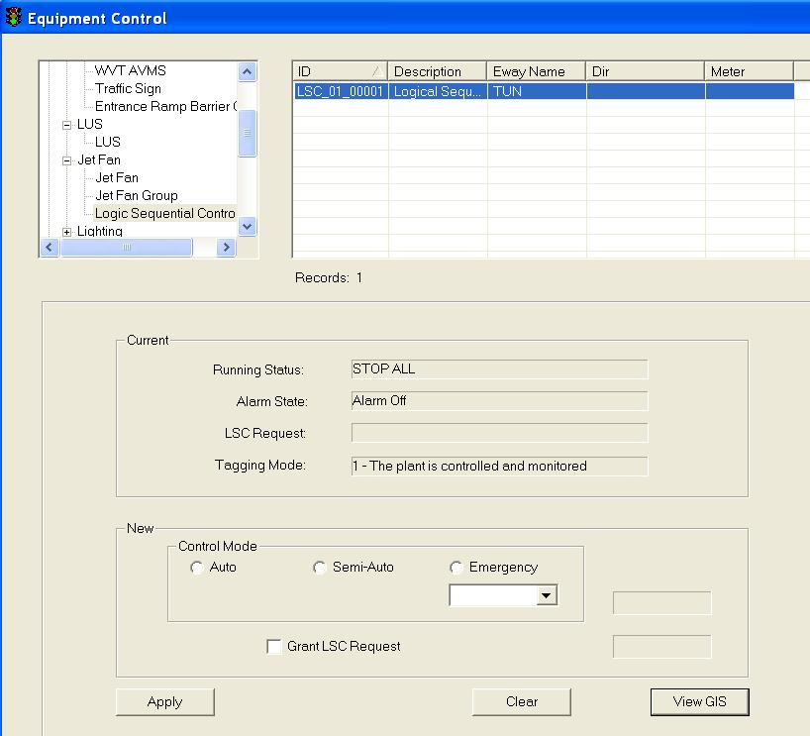

  Click on any equipment to select it.

The selected equipment will be highlighted in blue background. The current settings for the selected equipment appear in the Current panel.

5.   In the New panel, click on Group Control Mode to select one of these three modes (Auto, Semi-Auto or Emergency). If Emergency mode is selected, choose one emergency mode in the dropdown list.

6.  In the New panel, click on Grant LSC Request to grant LSC request.

7.  Click on Apply button to save the changes.

8.  Wait for the system to response.

•    If the remote control is successful, the response will show “Ok”.

•    If the system response with a “Time Out” after 30 seconds, you should try again by clicking on Apply button.

•    If the system response with “Not Sent”, it simply means that you have not set the new setting.

###### View GIS

Click on View GIS button.

The GIS changes its view and the equipment is highlighted.

|  |
| --- |
|  |

Figure 128 - Highlighted WVT Jet Fan

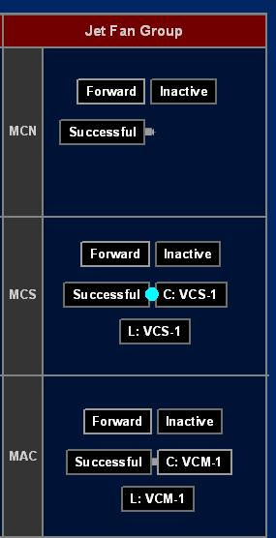

Figure 129 - Highlighted WVT Jet Fan Group

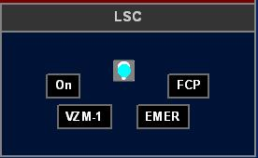

Figure 130 - Highlighted WVT LSC

##### Lighting

|  |  |  |  |  |  |  |
| --- | --- | --- | --- | --- | --- | --- |
| **User profile** | | | | | **Operation mode** | |
| DO | Operator | FC | ITSC | Supervisor | PCM | FCM |
| ✓ | ✓ \* | ✓ \*\* | ✓ | ✓ | ✓ | ✓ |

\* Only WVT and Zone 1 operators can control

\*\* Only viewing is allowed

For Lighting Control in the tunnel, IW CCM  has the following features:

•    Control Tunnel Lighting

•    Control Beacon Lighting

•    View GIS

###### Control Beacon Lighting

1.   In the equipment list, click on + sign besides Lighting.

The list expands to show the list of Lighting equipment.

2.   Click on Beacon Lighting.

A list of equipment appears on the right with ID, Description, Eway Name, Dir and Kilometer information.

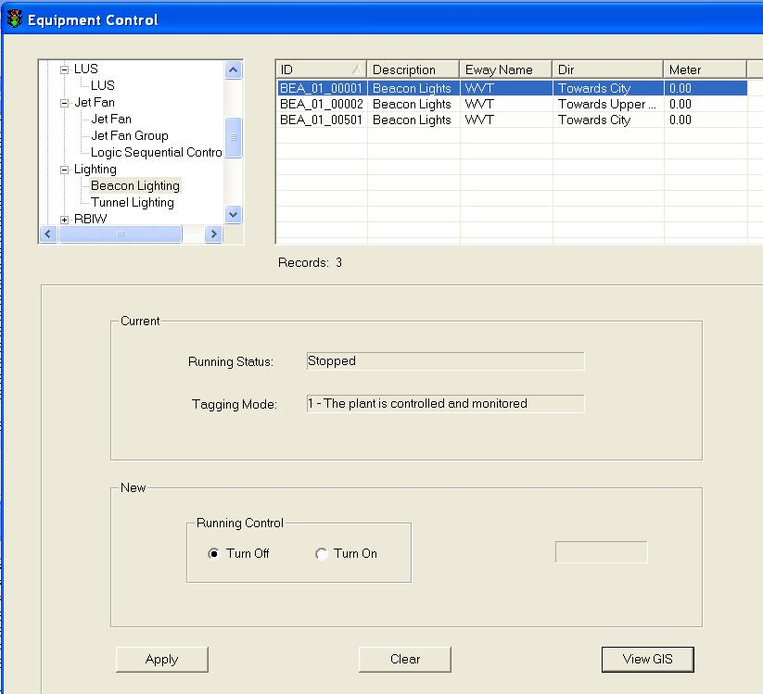

3.  Click on the  beacon lighting equipment to select it.

The selected equipment will be highlighted in blue background. The current settings for the selected equipment appear in the Current panel.

4.  In the New panel, click on Turn Off or Turn On to control beacon light running status

5.  Click on Apply button to save the changes.

6.   Wait for the system to response.

•     If the remote control is successful, the response will show “Ok”.

•     If the system response with a “Time Out” after 30 seconds, you should try again by clicking on Apply button.

•     If the system response with “Not Sent”, it simply means that you have not set the new setting.

|  |
| --- |
| **Note** |
| Remote Control is only allowed when the beacon lighting alarm is off and tagging mode is 1. |

###### Control Tunnel Lighting

1.   In the equipment list, click on + sign besides Lighting.

The list expands to show the list of Lighting equipment.

2.   Click on Tunnel Lighting.

A list of equipment appears on the right with ID, Description, Eway Name, Dir and Kilometer information.

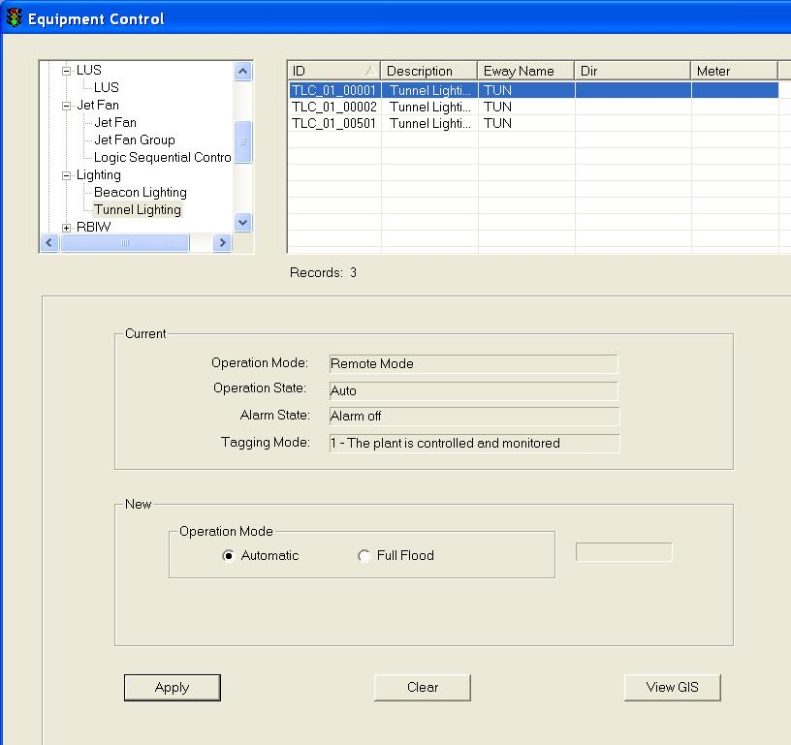

3.  Click on the tunnel lighting equipment to select it.

The selected equipment will be highlighted in blue background. The current settings for the selected equipment appear in the Current panel.

4.  In the New panel, click on Automatic or Full Flood for the Tunnel lighting operation mode control

5.  Click on Apply button to save the changes.

6.   Wait for the system to response.

•     If the remote control is successful, the response will show “Ok”.

•     If the system response with a “Time Out” after 30 seconds, you should try again by clicking on Apply button.

•     If the system response with “Not Sent”, it simply means that you have not set the new setting.

|  |
| --- |
| **Note** |
| Remote Control is only allowed when the tunnel lighting alarm is off and tagging mode is 1. |

###### View GIS

  Click on View GIS button.

The GIS changes its view and the equipment is highlighted.

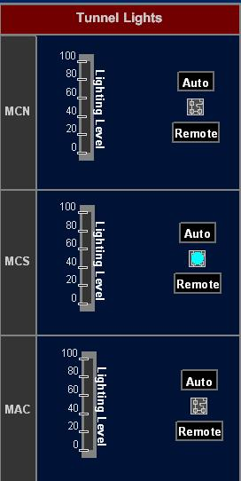

Figure 131 - Highlighted WVT Tunnel lighting

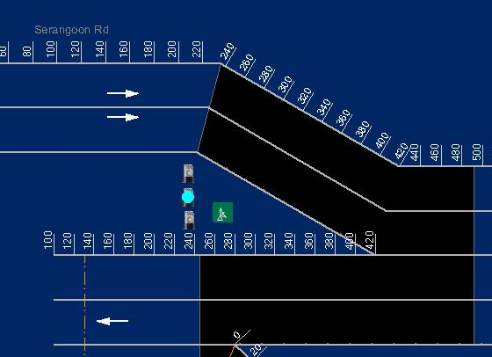

Figure 132 - Highlighted WVT Beacon lighting

##### RBIW

|  |  |  |  |  |  |  |
| --- | --- | --- | --- | --- | --- | --- |
| **User profile** | | | | | **Operation mode** | |
| DO | Operator | FC | ITSC | Supervisor | PCM | FCM |
| ✓ | ✓ \* | ✓ \*\* | ✓ | ✓ | ✓ | ✓ |

\* Only WVT and Zone 1 operators can control

\*\* Only viewing is allowed

For Lighting Control in the tunnel, IW CCM has the following features:

•    Control RBIW

•    View GIS

###### Control RBIW

1.   In the equipment list, click on + sign besides RBIW.

The list expands to show the list of RBIW equipment.

2.   Click on RBIW.

A list of equipment appears on the right with ID, Description, Eway Name, Dir and Kilometer information.

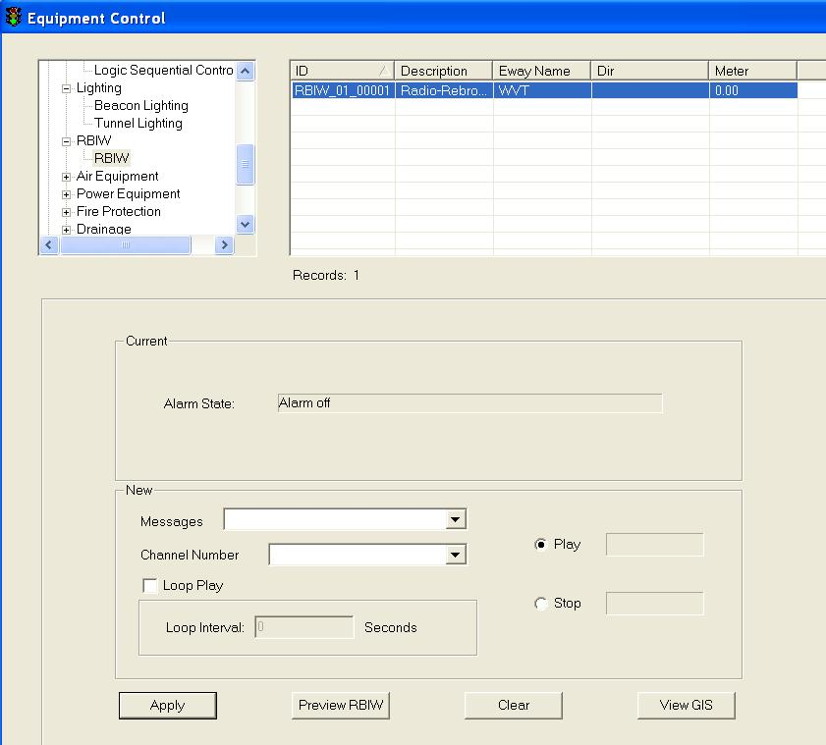

3.  Click on the RBIW equipment to select it.

The selected equipment will be highlighted in blue background. The current settings for the selected equipment appear in the Current panel.

4.  In the New panel, click on Play or Stop to control RBIW

     If play a RBIW message, choose a message from dropdown list of Message and choose a channel from dropdown list of Channel Number, click on Loop Play for playing loop.

5.  Click on Apply button to save the changes.

6.   Wait for the system to response.

•     If the remote control is successful, the response will show “Ok”.

•     If the system response with a “Time Out” after 30 seconds, you should try again by clicking on Apply button.

•     If the system response with “Not Sent”, it simply means that you have not set the new setting.

|  |
| --- |
| **Note** |
| Remote Control is only allowed when the RBBI alarm is off and tagging mode is 1. |

###### View GIS

  Click on View GIS button.

The GIS changes its view and the equipment is highlighted.

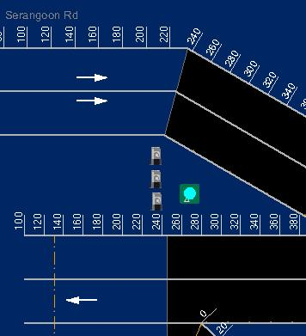

Figure 133 - Highlighted WVT RBIW

##### Air Equipment

|  |  |  |  |  |  |  |
| --- | --- | --- | --- | --- | --- | --- |
| **User profile** | | | | | **Operation mode** | |
| DO | Operator | FC | ITSC | Supervisor | PCM | FCM |
| ✓ | ✓ \* | ✓ \*\* | ✓ | ✓ | ✓ | ✓ |

\* Only WVT and Zone 1 operators can control

\*\* Only viewing is allowed

For Air Equipment Control in the tunnel, IW CCM has the following features:

•         Control Air Con

•         Control Fresh Air Fan

•         Control Mechanical Fan

•         View GIS

###### Control Air Con

    In the equipment list, click on + sign besides Air equipment.

The list expands to show the list of Air equipment.

    Click on Air Con.

A list of equipment appears on the right with ID, Description, Eway Name, Dir and Kilometer information.

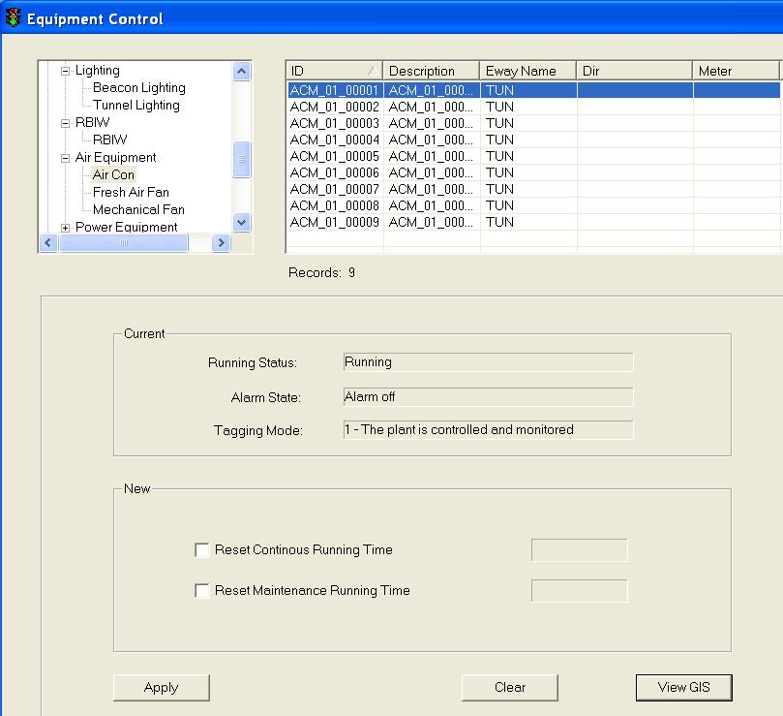

  Click on any equipment to select it. To do multiple selection, press and hold Shift button or Ctrl button on your keyboard and click on the equipment on the list.

The selected equipment will be highlighted in blue background. The current settings for the selected equipment appear in the Current panel.

   In the New panel, click on Reset Continuous Running Hours to reset running hours to 0

  Click on Reset Maintenance Running Hours to reset the running hours to 0.

   Click on Apply button to save the changes.

   Wait for the system to response.

•     If the remote control is successful, the response will show “Ok”.

•     If the system response with a “Time Out” after 30 seconds, you should try again by clicking on Apply button.

•      If the system response with “Not Sent”, it simply means that you have not set the new setting.

|  |
| --- |
| **Note** |
| Remote Control is only allowed when the air con alarm state is off and tagging mode is 1. |

###### Control Fresh Air Fan

    In the equipment list, click on + sign besides Air equipment.

The list expands to show the list of Air equipment.

    Click on Fresh Air Fan.

A list of equipment appears on the right with ID, Description, Eway Name, Dir and Kilometer information.

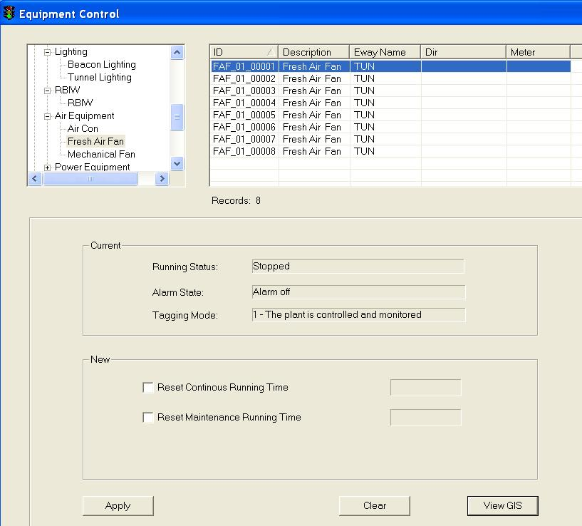

  Click on any equipment to select it. To do multiple selection, press and hold Shift button or Ctrl button on your keyboard and click on the equipment on the list.

The selected equipment will be highlighted in blue background. The current settings for the selected equipment appear in the Current panel.

   In the New panel, click on Reset Continuous Running Hours to reset running hours to 0

  Click on Reset Maintenance Running Hours to reset the running hours to 0.

   Click on Apply button to save the changes.

   Wait for the system to response.

•     If the remote control is successful, the response will show “Ok”.

•     If the system response with a “Time Out” after 30 seconds, you should try again by clicking on Apply button.

•      If the system response with “Not Sent”, it simply means that you have not set the new setting.

|  |
| --- |
| **Note** |
| Remote Control is only allowed when the fresh air fan alarm state is off and tagging mode is 1. |

###### Control Mechanical Fan

    In the equipment list, click on + sign besides Air equipment.

The list expands to show the list of Air equipment.

    Click on Mechanical Fan.

A list of equipment appears on the right with ID, Description, Eway Name, Dir and Kilometer information.

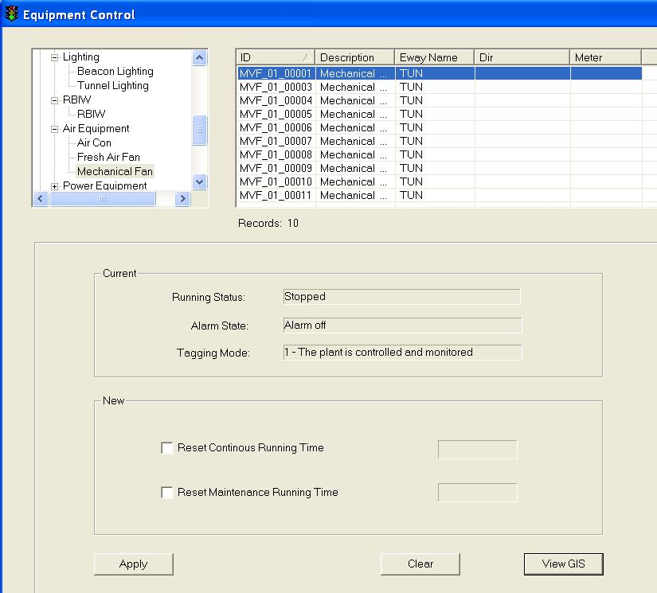

  Click on any equipment to select it. To do multiple selection, press and hold Shift button or Ctrl button on your keyboard and click on the equipment on the list.

The selected equipment will be highlighted in blue background. The current settings for the selected equipment appear in the Current panel.

   In the New panel, click on Reset Continuous Running Hours to reset running hours to 0

  In the New panel, click on Reset Maintenance Running Hours to reset the running hours to 0.

   Click on Apply button to save the changes.

   Wait for the system to response.

•     If the remote control is successful, the response will show “Ok”.

•     If the system response with a “Time Out” after 30 seconds, you should try again by clicking on Apply button.

•      If the system response with “Not Sent”, it simply means that you have not set the new setting.

|  |
| --- |
| **Note** |
| Remote Control is only allowed when the fresh air fan alarm state is off and tagging mode is 1. |

###### View GIS

Click on View GIS button.

The GIS changes its view and the equipment is highlighted.

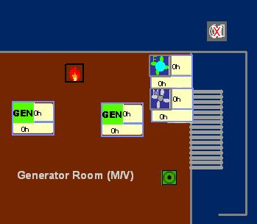

Figure 134 – Highlighted WVT Fresh Air Fan

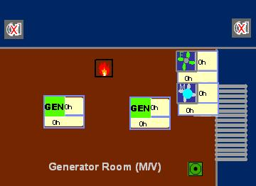

Figure 135 – Highlighted WVT Mechanical Fan

|  |
| --- |
| **Note** |
| You can clear the light blue color highlight with the Clear Selection Description: c:\_temp\iw help\events\equipment control\PMCS\AirCon\View G84.jpg tool on GIS toolbar. |

##### Power Equipment

|  |  |  |  |  |  |  |
| --- | --- | --- | --- | --- | --- | --- |
| **User profile** | | | | | **Operation mode** | |
| DO | Operator | FC | ITSC | Supervisor | PCM | FCM |
| ✓ | ✓ \* | ✓ \*\* | ✓ | ✓ | ✓ | ✓ |

\* Only WVT and Zone 1 operators can control

\*\* Only viewing is allowed

For Power Equipment Control in the tunnel, IW CCM  has the following features:

•         Control Generator

•         Control Fuel Oil Pump

•         View GIS

###### Control Generator

    In the equipment list, click on + sign besides power equipment.

The list expands to show the list of power equipment.

    Click on Genreator.

A list of equipment appears on the right with ID, Description, Eway Name, Dir and Kilometer information.

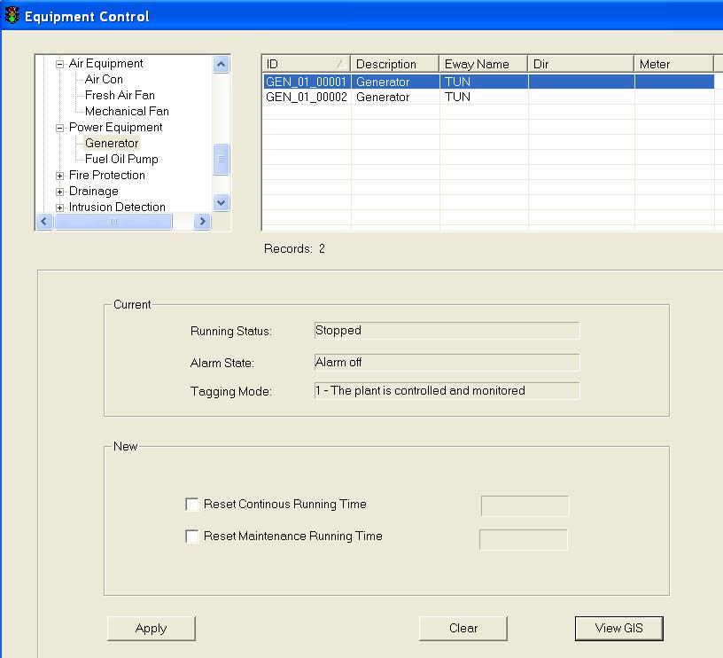

  Click on any equipment to select it.

The selected equipment will be highlighted in blue background. The current settings for the selected equipment appear in the Current panel.

   In the New panel, click on Reset Continuous Running Hours to reset running hours to 0

  Click on Reset Maintenance Running Hours to reset the running hours to 0.

   Click on Apply button to save the changes.

   Wait for the system to response.

•     If the remote control is successful, the response will show “Ok”.

•     If the system response with a “Time Out” after 30 seconds, you should try again by clicking on Apply button.

•      If the system response with “Not Sent”, it simply means that you have not set the new setting.

|  |
| --- |
| **Note** |
| Remote Control is only allowed when the generator alarm state is off and tagging mode is 1. |

###### Control Fuel Oil Pump

    In the equipment list, click on + sign besides power equipment.

The list expands to show the list of power equipment.

    Click on Fuel Oil Pump.

A list of equipment appears on the right with ID, Description, Eway Name, Dir and Kilometer information.

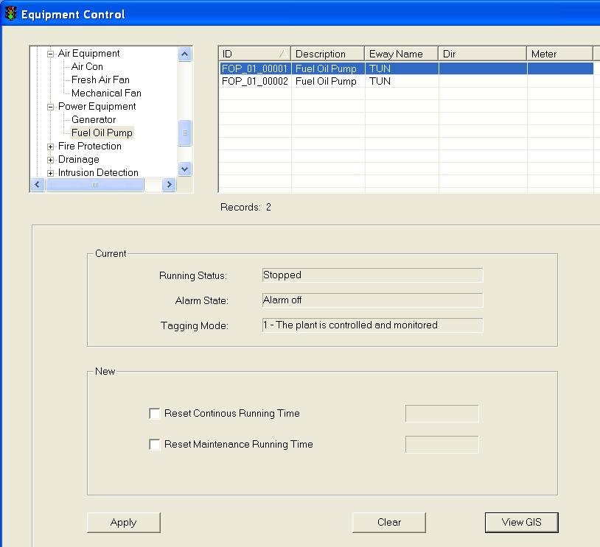

  Click on any equipment to select it.

The selected equipment will be highlighted in blue background. The current settings for the selected equipment appear in the Current panel.

   In the New panel, click on Reset Continuous Running Hours to reset running hours to 0

  Click on Reset Maintenance Running Hours to reset the running hours to 0.

   Click on Apply button to save the changes.

   Wait for the system to response.

•     If the remote control is successful, the response will show “Ok”.

•     If the system response with a “Time Out” after 30 seconds, you should try again by clicking on Apply button.

•      If the system response with “Not Sent”, it simply means that you have not set the new setting.

|  |
| --- |
| **Note** |
| Remote Control is only allowed when the generator alarm state is off and tagging mode is 1. |

###### View GIS

|  |  |  |  |  |  |  |
| --- | --- | --- | --- | --- | --- | --- |
| **User profile** | | | | | **Operation mode** | |
| DO | Operator | FC | ITSC | Supervisor | PCM | FCM |
| ✓ | ✓ | ✓ | ✓ | ✓ | ✓ | ✓ |

Click on View GIS button.

The GIS changes its view and the equipment is highlighted.

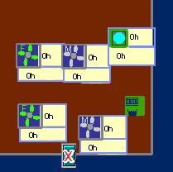

Figure 136 – Highlighted WVT Fuel Oil Pump

|  |
| --- |
| **Note** |
| You can clear the light blue color highlight with the Clear Selection Description: c:\_temp\iw help\events\equipment control\PMCS\AirCon\View G84.jpg tool on GIS toolbar. |

##### Fire Protection

|  |  |  |  |  |  |  |
| --- | --- | --- | --- | --- | --- | --- |
| **User profile** | | | | | **Operation mode** | |
| DO | Operator | FC | ITSC | Supervisor | PCM | FCM |
| ✓ | ✓ \* | ✓ \*\* | ✓ | ✓ | ✓ | ✓ |

\* Only WVT and Zone 1 operators can control

\*\* Only viewing is allowed

For Lighting Control in the tunnel, IW CCM has the following features:

•    Control Deluge Valve

•    Control Deluge Countdown Timer

•    Control Opening Parameter

•    View GIS

###### Control Deluge Valve

    In the equipment list, click on + sign besides power equipment.

The list expands to show the list of Fire Protection equipment.

    Click on Deluge Valve.

A list of equipment appears on the right with ID, Description, Eway Name, Dir and Kilometer information.

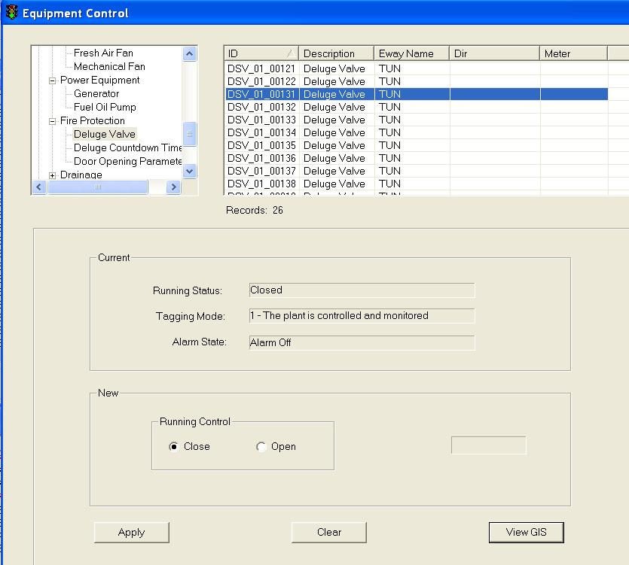

  Click on any equipment to select it.

The selected equipment will be highlighted in blue background. The current settings for the selected equipment appear in the Current panel.

   In the New panel, click on Close or Open to control deluge valve running status.

   Click on Apply button to save the changes.

   Wait for the system to response.

•     If the remote control is successful, the response will show “Ok”.

•     If the system response with a “Time Out” after 30 seconds, you should try again by clicking on Apply button.

•      If the system response with “Not Sent”, it simply means that you have not set the new setting.

|  |
| --- |
| **Note** |
| Remote Control is only allowed when the generator alarm state is off and tagging mode is 1. |

###### Control Deluge Countdown Timer

    In the equipment list, click on + sign besides power equipment.

The list expands to show the list of Fire Protection equipment.

    Click on Deluge Countdown Timer.

A list of equipment appears on the right with ID, Description, Eway Name, Dir and Kilometer information.

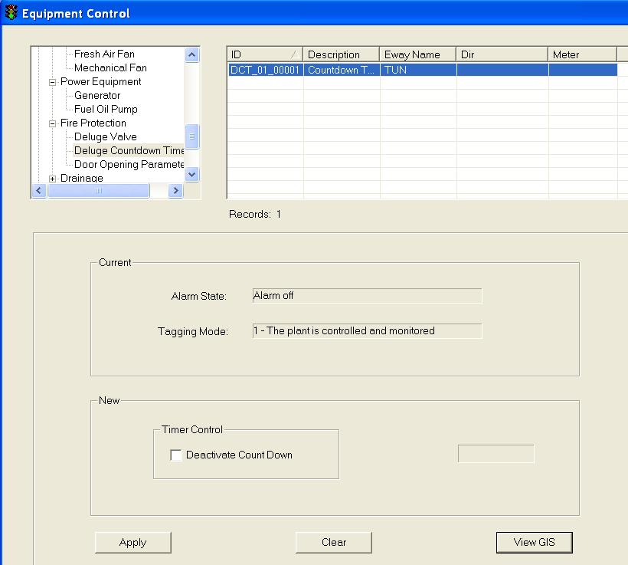

  Click on any equipment to select it.

The selected equipment will be highlighted in blue background. The current settings for the selected equipment appear in the Current panel.

   In the New panel, click on Deactivate CountDown to deactivate the device.

   Click on Apply button to save the changes.

   Wait for the system to response.

•     If the remote control is successful, the response will show “Ok”.

•     If the system response with a “Time Out” after 30 seconds, you should try again by clicking on Apply button.

•      If the system response with “Not Sent”, it simply means that you have not set the new setting.

|  |
| --- |
| **Note** |
| Remote Control is only allowed when the generator alarm state is off and tagging mode is 1. |

###### Control Door Opening Parameter

    In the equipment list, click on + sign besides power equipment.

The list expands to show the list of Fire Protection equipment.

    Click on Door Opening Parameter.

A list of equipment appears on the right with ID, Description, Eway Name, Dir and Kilometer information.

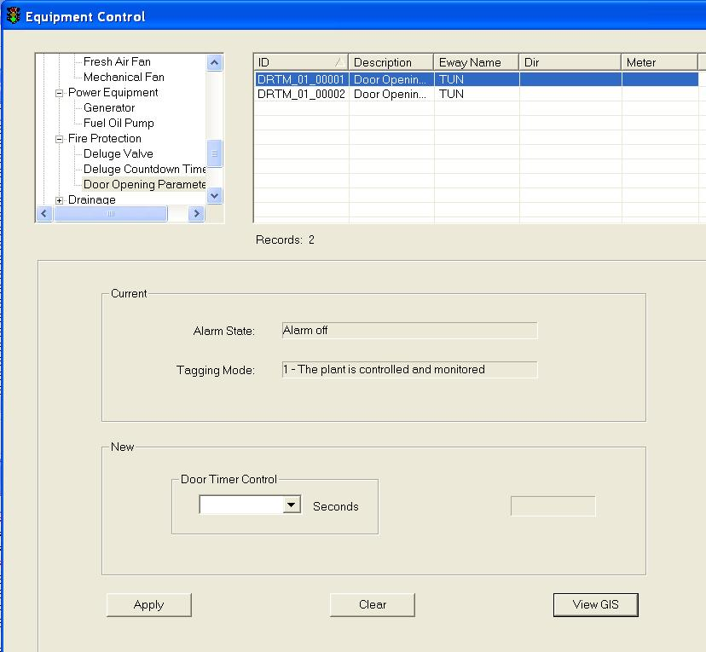

  Click on any equipment to select it.

The selected equipment will be highlighted in blue background. The current settings for the selected equipment appear in the Current panel.

   In the New panel, choose an option (0/30/60/90/120) from the dropdown list of Door Timer Control.

   Click on Apply button to save the changes.

   Wait for the system to response.

•     If the remote control is successful, the response will show “Ok”.

•     If the system response with a “Time Out” after 30 seconds, you should try again by clicking on Apply button.

•      If the system response with “Not Sent”, it simply means that you have not set the new setting.

|  |
| --- |
| **Note** |
| Remote Control is only allowed when the generator alarm state is off and tagging mode is 1. |

###### View GIS

|  |  |  |  |  |  |  |
| --- | --- | --- | --- | --- | --- | --- |
| **User profile** | | | | | **Operation mode** | |
| DO | Operator | FC | ITSC | Supervisor | PCM | FCM |
| ✓ | ✓ | ✓ | ✓ | ✓ | ✓ | ✓ |

Click on View GIS button.

The GIS changes its view and the equipment is highlighted.

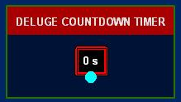

Figure 137 - Highlighted WVT Deluge Valve

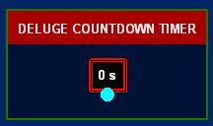

Figure 138 - Highlighted WVT Deluge Countdown Timer

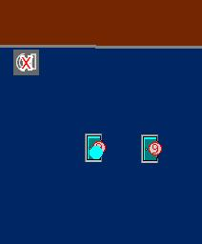

Figure 139 - Highlighted WVT Door Opening Parameter

|  |
| --- |
| **Note** |
| You can clear the light blue color highlight with the Clear Selection Description: c:\_temp\iw help\events\equipment control\PMCS\AirCon\View G84.jpg tool on GIS toolbar. |

##### Drainage

|  |  |  |  |  |  |  |
| --- | --- | --- | --- | --- | --- | --- |
| **User profile** | | | | | **Operation mode** | |
| DO | Operator | FC | ITSC | Supervisor | PCM | FCM |
| ✓ | ✓ \* | ✓ \*\* | ✓ | ✓ | ✓ | ✓ |

\* Only WVT and Zone 1 operators can control

\*\* Only viewing is allowed

For Lighting Control in the tunnel, IW CCM has the following features:

•    Control Waste Water Drainage

 •    View GIS

###### Control Waste Water Drainage

    In the equipment list, click on + sign besides power equipment.

The list expands to show the list of Drainage equipment.

    Click on Waste Water Drainage Flood Sensor.

A list of equipment appears on the right with ID, Description, Eway Name, Dir and Kilometer information.

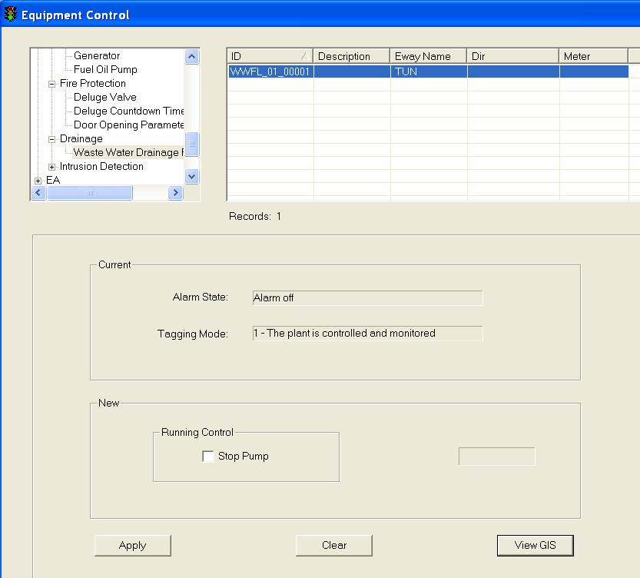

  Click on any equipment to select it.

The selected equipment will be highlighted in blue background. The current settings for the selected equipment appear in the Current panel.

   In the New panel, click on Stop Pump to stop the selected equipment from running.

   Click on Apply button to save the changes.

   Wait for the system to response.

•     If the remote control is successful, the response will show “Ok”.

•     If the system response with a “Time Out” after 30 seconds, you should try again by clicking on Apply button.

•      If the system response with “Not Sent”, it simply means that you have not set the new setting.

|  |
| --- |
| **Note** |
| Remote Control is only allowed when the generator alarm state is off and tagging mode is 1. |

###### View GIS

|  |  |  |  |  |  |  |
| --- | --- | --- | --- | --- | --- | --- |
| **User profile** | | | | | **Operation mode** | |
| DO | Operator | FC | ITSC | Supervisor | PCM | FCM |
| ✓ | ✓ | ✓ | ✓ | ✓ | ✓ | ✓ |

Click on View GIS button.

The GIS changes its view and the equipment is highlighted.

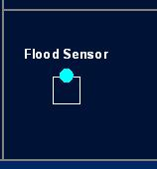

Figure 140 - Highlighted WVT Waste Water Drainage

|  |
| --- |
| **Note** |
| You can clear the light blue color highlight with the Clear Selection Description: c:\_temp\iw help\events\equipment control\PMCS\AirCon\View G84.jpg tool on GIS toolbar. |

##### Intrusion Detection

|  |  |  |  |  |  |  |
| --- | --- | --- | --- | --- | --- | --- |
| **User profile** | | | | | **Operation mode** | |
| DO | Operator | FC | ITSC | Supervisor | PCM | FCM |
| ✓ | ✓ \* | ✓ \*\* | ✓ | ✓ | ✓ | ✓ |

\* Only WVT and Zone 1 operators can control

\*\* Only viewing is allowed

For Lighting Control in the tunnel, IW CCM has the following features:

•    Control Intrusion Alarm System Camera

•    Control ITPMS Niche Door

•    Control Electrical Niche Door

•    Control Fire Extinguisher/ETS Door

•    Control FB Door

•    View GIS

###### Control Intrusion Alarm System Camera

    In the equipment list, click on + sign besides power equipment.

The list expands to show the list of Intrusion Detection equipment.

    Click on Intrusion Alarm System Camera.

A list of equipment appears on the right with ID, Description, Eway Name, Dir and Kilometer information.

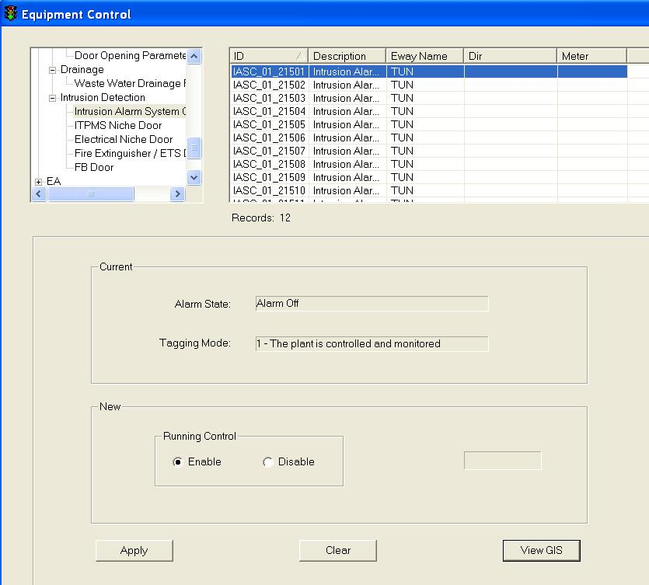

  Click on any equipment to select it.

The selected equipment will be highlighted in blue background. The current settings for the selected equipment appear in the Current panel.

   In the New panel, click on Enable or Disable to control camera running status.

   Click on Apply button to save the changes.

   Wait for the system to response.

•     If the remote control is successful, the response will show “Ok”.

•     If the system response with a “Time Out” after 30 seconds, you should try again by clicking on Apply button.

•      If the system response with “Not Sent”, it simply means that you have not set the new setting.

|  |
| --- |
| **Note** |
| Remote Control is only allowed when the generator alarm state is off and tagging mode is 1. |

###### Control ITPMS Niche Door

    In the equipment list, click on + sign besides power equipment.

The list expands to show the list of Intrusion Detection equipment.

    Click on ITPMS Niche Door.

A list of equipment appears on the right with ID, Description, Eway Name, Dir and Kilometer information.

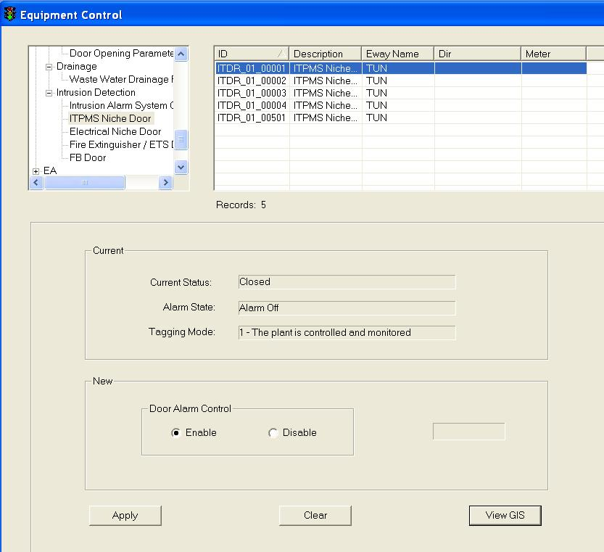

  Click on any equipment to select it.

The selected equipment will be highlighted in blue background. The current settings for the selected equipment appear in the Current panel.

   In the New panel, click on Enable or Disable to control door running status.

   Click on Apply button to save the changes.

   Wait for the system to response.

•     If the remote control is successful, the response will show “Ok”.

•     If the system response with a “Time Out” after 30 seconds, you should try again by clicking on Apply button.

•      If the system response with “Not Sent”, it simply means that you have not set the new setting.

|  |
| --- |
| **Note** |
| Remote Control is only allowed when the generator alarm state is off and tagging mode is 1. |

###### Control Electrical Niche Door

    In the equipment list, click on + sign besides power equipment.

The list expands to show the list of Intrusion Detection equipment.

    Click on Electrical Niche Door.

A list of equipment appears on the right with ID, Description, Eway Name, Dir and Kilometer information.

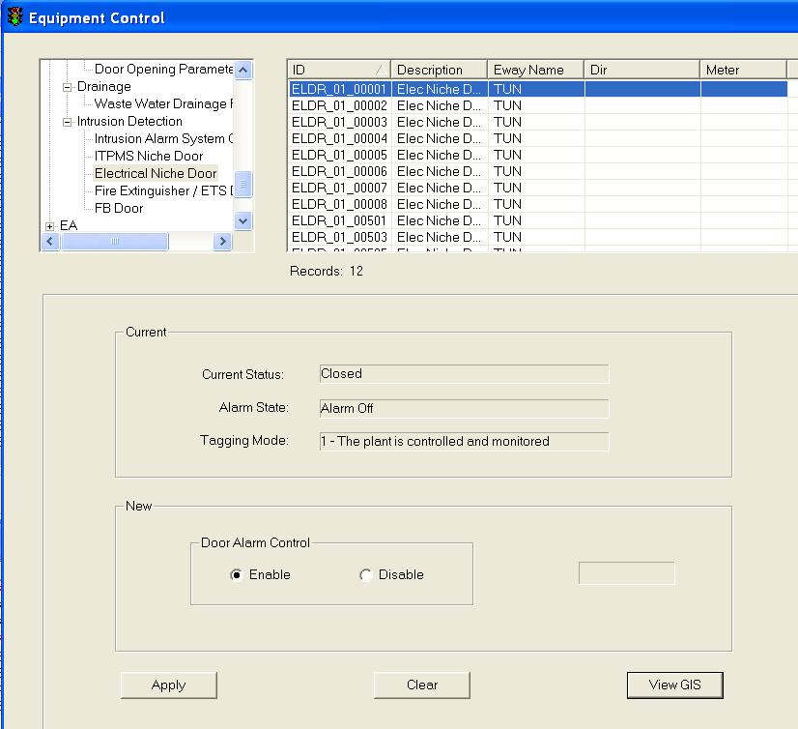

  Click on any equipment to select it.

The selected equipment will be highlighted in blue background. The current settings for the selected equipment appear in the Current panel.

   In the New panel, click on Enable or Disable to control door running status.

   Click on Apply button to save the changes.

   Wait for the system to response.

•     If the remote control is successful, the response will show “Ok”.

•     If the system response with a “Time Out” after 30 seconds, you should try again by clicking on Apply button.

•      If the system response with “Not Sent”, it simply means that you have not set the new setting.

|  |
| --- |
| **Note** |
| Remote Control is only allowed when the generator alarm state is off and tagging mode is 1. |

###### Control Fire Extinguisher/ETS Door

    In the equipment list, click on + sign besides power equipment.

The list expands to show the list of Intrusion Detection equipment.

    Click on Fire Extinguisher/ETS Door.

A list of equipment appears on the right with ID, Description, Eway Name, Dir and Kilometer information.

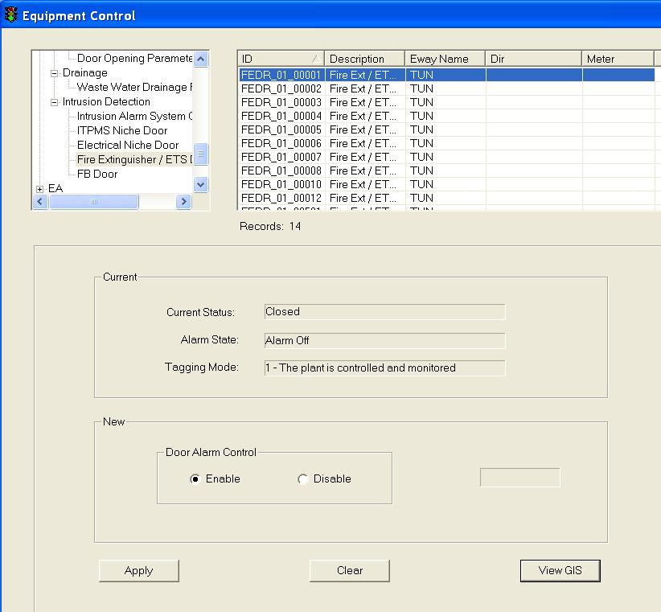

  Click on any equipment to select it.

The selected equipment will be highlighted in blue background. The current settings for the selected equipment appear in the Current panel.

   In the New panel, click on Enable or Disable to control door running status.

   Click on Apply button to save the changes.

   Wait for the system to response.

•     If the remote control is successful, the response will show “Ok”.

•     If the system response with a “Time Out” after 30 seconds, you should try again by clicking on Apply button.

•      If the system response with “Not Sent”, it simply means that you have not set the new setting.

|  |
| --- |
| **Note** |
| Remote Control is only allowed when the generator alarm state is off and tagging mode is 1. |

###### Control FB Door

    In the equipment list, click on + sign besides power equipment.

The list expands to show the list of Intrusion Detection equipment.

    Click on FB Door.

A list of equipment appears on the right with ID, Description, Eway Name, Dir and Kilometer information.

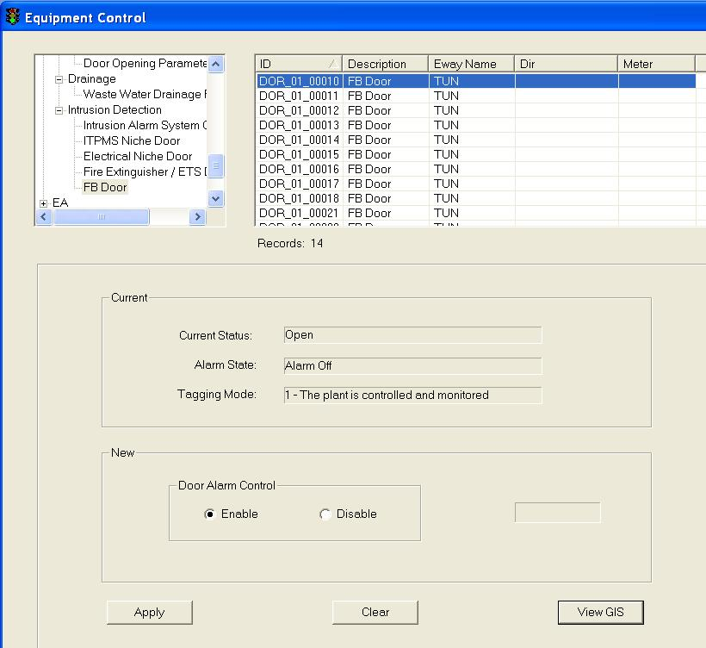

  Click on any equipment to select it.

The selected equipment will be highlighted in blue background. The current settings for the selected equipment appear in the Current panel.

   In the New panel, click on Enable or Disable to control door running status.

   Click on Apply button to save the changes.

   Wait for the system to response.

•     If the remote control is successful, the response will show “Ok”.

•     If the system response with a “Time Out” after 30 seconds, you should try again by clicking on Apply button.

•      If the system response with “Not Sent”, it simply means that you have not set the new setting.

|  |
| --- |
| **Note** |
| Remote Control is only allowed when the generator alarm state is off and tagging mode is 1. |

###### View GIS

|  |  |  |  |  |  |  |
| --- | --- | --- | --- | --- | --- | --- |
| **User profile** | | | | | **Operation mode** | |
| DO | Operator | FC | ITSC | Supervisor | PCM | FCM |
| ✓ | ✓ | ✓ | ✓ | ✓ | ✓ | ✓ |

Click on View GIS button.

The GIS changes its view and the equipment is highlighted.

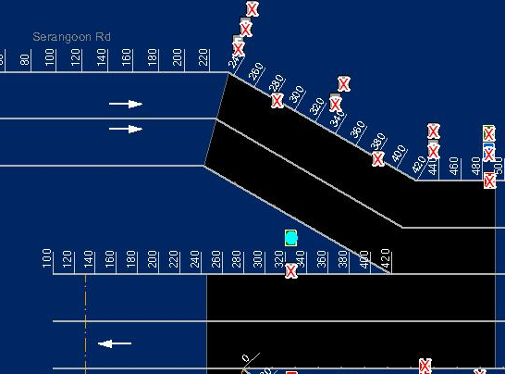

Figure 141 - Highlighted WVT IASC

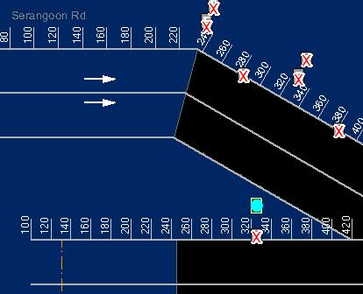

Figure 142 - Highlighted WVT ITPMS Niche Door

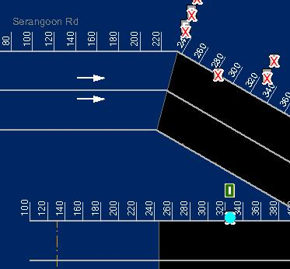

Figure 143 - Highlighted WVT Electrical Niche Door

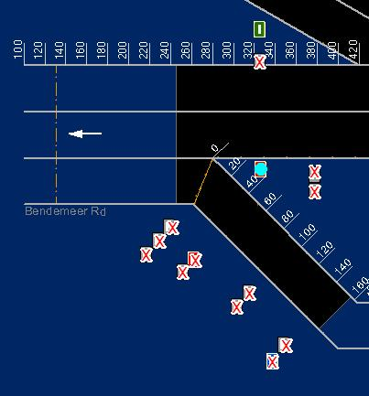

Figure 144 - Highlighted WVT Fire Extinguisher/ETS Door

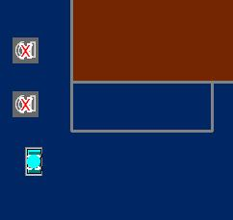

Figure 145 - Highlighted WVT FB Door

|  |
| --- |
| **Note** |
| You can clear the light blue color highlight with the Clear Selection Description: c:\_temp\iw help\events\equipment control\PMCS\AirCon\View G84.jpg tool on GIS toolbar. |

#### SGT

##### Variable Message Sign (VMS)

The user profile control the functions the user is authorize to use under Platform Control Mode (PCM) or Fall back Control Mode (FCM). Every user will have one user account that enables the user to login to IW. Every user account belongs to a profile.

|  |  |  |  |  |  |  |
| --- | --- | --- | --- | --- | --- | --- |
| **User profile** | | | | | **Operation mode** | |
| DO | Operator | FC | ITSC | Supervisor | PCM | FCM |
| ✓ | ✓ | ✓ | ✓ | ✓ | ✓ |  |

For each WVT VMS, you may change the following setting:



###### Search and Retrieve VMS

   In the equipment list, click on + sign besides VMS.

The list expands to show the list of VMS equipment.

   Click on VMS (SGT EVMS or SGT AVMS).

A list of equipment appears on the right with ID, Description, Eway Name, Dir and Kilometer information.

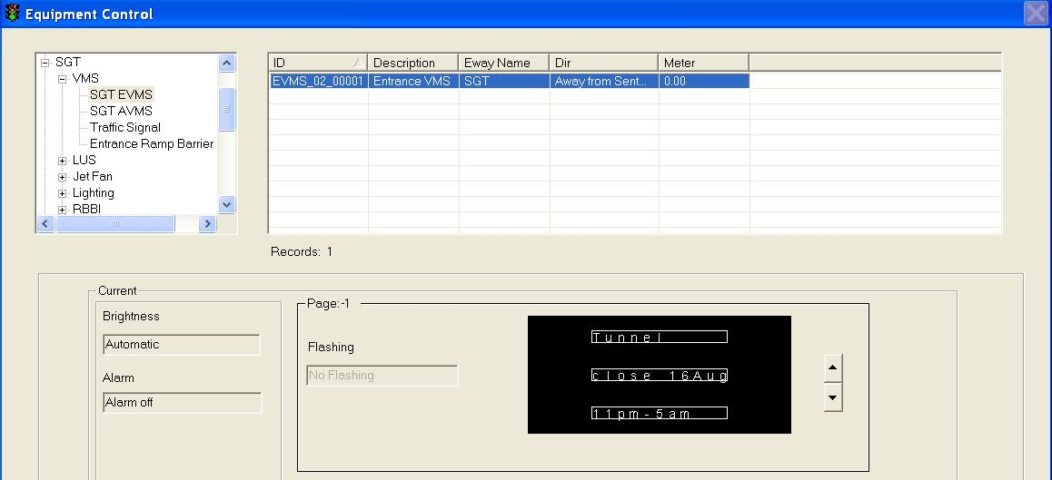

  Click on any equipment to select it.

The selected equipment will be highlighted in blue background. The current settings for the selected equipment appear in the Current panel.

###### Remote Control SGT EVMS and SGT AVMS

   Choose a new message from the [VMS Library](#_VMS_library) or use [Default message](#_VMS_default_librarys).

   In the Brightness panel, click on a setting.

   Click on Apply button to save the changes.

   Wait for the system to response.

•    If the remote control is successful, the response will show “Ok”.

•    If the system response with a “Time Out” after 30 seconds, you should try again by clicking on Apply button.

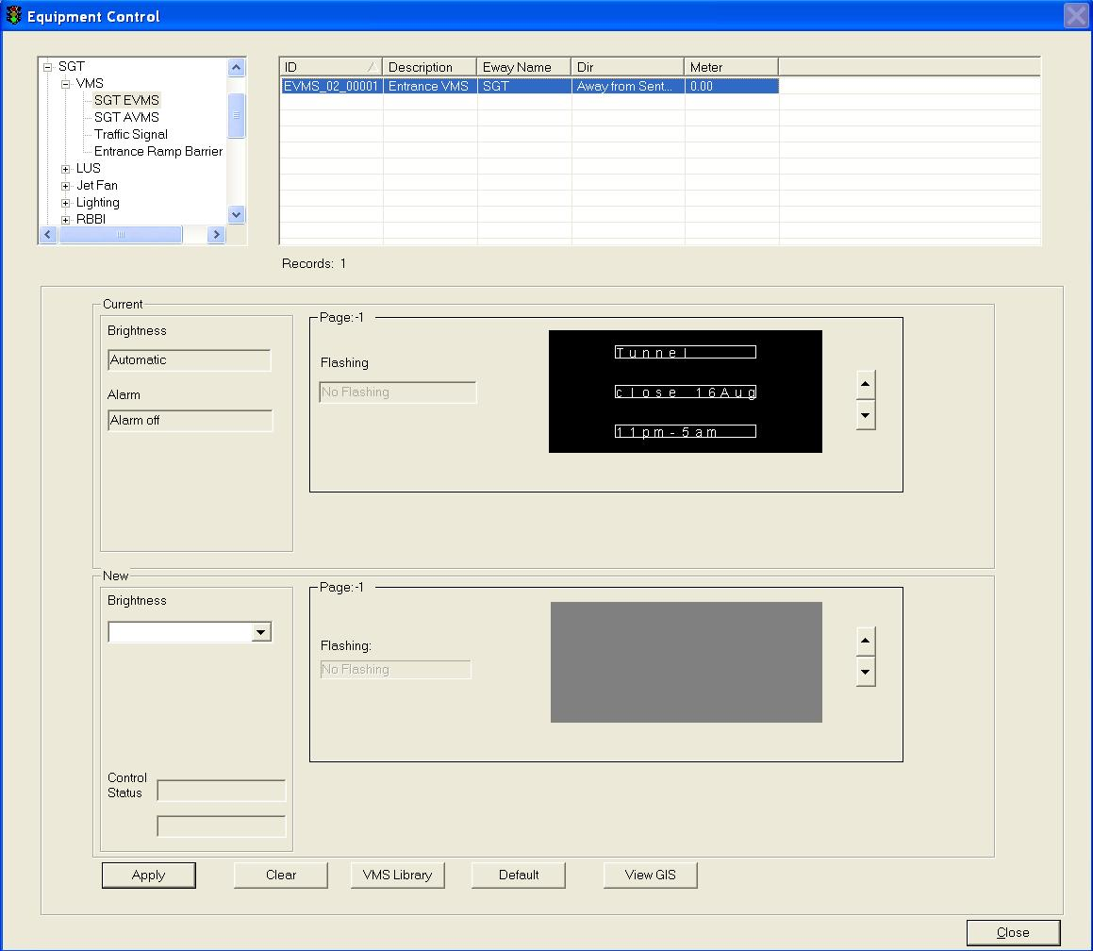

###### Remote Control Traffic Sign

1.   In the equipment list, click on + sign besides VMS.

The list expands to show the list of SGT VMS.

2.   Click on Traffic Sign.

A list of equipment appears on the right with ID, Description, Eway Name, Dir and Kilometer information.

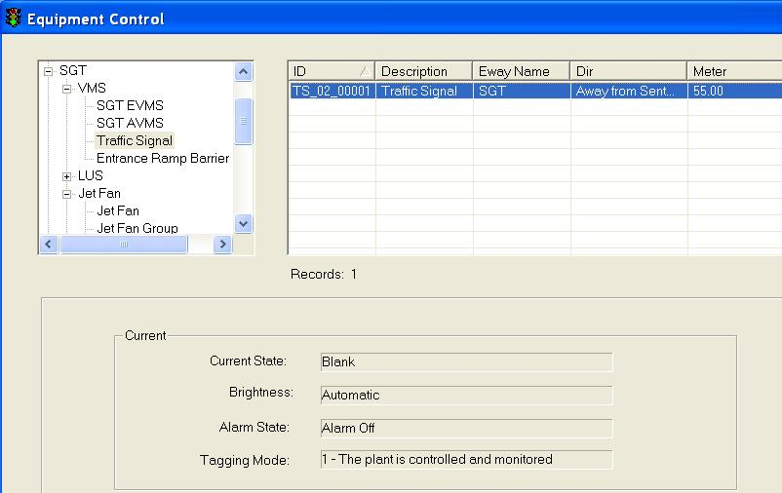

3.  Click on the Traffic Sign equipment to select it.

The selected equipment will be highlighted in blue background. The current settings for the selected equipment appear in the Current panel.

4.  In the New panel, choose a state (BLANK/GREEN/RED/AMBER) from dropdown list.

5.  Click on Apply button to save the changes.

6.   Wait for the system to response.

•     If the remote control is successful, the response will show “Ok”.

•     If the system response with a “Time Out” after 30 seconds, you should try again by clicking on Apply button.

•     If the system response with “Not Sent”, it simply means that you have not set the new setting.

###### Remote Control Entrance Ramp Barrier Group

1.   In the equipment list, click on + sign besides VMS.

The list expands to show the list of WVT VMS.

2.   Click on Entrance Ramp Barrier Group.

A list of equipment appears on the right with ID, Description, Eway Name, Dir and Kilometer information.

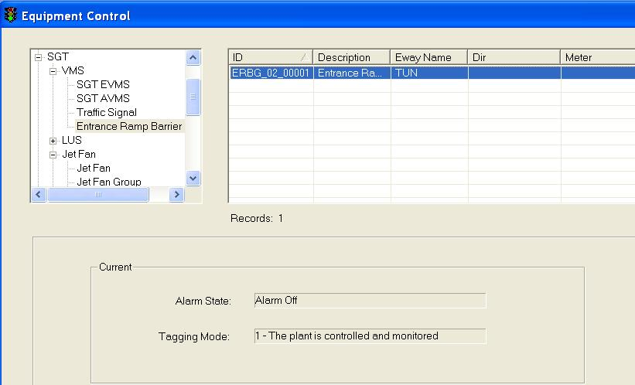

3. Click on the Entrance Ramp Barrier Group equipment to select it.

The selected equipment will be highlighted in blue background. The current settings for the selected equipment appear in the Current panel.

4.  In the New panel, click on Close or Open to control Entrance Ramp Barrier Group running status

5.  Click on Apply button to save the changes.

6.   Wait for the system to response.

•     If the remote control is successful, the response will show “Ok”.

•     If the system response with a “Time Out” after 30 seconds, you should try again by clicking on Apply button.

•     If the system response with “Not Sent”, it simply means that you have not set the new setting.

###### Choose new message from VMS Library

  Click on VMS Library button.

The VMS Library window appears.

  Click on Expressway dropdown arrow, and click on an expressway name.

  Click on Category dropdown arrow, and click on a category.

A list of messages for the selected equipment type, expressway and category appears on the right.

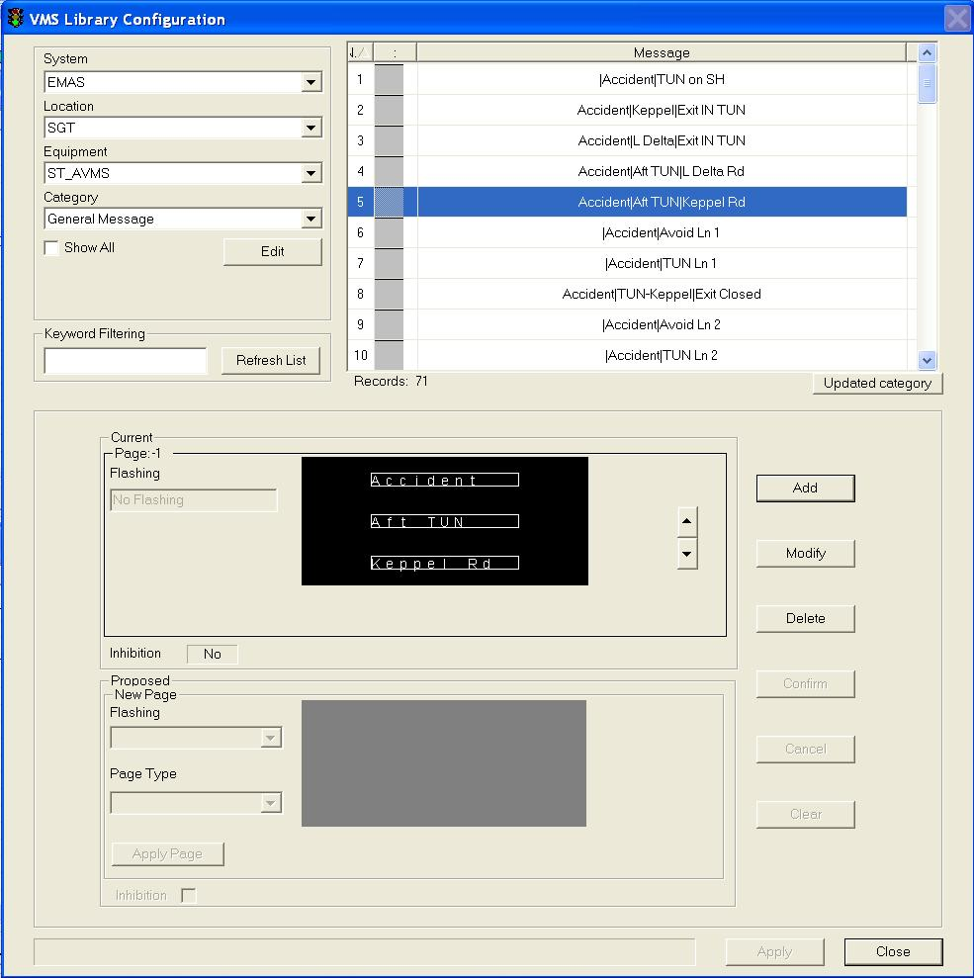

  Click on the desired message to select it.

The selected message will be highlighted in blue background. The current settings for the selected message appear in the Current panel.

  Click on Apply button to use this message as the new message or repeat steps 2 – 5 to choose another message.

The VMS Library window closes and the selected message settings appear in the New panel.

  In the Brightness panel, click on a setting.

  Click on Apply button to activate the new changes to the VMS on site.

 Wait for the system to response:

•    If the remote control is successful, the response will show “Ok”. This means the message is sent successfully to the site equipment.

•    If the system response with a “Time Out” after 30 seconds, you should try again by clicking on Apply button as the site equipment is not responding.

###### Set new message using messages in VMS Default Library

   Click on Default button.

The default message (from VMS Default Library) for the selected equipment appears in the New panel.

   In the Brightness panel, click on a setting.

   Click on Apply button to save the changes.

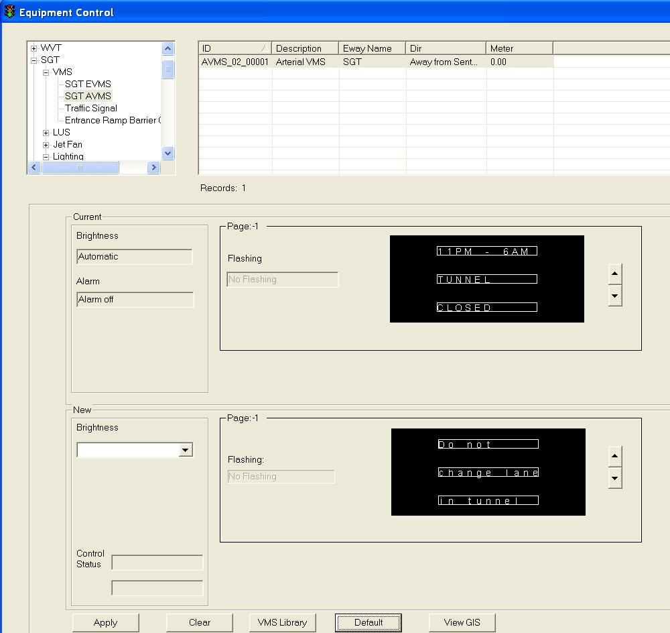

###### View GIS

Click on View GIS button.

The GIS changes its view and the equipment is highlighted.

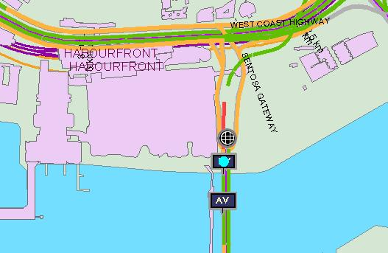

##### LUS

The user profile control the functions the user is authorize to use under Platform Control Mode (PCM) or Fall back Control Mode (FCM). Every user will have one user account that enables the user to login to IW. Every user account belongs to a profile.

|  |  |  |  |  |  |  |
| --- | --- | --- | --- | --- | --- | --- |
| **User profile** | | | | | **Operation mode** | |
| DO | Operator | FC | ITSC | Supervisor | PCM | FCM |
| ✓ | ✓ \* | ✓ \*\* | ✓ | ✓ | ✓ | ✓ |

\* Only SGT and Zone 1 operators can control

\*\* FC can only view

You may change the graphic code – green arrow, amber cross, red cross or blank

###### Select LUS from GIS

1       Click on GIS SGT Tunnel button.

The GIS on the right switch to tunnel diagram.

2     On tunnel diagram, click on the LUS button to enable LUS.

Tunnel view with LUS are enabled.

3      Double click on one LUS icon

The selected LUS will be highlighted and LUS control panel display in the CCM

4      In the New panel, click on a new graphic icon.

5      Click on Apply button to save the changes.

Wait for the system to response.

* If the remote control is successful, the response will show “Ok”.
* If the system response with a “Time Out” after 30 secs, you should try again by clicking on Apply button.

###### Control LUS

    In the equipment list, click on + sign besides LUS.

The list expands to show the list of LUS equipment.

  Click on LUS.

A list of equipment appears on the right with ID, Description, Eway Name, Dir and Kilometer information.

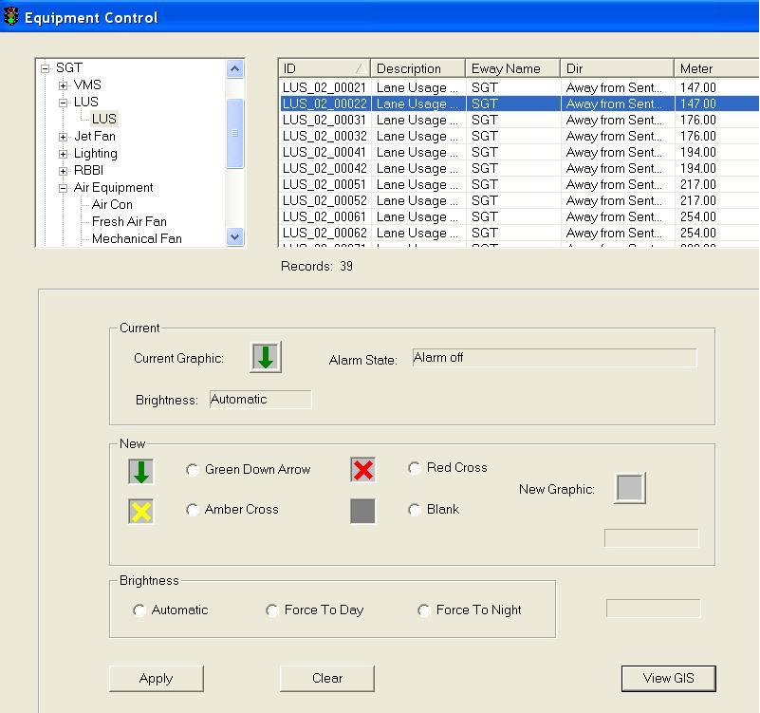

3. Click on any equipment to select it. To do multiple selections, press and hold Shift button or Ctrl button on your keyboard and click on the equipment on the list.

The selected equipment will be highlighted in blue background. The current settings for the selected equipment appear in the Current panel.

   In the New panel, click on a new graphic icon.

5.  Click on one of Brightness settings (Automatic, Force To Day or Force To Night)

   Click on Apply button to save the changes.

   Wait for the system to response.

•    If the remote control is successful, the response will show “Ok”.

•   If the system response with a “Time Out” after 30 seconds, you should try again by clicking on Apply button.

|  |
| --- |
| **Note** |
| •     Remote Control is only allowed when the alarm state is off.  •    Once SGT changes the site equipment, the LUS on GIS will show the new graphic. |

###### View GIS

Click on View GIS button.

The GIS changes its view and the equipment is highlighted.

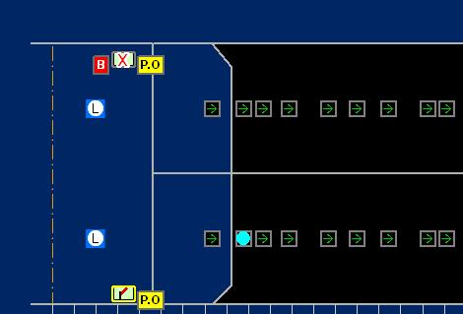

|  |
| --- |
| **Note** |
| You can clear the light blue color highlight with the Clear Selection Description: c:\_temp\iw help\events\equipment control\lus\View G76.jpg tool on GIS toolbar. |

##### Jet Fan

|  |  |  |  |  |  |  |
| --- | --- | --- | --- | --- | --- | --- |
| **User profile** | | | | | **Operation mode** | |
| DO | Operator | FC | ITSC | Supervisor | PCM | FCM |
| ✓ | ✓ \* | ✓ \*\* | ✓ | ✓ | ✓ | ✓ |

\* Only SGT and Zone 1 operators can control

\*\* Only viewing is allowed

For Jet Fan Control in the tunnel, IW CCM  has the following features:

•    Control Jet Fan Group

•    Control Jet Fan

•    Control Logic Sequential Controller

•    View GIS

###### Control Jet Fan

1.   In the equipment list, click on + sign besides Jet Fan.

2.   The list expands to show the Jet fan group, Jet Fan and Logic Sequential Controller

3.   Click on Jet Fan.

A list of equipment appears on the right with ID, Description, Eway Name, Dir and Kilometer information.

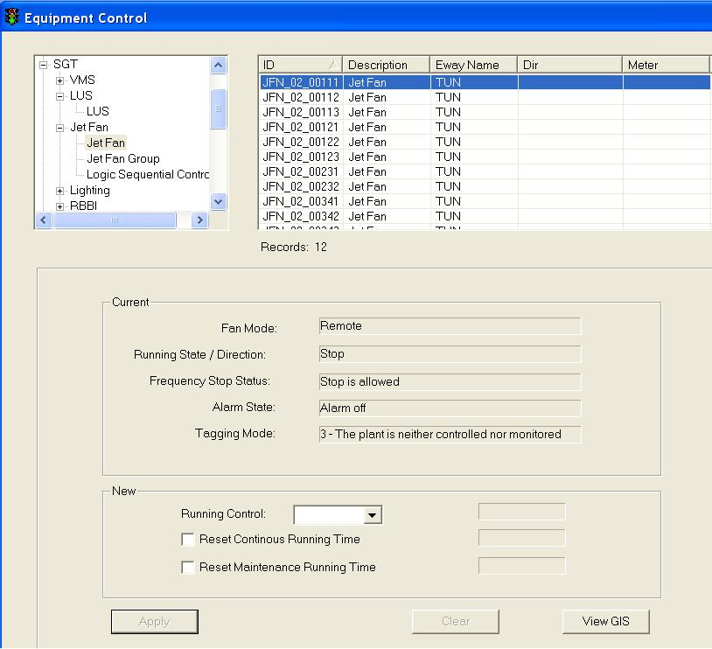

  Click on any equipment to select it. To do multiple selections, press and hold Shift button or Ctrl button on your keyboard and click on the equipment on the list.

The selected equipment will be highlighted in blue background. The current settings for the selected equipment appear in the Current panel.

5.   In the New panel, click on Start/Stop Control dropdown arrow, and click an action.

6.  Click on Reset Continous Running Time to reset the running hours to 0.

7.  Click on Reset Maintenance Running Time to reset the running hours to 0.

8.  Click on Apply button to save the changes.

9.  Wait for the system to response.

•    If the remote control is successful, the response will show “Ok”.

•    If the system response with a “Time Out” after 30 seconds, you should try again by clicking on Apply button.

•    If the system response with “Not Sent”, it simply means that you have not set the new setting.

|  |
| --- |
| **Note** |
| Remote Control is only allowed when the alarm state is off and tagging mode is 1. |

###### Control Jet Fan Group

1.   In the equipment list, click on + sign besides Jet Fan.

2.   The list expands to show the Jet fan group, Jet Fan and Logic Sequential Controller

3.   Click on Jet Fan Group.

A list of equipment appears on the right with ID, Description, Eway Name, Dir and Kilometer information.

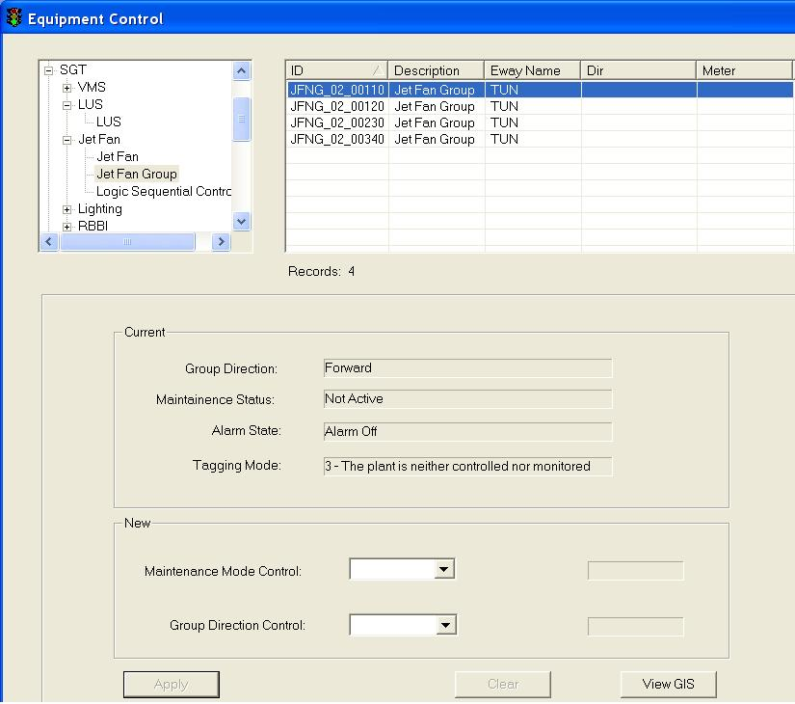

 4. Click on any equipment to select it.

The selected equipment will be highlighted in blue background. The current settings for the selected equipment appear in the Current panel.

5.   In the New panel, click on Maintenance Mode Control. Then, choose one mode (Normal or Active) in the dropdown list.

6.  In the New panel, click on drop down arrow to change all jet fans direction (Forward and Reverse).

7.  Click on Apply button to save the changes.

8.  Wait for the system to response.

•    If the remote control is successful, the response will show “Ok”.

•    If the system response with a “Time Out” after 30 seconds, you should try again by clicking on Apply button.

•    If the system response with “Not Sent”, it simply means that you have not set the new setting.

|  |
| --- |
| **Note** |
| Remote Control is only allowed when the alarm state is off and tagging mode is 1. |

###### Control Logic Sequential Controller

1.   In the equipment list, click on + sign besides Jet Fan.

2.   The list expands to show the Jet fan group, Jet Fan and Logic Sequential Controller

3.   Click on Jet Fan Group.

A list of equipment appears on the right with ID, Description, Eway Name, Dir and Kilometer information.

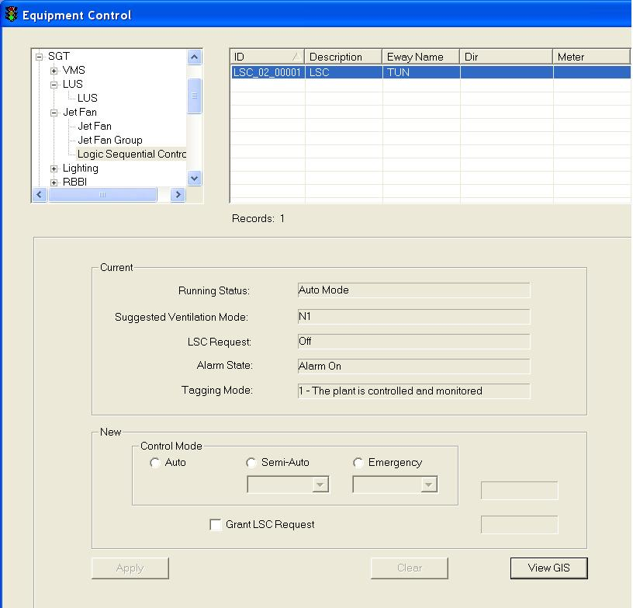

  Click on any equipment to select it.

The selected equipment will be highlighted in blue background. The current settings for the selected equipment appear in the Current panel.

5.   In the New panel, click on Group Control Mode to select one of these three modes (Auto, Semi-Auto or Emergency).

If Semi-Auto mode is selected, choose one semi-auto mode in the dropdown list.

If Emergency mode is selected, choose one emergency mode in the dropdown list.

6.  In the New panel, click on Grant LSC Request to grant LSC request.

7.  Click on Apply button to save the changes.

8.  Wait for the system to response.

•    If the remote control is successful, the response will show “Ok”.

•    If the system response with a “Time Out” after 30 seconds, you should try again by clicking on Apply button.

•    If the system response with “Not Sent”, it simply means that you have not set the new setting.

###### View GIS

Click on View GIS button.

The GIS changes its view and the equipment is highlighted.

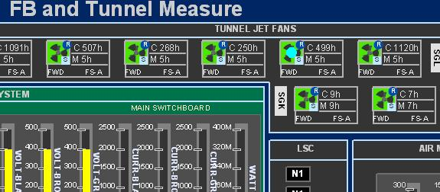

Highlighted SGT Jet Fan

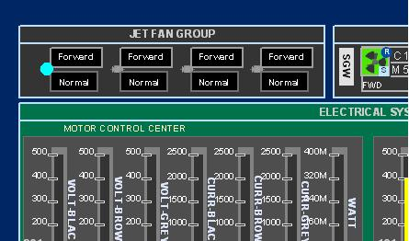

Highlighted SGT Jet Fan Group

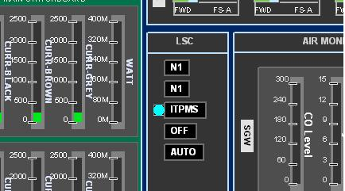

Highlighted SGT LSC

##### Lighting

|  |  |  |  |  |  |  |
| --- | --- | --- | --- | --- | --- | --- |
| **User profile** | | | | | **Operation mode** | |
| DO | Operator | FC | ITSC | Supervisor | PCM | FCM |
| ✓ | ✓ \* | ✓ \*\* | ✓ | ✓ | ✓ | ✓ |

\* Only SGT and Zone 1 operators can control

\*\* Only viewing is allowed

For Lighting Control in the tunnel, IW CCM  has the following features:

•    Control Tunnel Lighting

•    Control Beacon Lighting

•    Control Strobe Light

•    View GIS

###### Control Beacon Lighting

1.   In the equipment list, click on + sign besides Lighting.

The list expands to show the list of Lighting equipment.

2.   Click on Beacon Lighting.

A list of equipment appears on the right with ID, Description, Eway Name, Dir and Kilometer information.

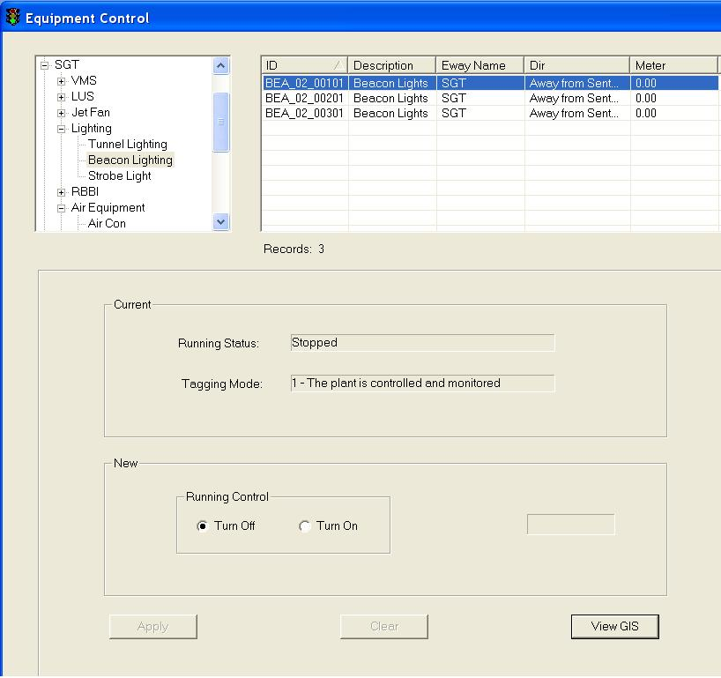

3.  Click on the  beacon lighting equipment to select it.

The selected equipment will be highlighted in blue background. The current settings for the selected equipment appear in the Current panel.

4.  In the New panel, click on Turn Off or Turn On to control beacon light running status

5.  Click on Apply button to save the changes.

6.   Wait for the system to response.

•     If the remote control is successful, the response will show “Ok”.

•     If the system response with a “Time Out” after 30 seconds, you should try again by clicking on Apply button.

•     If the system response with “Not Sent”, it simply means that you have not set the new setting.

|  |
| --- |
| **Note** |
| Remote Control is only allowed when the beacon lighting alarm is off and tagging mode is 1. |

###### Control Tunnel Lighting

1.   In the equipment list, click on + sign besides Lighting.

The list expands to show the list of Lighting equipment.

2.   Click on Tunnel Lighting.

A list of equipment appears on the right with ID, Description, Eway Name, Dir and Kilometer information.

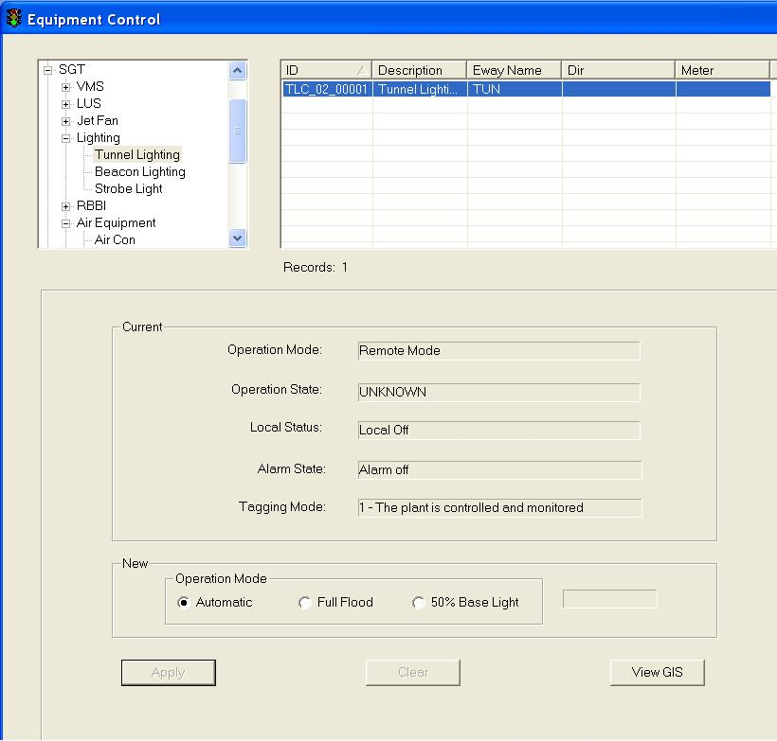

3.  Click on the tunnel lighting equipment to select it.

The selected equipment will be highlighted in blue background. The current settings for the selected equipment appear in the Current panel.

4.  In the New panel, click on Automatic or Full Flood or 50% Base Light for the Tunnel lighting operation mode control

5.  Click on Apply button to save the changes.

6.   Wait for the system to response.

•     If the remote control is successful, the response will show “Ok”.

•     If the system response with a “Time Out” after 30 seconds, you should try again by clicking on Apply button.

•     If the system response with “Not Sent”, it simply means that you have not set the new setting.

|  |
| --- |
| **Note** |
| Remote Control is only allowed when the tunnel lighting alarm is off and tagging mode is 1. |

###### Control Strobe Light

1.   In the equipment list, click on + sign besides Lighting.

The list expands to show the list of Lighting equipment.

2.   Click on Tunnel Lighting.

A list of equipment appears on the right with ID, Description, Eway Name, Dir and Kilometer information.

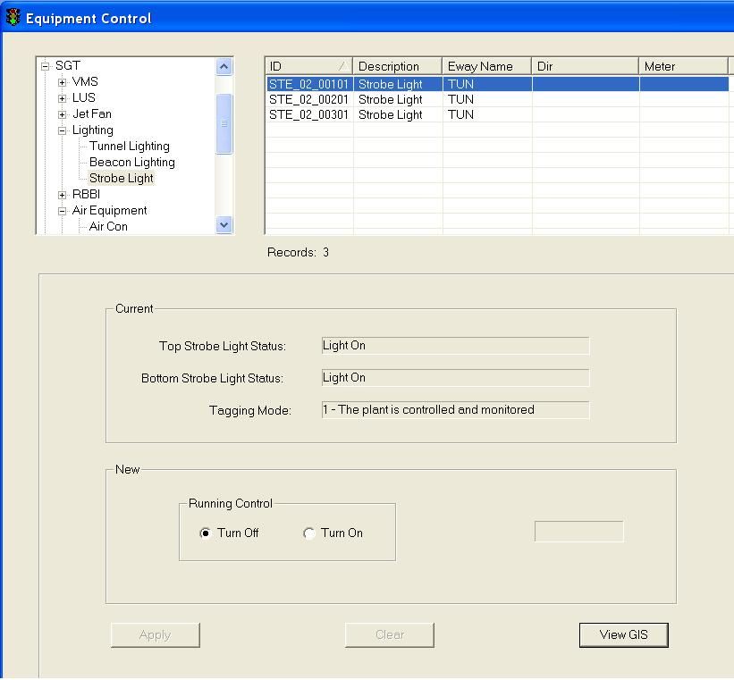

3.  Click on the strobe light equipment to select it.

The selected equipment will be highlighted in blue background. The current settings for the selected equipment appear in the Current panel.

4.  In the New panel, click on Turn Off or Turn On to control strobe light running status.

5.  Click on Apply button to save the changes.

6.   Wait for the system to response.

•     If the remote control is successful, the response will show “Ok”.

•     If the system response with a “Time Out” after 30 seconds, you should try again by clicking on Apply button.

•     If the system response with “Not Sent”, it simply means that you have not set the new setting.

|  |
| --- |
| **Note** |
| Remote Control is only allowed when the tunnel lighting alarm is off and tagging mode is 1. |

###### View GIS

  Click on View GIS button.

The GIS changes its view and the equipment is highlighted.

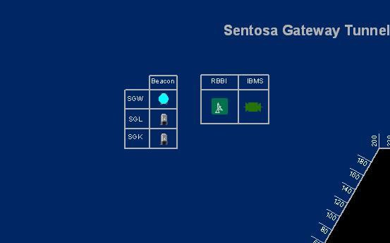

Highlighted SGT Beacon Lighting

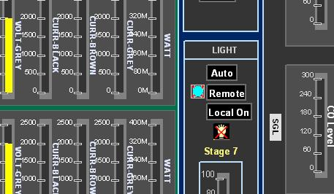

Highlighted SGT Tunnel Lighting

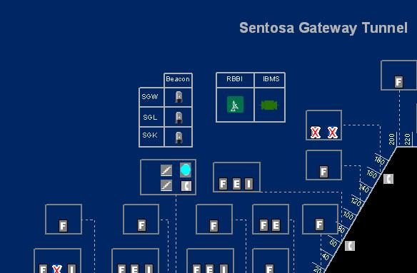

Highlighted SGT Strobe Light

##### RBBI

|  |  |  |  |  |  |  |
| --- | --- | --- | --- | --- | --- | --- |
| **User profile** | | | | | **Operation mode** | |
| DO | Operator | FC | ITSC | Supervisor | PCM | FCM |
| ✓ | ✓ \* | ✓ \*\* | ✓ | ✓ | ✓ | ✓ |

\* Only SGT and Zone 1 operators can control

\*\* Only viewing is allowed

For Lighting Control in the tunnel, IW CCM has the following features:

•    Control RBBI

•    View GIS

###### Control RBBI

1.   In the equipment list, click on + sign besides RBBI.

The list expands to show the list of RBBI equipment.

2.   Click on RBBI.

A list of equipment appears on the right with ID, Description, Eway Name, Dir and Kilometer information.

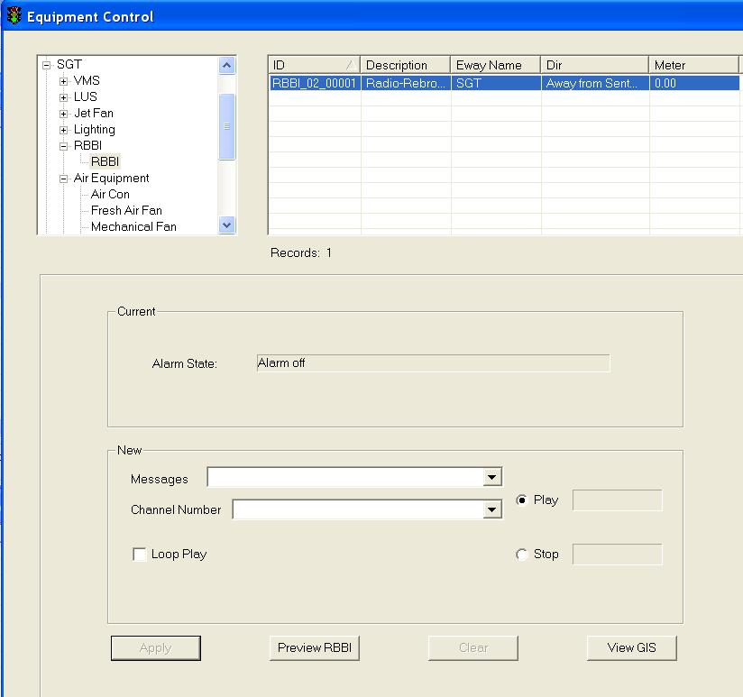

3.  Click on the RBBI equipment to select it.

The selected equipment will be highlighted in blue background. The current settings for the selected equipment appear in the Current panel.

4.  In the New panel, click on Play or Stop to control RBBI

     If play a RBBI message, choose a message from dropdown list of Message and choose a channel from dropdown list of Channel Number, click on Loop Play for playing loop.

5.  Click on Apply button to save the changes.

6.   Wait for the system to response.

•     If the remote control is successful, the response will show “Ok”.

•     If the system response with a “Time Out” after 30 seconds, you should try again by clicking on Apply button.

•     If the system response with “Not Sent”, it simply means that you have not set the new setting.

|  |
| --- |
| **Note** |
| Remote Control is only allowed when the RBBI alarm is off and tagging mode is 1. |

###### View GIS

  Click on View GIS button.

The GIS changes its view and the equipment is highlighted.

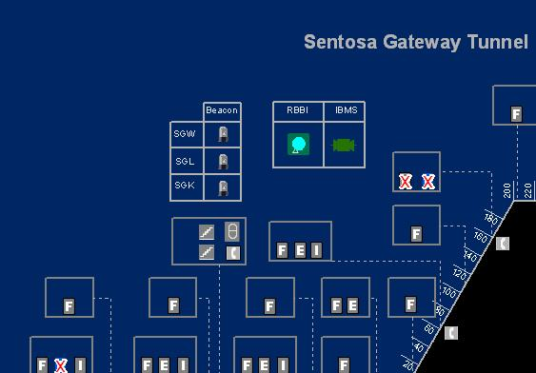

Highlighted SGT RBBI

##### Air Equipment

|  |  |  |  |  |  |  |
| --- | --- | --- | --- | --- | --- | --- |
| **User profile** | | | | | **Operation mode** | |
| DO | Operator | FC | ITSC | Supervisor | PCM | FCM |
| ✓ | ✓ \* | ✓ \*\* | ✓ | ✓ | ✓ | ✓ |

\* Only SGT and Zone 1 operators can control

\*\* Only viewing is allowed

For Air Equipment Control in the tunnel, IW CCM has the following features:

•         Control Air Con

•         Control Fresh Air Fan

•         Control Mechanical Fan

•         Control ECS Calendar

•         View GIS

###### Control Air Con

    In the equipment list, click on + sign besides Air equipment.

The list expands to show the list of Air equipment.

    Click on Air Con.

A list of equipment appears on the right with ID, Description, Eway Name, Dir and Kilometer information.

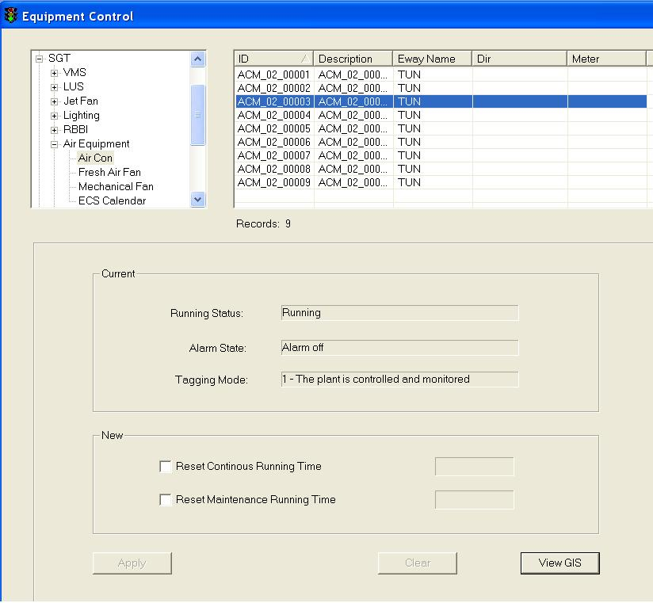

  Click on any equipment to select it. To do multiple selections, press and hold Shift button or Ctrl button on your keyboard and click on the equipment on the list.

The selected equipment will be highlighted in blue background. The current settings for the selected equipment appear in the Current panel.

   In the New panel, click on Reset Continuous Running Hours to reset running hours to 0

  Click on Reset Maintenance Running Hours to reset the running hours to 0.

   Click on Apply button to save the changes.

   Wait for the system to response.

•     If the remote control is successful, the response will show “Ok”.

•     If the system response with a “Time Out” after 30 seconds, you should try again by clicking on Apply button.

•      If the system response with “Not Sent”, it simply means that you have not set the new setting.

|  |
| --- |
| **Note** |
| Remote Control is only allowed when the air con alarm state is off and tagging mode is 1. |

###### Control Fresh Air Fan

    In the equipment list, click on + sign besides Air equipment.

The list expands to show the list of Air equipment.

    Click on Fresh Air Fan.

A list of equipment appears on the right with ID, Description, Eway Name, Dir and Kilometer information.

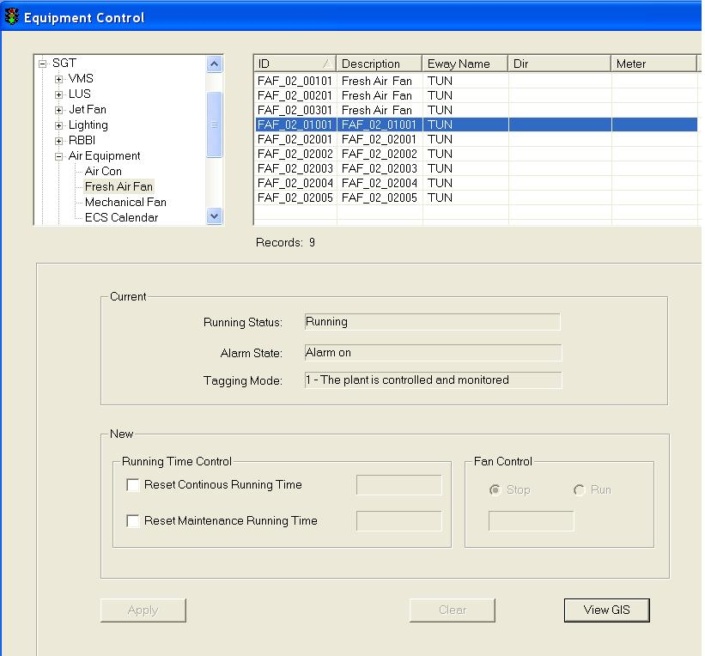

  Click on any equipment to select it. To do multiple selections, press and hold Shift button or Ctrl button on your keyboard and click on the equipment on the list.

The selected equipment will be highlighted in blue background. The current settings for the selected equipment appear in the Current panel.

   In the New panel, click on Reset Continuous Running Hours to reset running hours to 0

  Click on Reset Maintenance Running Hours to reset the running hours to 0.

6. Click on Stop or Run in Fan Control Group to change fan’s running status.

   Click on Apply button to save the changes.

   Wait for the system to response.

•     If the remote control is successful, the response will show “Ok”.

•     If the system response with a “Time Out” after 30 seconds, you should try again by clicking on Apply button.

•      If the system response with “Not Sent”, it simply means that you have not set the new setting.

|  |
| --- |
| **Note** |
| Remote Control is only allowed when the air con alarm state is off and tagging mode is 1. |

###### Control Mechanical Fan

    In the equipment list, click on + sign besides Air equipment.

The list expands to show the list of Air equipment.

    Click on Mechanical Fan.

A list of equipment appears on the right with ID, Description, Eway Name, Dir and Kilometer information.

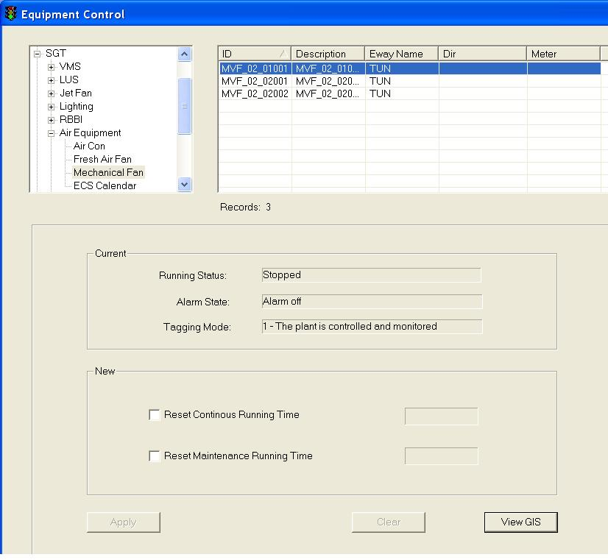

  Click on any equipment to select it. To do multiple selections, press and hold Shift button or Ctrl button on your keyboard and click on the equipment on the list.

The selected equipment will be highlighted in blue background. The current settings for the selected equipment appear in the Current panel.

   In the New panel, click on Reset Continuous Running Hours to reset running hours to 0

  In the New panel, click on Reset Maintenance Running Hours to reset the running hours to 0.

   Click on Apply button to save the changes.

   Wait for the system to response.

•     If the remote control is successful, the response will show “Ok”.

•     If the system response with a “Time Out” after 30 seconds, you should try again by clicking on Apply button.

•      If the system response with “Not Sent”, it simply means that you have not set the new setting.

|  |
| --- |
| **Note** |
| Remote Control is only allowed when the fresh air fan alarm state is off and tagging mode is 1. |

###### Control ECS Calendar

    In the equipment list, click on + sign besides Air equipment.

The list expands to show the list of Air equipment.

    Click on ECS Calendar.

A list of equipment appears on the right with ID, Description, Eway Name, Dir and Kilometer information.

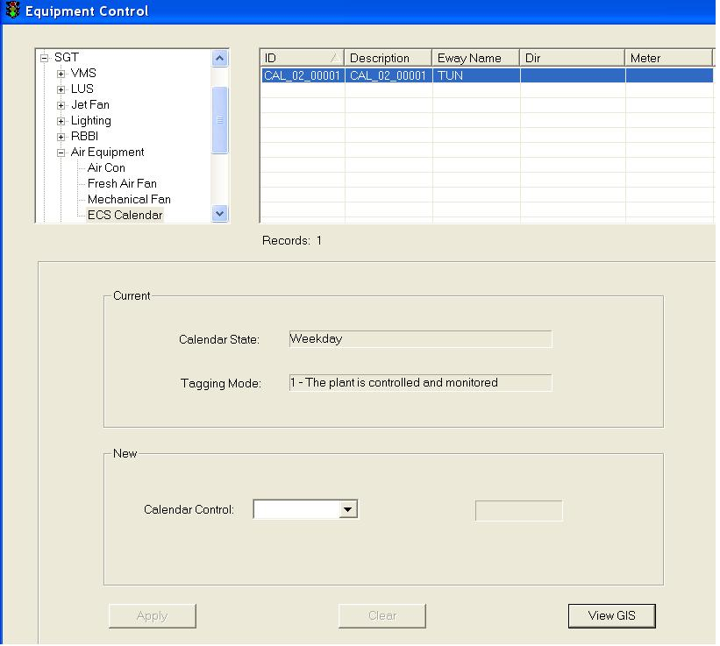

  Click on any equipment to select it. To do multiple selections, press and hold Shift button or Ctrl button on your keyboard and click on the equipment on the list.

The selected equipment will be highlighted in blue background. The current settings for the selected equipment appear in the Current panel.

   In the New panel, choose one option (Weekday, Saturday, Sunday or Holiday) from drop down list to control this equipment.

   Click on Apply button to save the changes.

   Wait for the system to response.

•     If the remote control is successful, the response will show “Ok”.

•     If the system response with a “Time Out” after 30 seconds, you should try again by clicking on Apply button.

•      If the system response with “Not Sent”, it simply means that you have not set the new setting.

|  |
| --- |
| **Note** |
| Remote Control is only allowed when the air con alarm state is off and tagging mode is 1. |

###### View GIS

  Click on View GIS button.

The GIS changes its view and the equipment is highlighted.

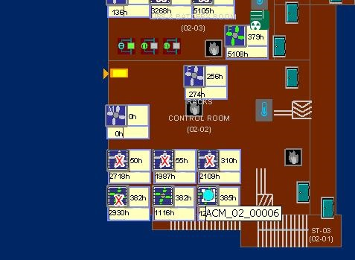

Highlighted SGT Air Con

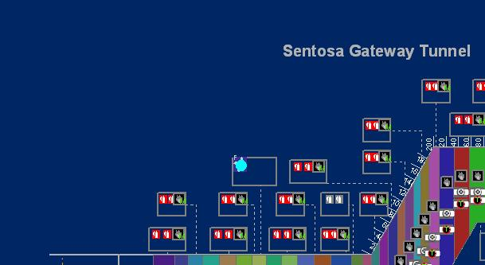

Highlighted SGT Fresh Air Fan

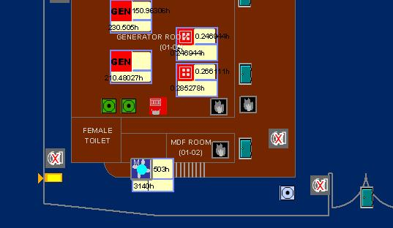

Highlighted SGT Mechanical Fan

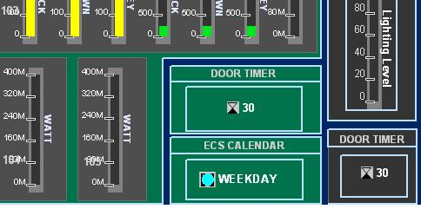

Highlighted SGT ECS Calendar

##### Power Equipment

|  |  |  |  |  |  |  |
| --- | --- | --- | --- | --- | --- | --- |
| **User profile** | | | | | **Operation mode** | |
| DO | Operator | FC | ITSC | Supervisor | PCM | FCM |
| ✓ | ✓ \* | ✓ \*\* | ✓ | ✓ | ✓ | ✓ |

\* Only SGT and Zone 1 operators can control

\*\* Only viewing is allowed

For Power Equipment Control in the tunnel, IW CCM  has the following features:

•         Control Generator

•         Control Fuel Oil Pump

•         View GIS

###### Control Generator

    In the equipment list, click on + sign besides power equipment.

The list expands to show the list of power equipment.

    Click on Genreator.

A list of equipment appears on the right with ID, Description, Eway Name, Dir and Kilometer information.

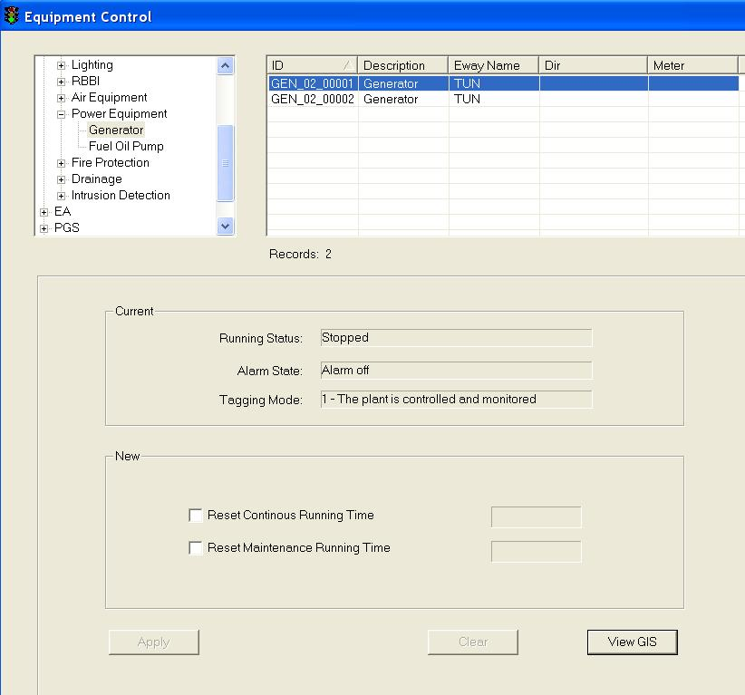

  Click on any equipment to select it.

The selected equipment will be highlighted in blue background. The current settings for the selected equipment appear in the Current panel.

   In the New panel, click on Reset Continuous Running Hours to reset running hours to 0

  Click on Reset Maintenance Running Hours to reset the running hours to 0.

   Click on Apply button to save the changes.

   Wait for the system to response.

•     If the remote control is successful, the response will show “Ok”.

•     If the system response with a “Time Out” after 30 seconds, you should try again by clicking on Apply button.

•      If the system response with “Not Sent”, it simply means that you have not set the new setting.

|  |
| --- |
| **Note** |
| Remote Control is only allowed when the generator alarm state is off and tagging mode is 1. |

###### Control Fuel Oil Pump

    In the equipment list, click on + sign besides power equipment.

The list expands to show the list of power equipment.

    Click on Fuel Oil Pump.

A list of equipment appears on the right with ID, Description, Eway Name, Dir and Kilometer information.

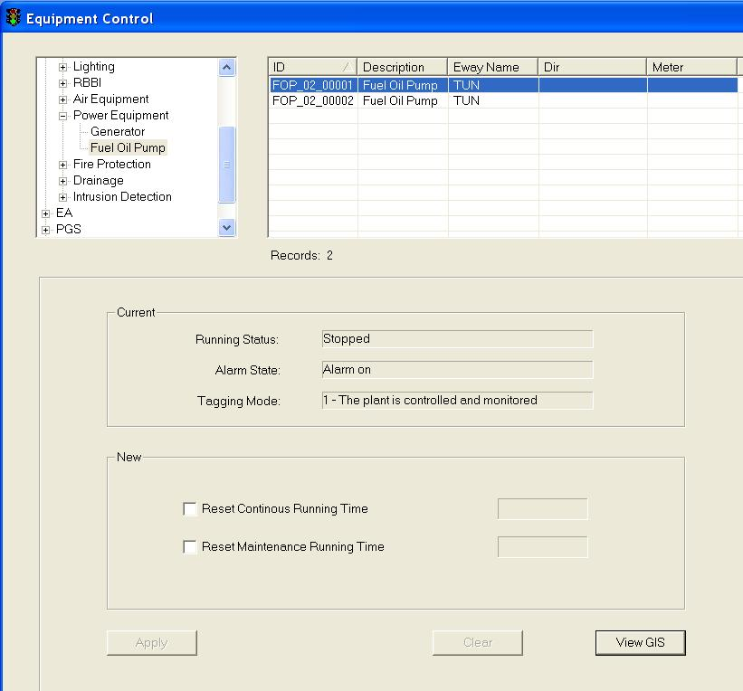

  Click on any equipment to select it.

The selected equipment will be highlighted in blue background. The current settings for the selected equipment appear in the Current panel.

   In the New panel, click on Reset Continuous Running Hours to reset running hours to 0

  Click on Reset Maintenance Running Hours to reset the running hours to 0.

   Click on Apply button to save the changes.

   Wait for the system to response.

•     If the remote control is successful, the response will show “Ok”.

•     If the system response with a “Time Out” after 30 seconds, you should try again by clicking on Apply button.

•      If the system response with “Not Sent”, it simply means that you have not set the new setting.

|  |
| --- |
| **Note** |
| Remote Control is only allowed when the generator alarm state is off and tagging mode is 1. |

###### View GIS

|  |  |  |  |  |  |  |
| --- | --- | --- | --- | --- | --- | --- |
| **User profile** | | | | | **Operation mode** | |
| DO | Operator | FC | ITSC | Supervisor | PCM | FCM |
| ✓ | ✓ | ✓ | ✓ | ✓ | ✓ | ✓ |

Click on View GIS button.

The GIS changes its view and the equipment is highlighted.

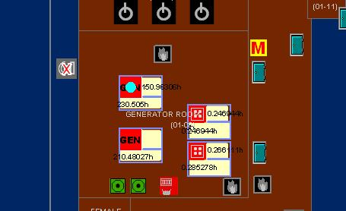

Highlighted SGT Generator

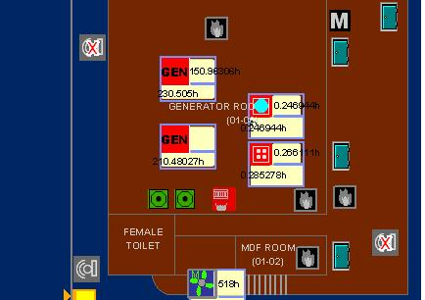

Highlighted SGT Fuel Oil Pump

##### Fire Protection

|  |  |  |  |  |  |  |
| --- | --- | --- | --- | --- | --- | --- |
| **User profile** | | | | | **Operation mode** | |
| DO | Operator | FC | ITSC | Supervisor | PCM | FCM |
| ✓ | ✓ \* | ✓ \*\* | ✓ | ✓ | ✓ | ✓ |

\* Only SGT and Zone 1 operators can control

\*\* Only viewing is allowed

For Lighting Control in the tunnel, IW CCM has the following features:

•    Control Deluge Valve

•    Control Opening Parameter

•    View GIS

###### Control Deluge Valve

    In the equipment list, click on + sign besides power equipment.

The list expands to show the list of Fire Protection equipment.

    Click on Deluge Valve.

A list of equipment appears on the right with ID, Description, Eway Name, Dir and Kilometer information.

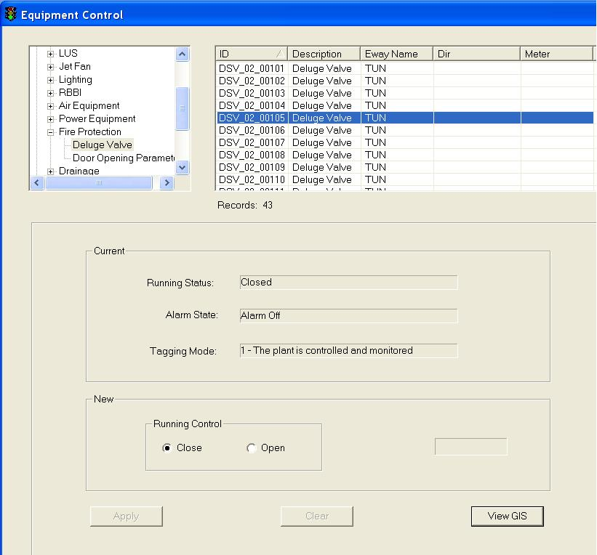

  Click on any equipment to select it.

The selected equipment will be highlighted in blue background. The current settings for the selected equipment appear in the Current panel.

   In the New panel, click on Close or Open to control deluge valve running status.

   Click on Apply button to save the changes.

   Wait for the system to response.

•     If the remote control is successful, the response will show “Ok”.

•     If the system response with a “Time Out” after 30 seconds, you should try again by clicking on Apply button.

•      If the system response with “Not Sent”, it simply means that you have not set the new setting.

|  |
| --- |
| **Note** |
| Remote Control is only allowed when the generator alarm state is off and tagging mode is 1. |

###### Control Door Opening Parameter

    In the equipment list, click on + sign besides power equipment.

The list expands to show the list of Fire Protection equipment.

    Click on Door Opening Parameter.

A list of equipment appears on the right with ID, Description, Eway Name, Dir and Kilometer information.

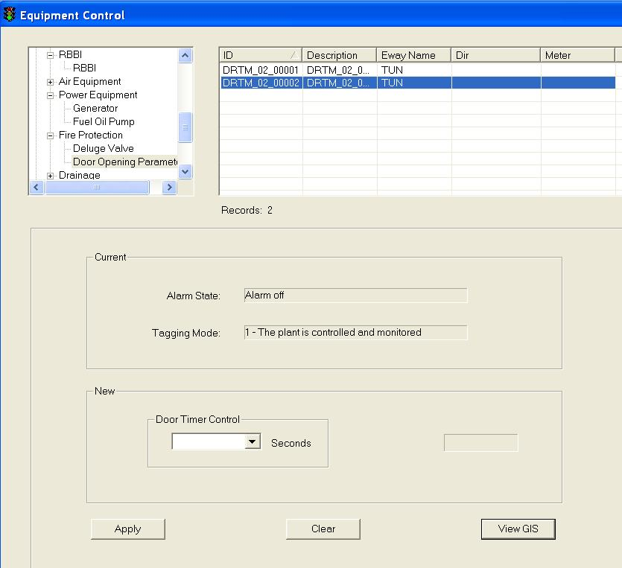

  Click on any equipment to select it.

The selected equipment will be highlighted in blue background. The current settings for the selected equipment appear in the Current panel.

   In the New panel, choose an option (1/30/60/90/120) from the dropdown list of Door Timer Control.

   Click on Apply button to save the changes.

   Wait for the system to response.

•     If the remote control is successful, the response will show “Ok”.

•     If the system response with a “Time Out” after 30 seconds, you should try again by clicking on Apply button.

•      If the system response with “Not Sent”, it simply means that you have not set the new setting.

|  |
| --- |
| **Note** |
| Remote Control is only allowed when the generator alarm state is off and tagging mode is 1. |

###### View GIS

|  |  |  |  |  |  |  |
| --- | --- | --- | --- | --- | --- | --- |
| **User profile** | | | | | **Operation mode** | |
| DO | Operator | FC | ITSC | Supervisor | PCM | FCM |
| ✓ | ✓ | ✓ | ✓ | ✓ | ✓ | ✓ |

Click on View GIS button.

The GIS changes its view and the equipment is highlighted.

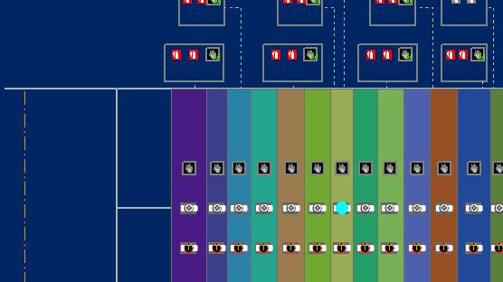

Highlighted SGT Deluge Valve

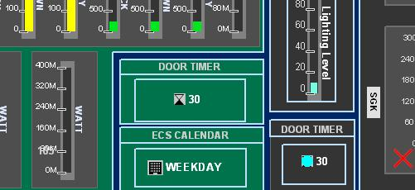

Highlighted SGT Door Opening Parameter

##### Drainage

|  |  |  |  |  |  |  |
| --- | --- | --- | --- | --- | --- | --- |
| **User profile** | | | | | **Operation mode** | |
| DO | Operator | FC | ITSC | Supervisor | PCM | FCM |
| ✓ | ✓ \* | ✓ \*\* | ✓ | ✓ | ✓ | ✓ |

\* Only SGT and Zone 1 operators can control

\*\* Only viewing is allowed

For Lighting Control in the tunnel, IW CCM has the following features:

•    Control Waste Water Control Pannel

 •    View GIS

###### Control Waste Water Control Panel

    In the equipment list, click on + sign besides power equipment.

The list expands to show the list of Drainage equipment.

    Click on Waste Water Control Panel.

A list of equipment appears on the right with ID, Description, Eway Name, Dir and Kilometer information.

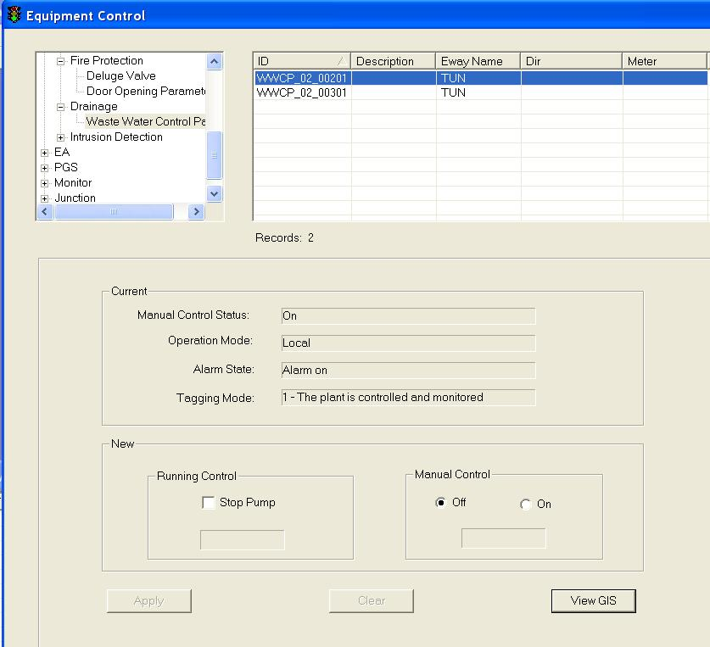

  Click on any equipment to select it.

The selected equipment will be highlighted in blue background. The current settings for the selected equipment appear in the Current panel.

   In the Running Control panel, click on Stop Pump to stop the selected equipment from running.

5. In the Manual Control panel, click On/Off to change manual control status.

   Click on Apply button to save the changes.

   Wait for the system to response.

•     If the remote control is successful, the response will show “Ok”.

•     If the system response with a “Time Out” after 30 seconds, you should try again by clicking on Apply button.

•      If the system response with “Not Sent”, it simply means that you have not set the new setting.

|  |
| --- |
| **Note** |
| Remote Control is only allowed when the generator alarm state is off and tagging mode is 1. |

###### View GIS

|  |  |  |  |  |  |  |
| --- | --- | --- | --- | --- | --- | --- |
| **User profile** | | | | | **Operation mode** | |
| DO | Operator | FC | ITSC | Supervisor | PCM | FCM |
| ✓ | ✓ | ✓ | ✓ | ✓ | ✓ | ✓ |

Click on View GIS button.

The GIS changes its view and the equipment is highlighted.

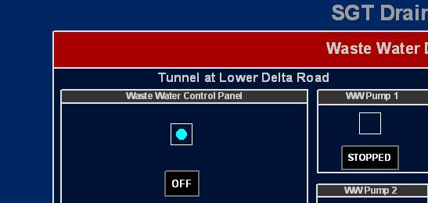

Highlighted SGT Waste Water Control Panel

##### Intrusion Detection

|  |  |  |  |  |  |  |
| --- | --- | --- | --- | --- | --- | --- |
| **User profile** | | | | | **Operation mode** | |
| DO | Operator | FC | ITSC | Supervisor | PCM | FCM |
| ✓ | ✓ \* | ✓ \*\* | ✓ | ✓ | ✓ | ✓ |

\* Only SGT and Zone 1 operators can control

\*\* Only viewing is allowed

For Lighting Control in the tunnel, IW CCM has the following features:

•    Control Intrusion Alarm System Camera

•    Control ITPMS Niche Door

•    Control Electrical Niche Door

•    Control Drainage Niche Door

•    Control Fire Extinguisher/ETS Door

•    Control FB Door

•    Control Emergency Escape Staircase Door

•    View GIS

###### Control Intrusion Alarm System Camera

    In the equipment list, click on + sign besides power equipment.

The list expands to show the list of Intrusion Detection equipment.

    Click on Intrusion Alarm System Camera.

A list of equipment appears on the right with ID, Description, Eway Name, Dir and Kilometer information.

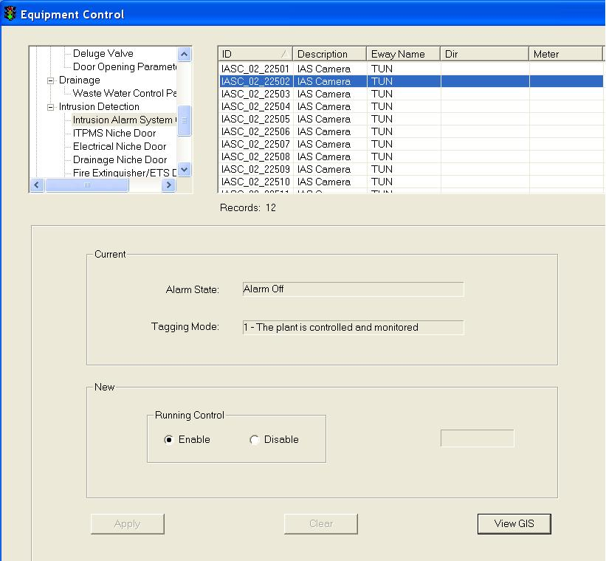

  Click on any equipment to select it.

The selected equipment will be highlighted in blue background. The current settings for the selected equipment appear in the Current panel.

   In the New panel, click on Enable or Disable to control camera running status.

   Click on Apply button to save the changes.

   Wait for the system to response.

•     If the remote control is successful, the response will show “Ok”.

•     If the system response with a “Time Out” after 30 seconds, you should try again by clicking on Apply button.

•      If the system response with “Not Sent”, it simply means that you have not set the new setting.

|  |
| --- |
| **Note** |
| Remote Control is only allowed when the generator alarm state is off and tagging mode is 1. |

###### Control ITPMS Niche Door

    In the equipment list, click on + sign besides power equipment.

The list expands to show the list of Intrusion Detection equipment.

    Click on ITPMS Niche Door.

A list of equipment appears on the right with ID, Description, Eway Name, Dir and Kilometer information.

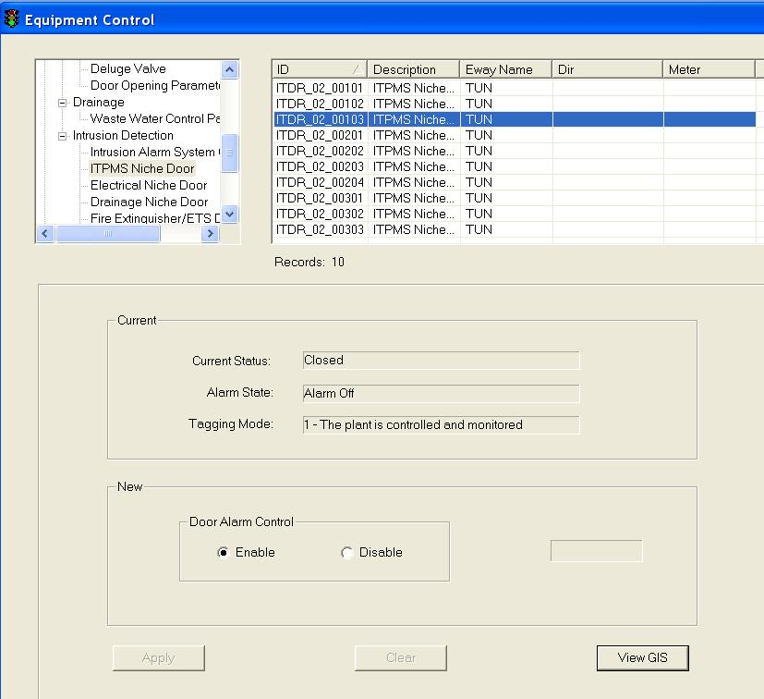

  Click on any equipment to select it.

The selected equipment will be highlighted in blue background. The current settings for the selected equipment appear in the Current panel.

   In the New panel, click on Enable or Disable to control door running status.

   Click on Apply button to save the changes.

   Wait for the system to response.

•     If the remote control is successful, the response will show “Ok”.

•     If the system response with a “Time Out” after 30 seconds, you should try again by clicking on Apply button.

•      If the system response with “Not Sent”, it simply means that you have not set the new setting.

|  |
| --- |
| **Note** |
| Remote Control is only allowed when the generator alarm state is off and tagging mode is 1. |

###### Control Electrical Niche Door

    In the equipment list, click on + sign besides power equipment.

The list expands to show the list of Intrusion Detection equipment.

    Click on Electrical Niche Door.

A list of equipment appears on the right with ID, Description, Eway Name, Dir and Kilometer information.

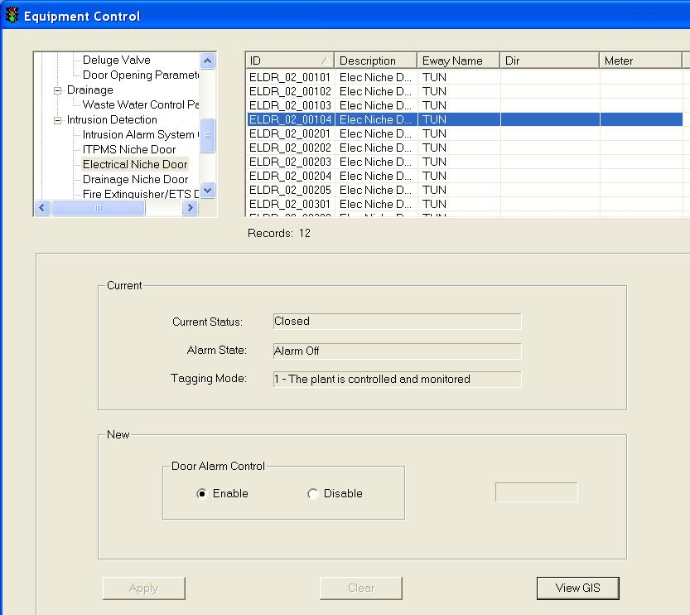

  Click on any equipment to select it.

The selected equipment will be highlighted in blue background. The current settings for the selected equipment appear in the Current panel.

   In the New panel, click on Enable or Disable to control door running status.

   Click on Apply button to save the changes.

   Wait for the system to response.

•     If the remote control is successful, the response will show “Ok”.

•     If the system response with a “Time Out” after 30 seconds, you should try again by clicking on Apply button.

•      If the system response with “Not Sent”, it simply means that you have not set the new setting.

|  |
| --- |
| **Note** |
| Remote Control is only allowed when the generator alarm state is off and tagging mode is 1. |

###### Control Drainage Niche Door

    In the equipment list, click on + sign besides power equipment.

The list expands to show the list of Intrusion Detection equipment.

    Click on Drainage Niche Door.

A list of equipment appears on the right with ID, Description, Eway Name, Dir and Kilometer information.

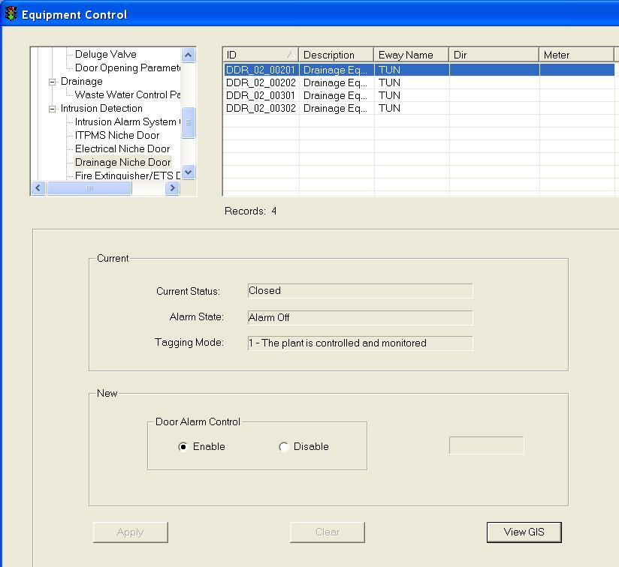

  Click on any equipment to select it.

The selected equipment will be highlighted in blue background. The current settings for the selected equipment appear in the Current panel.

   In the New panel, click on Enable or Disable to control door running status.

   Click on Apply button to save the changes.

   Wait for the system to response.

•     If the remote control is successful, the response will show “Ok”.

•     If the system response with a “Time Out” after 30 seconds, you should try again by clicking on Apply button.

•      If the system response with “Not Sent”, it simply means that you have not set the new setting.

|  |
| --- |
| **Note** |
| Remote Control is only allowed when the generator alarm state is off and tagging mode is 1. |

###### Control Fire Extinguisher/ETS Door

    In the equipment list, click on + sign besides power equipment.

The list expands to show the list of Intrusion Detection equipment.

    Click on Fire Extinguisher/ETS Door.

A list of equipment appears on the right with ID, Description, Eway Name, Dir and Kilometer information.

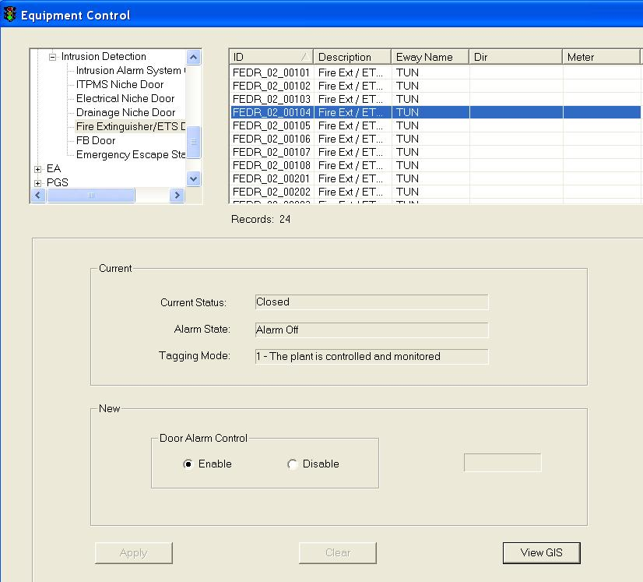

  Click on any equipment to select it.

The selected equipment will be highlighted in blue background. The current settings for the selected equipment appear in the Current panel.

   In the New panel, click on Enable or Disable to control door running status.

   Click on Apply button to save the changes.

   Wait for the system to response.

•     If the remote control is successful, the response will show “Ok”.

•     If the system response with a “Time Out” after 30 seconds, you should try again by clicking on Apply button.

•      If the system response with “Not Sent”, it simply means that you have not set the new setting.

|  |
| --- |
| **Note** |
| Remote Control is only allowed when the generator alarm state is off and tagging mode is 1. |

###### Control FB Door

    In the equipment list, click on + sign besides power equipment.

The list expands to show the list of Intrusion Detection equipment.

    Click on FB Door.

A list of equipment appears on the right with ID, Description, Eway Name, Dir and Kilometer information.

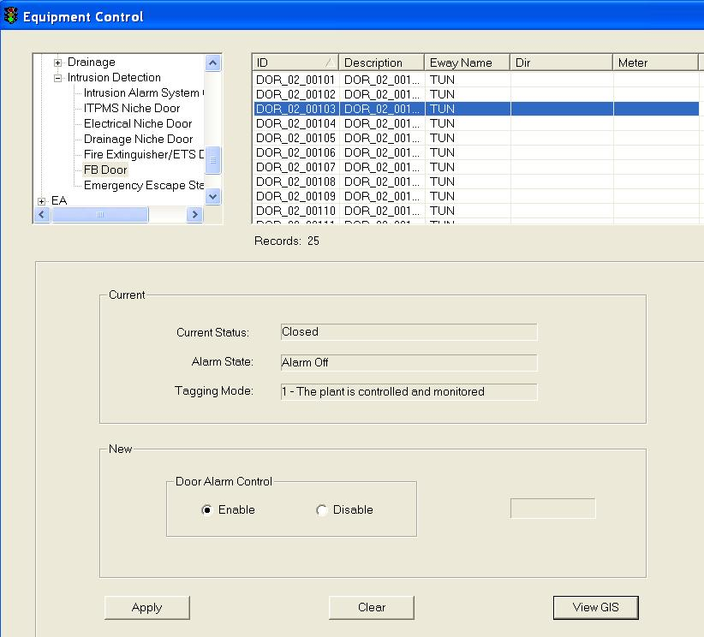

  Click on any equipment to select it.

The selected equipment will be highlighted in blue background. The current settings for the selected equipment appear in the Current panel.

   In the New panel, click on Enable or Disable to control door running status.

   Click on Apply button to save the changes.

   Wait for the system to response.

•     If the remote control is successful, the response will show “Ok”.

•     If the system response with a “Time Out” after 30 seconds, you should try again by clicking on Apply button.

•      If the system response with “Not Sent”, it simply means that you have not set the new setting.

|  |
| --- |
| **Note** |
| Remote Control is only allowed when the generator alarm state is off and tagging mode is 1. |

###### Control Emergency Escape Staircase Door

    In the equipment list, click on + sign besides power equipment.

The list expands to show the list of Intrusion Detection equipment.

    Click on Emergency Escape Staircase Dorr.

A list of equipment appears on the right with ID, Description, Eway Name, Dir and Kilometer information.

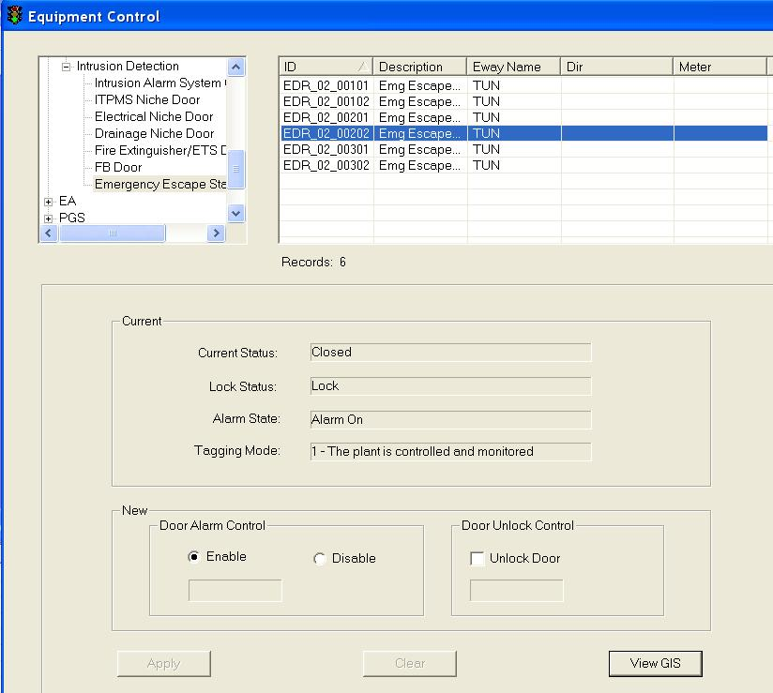

  Click on any equipment to select it.

The selected equipment will be highlighted in blue background. The current settings for the selected equipment appear in the Current panel.

   In the Door Alarm Control panel, click on Enable or Disable to control door running status.

5. In the Door Unlock Control panel, click Unlock Door to unlock door.

   Click on Apply button to save the changes.

   Wait for the system to response.

•     If the remote control is successful, the response will show “Ok”.

•     If the system response with a “Time Out” after 30 seconds, you should try again by clicking on Apply button.

•      If the system response with “Not Sent”, it simply means that you have not set the new setting.

|  |
| --- |
| **Note** |
| Remote Control is only allowed when the generator alarm state is off and tagging mode is 1. |

###### View GIS

|  |  |  |  |  |  |  |
| --- | --- | --- | --- | --- | --- | --- |
| **User profile** | | | | | **Operation mode** | |
| DO | Operator | FC | ITSC | Supervisor | PCM | FCM |
| ✓ | ✓ | ✓ | ✓ | ✓ | ✓ | ✓ |

Click on View GIS button.

The GIS changes its view and the equipment is highlighted.

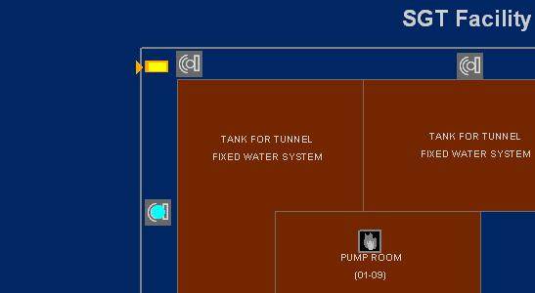

Highlighted SGT Intrusion Alarm System Camera

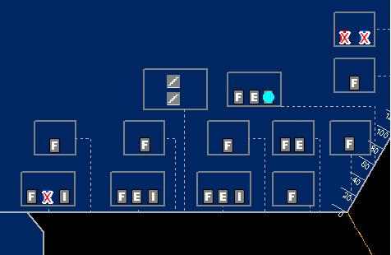

Highlighted SGT ITPMS Niche door

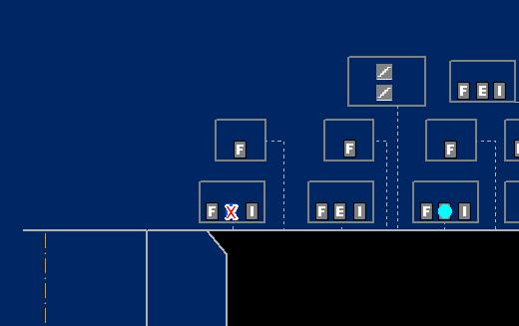

Highlighted SGT Electrical Niche door

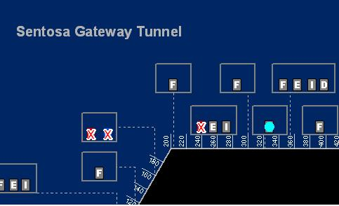

Highlighted SGT Drainage Niche door

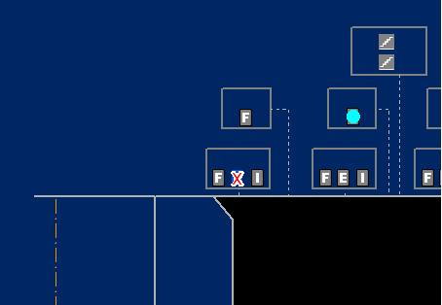

Highlighted SGT Fire Extinguisher/ETS door

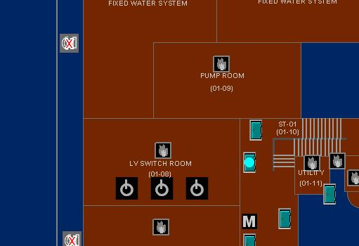

Highlighted SGT FB door

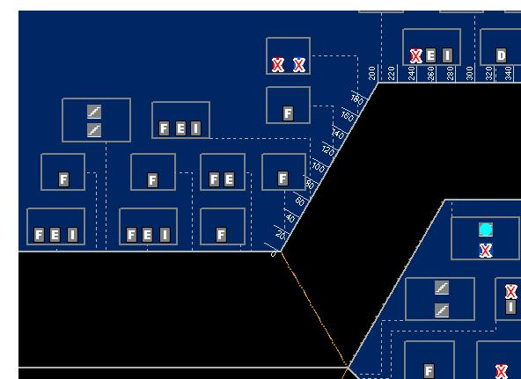

Highlighted SGT Emergency Escape Staircase door

#### EMAS

##### VMS (Full Graphic)

The user profile control the functions the user is authorize to use under Platform Control Mode (PCM) or Fall back Control Mode (FCM). Every user will have one user account that enables the user to login to IW. Every user account belongs to a profile.

|  |  |  |  |  |  |  |
| --- | --- | --- | --- | --- | --- | --- |
| **User profile** | | | | | **Operation mode** | |
| DO | Operator | FC | ITSC | Supervisor | PCM | FCM |
| ✓ | ✓ | ✓ | ✓ | ✓ | ✓ |  |

For each EMAS VMS, you may change the following setting:

|  |  |  |  |  |  |
| --- | --- | --- | --- | --- | --- |
|  | TIP | TEP | TTP | TSP | TIC |
| Message from VMS Library to be displayed | 🗸 | 🗸 | 🗸 |  |  |
| Message from VMS Default Library to be displayed | 🗸 | 🗸 | 🗸 | 🗸 | 🗸 |
| Pictogram to be displayed | 🗸 | 🗸 | 🗸 | 🗸 | 🗸 |
| Travel Time Display | 🗸 | 🗸 | 🗸 |  |  |
| Dim Mode / Dim Level | 🗸 | 🗸 | 🗸 | 🗸 | 🗸 |
| Flashing Mode: on / off |  |  |  | 🗸 | 🗸 |
| Flashing Mode: (Normal / All / Text Only / Graphic Only) | 🗸 | 🗸 | 🗸 |  |  |
| Toggle Mode: (Toggle / No Toggle / Scroll Up) | 🗸 | 🗸 | 🗸 | 🗸 | 🗸 |

###### Search and Retrieve VMS (Full Graphic)

   In the equipment list, click on + sign besides VMS (Full Graphic).

The list expands to show the list of VMS Full Graphic equipment.

   Click on VMS (TIP/TEP/TTP/TSP/TIC).

A list of equipment appears on the right with ID, Description, Location, Road name and Kilometer information.

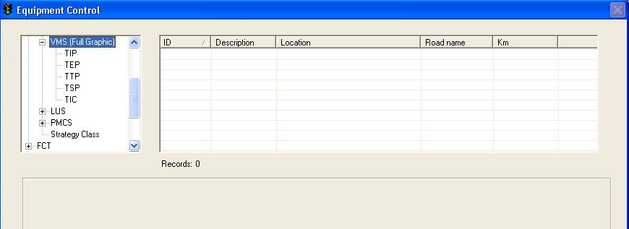

Figure 152 - EMAS VMS (Full Graphic) Equipment Control window

  Click on any equipment to select it. To do multiple selection, press and hold Shift button or Ctrl button on your keyboard and click on the equipment on the list.

The selected equipment will be highlighted in blue background. The current settings for the selected equipment appear in the Current panel.

###### Remote Control TIP, TEP, TTP

   Choose a new message from the [VMS Library](#_VMS_library) or use [Default message](#_VMS_default_librarys).

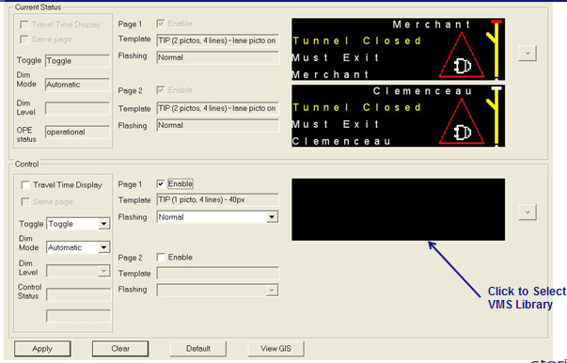

Use default message

   Choose display mode.

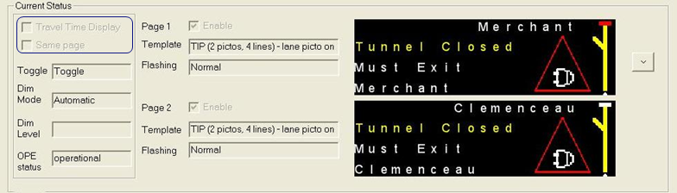

* Display mode
  + 1: display message and travel time on different pages
  + 2: display message only
  + If ticked, page 3 will be disabled from user control and new page showing Travel Time will be added by FELS

   Choose toggle mode.



* Toggle mode
  + Normal, no toggle (display the 1st page only)
  + Toggle
  + Scroll up

   Choose dimming level.

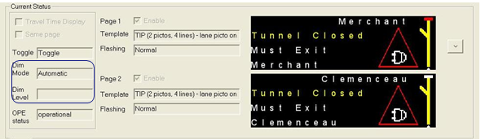

* Dimming control
  + Dimming mode (Manual, Automatic, Timetable)
  + Dimming level (only applicable to manual dimming mode; range from 1 to 12)

•    Ope status.

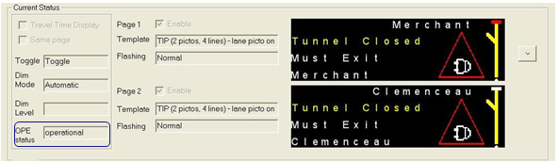

* OPE status
  + Display the operational status of current equipment

•    Template and flashing.

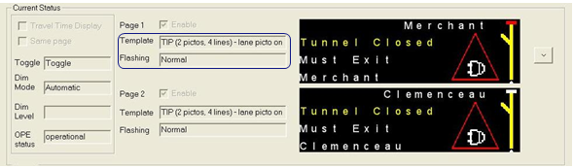

* Template
  + Template used by current page
* Flashing
  + Flashing mode set in current page (Normal, Flash All, Flash Text only, Flash Graphic only)

   Click on Apply button to save the changes.

   Wait for the system to response.

•    If the remote control is successful, the response will show “Ok”.

•    If the system response with a “Time Out” after 30 seconds, you should try again by clicking on Apply button.

•    If the system response with “Not Sent”, it simply means that you have not set the new setting. E.g. you may have chosen a new Graphic Icon but you did not choose a new Brightness. Hence when you click on Apply button, the system immediately replies with “Not Sent” beside the Brightness panel.

###### Remote Control TSP

   In the New panel, click a Graphic Icon.

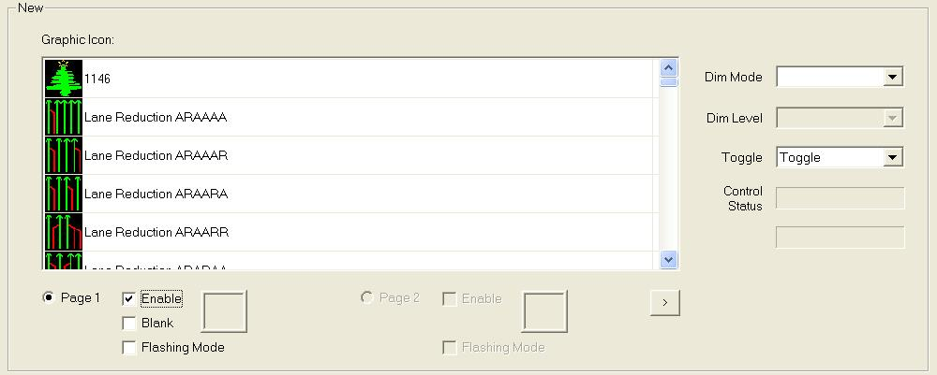

* The Blank template can only be applied to the 1st page
* Enable page for modification
* Radio button of the page is selected, indicating the page activated for modification

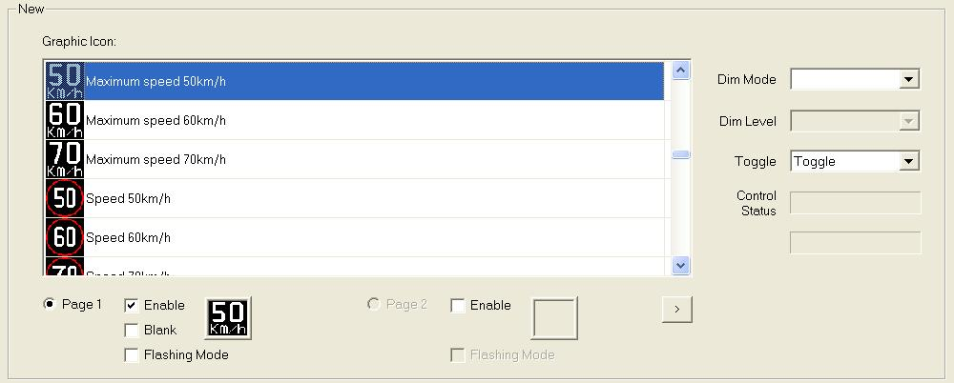

* Double click the pictogram to set the activate page (Page 1)
* The next page can then be enabled for modification

  Click on Flashing Mode checkbox if flashing mode for this message is yes.

   Choose Dim Mode and Dim Level.

4. Choose Toggle.

   Click on Apply button to save the changes.

   Wait for the system to response.

•    If the remote control is successful, the response will show “Ok”.

•    If the system response with a “Time Out” after 30 seconds, you should try again by clicking on Apply button.

•    If the system response with “Not Sent”, it simply means that you have not set the new setting. E.g. you may have chosen a new Graphic Icon but you did not choose a new Brightness. Hence when you click on Apply button, the system immediately replies with “Not Sent” beside the Brightness panel.

###### Remote Control TIC

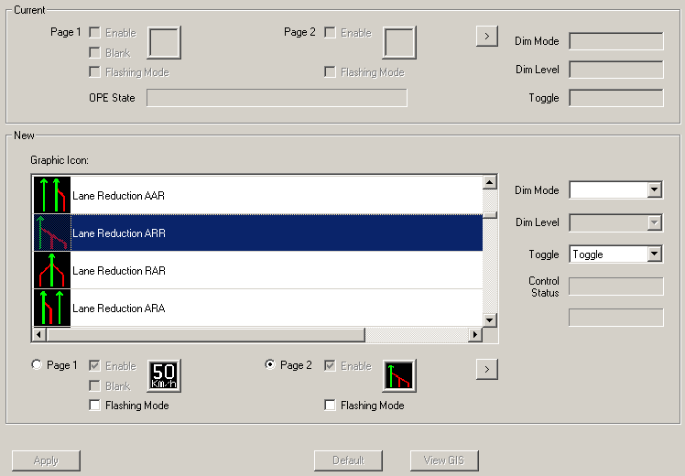

* TIC cannot be controlled from CCM
* “Apply” button is always disabled

###### Choose new message from VMS Library

  Click on VMS Library button.

The VMS Library window appears.

  Click on Expressway dropdown arrow, and click on an expressway name.

  Click on Category dropdown arrow, and click on a category.

A list of messages  for the selected equipment type, expressway and category appears on the right.

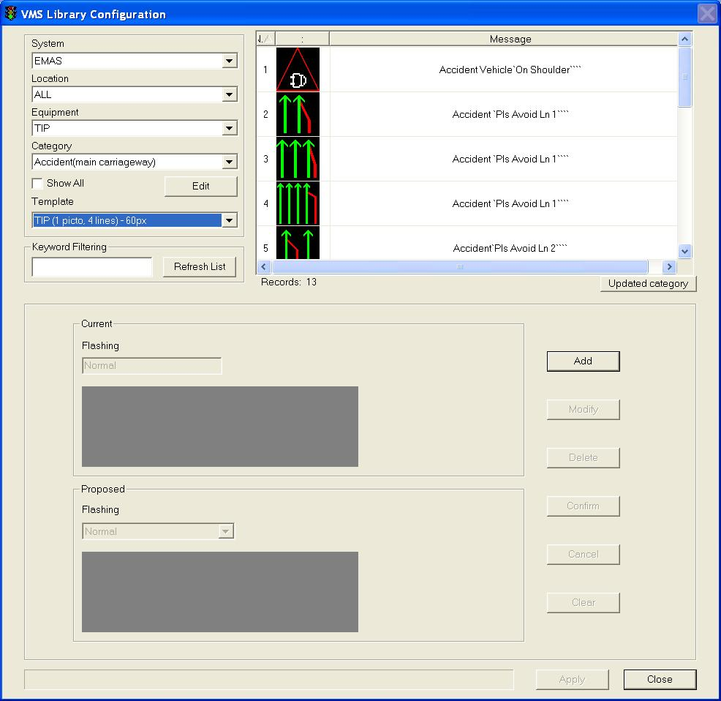

4. Click on the desired message to select it.

The selected message will be highlighted in blue background. The current settings for the selected message appear in the Current panel.

  Click on Apply button to use this message as the new message or repeat steps 2 – 5 to choose another message.

The VMS Library window closes and the selected message settings appear in the New panel.

 Wait for the system to response:

•    If the remote control is successful, the response will show “Ok”. This means the message is sent successfully to the site equipment.

•    If the system response with a “Time Out” after 30 seconds, you should try again by clicking on Apply button as the site equipment is not responding.

###### Set new message using messages in VMS Default Library

   Click on Default button.

The default message (from VMS Default Library) for the selected equipment appears in the New panel.

   Click on Apply button to save the changes.

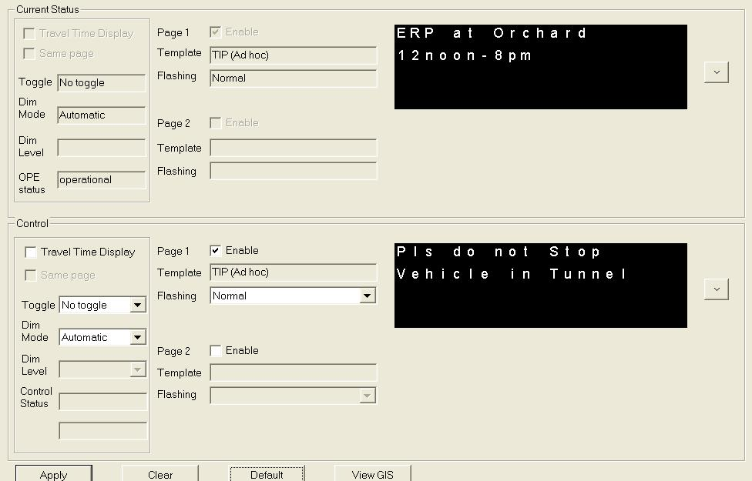

###### View GIS

Click on View GIS button.

The GIS changes its view and the equipment is highlighted.

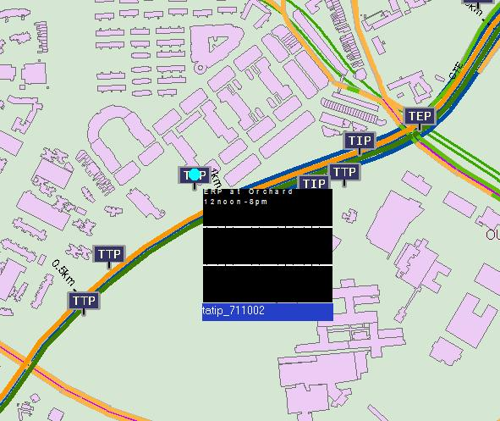

Figure 153 - View VMS Full Graphic on GIS

|  |
| --- |
| **Note** |
| You can clear the light blue colour highlight with the Clear Selection Description: c:\_temp\iw help\events\equipment control\View G65.jpg tool on GIS toolbar. |

##### Camera

The user profile control the functions the user is authorize to use under Platform Control Mode (PCM) or Fall back Control Mode (FCM). Every user will have one user account that enables the user to login to IW. Every user account belongs to a profile.

|  |  |  |  |  |  |  |
| --- | --- | --- | --- | --- | --- | --- |
| **User profile** | | | | | **Operation mode** | |
| DO | Operator | FC | ITSC | Supervisor | PCM | FCM |
| ✓ | ✓ \* | ✓ | ✓ | ✓ | ✓ | ✓ |

\* All functions except disable (lock) camera

You may change the position and enable / disable the use of camera (when camera is disabled, you cannot remote control camera and view the camera on CCTV).

|  |  |  |
| --- | --- | --- |
|  | Expressway Surveillance | Junction Surveillance |
| Camera position: VMS / SOS / Home / Away | ✓ |  |
| Camera position: position 1-12 |  | ✓ |
| Camera use: enable / disable | ✓ | ✓ |

###### Control Junction Surveillance Camera

   In the equipment list, click on + sign besides Camera.

The list expands to show the list of Camera equipment.

   Click on Junction Surveillance.

A list of equipment appears on the right with ID, Location, Dir and Kilometer information.

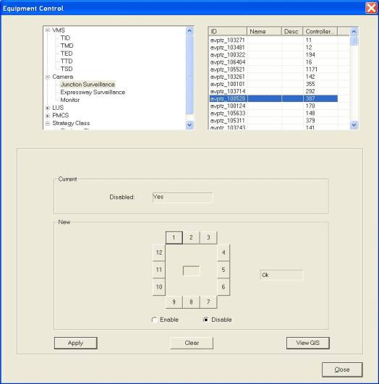

   Click on any equipment to select it. To do multiple selection, press and hold Shift button or Ctrl button on your keyboard and click on the equipment on the list.

The selected equipment will be highlighted in blue background. The current settings for the selected equipment appear in the Current panel.

   Wait for the system to response.

•    If the remote control is successful, the response will show “Ok”.

•    If the system response with a “Time Out” after 30 seconds, you should try again by clicking on Apply button.

•   If the system response with “Not Sent”, it simply means that you have not set the new setting.

|  |
| --- |
| **Note** |
| Remote Control is only allowed when the camera is not disabled. |

###### Control Expressway Surveillance Camera

  In the equipment list, click on + sign besides Camera.

  The list expands to show the list of Camera equipment.

  Click on Expressway Surveillance.

A list of equipment appears on the right with ID, Location, Dir and Kilometer information.

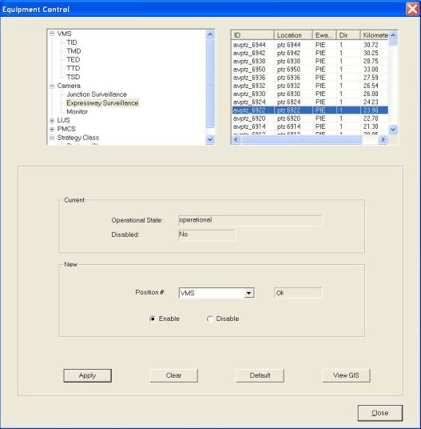

   Click on any equipment to select it. To do multiple selection, press and hold Shift button or Ctrl button on your keyboard and click on the equipment on the list.

The selected will be highlighted in blue background. The current settings for the selected equipment appear in the Current panel.

  In the New panel, click on a Position.

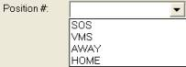

  Click on Apply button to set camera to the new position.

  Wait for the system to response.

•    If the remote control is successful, the response will show “Ok”.

•    If the system response with a “Time Out” after 30 seconds, you should try again by clicking on Apply button.

•    If the system response with “Not Sent”, it simply means that you have not set the new setting.

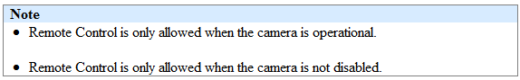

###### Control Monitor

   In the equipment list, click on + sign besides Camera.

The list expands to show the list of equipment types.

   Click on Monitor.

A list of monitors appears on the right with ID, Name and Description  information.

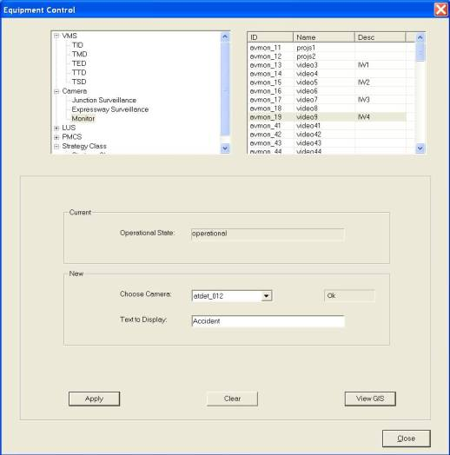

  Click on any equipment to select it. To do multiple selection, press and hold Shift button or Ctrl button on your keyboard and click on the equipment on the list.

The selected will be highlighted in blue background. The current settings for the selected equipment appear in the Current panel.

   In the New panel, click on Choose Camera dropdown arrow.

  Type text in the Text to Display textbox.

  Click on Apply button to save the changes.

|  |
| --- |
| **Note** |
| Remote Control is only allowed when the camera is operational. |

###### View GIS

  Click on View GIS button.

The GIS changes its view and the equipment is highlighted.

|  |
| --- |
| Description: c:\_temp\iw help\events\equipment control\camera\View G72.jpg |
| Figure 154 - View Camera on GIS |

|  |
| --- |
| **Note** |
| You can clear the light blue colour highlight with the Clear Selection Description: c:\_temp\iw help\events\equipment control\camera\View G71.jpg tool on GIS toolbar. |

##### Lane Use Signal (LUS)

The user profile control the functions the user is authorize to use under Platform Control Mode (PCM) or Fall back Control Mode (FCM). Every user will have one user account that enables the user to login to IW. Every user account belongs to a profile.

|  |  |  |  |  |  |  |
| --- | --- | --- | --- | --- | --- | --- |
| **User profile** | | | | | **Operation mode** | |
| DO | Operator | FC | ITSC | Supervisor | PCM | FCM |
| ✓ | ✓ \* | ✓ \*\* | ✓ | ✓ | ✓ | ✓ |

\* Only Tunnel and Zone 1 operators can control

\*\* FC can only view

You may change the graphic code – green arrow, amber cross or red cross

###### Select LUS from GIS

  Click on GIS Selection button.

The GIS on the right switch to tunnel diagram with LUS and the mouse cursor on the GIS turns to .

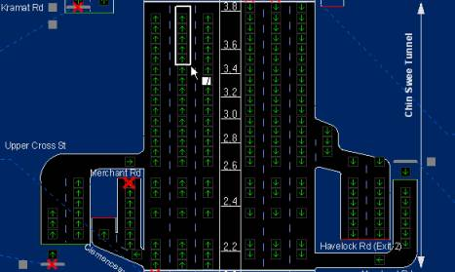

  On tunnel diagram, drag a rectangle over the set of LUS and release the mouse when done.

    The selected LUS are highlighted with Light blue color.

   Right click on tunnel diagram and choose “Send LUS to CCM”

The selected LUS will be highlighted in the list with grey color.

  In the New panel, click on a new graphic icon.

  Click on Apply button to save the changes.

  Wait for the system to response.

•     If the remote control is successful, the response will show “Ok”.

•     If the system response with a “Time Out” after 30 seconds, you should try again by clicking on Apply button.

###### Control LUS

    In the equipment list, click on + sign besides LUS.

The list expands to show the list of LUS equipment.

  Click on LUS.

A list of equipment appears on the right with ID, Location, Dir and Kilometer information.

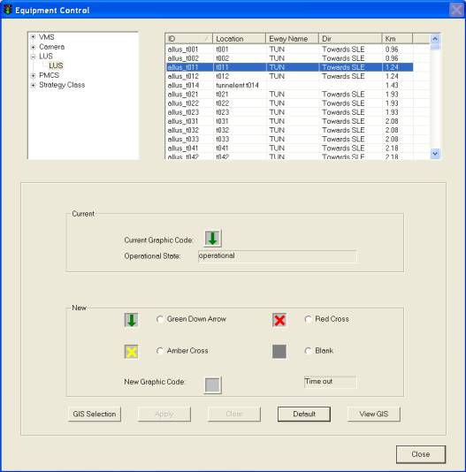

   Click on any equipment to select it. To do multiple selection, press and hold Shift button or Ctrl button on your keyboard and click on the equipment on the list.

The selected equipment will be highlighted in blue background. The current settings for the selected equipment appear in the Current panel.

   In the New panel, click on a new graphic icon.

   Click on Apply button to save the changes.

   Wait for the system to response.

•    If the remote control is successful, the response will show “Ok”.

•   If the system response with a “Time Out” after 30 seconds, you should try again by clicking on Apply button.

|  |
| --- |
| **Note** |
| •     Remote Control is only allowed when the camera is operational.  •    Once EMAS changes the site equipment, the LUS on GIS will show the new graphic. |

###### View GIS

Click on View GIS button.

The GIS changes its view and the equipment is highlighted.

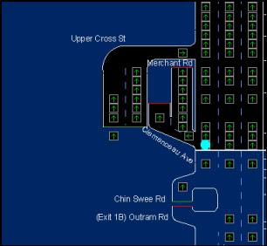

|  |
| --- |
| **Note** |
| You can clear the light blue color highlight with the Clear Selection Description: c:\_temp\iw help\events\equipment control\lus\View G76.jpg tool on GIS toolbar. |

##### Plant Management Control System (PMCS)

You can control the following equipment and their settings:

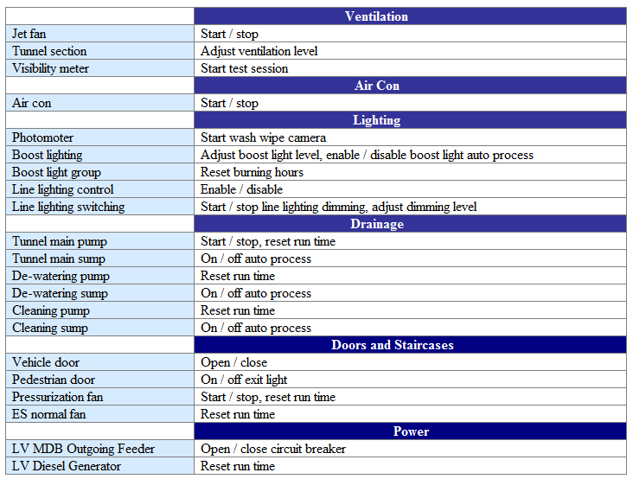

###### Ventilation

|  |  |  |  |  |  |  |
| --- | --- | --- | --- | --- | --- | --- |
| **User profile** | | | | | **Operation mode** | |
| DO | Operator | FC | ITSC | Supervisor | PCM | FCM |
| ✓ | ✓ \* | ✓ \*\* | ✓ | ✓ | ✓ | ✓ |

\* Only Tunnel and Zone 1 operators can control

\*\* Only viewing is allowed

For Ventilation Control  in the tunnel, IW CCM  has the following features:

•    [Control Jet Fan](#_Control_Jet_Fan_2)

•    [Control Tunnel Section (Tunnel Box )](#_Control_Tunnel_Section)

•   [Control Visibility Meter](#_Control_Visibility_Meter)

•    [View GIS](#_View_GIS)

Control Jet Fan

1.   In the equipment list, click on + sign besides PMCS.

2.   The list expands to show the list of PMCS equipment.

3.   Click on + sign besides Ventilation.

4.   Click on Jet Fan.

A list of equipment appears on the right with ID, Location, Eway code, Dir and Kilometer information.

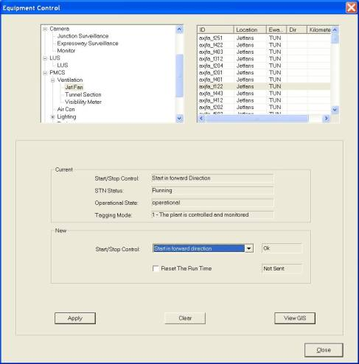

  Click on any equipment to select it. To do multiple selection, press and hold Shift button or Ctrl button on your keyboard and click on the equipment on the list.

The selected equipment will be highlighted in blue background. The current settings for the selected equipment appear in the Current panel.

6.   In the New panel, click on Start/Stop Control dropdown arrow, and click an action.

7.  Click on Reset The Run Time to reset the running hours to 0.

8.  Click on Apply button to save the changes.

9.  Wait for the system to response.

•    If the remote control is successful, the response will show “Ok”.

•    If the system response with a “Time Out” after 30 seconds, you should try again by clicking on Apply button.

•    If the system response with “Not Sent”, it simply means that you have not set the new setting.

|  |
| --- |
| **Note** |
| Remote Control is only allowed when the jet fan is operational and tagging mode is 1. |

Control Tunnel Section (Tunnel Box)

1.   In the equipment list, click on + sign besides PMCS.

The list expands to show the list of PMCS equipment.

2.   Click on + sign besides Ventilation.

3.   Click on Tunnel Section.

A list of equipment appears on the right with ID, Location, Eway code, Dir and Kilometer information.

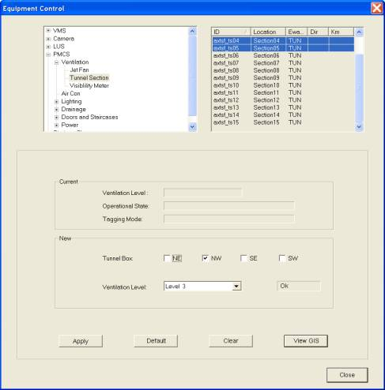

4.   In the New panel, click on a Tunnel Box, you may select more than one tunnel box.

5.  Click on Ventilation Level dropdown arrow, and click a level.

6.  Click on Apply button to save the changes.

7.  Wait for the system to response.

•    If the remote control is successful, the response will show “Ok”.

•     If the system response with a “Time Out” after 30 seconds, you should try again by clicking on Apply button.

•    If the system response with “Not Sent”, it simply means that you have not set the new setting.

|  |
| --- |
| **Note** |
| Remote Control is only allowed when the tunnel section is operational and tagging mode is 1. |

Control Visibility Meter

1.   In the equipment list, click on + sign besides PMCS.

The list expands to show the list of PMCS equipment.

2.   Click on + sign besides Ventilation.

3.   Click on Visibility Meter.

A list of equipment appears on the right with ID, Location, Eway code, Dir and Kilometer information.

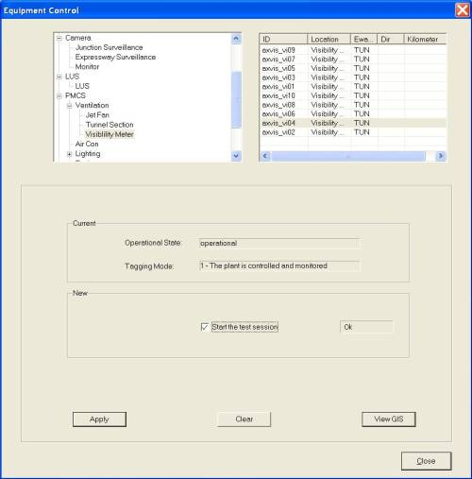

   Click on any equipment to select it. To do multiple selection, press and hold Shift button or Ctrl button on your keyboard and click on the equipment on the list.

The selected will be highlighted in blue background. The current settings for the selected equipment appear in the Current panel.

5.   In the New panel, click on Start the test session.

6.  Click on Apply button to save the changes.

7.  Wait for the system to response.

•    If the remote control is successful, the response will show “Ok”.

•    If the system response with a “Time Out” after 30 seconfs, you should try again by clicking on Apply button.

•    If the system response with “Not Sent”, it simply means that you have not set the new setting.

|  |
| --- |
| **Note** |
| Remote Control is only allowed when the visibility meter is operational and tagging mode is 1. |

View GIS

Click on View GIS button.

The GIS changes its view and the equipment is highlighted.

|  |
| --- |
| Description: c:\_temp\iw help\events\equipment control\pmcs\View G83.jpg |
| Figure 155 - Highlighted Jet Fan |

|  |
| --- |
| **Note** |
| You can clear the light blue color highlight with the Clear Selection Description: c:\_temp\iw help\events\equipment control\pmcs\View G81.jpg tool on GIS toolbar. |

###### Air Con

|  |  |  |  |  |  |  |
| --- | --- | --- | --- | --- | --- | --- |
| **User profile** | | | | | **Operation mode** | |
| DO | Operator | FC | ITSC | Supervisor | PCM | FCM |
| ✓ | ✓ \* | ✓ \*\* | ✓ | ✓ | ✓ | ✓ |

\* Only Tunnel and Zone 1 operators can control

\*\* Only viewing is allowed

For Air Con Control  in the tunnel, IW CCM  has the following features:

•         [Control Air Con](#_Control_Air_Con)

•         [View GIS](#_View_GIS_1)

Control Air Con

    In the equipment list, click on + sign besides PMCS.

The list expands to show the list of PMCS equipment.

    Click on Air Con.

A list of equipment appears on the right with ID, Location, Eway code, Dir and Kilometer information.

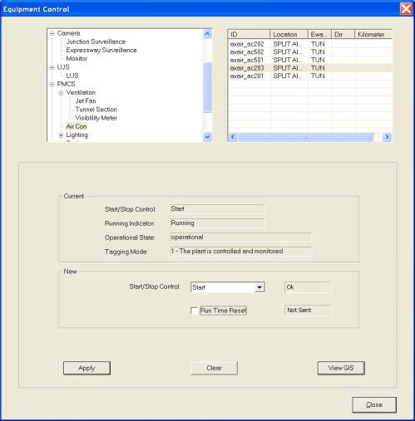

  Click on any equipment to select it. To do multiple selection, press and hold Shift button or Ctrl button on your keyboard and click on the equipment on the list.

The selected equipment will be highlighted in blue background. The current settings for the selected equipment appear in the Current panel.

   In the New panel, click on Start/Stop Control dropdown arrow, and click an action.

  Click on Run Time Reset to reset the running hours to 0.

   Click on Apply button to save the changes.

   Wait for the system to response.

•     If the remote control is successful, the response will show “Ok”.

•     If the system response with a “Time Out” after 30 seconds, you should try again by clicking on Apply button.

•      If the system response with “Not Sent”, it simply means that you have not set the new setting.

|  |
| --- |
| **Note** |
| Remote Control is only allowed when the air con is operational and tagging mode is 1. |

View GIS

|  |  |  |  |  |  |  |
| --- | --- | --- | --- | --- | --- | --- |
| **User profile** | | | | | **Operation mode** | |
| DO | Operator | FC | ITSC | Supervisor | PCM | FCM |
| ✓ | ✓ | ✓ | ✓ | ✓ | ✓ | ✓ |

Click on View GIS button.

The GIS changes its view and the equipment is highlighted.

|  |
| --- |
| Description: c:\_temp\iw help\events\equipment control\pmcs\aircon\View G85.jpg |
| Figure 156 - Highlighted Air Con |

|  |
| --- |
| **Note** |
| You can clear the light blue color highlight with the Clear Selection Description: c:\_temp\iw help\events\equipment control\pmcs\aircon\View G84.jpg tool on GIS toolbar. |

###### Lighting

|  |  |  |  |  |  |  |
| --- | --- | --- | --- | --- | --- | --- |
| **User profile** | | | | | **Operation mode** | |
| DO | Operator | FC | ITSC | Supervisor | PCM | FCM |
| ✓ | ✓ \* | ✓ \*\* | ✓ | ✓ | ✓ | ✓ |

\* Only Tunnel and Zone 1 operators can control

\*\* Only viewing is allowed

For Lighting Control  in the tunnel, IW CCM  has the following features:

•    [Control Photometer](#_Control_Photometer)

•    [Control Boost Lighting](#_Control_Boost_Lighting)

•    [Control](file:///C:\Users\Brenda%20Seah\Desktop\Drainage\Control%20De-watering%20Pump.htm) [Boost Lighting Group](#_Control_Boost_Light)

•    [Control](file:///C:\Users\Brenda%20Seah\Desktop\Doors%20and%20staircases\Control%20ES%20Normal%20Fan.htm) [Line Lighting Control North Tunnel](#_Control_Line_Lighting)

•    [Control](file:///C:\Users\Brenda%20Seah\Desktop\Doors%20and%20staircases\Control%20ES%20Normal%20Fan.htm) [Line Lighting Control South Tunnel](#_Control_Line_Lighting_1)

•    [Control](file:///C:\Users\Brenda%20Seah\Desktop\Doors%20and%20staircases\Control%20ES%20Normal%20Fan.htm) [Line Lighting Switching](#_Control_Line_Lighting_2)

•    [View GIS](#_View_GIS_2)

Control Photometer

1.  In the equipment list, click on + sign besides PMCS.

The list expands to show the list of PMCS equipment.

2.  Click on + sign besides Lighting.

3.  Click on Photometer.

A list of equipment appears on the right with ID, Location, Eway code, Dir and Kilometer information.

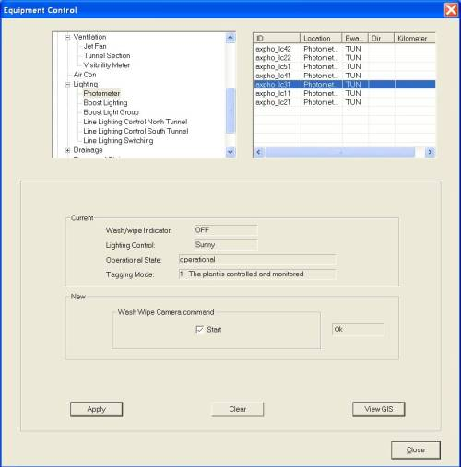

   Click on any equipment to select it. To do multiple selection, press and hold Shift button or Ctrl button on your keyboard and click on the equipment on the list.

The selected equipment will be highlighted in blue background. The current settings for the selected equipment appear in the Current panel.

5.   In the New panel, click on Start to start the Wash Wipe Camera.

6.   Click on Apply button to save the changes.

7.  Wait for the system to response.

•     If the remote control is successful, the response will show “Ok”.

•    If the system response with a “Time Out” after 30 seconds, you should try again by clicking on Apply button.

•    If the system response with “Not Sent”, it simply means that you have not set the new setting.

|  |
| --- |
| **Note** |
| Remote Control is only allowed when the photometer is operational and tagging mode is 1. |

Control Boost Lighting

1.   In the equipment list, click on + sign besides PMCS.

The list expands to show the list of PMCS equipment.

2.   Click on + sign besides Lighting.

3.   Click on Boost Lighting.

A list of equipment appears on the right with ID, Location, Eway code, Dir and Kilometer information.

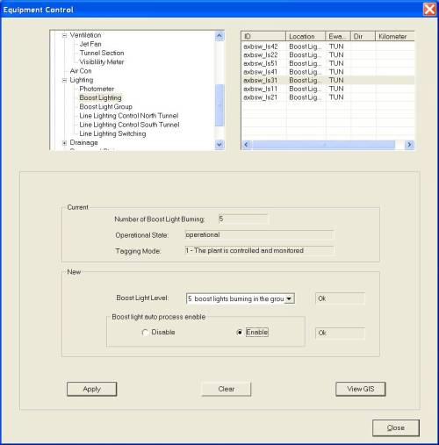

  Click on any equipment to select it. To do multiple selection, press and hold Shift button or Ctrl button on your keyboard and click on the equipment on the list.

The selected equipment will be highlighted in blue background. The current settings for the selected equipment appear in the Current panel.

5.   In the New panel, click on Boost Light Level dropdown arrow, and click a level.

6.   In Boost light auto process enable, click on disable or enable.

7.   Click on Reset The Run Time to reset the running hours to 0.

8.  Click on Apply button to save the changes.

9.  Wait for the system to response.

•     If the remote control is successful, the response will show “Ok”.

•    If the system response with a “Time Out” after 30 seconds, you should try again by clicking on Apply button.

•   If the system response with “Not Sent”, it simply means that you have not set the new setting.

|  |
| --- |
| **Note** |
| Remote Control is only allowed when the boost lighting is operational and tagging mode is 1. |

Control Boost Light Group

1.    In the equipment list, click on + sign besides PMCS.

The list expands to show the list of PMCS equipment.

2.    Click on + sign besides Lighting.

3.   Click on Boost Light Group.

A list of equipment appears on the right with ID, Location, Eway code, Dir and Kilometre information.

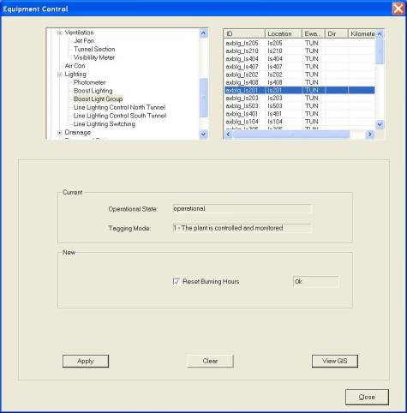

   Click on any equipment to select it. To do multiple selection, press and hold Shift button or Ctrl button on your keyboard and click on the equipment on the list.

The selected equipment will be highlighted in blue background. The current settings for the selected equipment appear in the Current panel.

5.   In the New panel, click on Reset The Run Time to reset the running hours to 0.

6.  Click on Apply button to save the changes.

7.  Wait for the system to response.

•    If the remote control is successful, the response will show “Ok”.

•    f the system response with a “Time Out” after 30 seconds, you should try again by clicking on Apply button.

•     If the system response with “Not Sent”, it simply means that you have not set the new setting.

|  |
| --- |
| **Note** |
| Remote Control is only allowed when the boost light group is operational and tagging mode is 1. |

Control Line Lighting Control North Tunnel

1.   In the equipment list, click on + sign besides PMCS.

The list expands to show the list of PMCS equipment.

2.   Click on + sign besides Lighting.

3.  Click on Line Lighting Control North Tunnel.

A list of equipment appears on the right with ID, Location, Eway code, Dir and Kilometer information.

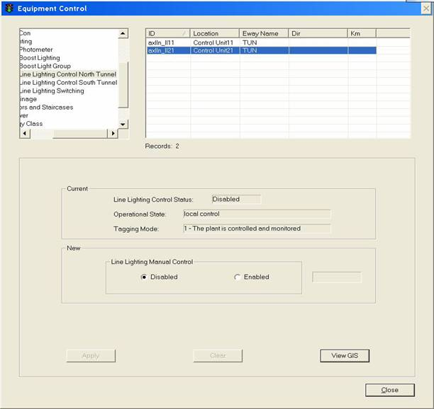

4.  Click on any equipment to select it. To do multiple selection, press and hold Shift button or Ctrl button on your keyboard and click on the equipment on the list..

The selected equipment will be highlighted in blue background. The current settings for the selected equipment appear in the Current panel.

5.  In the New panel, click on Enabled or Disabled for the Line Lighting Control.

6.  Click on Apply button to save the changes.

7.   Wait for the system to response.

•     If the remote control is successful, the response will show “Ok”.

•     If the system response with a “Time Out” after 30 seconds, you should try again by clicking on Apply button.

•     If the system response with “Not Sent”, it simply means that you have not set the new setting.

|  |
| --- |
| **Note** |
| Remote Control is only allowed when the line lighting control is operational and tagging mode is 1. |

Control Line Lighting Control South Tunnel

Controlling line lighting for south tunnel is the same as line lighting for north tunnel, please refer to [control line lighting control north tunnel.](#_Control_Line_Lighting)

Control Line Lighting Switching

1.  In the equipment list, click on + sign besides PMCS.

The list expands to show the list of PMCS equipment.

2.  Click on + sign besides Lighting.

3.  Click on Line Lighting Switching.

A list of equipment appears on the right with ID, Location, Eway code, Dir and Kilometer information.

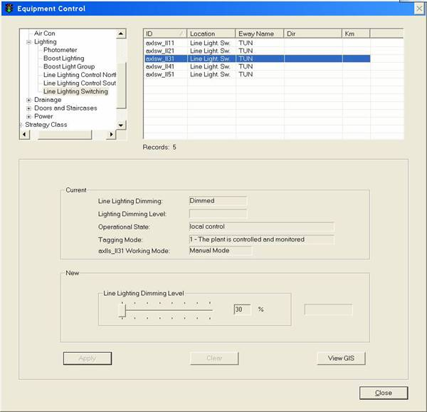

   Click on any equipment to select it. To do multiple selection, press and hold Shift button or Ctrl button on your keyboard and click on the equipment on the list.

The selected equipment will be highlighted in blue background. The current settings for the selected equipment appear in the Current panel.

5.  Choose Line Light Dimming Level to adjust the level (%).

7.  Click on Apply button to save the changes.

8.  Wait for the system to response.

•    If the remote control is successful, the response will show “Ok”.

•    If the system response with a “Time Out” after 30 seconds, you should try again by clicking on Apply button.

•    If the system response with “Not Sent”, it simply means that you have not set the new setting.

|  |
| --- |
| **Note** |
| Remote Control is only allowed when the line lighting switching is operational and tagging mode is 1. |

View GIS

  Click on View GIS button.

The GIS changes its view and the equipment is highlighted.

|  |
| --- |
| Description: c:\_temp\iw help\events\equipment control\pmcs\lighting\View G92.jpg |
| Figure 159 - Highlighted line lighting |

|  |
| --- |
| **Note** |
| You can clear the light blue color highlight with the Clear Selection Description: c:\_temp\iw help\events\equipment control\pmcs\lighting\View G91.jpg tool on GIS toolbar. |

###### Drainage

|  |  |  |  |  |  |  |
| --- | --- | --- | --- | --- | --- | --- |
| **User profile** | | | | | **Operation mode** | |
| DO | Operator | FC | ITSC | Supervisor | PCM | FCM |
| ✓ | ✓ \* | ✓ \*\* | ✓ | ✓ | ✓ | ✓ |

\* Only Tunnel and Zone 1 operators can control

\*\* Only viewing is allowed

For Drainage Control  in the tunnel, IW CCM  has the following features:

•   [Control Tunnel Main Pump](#_Control_Tunnel_Main)

•    [Control](file:///C:\Users\Brenda%20Seah\Desktop\Doors%20and%20staircases\Control%20Pedestrian%20Door.htm) [Tunnel Main Sump](#_Control_Tunnel_Main_1)

•    [Control De-watering Pump](#_Control_De-watering_Pump)

•    [Control](file:///C:\Users\Brenda%20Seah\Desktop\Doors%20and%20staircases\Control%20ES%20Normal%20Fan.htm) [De-watering Sump](#_Control_De-watering_Sump)

•    [Control Cleaning Pump](#_Control_Cleaning_Pump)

•    [Control](file:///C:\Users\Brenda%20Seah\Desktop\Doors%20and%20staircases\Control%20ES%20Normal%20Fan.htm) [Cleaning Sump](#_Control_Cleaning_Sump)

•    [View GIS](#_View_GIS_3)

Control Tunnel Main Pump

1.   In the equipment list, click on + sign besides PMCS.

The list expands to show the list of PMCS equipment.

2.   Click on + sign besides Drainage.

3.  Click on Tunnel Main Pump.

A list of equipment appears on the right with ID, Location, Eway code, Dir and Kilometer information.

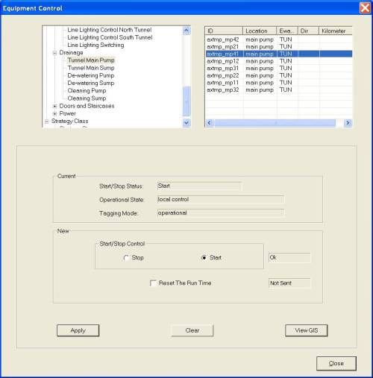

   Click on any equipment to select it. To do multiple selection, press and hold Shift button or Ctrl button on your keyboard and click on the equipment on the list.

The selected equipment will be highlighted in blue background. The current settings for the selected equipment appear in the Current panel.

5.  In the New panel, click on Start or Stop to start/stop the pump.

6.   Click on Reset The Run Time to reset the running hours to 0.

7.   Click on Apply button to save the changes.

8.  Wait for the system to response.

•    If the remote control is successful, the response will show “Ok”.

•     If the system response with a “Time Out” after 30 seconds, you should try again by clicking on Apply button.

•    If the system response with “Not Sent”, it simply means that you have not set the new setting.

|  |
| --- |
| **Note** |
| Remote Control is only allowed when the pump is operational and tagging mode is 1. |

Control Tunnel Main Sump

1.    In the equipment list, click on + sign besides PMCS.

The list expands to show the list of PMCS equipment.

2.   Click on + sign besides Drainage.

3.   Click on Tunnel Main Sump.

A list of equipment appears on the right with ID, Location, Eway code, Dir and Kilometer information.

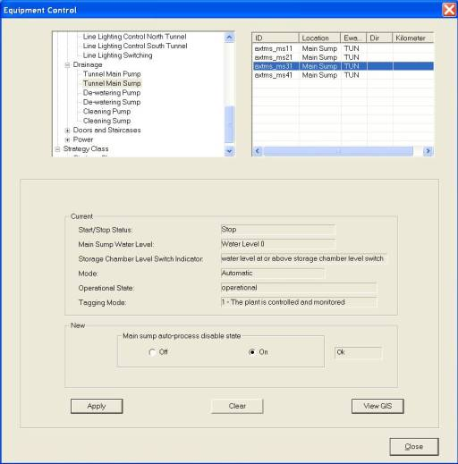

   Click on any equipment to select it. To do multiple selection, press and hold Shift button or Ctrl button on your keyboard and click on the equipment on the list.

The selected equipment will be highlighted in blue background. The current settings for the selected equipment appear in the Current panel.

5.   In the New panel, click on Off or On for Main sump auto-process disable state.

6.  Click on Apply button to save the changes.

7.   Wait for the system to response.

•    If the remote control is successful, the response will show “Ok”.

•  If the system response with a “Time Out” after 30 seconds, you should try again by clicking on Apply button.

•    If the system response with “Not Sent”, it simply means that you have not set the new setting.

|  |
| --- |
| **Note** |
| Remote Control is only allowed when the sump is operational and tagging mode is 1. |

Control De-watering Pump

1.   In the equipment list, click on + sign besides PMCS.

    The list expands to show the list of PMCS equipment.

2.  Click on + sign besides Drainage.

3.   Click on De-watering Pump.

    A list of equipment appears on the right with ID, Location, Eway code, Dir and Kilometer information.

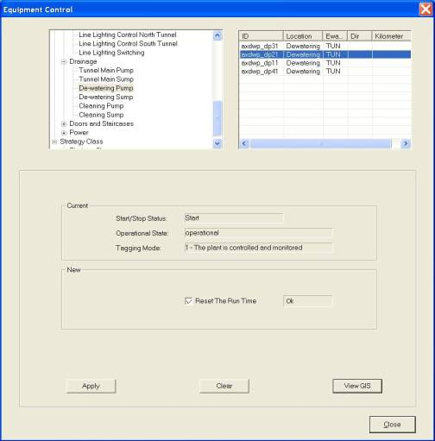

   Click on any equipment to select it. To do multiple selection, press and hold Shift button or Ctrl button on your keyboard and click on the equipment on the list.

The selected equipment will be highlighted in blue background. The current settings for the selected equipment appear in the Current panel.

5.   Click on Reset The Run Time to reset the running hours to 0.

6.   Click on Apply button to save the changes.

7.   Wait for the system to response.

•    If the remote control is successful, the response will show “Ok”.

•    If the system response with a “Time Out” after 30 seconds, you should try again by clicking on Apply button.

•    If the system response with “Not Sent”, it simply means that you have not set the new setting.

|  |
| --- |
| **Note** |
| Remote Control is only allowed when the pump is operational and tagging mode is 1. |

Control De-watering Sump

1.   In the equipment list, click on + sign besides PMCS.

The list expands to show the list of PMCS equipment.

2.   Click on + sign besides Drainage.

3.  Click on De-watering Pump.

A list of equipment appears on the right with ID, Location, Eway code, Dir and Kilometer information.

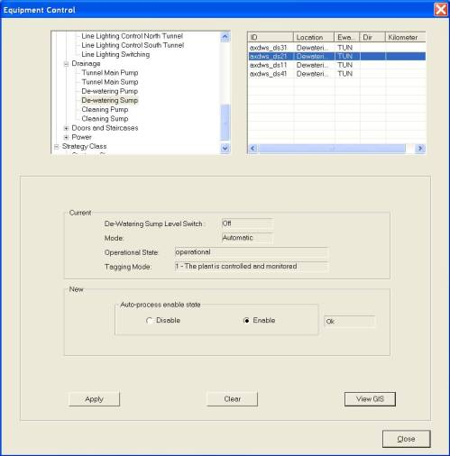

   Click on any equipment to select it. To do multiple selection, press and hold Shift button or Ctrl button on your keyboard and click on the equipment on the list.

The selected equipment will be highlighted in blue background. The current settings for the selected equipment appear in the Current panel.

5.   In the New panel, click on Off or On for auto-process disable state.

6.   Click on Apply button to save the changes.

7.   Wait for the system to response.

•    If the remote control is successful, the response will show “Ok”.

•     If the system response with a “Time Out” after 30 seconds, you should try again by clicking on Apply button.

•    If the system response with “Not Sent”, it simply means that you have not set the new setting.

|  |
| --- |
| **Note** |
| Remote Control is only allowed when the sump is operational and tagging mode is 1. |

Control Cleaning Pump

1.   In the equipment list, click on + sign besides PMCS.

The list expands to show the list of PMCS equipment.

2.   Click on + sign besides Drainage.

3.   Click on Cleaning Pump.

A list of equipment appears on the right with ID, Location, Eway code, Dir and Kilometer information.

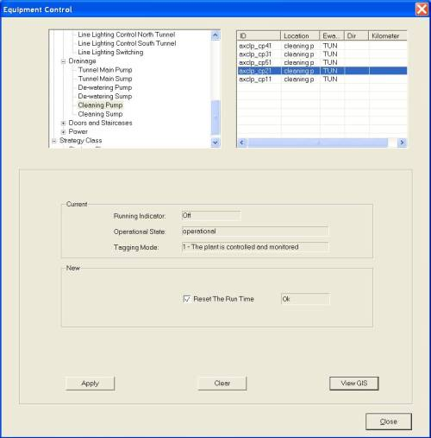

  Click on any equipment to select it. To do multiple selection, press and hold Shift button or Ctrl button on your keyboard and click on the equipment on the list.

The selected will be highlighted in blue background. The current settings for the selected equipment appear in the Current panel.

5.  Click on Reset The Run Time to reset the running hours to 0.

6.  Click on Apply button to save the changes.

7.  Wait for the system to response.

•    If the remote control is successful, the response will show “Ok”.

•  If the system response with a “Time Out” after 30 seconds, you should try again by clicking on Apply button.

•    If the system response with “Not Sent”, it simply means that you have not set the new setting.

|  |
| --- |
| **Note** |
| Remote Control is only allowed when the pump is operational and tagging mode is 1. |

Control Cleaning Sump

1.   In the equipment list, click on + sign besides PMCS.

The list expands to show the list of PMCS equipment.

2.   Click on + sign besides Drainage.

3.   Click on Cleaning Sump.

A list of equipment appears on the right with ID, Location, Eway code, Dir and Kilometer information.

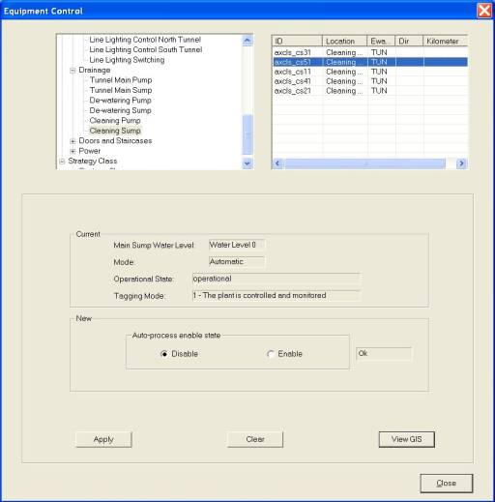

   Click on any equipment to select it. To do multiple selection, press and hold Shift button or Ctrl button on your keyboard and click on the equipment on the list.

The selected equipment will be highlighted in blue background. The current settings for the selected equipment appear in the Current panel.

5.   In the New panel, click on Off or On for auto-process disable state.

6.   Click on Apply button to save the changes.

7.   Wait for the system to response.

•    If the remote control is successful, the response will show “Ok”.

•    If the system response with a “Time Out” after 30 seconds, you should try again by clicking on Apply button.

•    If the system response with “Not Sent”, it simply means that you have not set the new setting.

|  |
| --- |
| **Note** |
| Remote Control is only allowed when the sump is operational and tagging mode is 1. |

View GIS

Click on View GIS button.

The GIS changes its view and the equipment is highlighted.

|  |
| --- |
| Description: c:\_temp\iw help\events\equipment control\pmcs\drainage\viewGIS.jpg |
| Figure 160 - Highlighted pump |

|  |
| --- |
| **Note** |
| You can clear the light blue colour highlight with the Clear Selection Description: c:\_temp\iw help\events\equipment control\pmcs\drainage\View G99.jpg tool on GIS toolbar. |

###### Doors and staircases

|  |  |  |  |  |  |  |
| --- | --- | --- | --- | --- | --- | --- |
| **User profile** | | | | | **Operation mode** | |
| DO | Operator | FC | ITSC | Supervisor | PCM | FCM |
| ✓ | ✓ \* | ✓ \*\* | ✓ | ✓ | ✓ | ✓ |

\* Only Tunnel and Zone 1 operators can control

\*\* Only viewing is allowed

For Doors and Staircases Control  in the tunnel, IW CCM  has the following features:

•   [Control Vehicle Door](#_Control_Vehicle_Door)

•   [Control Pedestrian Door](#_Control_Pedestrian_Door)

•   [Control Pressurization Fan](#_Control_Pressurization_Fan)

•   [Control ES Normal  Fan](#_Control_ES_Normal)

•   [View GIS](#_View_GIS_4)

Control Vehicle Door

   In the equipment list, click on + sign besides PMCS.

The list expands to show the list of PMCS equipment.

  Click on + sign besides Doors and Staircases.

3.  Click on Vehicle Door.

A list of equipment appears on the right with ID, Location, Eway code, Dir and Kilometer information.

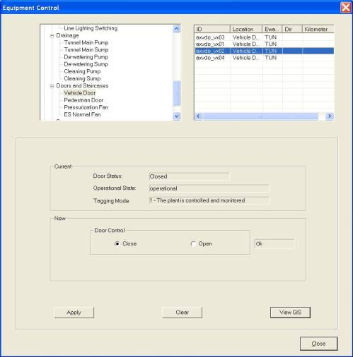

  Click on any equipment to select it. To do multiple selection, press and hold Shift button or Ctrl button on your keyboard and click on the equipment on the list.

The selected equipment will be highlighted in blue background. The current settings for the selected equipment appear in the Current panel.

5.  In the New panel, click on Close or Open to close/open the door.

6.  Click on Apply button to save the changes.

7.   Wait for the system to response.

•   If the remote control is successful, the response will show “Ok”.

•    If the system response with a “Time Out” after 30 seconds, you should try again by clicking on Apply button.

•   If the system response with “Not Sent”, it simply means that you have not set the new setting.

|  |
| --- |
| **Note** |
| Remote Control is only allowed when the door is operational and tagging mode is 1. |

Control Pedestrian Door

   In the equipment list, click on + sign besides PMCS.

The list expands to show the list of PMCS equipment.

  Click on + sign besides Doors and Staircases.

3.  Click on Pedestrian Door.

A list of equipment appears on the right with ID, Location, Eway code, Dir and Kilometer information.

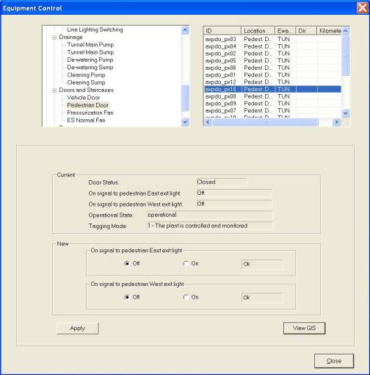

  Click on any equipment to select it. To do multiple selection, press and hold Shift button or Ctrl button on your keyboard and click on the equipment on the list.

The selected equipment will be highlighted in blue background. The current settings for the selected equipment appear in the Current panel.

5.  In the New panel, click on On or Off to on/off east exit light of the door.

6.   Click on On or Off to on/off west exit light of the door.

7.  Click on Apply button to save the changes.

8.  Wait for the system to response

•     If the remote control is successful, the response will show “Ok”.

•     If the system response with a “Time Out” after 30 seconds, you should try again by clicking on Apply button.

•     If the system response with “Not Sent”, it simply means that you have not set the new setting.

|  |
| --- |
| **Note** |
| Remote Control is only allowed when the door is operational and tagging mode is 1. |

Control Pressurization Fan

   In the equipment list, click on + sign besides PMCS.

The list expands to show the list of PMCS equipment.

   Click on + sign besides Doors and Staircases.

3.  Click on Pressurization Fan.

A list of equipment appears on the right with ID, Location, Eway code, Dir and Kilometer information.

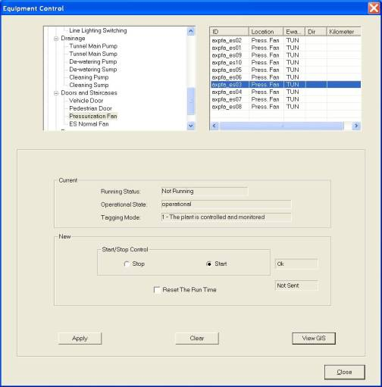

  Click on any equipment to select it. To do multiple selection, press and hold Shift button or Ctrl button on your keyboard and click on the equipment on the list.

The selected equipment will be highlighted in blue background. The current settings for the selected equipment appear in the Current panel.

5.   In the New panel, click on Stop or Start to stop/start the fan.

6.  Click on Reset The Run Time to reset the running hours to 0.

7.   Click on Apply button to save the changes.

8.  Wait for the system to response.

•    If the remote control is successful, the response will show “Ok”.

•    If the system response with a “Time Out” after 30 seconds, you should try again by clicking on Apply button.

•    If the system response with “Not Sent”, it simply means that you have not set the new setting.

|  |
| --- |
| **Note** |
| Remote Control is only allowed when the fan is operational and tagging mode is 1. |

Control ES Normal Fan

   In the equipment list, click on + sign besides PMCS.

The list expands to show the list of PMCS equipment.

   Click on + sign besides Doors and Staircases

3.   Click on ES Normal Fan.

A list of equipment appears on the right with ID, Location, Eway code, Dir and Kilometer information.

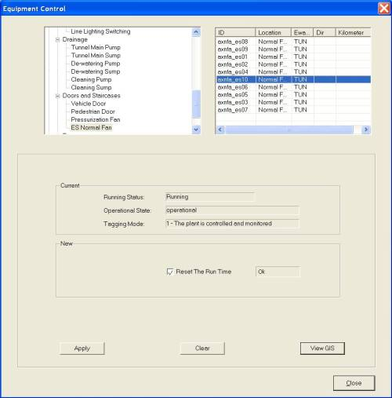

   Click on any equipment to select it. To do multiple selection, press and hold Shift button or Ctrl button on your keyboard and click on the equipment on the list.

The selected will be highlighted in blue background. The current settings for the selected equipment appear in the Current panel.

5.   Click on Reset The Run Time to reset the running hours to 0.

6.   Click on Apply button to save the changes.

7.   Wait for the system to response.

•     If the remote control is successful, the response will show “Ok”.

•     If the system response with a “Time Out” after 30 seconds, you should try again by clicking on Apply button.

•     If the system response with “Not Sent”, it simply means that you have not set the new setting.

|  |
| --- |
| **Note** |
| Remote Control is only allowed when the fan is operational and tagging mode is 1. |

View GIS

Click on View GIS button.

The GIS changes its view and the equipment is highlighted.

|  |
| --- |
| Description: c:\_temp\iw help\events\equipment control\pmcs\doors and staircases\View G7.jpg |
| Figure 159 - Highlighted vehicle door |

|  |
| --- |
| **Note** |
| You can clear the light blue color highlight with the Clear Selection Description: c:\_temp\iw help\events\equipment control\pmcs\doors and staircases\View G6.jpg tool on GIS toolbar. |

###### Power

|  |  |  |  |  |  |  |
| --- | --- | --- | --- | --- | --- | --- |
| **User profile** | | | | | **Operation mode** | |
| DO | Operator | FC | ITSC | Supervisor | PCM | FCM |
| ✓ | ✓ \* | ✓ \*\* | ✓ | ✓ | ✓ | ✓ |

\* Only Tunnel and Zone 1 operators can control

\*\* Only viewing is allowed

For Lighting Control  in the tunnel, IW CCM  has the following features:

•    [Control LV MDB Outgoing Feeder](#_Control_LV_MDB)

•    [Control LV Diesel Generator](#_Control_LV_Diesel)

•    [View GIS](#_View_GIS_5)

Control LV MDB Outgoing Feeder

1.   In the equipment list, click on + sign besides PMCS.

The list expands to show the list of PMCS equipment.

2.   Click on + sign besides Power.

3.   Click on LV MDB Outgoing Feeder.

A list of equipment appears on the right with ID, Location, Eway code, Dir and Kilometer information.

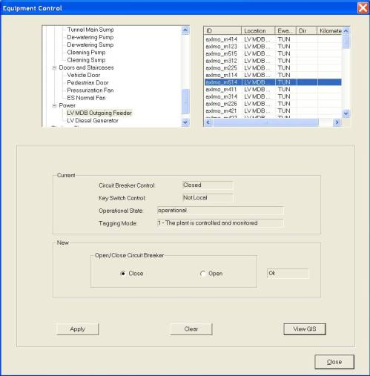

  Click on any equipment to select it. To do multiple selection, press and hold Shift button or Ctrl button on your keyboard and click on the equipment on the list.

5.  The selected equipment will be highlighted in blue background. The current settings for the selected equipment appear in the Current panel.

6.   In the New panel, click on Close or Open to close/open the circuit breaker.

7.  Click on Apply button to save the changes.

8.  Wait for the system to response.

•    If the remote control is successful, the response will show “Ok”.

•    If the system response with a “Time Out” after 30 seconds, you should try again by clicking on Apply button.

•    If the system response with “Not Sent”, it simply means that you have not set the new setting.

|  |
| --- |
| **Note** |
| Remote Control is only allowed when the feeder is operational and tagging mode is 1. |

Control LV Diesel Generator

1.   In the equipment list, click on + sign besides PMCS.

The list expands to show the list of PMCS equipment.

2.  Click on + sign besides Power.

3.   Click on LV Diesel Generator.

A list of equipment appears on the right with ID, Location, Eway code, Dir and Kilometer information.

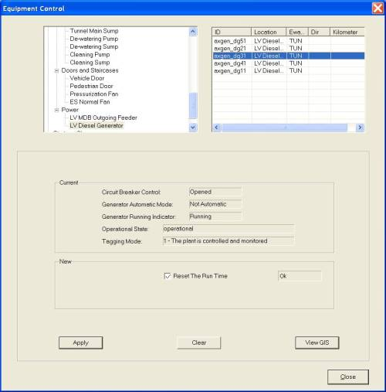

   Click on any equipment to select it. To do multiple selection, press and hold Shift button or Ctrl button on your keyboard and click on the equipment on the list.

The selected equipment will be highlighted in blue background. The current settings for the selected equipment appear in the Current panel.

5.   Click on Reset The Run Time to reset the running hours to 0.

6.  Click on Apply button to save the changes.

7.  Wait for the system to response.

•    If the remote control is successful, the response will show “Ok” .

•    If the system response with a “Time Out” after 30 seconds, you should try again by clicking on Apply button.

•    If the system response with “Not Sent”, it simply means that you have not set the new setting.

|  |
| --- |
| **Note** |
| Remote Control is only allowed when the generator is operational and tagging mode is 1. |

View GIS

Click on View GIS button.

The GIS changes its view and the equipment is highlighted.

|  |
| --- |
| Description: c:\_temp\iw help\events\equipment control\pmcs\power\View G11.jpg |
| Figure 160 - Highlighted diesel generator |

|  |
| --- |
| **Note** |
| You can clear the light blue color highlight with the Clear Selection Description: c:\_temp\iw help\events\equipment control\pmcs\power\View G10.jpg tool on GIS toolbar. |

###### Strategy class

The user profile control the functions the user is authorize to use under Platform Control Mode (PCM) or Fall back Control Mode (FCM). Every user will have one user account that enables the user to login to IW. Every user account belongs to a profile.

|  |  |  |  |  |  |  |
| --- | --- | --- | --- | --- | --- | --- |
| **User profile** | | | | | **Operation mode** | |
| DO | Operator | FC | ITSC | Supervisor | PCM | FCM |
| ✓ | ✓ | ✓ | ✓ | ✓ | ✓ | ✓ |

Activate / deactivate strategy class.

Control Strategy Class

1.    In the equipment list, click on + sign besides Strategy Class.

The list expands to show the list of PMCS equipment.

2.    Click on Strategy Class.

A list of equipment appears on the right with ID, Location, Eway code, Dir and Kilometer information.

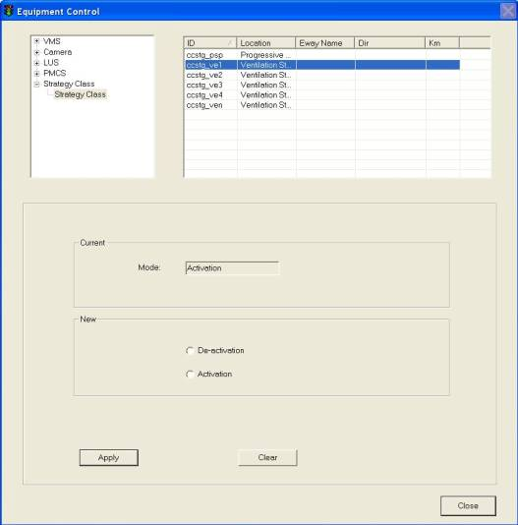

3.    Click on any equipment to select it.

The selected equipment will be highlighted in blue background. The current settings for the selected equipment appear in the Current panel.

4.    In the New panel, click on De-activation or Activation to de-activate/activate the strategy.

5.  Click on Apply button to save the changes.

6.   Wait for the system to response.

•    If the remote control is successful, the response will show “Ok”.

•    If the system response with a “Time Out” after 30 seconds, you should try again by clicking on Apply button.

•    If the system response with “Not Sent”, it simply means that you have not set the new setting.

|  |
| --- |
| **Note** |
| Remote Control is only allowed when the strategy class is operational and tagging mode is 1. |

#### EA

##### Variable Message Sign (VMS)

The user profile control the functions the user is authorize to use under Platform Control Mode (PCM) or Fall back Control Mode (FCM). Every user will have one user account that enables the user to login to IW. Every user account belongs to a profile.

|  |  |  |  |  |  |  |
| --- | --- | --- | --- | --- | --- | --- |
| **User profile** | | | | | **Operation mode** | |
| DO | Operator | FC | ITSC | Supervisor | PCM | FCM |
| ✓ | ✓ | ✓ | ✓ | ✓ | ✓ |  |

For each EA VMS, you may change the following setting:

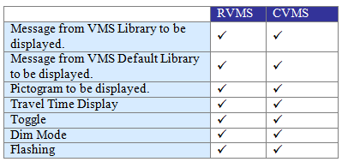

###### Search and Retrieve VMS

   In the equipment list, click on + sign besides AVMS.

The list expands to show the list of EA AVMS equipment.

   Click on VMS (EA RVMS or EA CVMS).

A list of equipment appears on the right with ID, Description, Eway Name, Dir and Kilometer information.

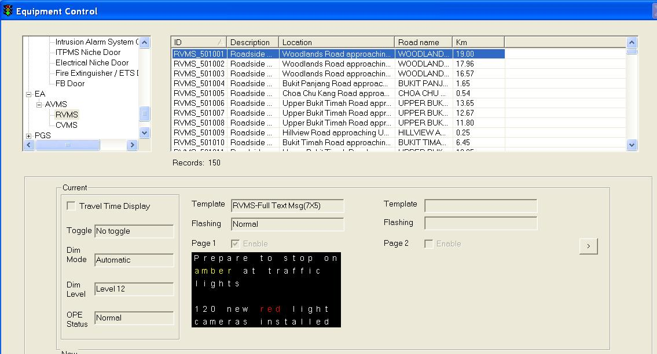

Figure 161 - EA VMS Equipment Control window

  Click on any equipment to select it. To do multiple selection, press and hold Shift button or Ctrl button on your keyboard and click on the equipment on the list.

The selected equipment will be highlighted in blue background. The current settings for the selected equipment appear in the Current panel.

###### Remote Control RVMS and CVMS

   Choose a new message from the [VMS Library](#_VMS_library) or use [Default message](#_VMS_default_librarys).

   In the new panel, click on Travel Time Display if travel time is needed; choose toggle option; choose dim mode.

   Click on Apply button to save the changes.

   Wait for the system to response.

•    If the remote control is successful, the response will show “Ok”.

•    If the system response with a “Time Out” after 30 seconds, you should try again by clicking on Apply button.

•    If the system response with “Not Sent”, it simply means that you have not set the new setting. E.g. you may have chosen a new Graphic Icon but you did not choose a new Brightness. Hence when you click on Apply button, the system immediately replies with “Not Sent” beside the Brightness panel.

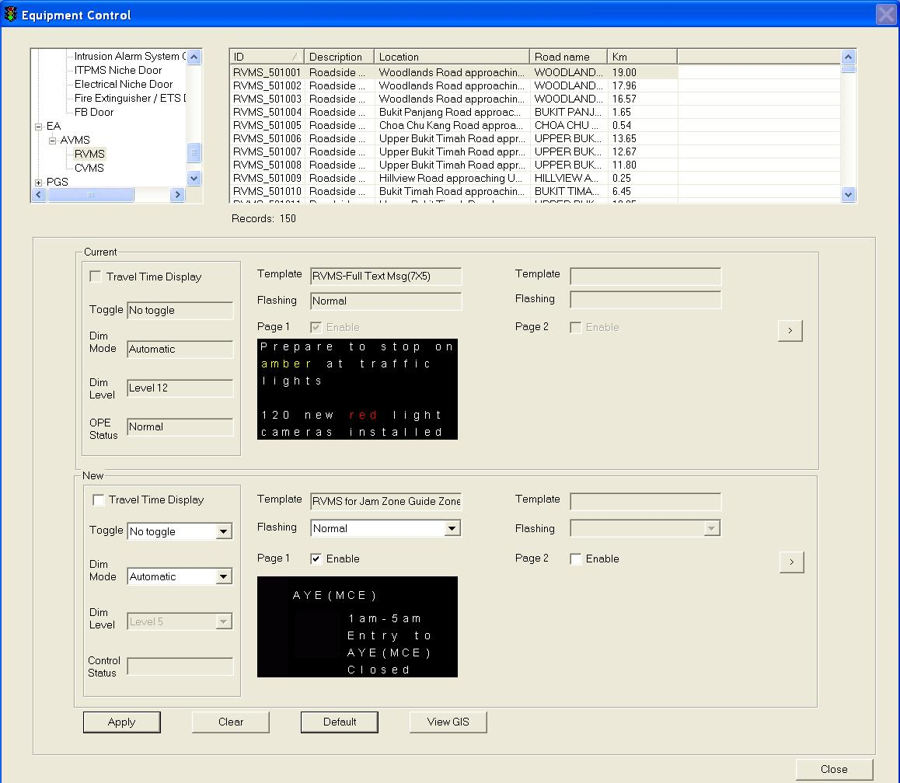

Figure 162 – EA RVMS control window

###### Choose new message from VMS Library

  Click on VMS Library button.

The VMS Library window appears.

  Click on Expressway dropdown arrow, and click on an expressway name.

  Click on Category dropdown arrow, and click on a category.

A list of messages for the selected equipment type, expressway and category appears on the right.

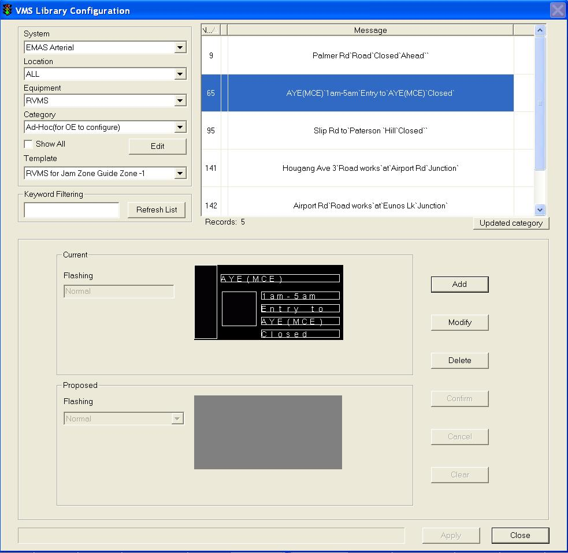

Figure 163 - EA VMS Library Window

  Click on the desired message to select it.

The selected message will be highlighted in blue background. The current settings for the selected message appear in the Current panel.

  Click on Apply button to use this message as the new message or repeat steps 2 – 5 to choose another message.

The VMS Library window closes and the selected message settings appear in the New panel.

  In the Brightness panel, click on a setting.

  Click on Apply button to activate the new changes to the VMS on site.

 Wait for the system to response:

•    If the remote control is successful, the response will show “Ok”. This means the message is sent successfully to the site equipment.

•    If the system response with a “Time Out” after 30 seconds, you should try again by clicking on Apply button as the site equipment is not responding.

###### Set new message using messages in VMS Default Library

   Click on Default button.

The default message (from VMS Default Library) for the selected equipment appears in the New panel.

   In the Brightness panel, click on a setting.

   Click on Apply button to save the changes.

|  |
| --- |
|  |

Figure 164 - EA VMS New Message Setting Window

###### View GIS

Click on View GIS button.

The GIS changes its view and the equipment is highlighted.

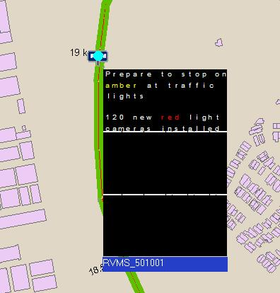

Figure 165 - View EA RVMS on GIS

#### PGS

##### Variable Message Sign (VMS)

The user profile control the functions the user is authorize to use under Platform Control Mode (PCM) or Fall back Control Mode (FCM). Every user will have one user account that enables the user to login to IW. Every user account belongs to a profile.

|  |  |  |  |  |  |  |
| --- | --- | --- | --- | --- | --- | --- |
| **User profile** | | | | | **Operation mode** | |
| DO | Operator | FC | ITSC | Supervisor | PCM | FCM |
| ✓ | ✓ | ✓ | ✓ | ✓ | ✓ |  |

For each PGS VMS, you may change the following setting:

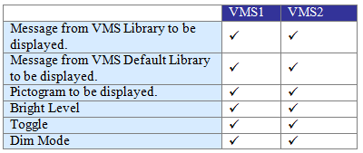

###### Search and Retrieve VMS

   In the equipment list, click on + sign besides AVMS.

The list expands to show the list of EA AVMS equipment.

   Click on VMS (EA RVMS or EA CVMS).

A list of equipment appears on the right with ID, Description, Eway Name, Dir and Kilometer information.

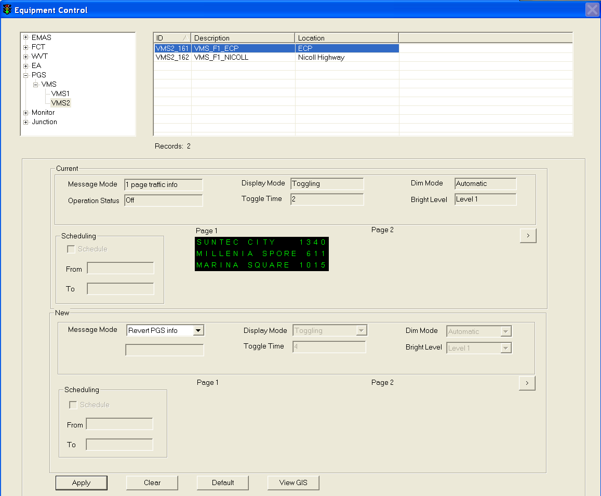

Figure 166 - PGS VMS Equipment Control window

  Click on any equipment to select it. To do multiple selection, press and hold Shift button or Ctrl button on your keyboard and click on the equipment on the list.

The selected equipment will be highlighted in blue background. The current settings for the selected equipment appear in the Current panel.

###### Remote Control RVMS and CVMS

   Choose a new message from the VMS Library or use Default message.

   In the new panel, click on Travel Time Display if travel time is needed; choose toggle option; choose dim mode.

   Click on Apply button to save the changes.

   Wait for the system to response.

•    If the remote control is successful, the response will show “Ok”.

•    If the system response with a “Time Out” after 30 seconds, you should try again by clicking on Apply button.

•    If the system response with “Not Sent”, it simply means that you have not set the new setting. E.g. you may have chosen a new Graphic Icon but you did not choose a new Brightness. Hence when you click on Apply button, the system immediately replies with “Not Sent” beside the Brightness panel.

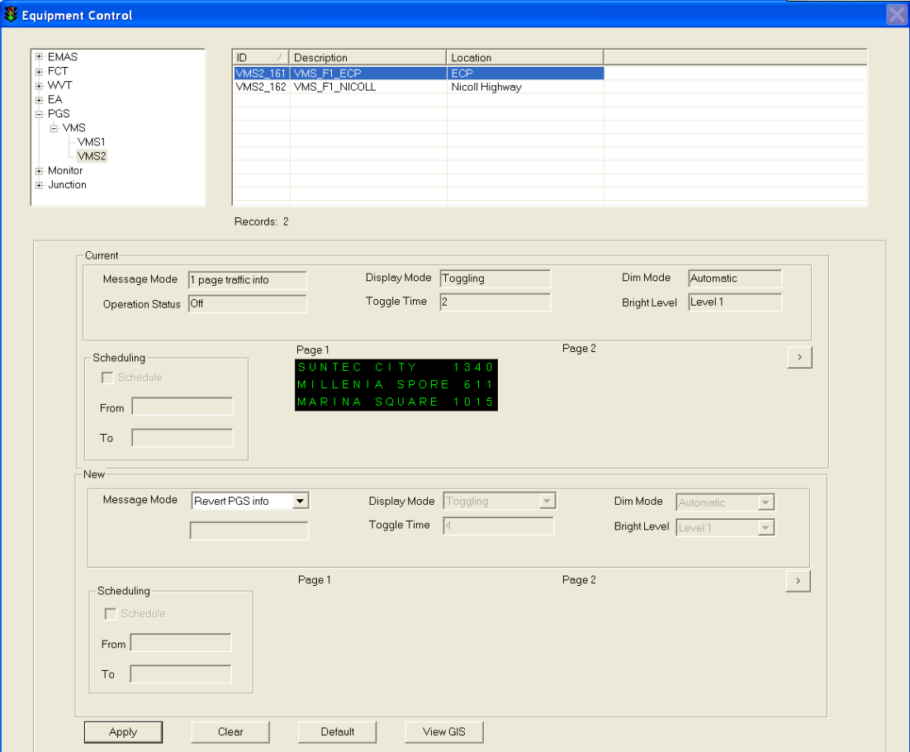

Figure 167 – PGS VMS2 control window

###### Choose new message from VMS Library

  Click on VMS Library button.

The VMS Library window appears.

  Click on Expressway dropdown arrow, and click on an expressway name.

  Click on Category dropdown arrow, and click on a category.

A list of messages for the selected equipment type, expressway and category appears on the right.

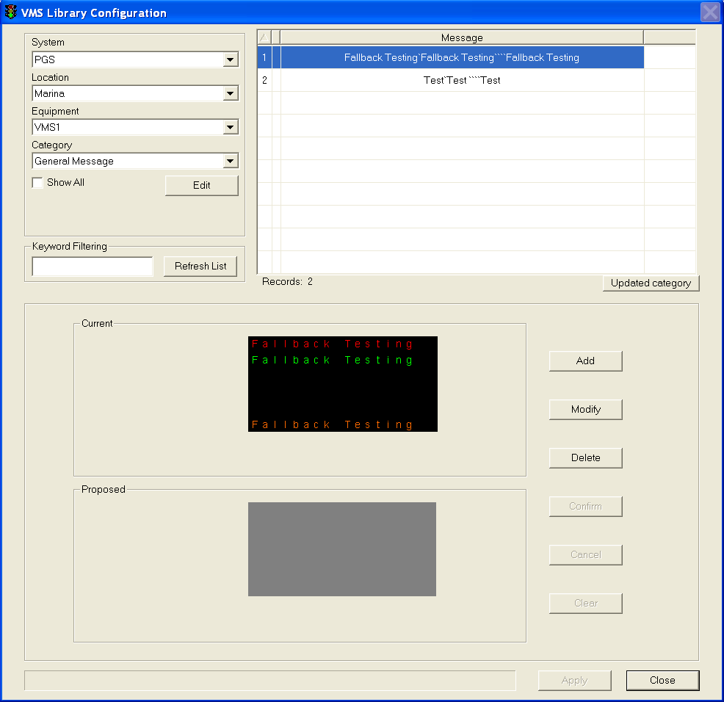

Figure 168 - PGS VMS Library Window

  Click on the desired message to select it.

The selected message will be highlighted in blue background. The current settings for the selected message appear in the Current panel.

  Click on Apply button to use this message as the new message or repeat steps 2 – 5 to choose another message.

The VMS Library window closes and the selected message settings appear in the New panel.

  In the Brightness panel, click on a setting.

  Click on Apply button to activate the new changes to the VMS on site.

 Wait for the system to response:

•    If the remote control is successful, the response will show “Ok”. This means the message is sent successfully to the site equipment.

•    If the system response with a “Time Out” after 30 seconds, you should try again by clicking on Apply button as the site equipment is not responding.

###### Set new message using messages in VMS Default Library

   Click on Default button.

The default message (from VMS Default Library) for the selected equipment appears in the New panel.

   In the Brightness panel, click on a setting.

   Click on Apply button to save the changes.

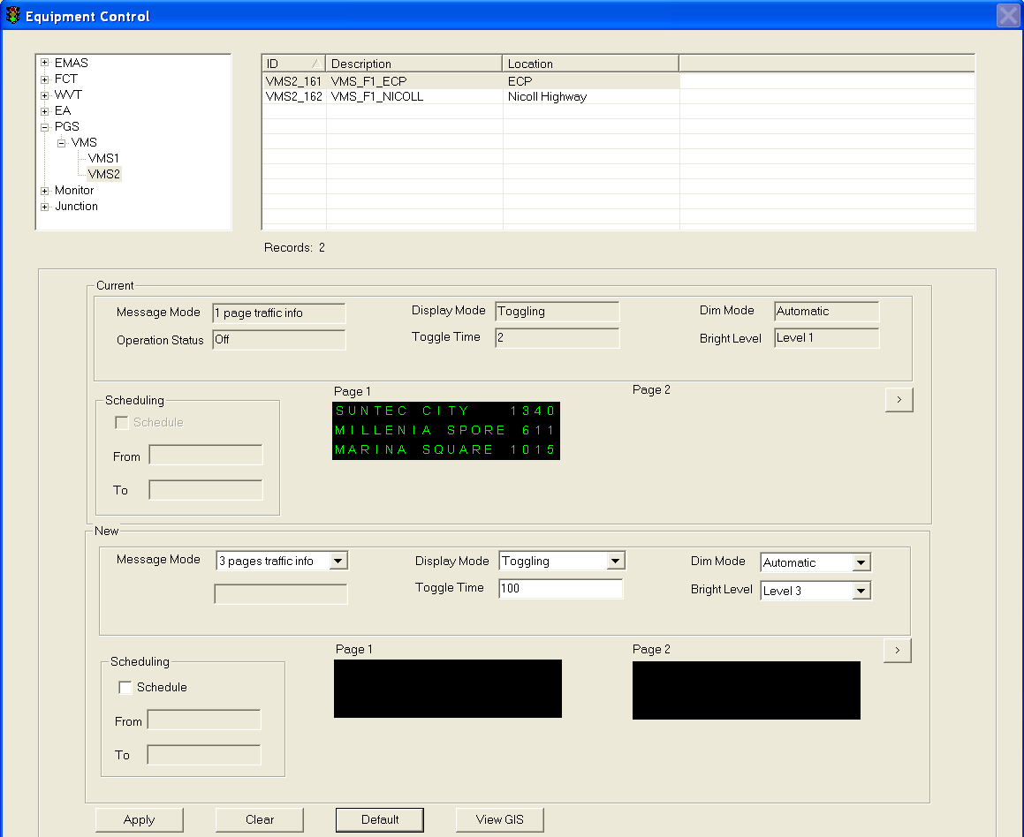

Figure 169 - PGS VMS New Message Setting Window

###### View GIS

Click on View GIS button.

The GIS changes its view and the equipment is highlighted.

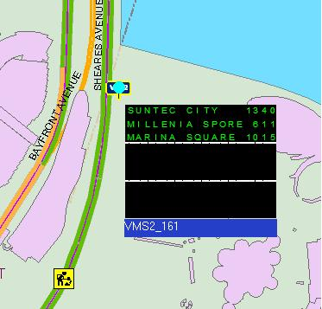

Figure 170 - View PGS VMS2 on GIS

#### Monitor

|  |  |  |  |  |  |  |
| --- | --- | --- | --- | --- | --- | --- |
| **User profile** | | | | | **Operation mode** | |
| DO | Operator | FC | ITSC | Supervisor | PCM | FCM |
| ✓ | ✓ \* | ✓ \*\* | ✓ | ✓ | ✓ | ✓ |

\* Only WVT and Zone 1 operators can control

\*\* Only viewing is allowed

For Lighting Control in the tunnel, IW CCM has the following features:

•    Control Monitor

###### Control Monitor

1.   In the equipment list, click on + sign besides Monitor.

2.   The list expands to show the Monitor equipment.

3.   Click on Monitor.

A list of equipment appears on the right with ID, Description, Eway Name, Dir and Kilometer information.

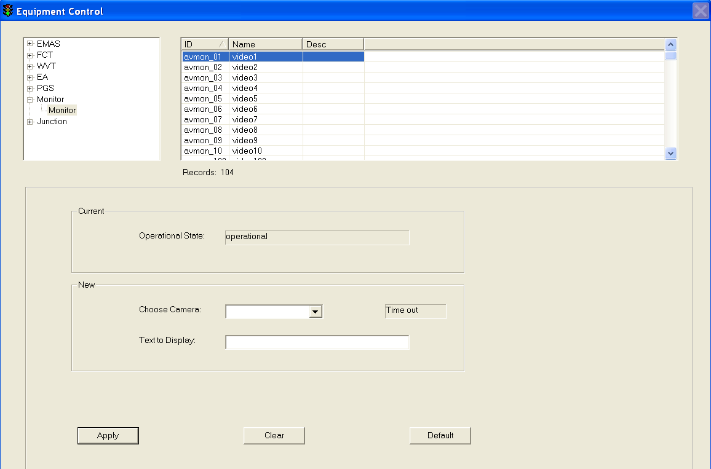

  Click on any equipment to select it.

The selected equipment will be highlighted in blue background. The current settings for the selected equipment appear in the Current panel.

5.   In the New panel, choose a camera from the dropdown list and type the text to display.

7.  Click on Apply button to save the changes.

8.  Wait for the system to response.

•    If the remote control is successful, the response will show “Ok”.

•    If the system response with a “Time Out” after 30 seconds, you should try again by clicking on Apply button.

•    If the system response with “Not Sent”, it simply means that you have not set the new setting.

#### Junction

|  |  |  |  |  |  |  |
| --- | --- | --- | --- | --- | --- | --- |
| **User profile** | | | | | **Operation mode** | |
| DO | Operator | FC | ITSC | Supervisor | PCM | FCM |
| ✓ | ✓ \* | ✓ \*\* | ✓ | ✓ | ✓ | ✓ |

\* Only WVT and Zone 1 operators can control

\*\* Only viewing is allowed

For Lighting Control in the tunnel, IW CCM has the following features:

•    Control Junction

###### Control Junction

1.   In the equipment list, click on + sign besides Monitor.

2.   The list expands to show the Junction equipment.

3.   Click on Junction.

A list of equipment appears on the right with ID, Description, Eway Name, Dir and Kilometer information.

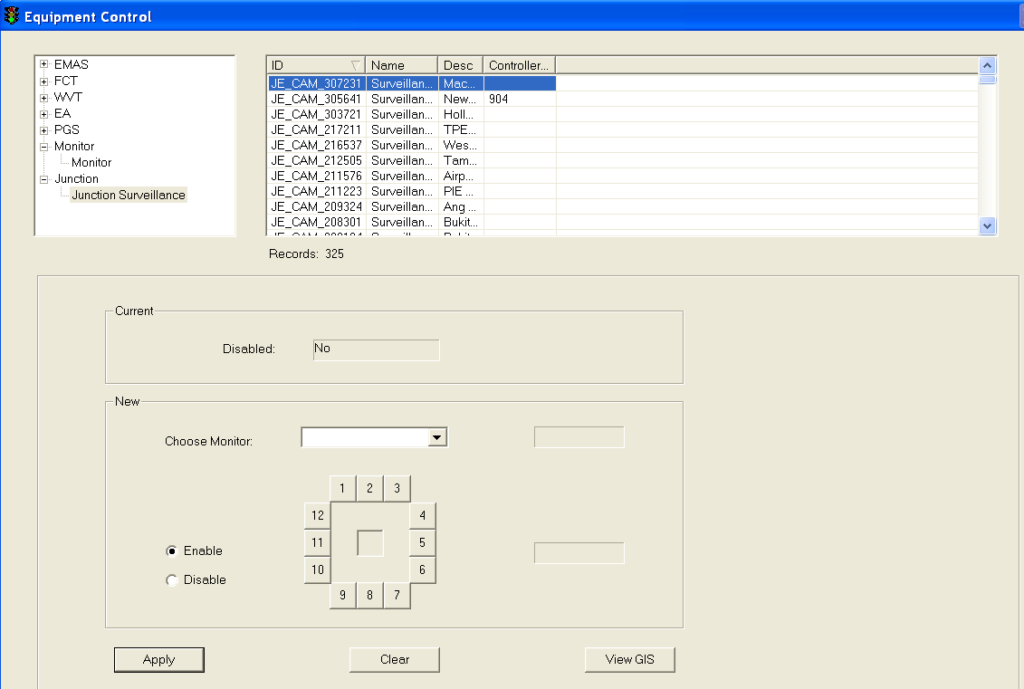

 Click on any equipment to select it.

The selected equipment will be highlighted in blue background. The current settings for the selected equipment appear in the Current panel.

5. In the New panel, choose a monitor from the dropdown list.

6. In the New panel, click on Enable or Disable to control junction surveillance camera.

7.  Click on Apply button to save the changes.

8.  Wait for the system to response.

•    If the remote control is successful, the response will show “Ok”.

•    If the system response with a “Time Out” after 30 seconds, you should try again by clicking on Apply button.

•    If the system response with “Not Sent”, it simply means that you have not set the new setting.

### Implement Predefined Plan (PP)

The user profile control the functions the user is authorize to use under Platform Control Mode (PCM) or Fall back Control Mode (FCM). Every user will have one user account that enables the user to login to IW. Every user account belongs to a profile.

|  |  |  |  |  |  |  |
| --- | --- | --- | --- | --- | --- | --- |
| **User profile** | | | | | **Operation mode** | |
| DO | Operator | FC | ITSC | Supervisor | PCM | FCM |
| ✓ | ✓ | ✓ | ✓ | ✓ | ✓ | ✓ \* |

          \* Only EMAS/GLIDE/ST/EA/PGS PP is available

A predefined plan consists of a set of control commands for the traffic and plant equipment that can be implemented at predefined schedules. Predefined plans also consist of fire plans, for implementation in the event of fire in the tunnel. The commands will be applied to the equipment when the plan is activated, e.g. congestion on the tunnel exits will require congestion messages to be displayed in the relevant VMS. The predefined schedules will allow the system to prompt users for activation when the schedule is up.

When a plan is activated, if there are EMAS/GLIDE/ST/EA/PGS equipment commands, the commands will be sent to EMAS/GLIDE/ST/EA/PGS and EMAS/GLIDE/ST/EA/PGS will reply with an acknowledgement:

•       “Ok” – The command is sent successfully to EMAS.

•       “Time Out” – The command is not received by EMAS or the command is received but EMAS does not send back a reply.

•    “Tagged Eqt” – The equipment is in tagging mode 2 or mode 3, hence the command will not be sent to respective interface.

As for GLIDE equipment commands, there will not be any status shown because GLIDE does not send back acknowledgement.

After the plan is implemented and you wish to resume the status of the equipment, you can implement the deactivation plan for plant equipment (PMCS), or release the activation plan for traffic equipment (LUS and VMS).

Equipment include:

•        VMS

•        Tunnel LUS

•        Tunnel PMCS equipment

•        Junction Traffic Controller

Features:

•       Search for configured predefined plans – by plan type, fire mode and activation.

•      View details of a selected plan.

•       Implement the selected plan – to change equipment status according to the commands in the plan.

•       Release the selected plan - to restore the status of equipment in the plan to their default status.

•      View commands and schedules of a plan.

Go to Events menu > Implement PP

|  |
| --- |
|  |
| Figure 171 - A PP window example |

#### Search for Plans

   Click on Search Plan button.

The Search Plan window appears.

   Click on PP Type dropdown arrow and click a type.

3.   In the Fire Mode Option panel, select an option.

4.  In the Activation Option panel, select an option.

5.  Click OK button.

The window closes and the search results appear in the list.

|  |
| --- |
|  |
| Figure 172 - The Search Plan window |

#### Implement Plan

   Select a plan from the list. If the list is empty, search for plans to retrieve plans first.

The selected plan will be highlighted in blue background. The current settings for the selected plan appear at the bottom of the list.

  Click on Implement Plan button.

A window will pop up to ask for confirmation to activate the selected plan. Click on Yes button to confirm activation, click No button to cancel activation.

|  |
| --- |
|  |
| Figure 173 - A sample of Implement Plan |

  Display result

A window will pop up to show the result of this implementation.

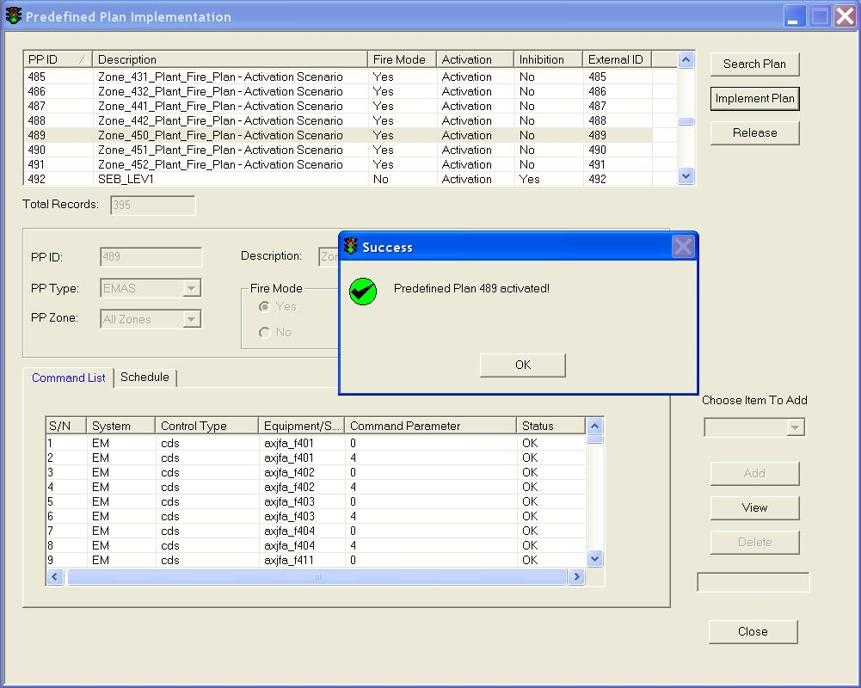

Figure 174 - PP implementation result

#### Release Plan

   Select a plan from the list. If the list is empty, search for plans to retrieve plans first.

The selected plan will be highlighted in blue background. The current settings for the selected plan appear at the bottom of the list.

   Click on Release button.

A window will pop up to ask for confirmation to release the selected plan. Click on Yes button to release, click No button to cancel.

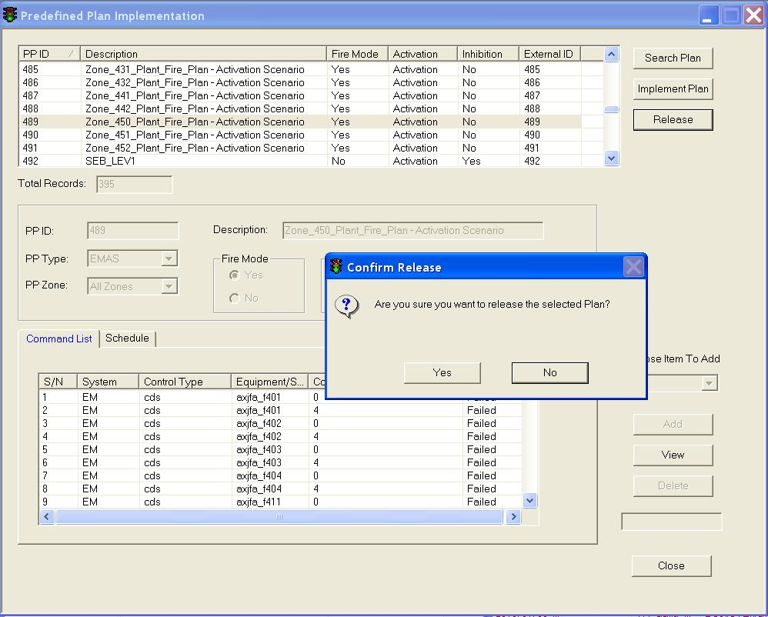

|  |
| --- |
| **Note** |
| The release function will only release VMS and LUS equipment in the plan.  VMS – message will be set back to default message configured.  LUS – graphic will be set back to default (green arrow). |

#### View Commands and Schedules of a Plan

Select a plan from the list. If the list is empty, search for plans to retrieve plans first.

The selected plan will be highlighted in blue background. The current settings for the selected plan appear at the bottom of the list. The commands and schedules for the selected plan (if any) will appear in the Command List tab and Schedule tab respectively.

|  |
| --- |
|  |
| Figure 175 - The Predefined Plan Implement Window |

  •        View command

  Select a command from the Command List.

The selected command will be highlighted in blue background.

  Click on View button.

A window will pop up showing more details about the selected command.

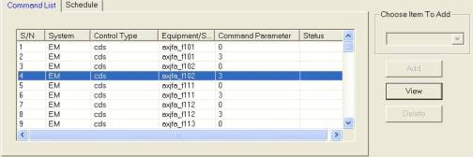

•        View schedule

  Select a schedule from the Schedule List.

The selected schedule will be highlighted in blue background.

  Click on View button.

A window will pop up showing more details about the selected schedule.

### New fax

The user profile control the functions the user is authorize to use under Platform Control Mode (PCM) or Fall back Control Mode (FCM). Every user will have one user account that enables the user to login to IW. Every user account belongs to a profile.

|  |  |  |  |  |  |  |
| --- | --- | --- | --- | --- | --- | --- |
| **User profile** | | | | | **Operation mode** | |
| DO | Operator | FC | ITSC | Supervisor | PCM | FCM |
| ✓ | ✓ | ✓ | ✓ | ✓ | ✓ | ✓ |

Allow users to send fax.

Features:

•       Send fax for IR and Technical alarm to both internal / external parties.

•       Select list of fax recipients for each fax.

|  |
| --- |
| **Note** |
| You can send fax from 4 locations:  •     IR window > Event Handling tab (IR fax)  •     IR list (IR fax)  •     Technical Alarm list (Technical alarm fax)  •     **Events** > **New Fax** menu (IR / Technical alarm fax) |

#### Send Fax

   In the List of Available Recipients panel, click on a recipient.

The selected recipient will be highlighted in blue background.

   Click on > button.

The recipient details will be added to the Selected Fax Recipients list on the right. To add more recipients, repeat steps 1-2.

   Click Incident Record or Technical Alarm for Label Type Selection.

4.  Type remark in the Remark textbox.

5.  Click **Preview** button to preview the fax.

6.   Click **Send** button to send the fax. The fax will be sent.

|  |
| --- |
| Description: c:\_temp\iw help\events\new fax\fax.jpg |
| Figure 178 - A sample of sending Fax |

|  |  |  |
| --- | --- | --- |
| **Error** | | |
| Message | Cause | Possible solution |
| Please select a recipient first ! | There is no recipient selected to receive the fax. | Select at least one recipient and try again. |

|  |
| --- |
| **Note** |
| The Event Content will be automatically updated if you open a new fax by right clicking on Technical Alarm list or IR list. E.g. the picture shown on the above has the Event Content updated. However, you may edit the Event Content if you open a new fax from the Events > New Fax menu. Just double click on the event data that you want to edit. |

### New SMS

The user profile control the functions the user is authorize to use under Platform Control Mode (PCM) or Fall back Control Mode (FCM). Every user will have one user account that enables the user to login to IW. Every user account belongs to a profile.

|  |  |  |  |  |  |  |
| --- | --- | --- | --- | --- | --- | --- |
| **User profile** | | | | | **Operation mode** | |
| DO | Operator | FC | ITSC | Supervisor | PCM | FCM |
| ✓ | ✓ | ✓ | ✓ | ✓ | ✓ |  |

Allow users to send message to mobile phones (SMS).

Features:

•       Send message to mobile phones (SMS).

•       Select list of SMS recipients for each message.

Go to **Events** menu > **New Message**.

|  |
| --- |
| Description: c:\_temp\iw help\events\new sms\New SM23.jpg |
| Figure 177 - A SMS window example |

|  |
| --- |
| **Note** |
| You can send sms from 3 locations:  •    IR list (IR fax)  •    Technical Alarm list (Technical alarm fax)  •    **Events** > **New Message** menu (IR / Technical alarm fax) |

#### Send Message

   In the List of Available Recipients panel, click on a recipient.

The selected recipient will be highlighted in blue background.

   Click on > button.

The recipient details will be added to the Selected Fax Recipients list on the right. To add more recipients, repeat steps 1-2.

   Type your message in the Message Content textbox.

4.  Click **Send** button to send the message.

|  |
| --- |
| Description: c:\_temp\iw help\events\new sms\sms.jpg |
| Figure 178 - A sample of sending message |

### Miscellaneous

•        [Reload Property Files](#_Reload_Property_Files)

The property files are loaded by the system administrator to configure OI Engine’s settings. Once System Administrator modifies the files, the property files must be reloaded so that the new settings can take effect. The property files are found on the machine where the OI Engine is installed, there are currently 3 property files:

    alarm\_filter.properties – alarm types found in this property file will still be received by system OI Engine but will not be shown on IW CCM.

    alert\_filter.properties – alerts types found in this property file will still be received by system OI Engine but will not be shown on IW CCM.

     oiengine.properties – to configure settings for the system OI Engine.

•       [Force Logout](#_Force_Logout)

If the IW application has exited abnormally, the account of the logged in user will be locked. The same logged in user for that IW would not be able to login to the same IW or other IWs again. Also, the zone(s) that were chosen by the locked user will not be available to other users. This function is available to perform a force logout for the locked user from the IW application so that the user can login again and free the zones that the user selected.

•       [Stop/Start GIS](#_Stop/Start_GIS)

To manually shut down the GIS or start the GIS application. The GIS data need to be compressed to improve performance of GIS on IW and need to be updated periodically to get new data, e.g. when there’re new roads. During the periodical maintenance of GIS data – when the server requires to compress / update data, no IW shall be connecting to the GIS server. Hence all IWs will shut down and disconnect from GIS server so that data compression or update can take place. When the GIS server has finish the tasks, the IW can reconnect back to the GIS server again.

•     [Mode Switch](#_Mode_Switch)

Switch between the platform mode and fallback mode. When ITSC decided to switch all IWs to work on fallback mode. The first IW that is going to be started (usually the DO’s IW) will check the “Start Control Service” so that the IW will now become the server, since during fallback mode, the iTransport server is not functioning.

•     [Clear Active Fire Plan](#_Clear_Active_Fire)

Manually clear active fire plan from system buffer. When the process is over, the flashing of IW Fire icon will be over.

•     [Restart Visinotify](#_Restart_Visinotify)

Visinotify will be restarted at backend, IR, Technical Alarm and Reading Alarm windows will refresh automatically.

#### Reload Property Files

The user profile control the functions the user is authorize to use under Platform Control Mode (PCM) or Fall back Control Mode (FCM). Every user will have one user account that enables the user to login to IW. Every user account belongs to a profile.

|  |  |  |  |  |  |  |
| --- | --- | --- | --- | --- | --- | --- |
| **User profile** | | | | | **Operation mode** | |
| DO | Operator | FC | ITSC | Supervisor | PCM | FCM |
| ✓ | ✓ | ✓ | ✓ | ✓ | ✓ |  |

Go to **Events** > **Miscellaneous** > **Reload Property File** menu.

The properties files will be reloaded.

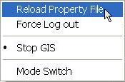

#### Force Logout

The user profile control the functions the user is authorize to use under Platform Control Mode (PCM) or Fall back Control Mode (FCM). Every user will have one user account that enables the user to login to IW. Every user account belongs to a profile.

|  |  |  |  |  |  |  |
| --- | --- | --- | --- | --- | --- | --- |
| **User profile** | | | | | **Operation mode** | |
| DO | Operator | FC | ITSC | Supervisor | PCM | FCM |
| ✓ | ✓ | ✓ | ✓ | ✓ | ✓ | ✓ |

1.    Click on a logon user.

The selected user will be highlighted with blue background.

2.     Click on **Force Logout** button.

The user is removed from the list.

|  |
| --- |
| Description: c:\_temp\iw help\events\miscellaneous\Force logout.jpg |
| Figure 179 - Force User Logout Window |

|  |
| --- |
| **Note** |
| •    You cannot force logout yourself.  •    If you force logout a user by mistake, that user will experience problems while using the IW. So he should logout and login again. |

#### Stop/Start GIS

The user profile control the functions the user is authorize to use under Platform Control Mode (PCM) or Fall back Control Mode (FCM). Every user will have one user account that enables the user to login to IW. Every user account belongs to a profile.

|  |  |  |  |  |  |  |
| --- | --- | --- | --- | --- | --- | --- |
| **User profile** | | | | | **Operation mode** | |
| DO | Operator | FC | ITSC | Supervisor | PCM | FCM |
| ✓ | ✓ | ✓ | ✓ | ✓ | ✓ | ✓ |

   Go to **Events** > **Miscellaneous** > **Stop GIS menu.**

GIS will be shut down and CCM is still functional.

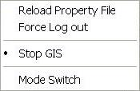

   Go to **Events** > **Miscellaneous** > **Start GIS** menu to start GIS again.

GIS will be reinitialized. It will take a few minutes.

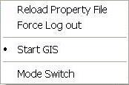

#### Mode Switch

The user profile control the functions the user is authorize to use under Platform Control Mode (PCM) or Fall back Control Mode (FCM). Every user will have one user account that enables the user to login to IW. Every user account belongs to a profile.

|  |  |  |  |  |  |  |
| --- | --- | --- | --- | --- | --- | --- |
| **User profile** | | | | | **Operation mode** | |
| DO | Operator | FC | ITSC | Supervisor | PCM | FCM |
| ✓ | ✓ | ✓ | ✓ | ✓ | ✓ | ✓ \* |

   In the Select Mode panel, click on the mode.

2.   If chosen mode is Fallback, the Fallback Type panel will be enabled.

3.  Click **OK** button to confirm mode switch.

|  |
| --- |
| Description: c:\_temp\iw help\events\miscellaneous\ModeSwitch.JPG |
| Figure 180 - The Mode Switch Window |

|  |
| --- |
| **Note** |
| •   The first IW that is going to be started (usually the DO’s IW) will check the “Start Control Service” so that the IW will start Fallback control service. Description: c:\_temp\iw help\events\miscellaneous\Mode S28.jpg, also need to specify the Previous mode.  •   Every time a mode switch is being done, you will be logged out, hence you will need to re-login again after you have select the mode. |

#### Clear Active Fire Plan

The user profile control the functions the user is authorize to use under Platform Control Mode (PCM) or Fall back Control Mode (FCM). Every user will have one user account that enables the user to login to IW. Every user account belongs to a profile.

|  |  |  |  |  |  |  |
| --- | --- | --- | --- | --- | --- | --- |
| **User profile** | | | | | **Operation mode** | |
| DO | Operator | FC | ITSC | Supervisor | PCM | FCM |
| ✓ |  | ✓ | ✓ |  | ✓ | ✓ \* |

   Go to **Events** > **Miscellaneous** > **Clear Active Fire Plan**

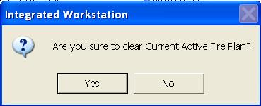

   Click **Yes** to clear current active fire plan from system buffer.

#### Restart Visinotify

The user profile control the functions the user is authorize to use under Platform Control Mode (PCM) or Fall back Control Mode (FCM). Every user will have one user account that enables the user to login to IW. Every user account belongs to a profile.

|  |  |  |  |  |  |  |
| --- | --- | --- | --- | --- | --- | --- |
| **User profile** | | | | | **Operation mode** | |
| DO | Operator | FC | ITSC | Supervisor | PCM | FCM |
| ✓ |  |  | ✓ |  | ✓ | ✓ \* |

   Go to **Events** > **Miscellaneous** > **Restart Visinotify**

Visinotify will be restarted at backend, IR, Technical Alarm and Reading Alarm windows will refresh automatically.

## History

The user profile control the functions the user is authorize to use under Platform Control Mode (PCM) or Fall back Control Mode (FCM). Every user will have one user account that enables the user to login to IW. Every user account belongs to a profile.

|  |  |  |  |  |  |  |
| --- | --- | --- | --- | --- | --- | --- |
| **User profile** | | | | | **Operation mode** | |
| DO | Operator | FC | ITSC | Supervisor | PCM | FCM |
| ✓ | ✓ | ✓ | ✓ | ✓ | ✓ | ✓ |

Provide viewing of historical records.

Types of records available:

•       Past traffic alerts

•       Past technical alarms

•       Past reading alarms

•        History of operator commands

•       Past incident records

•       Past equipment status

•       Past equipment status

•       Past work order records

Features:

•      Search and retrieve historical data.

•       Filter the historical data.

•      View GIS for the historical data.

### Traffic alert

The user profile control the functions the user is authorize to use under Platform Control Mode (PCM) or Fall back Control Mode (FCM). Every user will have one user account that enables the user to login to IW. Every user account belongs to a profile.

|  |  |  |  |  |  |  |
| --- | --- | --- | --- | --- | --- | --- |
| **User profile** | | | | | **Operation mode** | |
| DO | Operator | FC | ITSC | Supervisor | PCM | FCM |
| ✓ | ✓ | ✓ | ✓ | ✓ | ✓ | ✓ |

Go to **History** menu > **Traffic Alert.**

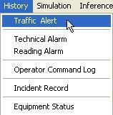

For historical traffic alert, IW CCM includes the following features:

•       [Filter The List](#_Filter_the_list)

•       [Search historical traffic alerts](#_Search_Historical_Traffic)

•        [View GIS](#_View_GIS_11)

#### Filter the list

1.   In the Traffic Alert History window, click on **Filter** button.

The Traffic Alert Filtering window appears.

|  |
| --- |
| TrafficAlertFilter |
| Figure 181 - Traffic Alert Filtering window |

2.   Select a Source.

3.   Select more than one source if you want to view alerts from multiple sources.

4.  Select a Zone/EAC Corridor.

5.  Select more than one Zone/EAC Corridor if you want to view alerts for multiple Zones / EAC Corridors.

6.   Click on **Apply** button and Close button.

The window closes and the filter function is enabled.

7.   Click on **Search** button, then search result by filtering will be listed out.

You may also filter the search result by clicking on **Filter** button.

#### Search Historical Traffic Alerts

1.    In the Traffic Alert History window, click on Start Time textbox to set the time.

|  |
| --- |
| Description: c:\_temp\iw help\history\traffic alert\Search25.jpg |
| Figure 182 - Traffic Alert History List Window |

2.   Click on End Time textbox to set the time.

3.   Click **Search** button.

The traffic alerts that occurred between selected Start Time and selected End Time appear in the list. You may filter the search result by clicking on **Filter** button.

#### View GIS

1.  Click on a traffic alert on the list.

The selected alert is highlighted with blue background.

2.  Click on **View GIS** button.

The GIS changes its view and the location of the alert is highlighted.

### Technical Alarm

The user profile control the functions the user is authorize to use under Platform Control Mode (PCM) or Fall back Control Mode (FCM). Every user will have one user account that enables the user to login to IW. Every user account belongs to a profile.

|  |  |  |  |  |  |  |
| --- | --- | --- | --- | --- | --- | --- |
| **User profile** | | | | | **Operation mode** | |
| DO | Operator | FC | ITSC | Supervisor | PCM | FCM |
| ✓ | ✓ | ✓ | ✓ | ✓ | ✓ | ✓ |

Go to **History** menu > **Technical Alarm.**

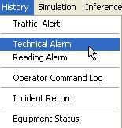

For historical technical alarm, IW CCM includes the following features:

•       [Filter The List](#_Filter_The_List_1)

•       [Search historical technical alarms](#_Search_Historical_Technical)

•       [View GIS](#_View_GIS_12)

#### Filter The List

1.   In the Technical Alarm History window, click on **Filter** button.

The Technical Alarm Filtering window appears.

|  |
| --- |
| TechAlarmFilter  Figure 183 - Technical Alarm History Window |

2.    Select a Source.

Select more than one source if you want to view alarms from multiple sources.

3.    Select a Zone.

Select more than one zone if you want to view alarms for multiple zones.

4.    Select an EAC Corridor.

Select more than one EAC Corridor if you want to view alarms for multiple EAC Corridors.

  Select equipment from Equipment list into Filter Type list. To add all equipment without making any selection, proceed to step 5. To add equipment by selection, proceed to step 6.

6.  Click on >> button. Proceed to step 9.

7.  Click on + in the Equipment list to expand the list.

8.   Select an equipment type.

9.   Click on > button to add the selected equipment to Filter Type list. To add another equipment, repeat steps 7 – 8.

10.  Click on **Apply** button.

The window closes and the filter function is enable.

11. Click on **Search** button, then search result by filtering will be listed out.

You may also filter the search result by clicking on **Filter** button.

#### Search Historical Technical Alarms

1.   In the Technical Alarm History window, click on **Filter** button to filter the search results.

|  |
| --- |
| Description: c:\_temp\iw help\history\technical alarm\Search27.jpg |
| Figure 184 - Technical Alarm History List Window |

2.  Click on Start Time textbox to set the time.

3.  Click on End Time textbox to set the time.

4.  Click **Search** button.

The technical alarms that occurred between selected Start Time and selected End Time appear in the list.

#### View GIS

1.   Click on a technical alarm on the list.

The selected alarm is highlighted with blue background.

2.   Click on **View GIS** button.

The GIS changes its view and the location of the alarm is highlighted.

### Reading Alarms

The user profile control the functions the user is authorize to use under Platform Control Mode (PCM) or Fall back Control Mode (FCM). Every user will have one user account that enables the user to login to IW. Every user account belongs to a profile.

|  |  |  |  |  |  |  |
| --- | --- | --- | --- | --- | --- | --- |
| **User profile** | | | | | **Operation mode** | |
| DO | Operator | FC | ITSC | Supervisor | PCM | FCM |
| ✓ | ✓ | ✓ | ✓ | ✓ | ✓ | ✓ |

Go to **History** menu > **Reading Alarm.**

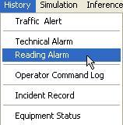

For historical reading alarms, IW CCM includes the following features:

•       [Filter The List](#_Filter_The_List_2)

•       [Search historical reading alarms](#_Search_Historical_Reading)

•       [View GIS](#_View_GIS_13)

#### Filter The List

1.   In the Reading Alarm History window, click on **Filter** button.

The Reading Alarm Filtering window appears.

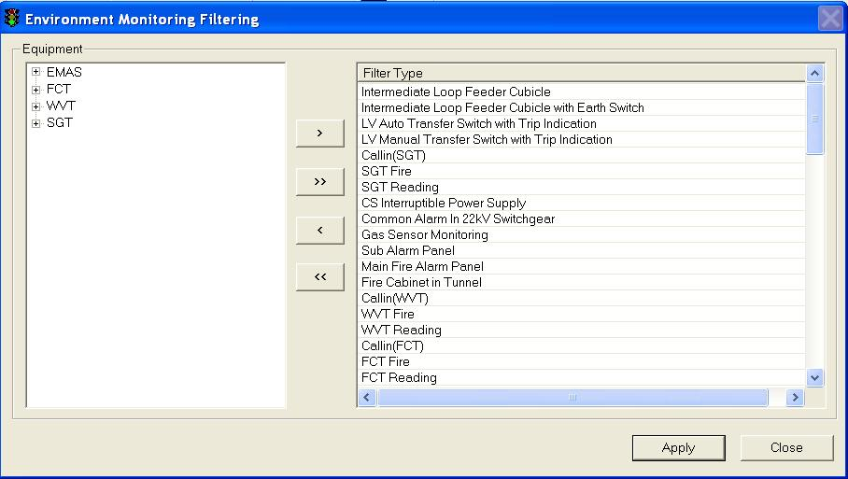

2.   Click on + to expand the source of equipment (EMAS/FCT/WVT/SGT)

3.   Select equipment from Equipment list into Filter Type list.

4.    Click on > button.

Repeat step 3 – 4 to add more equipment to the Filter Type list.

5.   Click on **Apply** button.

The window closes and the filter function is enabled.

5.   Click on **Search** button, then search result by filtering will be listed out.

You may also filter the search result by clicking on **Filter** button.

#### Search Historical Reading Alarms

1.    In the Reading Alarm History window, click on **Filter** button to filter the search results.

|  |
| --- |
| Description: c:\_temp\iw help\history\reading alarm\Search28.jpg |
| Figure 185 - Reading Alarm History Window |

2.  Click on Start Time textbox to set the time.

3.   Click on End Time textbox to set the time.

4.   Click **Search** button.

The reading alarms that occurred between selected Start Time and selected End Time appear in the list.

#### View GIS

1.    Click on a reading alarm on the list.

The selected alarm is highlighted with blue background.

2.    Click on **View GIS** button.

The GIS changes its view and the location of the alarm is highlighted.

### Operator Command Logs

The user profile control the functions the user is authorize to use under Platform Control Mode (PCM) or Fall back Control Mode (FCM). Every user will have one user account that enables the user to login to IW. Every user account belongs to a profile.

|  |  |  |  |  |  |  |
| --- | --- | --- | --- | --- | --- | --- |
| **User profile** | | | | | **Operation mode** | |
| DO | Operator | FC | ITSC | Supervisor | PCM | FCM |
| ✓ | ✓ | ✓ | ✓ | ✓ | ✓ | ✓ |

Go to **History** menu > **Operator Command Log.**

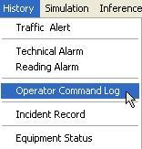

For historical operator command log, IW CCM includes the following features:

* [Search Historical Operator Commands](#_Search_Historical_Operator)
* [Operator Commands types](#_Operator_Commands_Types)

#### Search Historical Operator Commands

1.   In the Operator Command Log window. Click on Start Time textbox to set the time.

|  |
| --- |
| HistOPECMDPrint |
| Operator Command Log Window |

2.   Click on End Time textbox to set the time.

3.   Enter User ID if you want to retrieve only commands for a certain user.

4.   In the Command Types panel, click on the command types.

5.   Click **Search** button.

6.   Click **Reset** button to clear the all the previous settings and start a new search.

#### Operator Commands Types

Allow searching and retrieval of operators’ commands.

|  |  |
| --- | --- |
| **Operator Commands Types** | |
| •    Manual Control commands  •    Manual equipment control commands  •    Manual junction control commands  •    EMAS action plan execution commands  •    IR Handling commands  •    IR creation  •   IR update  •    IR closure  •     Activate IP  •     Event action plan activation command  •     PP Configuration commands  •      PP creation  •      PP update  •      PP deletion  •     Activate PP commands  •     PP activation commands | • Miscellaneous  •     User login and logout  •     Configuration of users and profiles  •     Configuration of fax setting: servers, templates and recipients  •     Configuration of pictograms  •     Configuration of VMS libraries  •    Configuration of IR labels  •     Configuration of camera disabling  •     Configuration of VMS default messages  •     Configuration of TTD threshold values  •     Fax sending and paging  •    Control mode switching  •     IFM switching on/off  •     IW GIS switching on/off  •     PMCS filtering  •     Deletion of technical alarms  •     Reloading of property file |

### Incident Record

The user profile control the functions the user is authorize to use under Platform Control Mode (PCM) or Fall back Control Mode (FCM). Every user will have one user account that enables the user to login to IW. Every user account belongs to a profile.

|  |  |  |  |  |  |  |
| --- | --- | --- | --- | --- | --- | --- |
| **User profile** | | | | | **Operation mode** | |
| DO | Operator | FC | ITSC | Supervisor | PCM | FCM |
| ✓ | ✓ | ✓ | ✓ | ✓ | ✓ | ✓ |

Go to **History** menu > **Incident Record.**

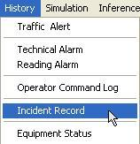

For historical incident record, IW CCM includes the following features:

•    [Filter The List](#_Filter_The_List_3)

•    [Search Historical Incident Record](#_Search_Historical_Incident)

•    [View CCTV, Prioritising and Editing Incident Records](#_View_CCTV_&)

#### Filter The List

1.   In the IR History List window, Click on **Filter** button to show IR List Filtering window.

|  |
| --- |
|  |
| Figure 188 - The IR List Filtering window |

2.   Select Incident Type(s).

Select more than one type if you want to view IR of multiple types.

3.   Select Zone(s).

Select more than one zone if you want to view IR for multiple zones.

4.   Click on **Apply** button.

The window closes and the filter function is enabled.

5.   Click on **Search** button, then search result by filtering will be listed out.

You may also filter the search result by clicking on **Filter** button.

#### Search Historical Incident Record

1.   In the IR History List window, click on Start Time textbox to set the time.

|  |
| --- |
| HistIRPrint |
| Figure 187 - IR History List Window |

2.   Click on End Time textbox to set the time.

3.   Click **Search** button.

The incident records that occurred between selected Start Time and selected End Time appear in the list. You may filter the search result by clicking on Filter button.

#### View CCTV & Prioritising & Edit IR

The functions are the same as those for IR List. Please refer to:

•       Refer to [here](#_View_CCTV) for CCTV function

•       Refer to [here](#_Prioritising_of_IR) for Prioritise function

•       Refer to [here](#_View_/_Edit) for edit function

### Equipment Status

The user profile control the functions the user is authorize to use under Platform Control Mode (PCM) or Fall back Control Mode (FCM). Every user will have one user account that enables the user to login to IW. Every user account belongs to a profile.

|  |  |  |  |  |  |  |
| --- | --- | --- | --- | --- | --- | --- |
| **User profile** | | | | | **Operation mode** | |
| DO | Operator | FC | ITSC | Supervisor | PCM | FCM |
| ✓ | ✓ | ✓ | ✓ | ✓ | ✓ |  |

Go to **History** menu > **Equipment Status**.

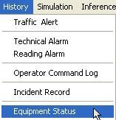

For historical equipment status, IW CCM includes the following features:

* [Search Historical Equipment Status](#_Search_Historical_Equipment)
* [View GIS](#_View_GIS_14)

#### Search Historical Equipment Status

1.   In the Equipment Status History window, click on Start Time textbox to set the time.

|  |
| --- |
| Description: c:\_temp\iw help\history\equipment status\Search31.jpg |
| Figure 188 - Equipment Status History List Window |

2.  Click on End Time textbox to set the time.

3.  Click **Search** button.

The Equipment Status that occurred between selected Start Time and selected End Time appear in the list.

#### View GIS

1.   Click on an equipment status on the list.

The selected alarm is highlighted with blue background.

2.  Click on **View GIS** button.

The GIS changes its view and the location of the alarm is highlighted.

### Work Order

The user profile control the functions the user is authorize to use under Platform Control Mode (PCM) or Fall back Control Mode (FCM). Every user will have one user account that enables the user to login to IW. Every user account belongs to a profile.

|  |  |  |  |  |  |  |
| --- | --- | --- | --- | --- | --- | --- |
| **User profile** | | | | | **Operation mode** | |
| DO | Operator | FC | ITSC | Supervisor | PCM | FCM |
| ✓ | ✓ | ✓ | ✓ | ✓ | ✓ | ✓ |

Go to **History** menu > **Work Order.**

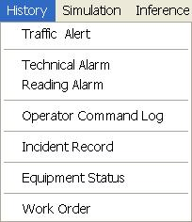

For historical work order, IW CCM includes the following features:

•       [Filter The List](#_Filter_the_list_4)

•       [Search historical work order](#_Search_Historical_Work)

#### Filter the list

1.   In the Work Order History window, click on **Filter** button.

The Work Order Filtering window appears.

|  |
| --- |
| workorderfilter |
| Figure 189 - Work Order Filtering window |

2.   Select a Source.

3.   Click on **Apply** button and Close button.

The window closes and the filter function is enabled.

4.   Click on **Search** button, then search result by filtering will be listed out.

You may also filter the search result by clicking on **Filter** button.

#### Search Historical Work Orders

1.    In the Work Order History window, click on Start Time textbox to set the time.

|  |
| --- |
| Description: c:\_temp\iw help\history\work order\Search32.jpg |
| Figure 190 - Work Order History List Window |

2.   Click on End Time textbox to set the time.

3.   Click **Search** button.

The work orders that occurred between selected Start Time and selected End Time appear in the list. You may filter the search result by clicking on **Filter** button.

## Launch Simulation

This is for authorized user to launch Simulation Software from IW.

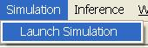

### Simulation Software

This software is for authorized user to simulate traffic network data.

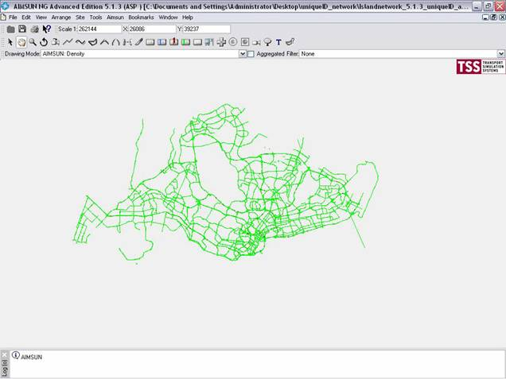

## Inference

The user profile control the functions the user is authorize to use under Platform Control Mode (PCM) or Fall back Control Mode (FCM). Every user will have one user account that enables the user to login to IW. Every user account belongs to a profile.

|  |  |  |  |  |  |  |
| --- | --- | --- | --- | --- | --- | --- |
| **User profile** | | | | | **Operation mode** | |
| DO | Operator | FC | ITSC | Supervisor | PCM | FCM |
| ✓ | ✓ | ✓ | ✓ | ✓ | ✓ | ✓ |

For **Inference** menu, there are two sub-menu items:

* [Knowledge base](#_Knowledge_Base), which allows authorized user to switch on/off inference module.
* [AID Status](#_AID_Status), which allows authorized user to set Automatic Incident Detection (AID) module status.

### Knowledge Base

Click on **Inference** menu, and click **Knowledge Base**.

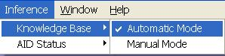

Provide switching of inference operational mode for IW.

|  |
| --- |
| **Platform Mode** |
| Switch between Inference Automatic Mode and Manual Mode:  •      Automatic Control Mode – Inference module is on / functioning, is able to recommend event action plans.  •      Manual Control Mode – Inference module is on/ non-functioning, does not recommend event action plans.  •       Disable Status – Inference module is down/ non-functioning, does not recommend event action plans, menu is disabled. |
| **Fallback Mode** |
| EMAS KB status is for shown only, cannot switch from IW:  •       Fallback Automatic Control Mode – Fallback mode; EMAS KB is on/functioning, is able to recommend event action plans.  •       Fallback Manual Control Mode – Fallback mode; EMAS KB is off / not functioning, is not able to recommend event action plans. |

### AID Status

Click on **Inference** menu, and click **AID Status**.

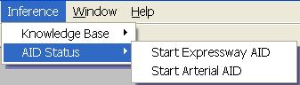

Provide switching of AID operational mode for IW.

|  |  |
| --- | --- |
| **Platform Mode** | **Fallback Mode** |
| Switch between AID Status:  •       Start/Stop Expressway AID, if Expressway AID is on, Inference module shall generate traffic alerts for expressway; otherwise, no traffic alerts from Inference module shall be generated.  •       Start/Stop Arterial Road AID, if Arterial AID is on, Inference module shall generate traffic alerts for arterial road; otherwise, no traffic alerts from Inference module shall be generated. | N.A. |

|  |
| --- |
| **NOTE** |
| If inference module is down, then the AID menu shall be grayed off. |

## Help

The user profile control the functions the user is authorize to use under Platform Control Mode (PCM) or Fall back Control Mode (FCM). Every user will have one user account that enables the user to login to IW. Every user account belongs to a profile.

|  |  |  |  |  |  |  |
| --- | --- | --- | --- | --- | --- | --- |
| **User profile** | | | | | **Operation mode** | |
| DO | Operator | FC | ITSC | Supervisor | PCM | FCM |
| ✓ | ✓ | ✓ | ✓ | ✓ | ✓ | ✓ |

Provide online help if you need more information about a procedure or topic. Also available is the IW version and copyright information.

Features:

•       [Access to help contents.](#_Access_Help)

•       [View About IW information.](#_View_About_Information)

### Access Help

Click on **Help** menu, and click **Help Topics**.

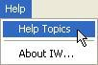

The Help window appears.

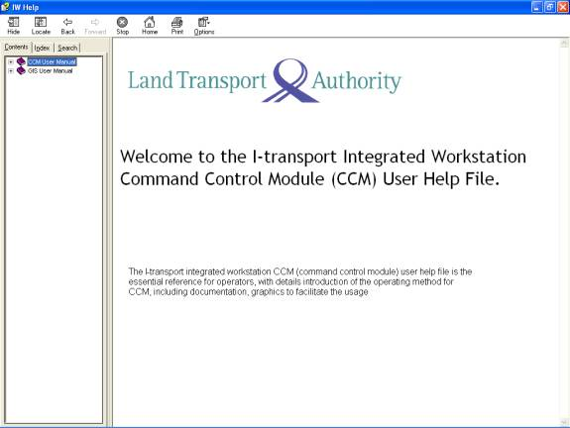

### View About Information

Click on **Help** menu, and click **About IW…**.

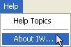

The About IW window appears.

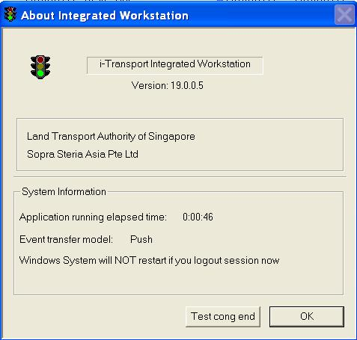

## ICA Equipment

Provide the list of ICA equipment for IW.

|  |  |  |
| --- | --- | --- |
| **To Woodlands Checkpoint** | | |
| S/no | Equipment ID | SIR No |
| 1 | 2106S | 1 |
| 2 | 2108S | 2 |
| 3 | 2110S | 3 |
| 4 | 2112S | 4 |
| 5 | 2114S | 7 |
| 6 | 2115S | 6 |
| 7 | 2116S | 8 |
| 8 | 2118S | 5 |
| 9 | 2120S | 11 |
| 10 | 2122S | 10 |
| 11 | 9112S | 9 |
| **To Tuas Checkpoint** | | |
| S/no | Equipment ID | SIR No |
| 1 | 4120S | 8 |
| 2 | 4126S | 1 |
| 3 | 4128S | 2 |
| 4 | 4130S | 6 |
| 5 | 4134S | 7 |
| 6 | 4136S | 5 |
| 7 | 6120S | 9 |
| 8 | 6130S | 3 |
| 9 | 6132S | 4 |

# GIS User Manual

**Welcome to the i-transport Integrated Workstation Geographical Information System (GIS) User Help File.**

The i-transport integrated workstation GIS (geographical information system) user help file is the essential reference for operators, with details introduction of the operating method for GIS, including documentation, graphics to facilitate the usage.

## Overview of GIS

The GIS main environment consists of a toolbar, table of contents and map display area.

|  |
| --- |
| C:\Users\tisin\AppData\Local\Microsoft\Windows\Temporary Internet Files\Content.Word\globalmap.jpg |
| Figure 191 - GIS Map Display Area |
|  |
| Figure 192 - GIS tool bar |

|  |
| --- |
| **Note** |
| Under some circumstances, the map may take a long time to refresh. Do not forcibly exit the program; it will eventually refresh successfully.  The map's refresh time typically takes about 5 secs but sometimes longer if:  •       The junction layer ( Description: c:\_temp\gis\overview of gis\Overvi2.jpgis activated) is displayed. This layer carry massive amount of data hence will take minutes to be loaded when you are at zone view ( Description: c:\_temp\gis\overview of gis\Overvi3.jpgis activated). So you should hide this layer whenever it's not needed.  •       The network or server is having some problem or performing backup. Should you experience slow performance while using GIS, the network or server may be problematic or the server may be doing some routine task e.g. backup. Under such circumstances, your IW shouldn't be the only one affected, all IW users should experience the same problem. |

### The toolbar

The toolbar is made up of 5 sub toolbars:

•    map navigation toolbar

•     traffic and surveillance equipment display and monitoring toolbar

•     tunnel toolbar

•     system toolbar

•     project toolbar.

The tools on the toolbar have different functions, some are to display equipment on map, some are for map navigation purpose. You can mouse over the tool to see what is the function of the tool:

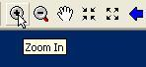

Also, the status bar will show description of the tool you mouse over:



1.   Map navigation toolbar

|  |
| --- |
| The map navigation toolbar allows you to perform functions like zoom in and out of the map, pan the map, view LOS / Speed information and so on. |
|  |
|  |

|  |  |  |  |  |  |  |  |  |  |  |  |  |  |  |  |  |  |  |  |  |  |  |  |  |  |  |  |  |  |  |  |  |  |  |  |  |  |  |  |  |
| --- | --- | --- | --- | --- | --- | --- | --- | --- | --- | --- | --- | --- | --- | --- | --- | --- | --- | --- | --- | --- | --- | --- | --- | --- | --- | --- | --- | --- | --- | --- | --- | --- | --- | --- | --- | --- | --- | --- | --- | --- |
| |  |  | | --- | --- | |  |  | | **Zoom in** | Zoom in to an area of the map by clicking or dragging a box. | | **Zoom out** | Zoom out from an area of the map by clicking or dragging a box. | | **Fixed zoom in** | Zoom in from the center of the map at a fix scale | | **Fixed zoom out** | Zoom out from the center of the map at a fix scale | | **Pan** | Pan the area of the map in the direction of dragging the mouse pointer. | | **Zoom previous** | Zoom to the previous map view. | | **Zoom next** | Zoom to the next map view. | | **Default** | Change the mouse pointer to default pointer. | | **Overview** | Turn on or off the overview map. | | **Global** | Zoom to the full view. | | **Building Names** | Enable/Disable building name display | | **Realtime Road Works**  **Search** | Display road works according to third-party info.  Search for roads, junctions, equipment and IR. | | **Zone view** | Zoom to the own operating zone view. | | **Level two view** | Zoom to a view with about distance of 3 TIDs. | | **Level three view** | Zoom to a view with approximately 500 metres. | | **Estimated speed** | Display estimated speed information on the map. | | **Speed** | Display speed information on the map. | | **LOS** | Display level of service information on the map. | | **Static**  **Predicted Speed**  **Predicted Volume** | Display kerb lines, arrow markings, lane markings and so on.  Expected traffic speed in ten minutes time.  Expected traffic volume in ten minutes time. | |

2.   Traffic And Surveillance Equipment Display And Monitoring toolbar

|  |
| --- |
| The Traffic And Surveillance Equipment Display And Monitoring toolbar allows you to perform functions like check VMS status, view technical alarm and so on.  Open View  FCT Open View  WVT Open View  VMS  EA VMS  PGS VMS  Detection camera  Surveillance camera  Junctions  JEYE Camera  Traffic Alerts  PUB CCTV  Monitor |
|  |
| |  |  | | --- | --- | | **Open View** | Allow you to go to open GIS map if you are in tunnel view or it can also hide all the turned on traffic equipment. | | **VMS** | Display / hide VMS location and status on the map. | | **VMS Message** | Display / hide VMS messages on the map. | | **EA VMS** | Display / hide EA VMS location and status on the map | | **PGS VMS** | Display / hide PGS VMS location and status on the map | | **Detection camera** | Display / hide detection cameras’ location and status on the map. | | **Surveillance camera** | Display / hide surveillance cameras’ location and status on the map. | | **FCT Open View** | Zoom into FCT location on the map. | | **WVT Open View** | Zoom into WVT location on the map. | | **Junctions** | Display / hide junctions’ location and status on the map. | | **JEYE Camera** | Display / hide Jeye cameras’ location and status on the map. | | **Traffic alerts** | Display / hide traffic alerts on the map. | | **PUB CCTV** | Display / hide PUB CCTV cameras on the map. | | **Monitor** | Allow you to left click on equipment to control them / mouse-over equipment to see information / right click on road to create IR. | |

3. Tunnel toolbar

|  |
| --- |
| The Tunnel toolbar allows you to perform functions like monitor tunnel equipment status, detect tunnel event and so on. |
|  |
| FCT Tunnel View  WVT Tunnel View  SGT Tunnel View  CTE Tunnel View  Ventilation  Drainage  Lighting  Air con  Fire  Power |
| |  |  | | --- | --- | | **FCT Tunnel View** | Display FCT tunnel map. | | **WVT Tunnel View** | Display WVT tunnel map. | | **SGT Tunnel View** | Display SGT tunnel map. | | **CTE Tunnel View** | Display CTE tunnel main portal, entrances and exits on the map. | | **Fire** | View PMCS fire, doors and staircases diagram. | | **Ventilation** | View PMCS ventilation diagram. | | **Drainage** | View PMCS drainage sump diagram. | | **Lighting** | View PMCS lighting diagram. | | **Air conditioning** | View PMCS air conditioning diagram. | | **Power** | View PMCS power diagram. | |

4. System toolbar

|  |
| --- |
| The System toolbar allows you to perform functions like monitoring system health status and EMAS network status. |
|  |
| System health  EMAS health  FELS health  JEYE health  Short Tunnel health  FCT health  WVT health  EA health  NMS health  LUS Controller health  SGT health |
| |  |  | | --- | --- | | **System health** | View System health status diagram. | | **EMAS health** | View EMAS health status diagram. | | **FELS health** | View FELS health status diagram | | **Junction Eyes health** | View Junction Eyes health status diagram. | | **Short Tunnel health** | View Short Tunnel health status diagram. | | **FCT health** | View FCT health status diagram. | | **WVT health** | View WVT health status diagram. | | **EA health** | View EA health status diagram. | | **NMS health** | View NMS health status diagram. | | **LUS Controller health** | View LUS Controller health status diagram. | |

5. Project toolbar

|  |
| --- |
| The project toolbar allows you to perform functions like print, logout and so on. |
| Description: c:\_temp\gis\overview of gis\project.JPG |
| |  |  | | --- | --- | | **Table of Contents** | Display Table of Contents | | **Print** | Print the map view. | | **Clear selection** | Clear the map of selection. | | **Refresh** | Refresh the map view. | | **Map Scale** | Display map scale | | **IW Help** | Display Help window | | **Legend Help** | Display GIS Legend Help window. | |

### The table of contents

The table of contents is functioned like a legend. It shows a list of layers in a map or diagram. Under each layer’s name, you can see the symbols used to represent the objects of that layer. On the left of the layer’s name, there is a checkbox that allows you to indicate whether or not the layer is visible.

The layers in the table of contents is ordered with a purpose, the topmost layer is drawn last and will not be overlapped by other layers. On the other hand, the bottommost layer is drawn first and will be overlapped by other layers.

Click the **table of contents** button  on the toolbar.

|  |
| --- |
| Description: c:\_temp\gis\overview of gis\table_content_click.JPG |

A Table of Contents window will appear.

|  |
| --- |
| Description: c:\_temp\gis\overview of gis\table_contents_list.JPG |
| Figure 193 - The Table of Contents window |

|  |
| --- |
| **Note** |
| This is meant only for the DO and administrators. This function will not be available to the operators. Operators may refer to Online help to view the legends. |

### The map display area

The map display area displays Open Expressways and Roads map or Synoptic diagram depending on which tool on the toolbar is activated. In order to zoom into different view of the map, you have to use functions like zoom in, zoom out or pan on the toolbar.

1.   Open Expressways and Road map

The map contains Singapore island, expressways, roads and MRT lines. When you are viewing the map, you can:

•       Do map navigation, e.g. Zoom in. (refer to [hese](#_Map_Navigation) for details on Map Navigation)

•       Change view using predefined views, e.g. 3 TID view (refer to [here](#_Zooming_map_using) for details on Zooming map using pre-defined levels)

•       View and control equipment.. (refer to [here](#_Traffic_and_Surveillance) for details on Traffic and Surveillance Equipment Monitoring and Display)

•       View traffic condition and event locations, e.g. Speed. (refer to [here](#_Traffic_Condition_Monitoring) for details on Traffic Condition Monitoring)

•       Search for roads, junction, equipment and IR. (refer to [here](#_Search) for details on Search )

2.   Schematic diagrams

The diagrams contain deep blue background and objects. There are 2 types of schematic diagram:

•      Tunnel schematic diagram

•       System status diagram

When you are viewing the diagrams, you can:

•      View different region of the tunnel, e.g. NorthEast region. (refer to [here](#_Zooming_map_using) for details on Zooming map using pre-defined levels)

•       View and remote control equipment, e.g. LUS.

•       View dynamic graphs, e.g. PMCS power measures.

### The status bar



The status bar shows three types of information:

**•** Status message

The status of map loading, e.g. “Labelling…”, “Drawing…” etc. These messages appear when the GIS is busy performing certain actions. At the same time the globe icon  will appear and spin. When the GIS has finished with the actions, the status will be empty and the globe icon will disappear.

**•** Help tips

Help messages for the toolbars. When you mouse over the toolbars, the description of the tool will be shown.

**•** Map coordinates

When your mouse is within the map display area (refer to [here](#_The_map_display)), the XY coordinates will show. The XY coordinates are the current mouse position. They are just for informational purpose.

|  |
| --- |
| **Note** |
| While the GIS is busy (status messages appear and globe icon Description: c:\_temp\gis\overview of gis\The st17.jpg spins), it is recommended that you should not do anything but to wait for GIS to finish whatever it’s doing. Otherwise, error may occur. Once the GIS is not busy (status messages and globe icon disappear), it’s safe to proceed. |

## Map Navigation

The user profile control the functions the user is authorize to use under Platform Control Mode (PCM) or Fall back Control Mode (FCM). Every user will have one user account that enables the user to login to IW. Every user account belongs to a profile.

|  |  |  |  |  |  |  |
| --- | --- | --- | --- | --- | --- | --- |
| **User profile** | | | | | **Operation mode** | |
| DO | Operator | FC | ITSC | Supervisor | PCM | FCM |
| ✓ | ✓ | ✓ | ✓ | ✓ | ✓ | ✓ |

You can do things like:

•    [Zoom In](#_Zoom_In)

•    [Zoom Out](#_Zoom_Out)

•   [Pan](#_Pan)

•   [Fixed Zoom In](#_Fixed_Zoom_In)

•   [Fixed Zoom Out](#_Fixed_Zoom_Out)

•   [Zoom Previous](#_Zoom_Previous)

•   [Zoom Next](#_Zoom_Next)

•    [Zoom to Zone](#_Zooming_map_using)

•    [Zoom to level 2 View (3 TID view)](#_Zooming_map_using)

•    [Zoom to level 3 View (Detail level)](#_Zooming_map_using)

|  |
| --- |
| Figure 194 - An “Zoom to Zone” example |

|  |
| --- |
| **Note** |
| Map Navigation toolbar is not available for tunnel diagrams because tunnel diagrams have other sets of toolbar. It is only available for open expressways and roads map. |

### Zoom In

There are 2 ways of “zooming in” in a map.

•    By selecting a point.

    Click the **Zoom In** button  on the toolbar.

2.      Left-click anywhere on the map.

The map will zoom in to the location you have clicked.

•    By dragging a box

     Click the **Zoom In** button  on the toolbar.

      Left-click anywhere on the map (this set the top left corner of the box), hold the mouse and drag it until the area is where you want the map to zoom to.

The map will zoom in to the location defined by the box.

|  |
| --- |
| Description: c:\_temp\gis\map navigation\Zoom I21.jpg  Figure 195 - A sample of Zoom In to area of map |

### Zoom Out

Click the **Zoom Out** button  on the toolbar.

Zoom Out is the same as Zoom In, You can do it by clicking or by dragging a box. Please refer to Zoom In for more information.

|  |
| --- |
| Description: c:\_temp\gis\map navigation\Zoom O23.jpg  Figure 196 - A sample of Zoom Out on map |

### Fixed Zoom In

Click the **Fixed Zoom In** button  on the toolbar.

The map will zoom in from the center of the map.

### Fixed Zoom Out

Click the **Fixed Zoom Out** button  on the toolbar.

The map will zoom out from the center of the map.

### Pan

1.  Click the **Pan** button  on the toolbar.

2.   Left-click anywhere on the map, hold the mouse and drag the map.

The map will slide to the direction of the mouse movement and refresh after the mouse is released.

|  |
| --- |
| Description: c:\_temp\gis\map navigation\Pan.ht27.jpg  Figure 197 - A sample of Panning current Map |

### Zoom Previous

Click the **Zoom Previous** button  on the toolbar.

When **Zoom Previous** button is enabled, it means that your current map view is not the first displayed view.  At this case if **Zoom Previous** button is clicked the map will go back to the previous displayed view.

### Zoom Next

Click the **Zoom Next** button  on the toolbar.

When **Zoom Next** button is enabled, it means that a few different map views have been displayed and your current map view is not the last displayed one.  At this case if **Zoom Next** button is clicked the map will go back (redo) to the next displayed view.

### Show / Hide Overview

Click on **Overview** button  on the toolbar.

The Overview window is shown.

|  |
| --- |
| Description: c:\_temp\gis\map navigation\Show_H32.jpg |
| Figure 198 - Display Overview Window |

|  |
| --- |
| **Note** |
| •       The red rectangle Description: c:\_temp\gis\map navigation\Show_H31.jpg shows the location you are currently on.  •      You can drag, shrink, or expand the box in the overview window to change the map in the map display area. |

### Zooming map using pre-defined levels

•    Zoom to Zone

Click the **Zone View** button  on the toolbar.

The map will zoom in to the full view on the zone you are currently operating on.

|  |
| --- |
| Description: c:\_temp\gis\map navigation\Zoomin34.jpg  Figure 199 - Zoom To Zone One Area |

|  |
| --- |
| **Note** |
| •   The Zone you are operating on depending on which zone(s) you have selected on the CCM login window.  •     If you have selected only 1 zone e.g. zone 2, click on this button will bring you the zone 2.  •      If you have selected more than 1 zones e.g. zone 4 and 5, click on this button will zoom to Zone 1 which is the default zone. |

•    Zoom to level 2 View

Click the **Level 2** button  on the toolbar.

The map will zoom in to a view with approximately 3 VMS view on the zone you are currently operating on.

|  |
| --- |
| Description: c:\_temp\gis\map navigation\Zoomin37.jpg  Figure 200 - Display Map at Level 2 |

|  |
| --- |
| **Note** |
| •     All expressways and major arterial roads are shown.  •     All expressways and major arterial roads are shown.  •    At this level, the km mark on expressway will be at 500m intervals.  •     At this level, the VMS message Description: c:\_temp\gis\map navigation\Zoomin36.jpg button is also enabled for you to show the VMS messages on map. |

•    Zoom to level 3 View (Detail Level)

Click the **Level 3** button  on the toolbar.

The map will zoom in to a view with approximately 500 metres (in vertical distance on the map display area).

|  |
| --- |
| Description: c:\_temp\gis\map navigation\Zoomin40.jpg  Figure 201 - Display Map at Level 3 |

|  |
| --- |
| **Note** |
| •     All roads are shown including expressway entrances and exits, slip roads and minor roads.  •     At this level and below, the km mark on expressway will be at 100m intervals instead of 500m intervals.  •     At this level and below, the **static info** Description: c:\_temp\gis\map navigation\Zoomin39.jpg button is also enabled for you to turn on the static view (kerb lines, lane markings, arrow markings and detector loops) |

## Traffic and Surveillance Equipment Monitoring and Display

Provide viewing and remote control of Traffic and Surveillance Equipment. You can view the status and functioning mode. You can also monitor the maps for defects and alarms.

   equipment include:

•       EMAS VMS and messages (TIP, TEP, TTP, TSP, TIC)

•       FCT VMS and messages (FCT\_AVMS, FCT\_TMD)

•       FCT VMS (NES, NLTS)

•        Junctions and J-Eyes

•        Surveillance Cameras

•        Detection Cameras

•        Others (SOS phones, PUB CCTV Cameras)

   Features:

•      View equipment location

•       Remote Equipment Control (available only if equipment is operational)

•       VMS

•       Junctions

•       Surveillance Camera

•       View PUB CCTV images

•       Color-code the equipment border to show different status. (not applicable to Junctions and J-Eyes)

    Grey – normal operation (with no message for VMS)

     Orange – communication failure

     Blue – normal operation (with message for VMS)

     Red – auto test equipment detects a severe error

     Yellow – local control

|  |
| --- |
| Description: c:\_temp\gis\traffic and surveillance equipment monitoring and display\traffi41.jpg |
| Figure 202 - A map with VMS equipment example |

### VMS

The user profile control the functions the user is authorize to use under Platform Control Mode (PCM) or Fall back Control Mode (FCM). Every user will have one user account that enables the user to login to IW. Every user account belongs to a profile.

|  |  |  |  |  |  |  |
| --- | --- | --- | --- | --- | --- | --- |
| **User profile** | | | | | **Operation mode** | |
| DO | Operator | FC | ITSC | Supervisor | PCM | FCM |
| ✓ | ✓ | ✓ | ✓ | ✓ | ✓ |  |

For VMS Monitoring and Display on IW GIS, the following features are provided:

•       [Display and Hide VMS](#_Display_and_Hide)

•       [Remote Control of a VMS on the GIS](#_Remote_Control_of)

•       [Display and hide EMAS VMS Message](#_Display_and_hide_1)

•       [Display and hide FCT VMS Message](#_Display_and_hide_2)

#### Display and Hide VMS

  Click the **VMS** button  on the toolbar.



The map refreshed and all the EMAS VMS (TIP, TTP, TEP, TSP, TIC)  and FCT VMS (FCT\_TMD, FCT\_AVMS, NES and NLTS)icons be displayed on the map.

  Click on the **VMS** button again and all the VMS icons will be hidden.

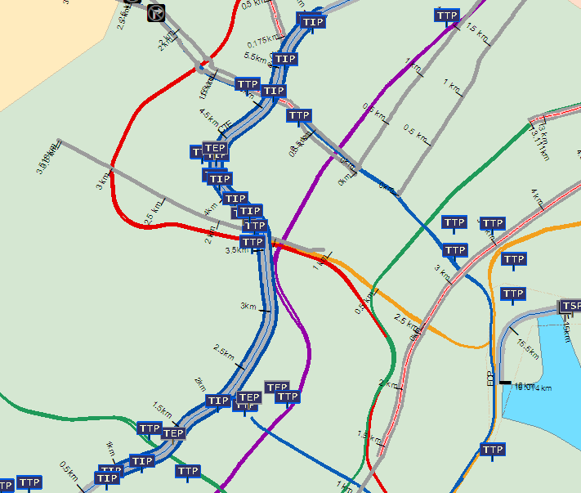

Figure 203 - Display all the VMS

VMS Symbols:

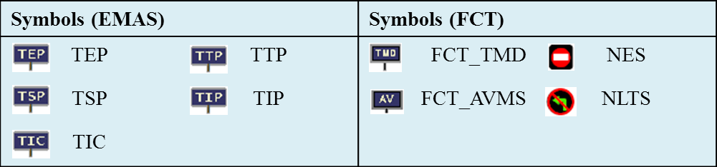

#### Remote Control of a VMS on the GIS

  Click the **Monitor** button  on the toolbar.



  Left click on a VMS on the map.

The selected VMS flashes. On CCM, the Remote Control window for this equipment appears, you can then view / edit the settings of the selected VMS.

 For more information on how to edit settings of EMAS VMS, please refer to [here](#_VMS_(Full_Graphic)).

 For more information on how to edit settings of FCT\_AVMS and FCT\_TMD, please refer to [here](#_Remote_Control_FCT_AVMS).

 For more information on how to edit settings of NES and NLTS, please refer to [here](#_Remote_Control_NES).

#### Display and hide EMAS VMS Message

•     View selective VMS message

  Click the **Monitor** button  on the toolbar



  Place your mouse over a VMS.

The detail VMS message with the locations will be displayed beside the VMS icon.

|  |
| --- |
| Description: c:\_temp\gis\traffic and surveillance equipment monitoring and display\vms\displa53.jpg |
| Figure 204 - Mouse over TMD to display Message |

|  |
| --- |
| Description: c:\_temp\gis\traffic and surveillance equipment monitoring and display\vms\displa54.gif |

•     Display all VMS messages

  Click the **VMS Message** button  on the toolbar.



The map refreshed and VMS messages for all VMS appear on the map.

  Click on the **VMS message** button again and all the VMS messages will be hidden.

|  |  |
| --- | --- |
| Description: c:\_temp\gis\traffic and surveillance equipment monitoring and display\vms\msg_display.JPG | |
| Figure 205 - Display VMS with Message | |
| Note: | The "\*" character on the VMS equipment means VMS message flash flag. KM label on the lower side of  VMS equipment is the distance from the entrance where this VMS is located at to the destination exit. |
|  | |

|  |
| --- |
| **Note** |
| The **VMS Message** button Description: c:\_temp\gis\traffic and surveillance equipment monitoring and display\vms\displa52.jpg will only be enabled if:  •       You have turn on VMS layer.  •       You are currently at level 2 view and below. |

#### Display and hide FCT VMS Message

•     View selective VMS message

1. Click the **Monitor** button  on the toolbar



  Place your mouse over a NES or NLTS.

|  |
| --- |
| Description: c:\_temp\gis\traffic and surveillance equipment monitoring and display\vms\displa59.jpg |
| Figure 206 - Mouse over NLTS to display Message |

|  |
| --- |
| **Note** |
| * NLTS\_00\_00001 is equipment ID * TUNNEL (CH:0) is the meter marking * AT QUEEN ST is location description |

  Place your mouse over a FCT\_AVMS or FCT\_TMD.

The detail VMS message with the locations will be displayed beside the VMS icon.

|  |
| --- |
| Description: c:\_temp\gis\traffic and surveillance equipment monitoring and display\vms\displa58.jpg |
| Figure 207 - Mouse over FCT\_TMD to display Message |

|  |
| --- |
| Description: c:\_temp\gis\traffic and surveillance equipment monitoring and display\vms\displa61.jpg |

•     Display all VMS messages

  Click the **VMS Message** button  on the toolbar.



The map refreshed and VMS messages for all VMS appear on the map.

  Click on the **VMS message** button again and all the VMS messages will be hidden.

|  |  |
| --- | --- |
| Description: c:\_temp\gis\traffic and surveillance equipment monitoring and display\vms\displa60.jpg | |
| Figure 208 - Display VMS with Message | |
| Note: | The "\*" character on the VMS equipment means VMS message flash flag. |
|  | |

|  |
| --- |
| **Note** |
| The **VMS Message** button Description: c:\_temp\gis\traffic and surveillance equipment monitoring and display\vms\displa52.jpg will only be enabled if:  •       You have turn on VMS layer.  •       You are currently at level 2 view and below. |

### Junctions and J-Eyes

The user profile control the functions the user is authorize to use under Platform Control Mode (PCM) or Fall back Control Mode (FCM). Every user will have one user account that enables the user to login to IW. Every user account belongs to a profile.

|  |  |  |  |  |  |  |
| --- | --- | --- | --- | --- | --- | --- |
| **User profile** | | | | | **Operation mode** | |
| DO | Operator | FC | ITSC | Supervisor | PCM | FCM |
| ✓ | ✓ | ✓ | ✓ | ✓ | ✓ | ✓ |

For Junction and J-Eye Monitoring and Display on  IW GIS, the following features are provided:

•       [Display and hide Glide Junctions and J-Eyes Camera](#_Display_and_hide_3)

•       [View Junction Info](#_View_Junction_Info)

•       [Remote Control of a Glide Junction from GIS](#_Remote_Control_of_1)

•       [View Junction Layout](#_View_Junction_Layout)

#### Display and hide Glide Junctions and J-Eyes Cameras

•     Display and hide Junctions

  Click the **Junctions** button  on the toolbar.



The map refreshed and the Glide Traffic Junctions appear on the map.

  Click on the **Junctions** button again and all the Glide junction icons will be hidden.

|  |
| --- |
| Description: c:\_temp\gis\traffic and surveillance equipment monitoring and display\junctions_and_j\junction_view.JPG |
| Figure 209 - Display Glide Junctions |

•     Display and hide J-Eye Cameras

  Click the **J-Eye Cameras** button  on the toolbar.



The map refreshed and J-Eye Cameras appear on the map.

  Click on the **J-Eye Cameras** button again and all the J-eyes Camera icons will be hidden.

|  |
| --- |
| Description: c:\_temp\gis\traffic and surveillance equipment monitoring and display\junctions_and_j\jcamera_view.JPG |
| Figure 210 - Display J-Eye Cameras |

#### View Junction Info

  Click the **Monitor** button  on the toolbar.



  Place your mouse over a Junction.

The detail junction information shows besides the Glide junction icon.

|  |
| --- |
| Description: c:\_temp\gis\traffic and surveillance equipment monitoring and display\junctions_and_j\junction_monitor.JPG  Figure 211 - Display detail info by mouse over a junction icon |

#### Remote Control of a Glide Junction from GIS

  Click the **Monitor** button  on the toolbar.



  Left click on a Junction on the map.

The selected Junction flashes. On CCM, the Junction control window for the Glide Junction appears, you can then view / edit the settings of the selected junction. For more information on how to edit settings of junction, please refer to [here](#_Junction_Control)**.**

|  |
| --- |
| Description: c:\_temp\gis\traffic and surveillance equipment monitoring and display\junctions_and_j\To Set1.jpg  Figure 212 - Junction Control Dialog on CCM |

#### View Junction Layout

  Right click on the Glide Junction icon.

A context menu appears.

|  |
| --- |
| Description: c:\_temp\gis\traffic and surveillance equipment monitoring and display\junctions_and_j\junction_detail.JPG  Figure 213 - Context menu by right click mouse on a junction icon |

  Click on **View Junction Layout** on the context menu.

The map zooms to the selected junction and shows the road layout (kerb lines, lane markings and arrow markings) of the junctions.

|  |
| --- |
| Description: c:\_temp\gis\traffic and surveillance equipment monitoring and display\junctions_and_j\view_j72.gif  Figure 214 - Display junction Layout |

### Expressway Surveillance Cameras

The user profile control the functions the user is authorize to use under Platform Control Mode (PCM) or Fall back Control Mode (FCM). Every user will have one user account that enables the user to login to IW. Every user account belongs to a profile.

|  |  |  |  |  |  |  |
| --- | --- | --- | --- | --- | --- | --- |
| **User profile** | | | | | **Operation mode** | |
| DO | Operator | FC | ITSC | Supervisor | PCM | FCM |
| ✓ | ✓ | ✓ | ✓ | ✓ | ✓ | ✓ |

For Expressway Surveillance Camera  Monitoring and Display on  IW GIS, the following features are provided:

•       [Display and hide EMAS Expressway Surveillance Cameras](#_Display_and_hide_4)

•       [View EMAS Surveillance Camera Info](#_View_Camera_Info)

•       [Remote Control of EMAS Surveillance Cameras on GIS](#_Remote_Control_of_2)

•       [Display and hide FCT Surveillance Cameras](#_Display_and_hide_5)

•       [View FCT Surveillance Camera Info](#_View_Camera_Info_1)

•       [Remote Control of FCT Surveillance Cameras on GIS](#_Remote_Control_of_3)

#### Display and hide Expressway Surveillance Cameras

  Click the **Surveillance Camera** button  on the toolbar.



The map refreshes and surveillance cameras appear on the map.

  Click on the **Surveillance camera** button again and the surveillance camera icons will be hidden.

|  |
| --- |
| Description: c:\_temp\gis\traffic and surveillance equipment monitoring and display\surveillance_cameras\scam_view.JPG |
| Figure 215 - Display Surveillance Camera in Expressway |

|  |  |
| --- | --- |
| **Symbols** | |
| Description: c:\_temp\gis\traffic and surveillance equipment monitoring and display\surveillance_cameras\displa56.jpg | Expressway Surveillance Camera |

#### View Camera Info

  Click the **Monitor** button  on the toolbar.



  Place your mouse over a Surveillance camera on the map.

The detail camera information with location is shown besides the camera icon.

|  |
| --- |
| Description: c:\_temp\gis\traffic and surveillance equipment monitoring and display\surveillance_cameras\scam_monitor.JPG |
| Figure 216 - Mouse Over Surveillance Camera Icon |
| Note:  “AVPTZ\_6921” is the equipment ID.  “PTZ ON LP1172” is the location description.  “23.51” is the kilometer marking. |

#### Remote Control of Surveillance Cameras on GIS

  Click the **Monitor** button  on the toolbar.



   Left click on a Surveillance Camera on the map.

The selected Camera flashes. On CCM, the Remote Control window appears, you can then view / edit the settings of the selected camera. For more information on how to edit settings of camera, please refer to [here](#_Control_Expressway_Surveillance) .

|  |
| --- |
| Description: c:\_temp\IW Help\Events\Equipment control\Contro68.jpg  Figure 217 - Equipment Control Dialog on CCM |

#### Display and hide FCT Surveillance Cameras

  Click the **Surveillance Camera** button  on the toolbar.



The map refreshes and surveillance cameras appear on the map.

  Click on the **Surveillance camera** button again and the surveillance camera icons will be hidden.

|  |
| --- |
|  |
| Description: c:\_temp\gis\traffic and surveillance equipment monitoring and display\surveillance_cameras\scam_FCT.JPG |
| Figure 218 - Display Surveillance Camera in FCT |

#### View Camera Info

  Click the **Monitor** button  on the toolbar.



  Place your mouse over a Surveillance camera on the map.

The detail camera information with location is shown besides the camera icon.

|  |
| --- |
| Description: c:\_temp\gis\traffic and surveillance equipment monitoring and display\surveillance_cameras\scam_view_FCT.JPG |
| Figure 219 - Mouse Over Surveillance Camera Icon |
| Note:  “PTZ\_00\_20903” is the equipment ID.  “Tunnel” is the location description.  “(CH: 200)” is the meter marking. |

#### Remote Control of Surveillance Cameras on GIS

  Click the **Monitor** button  on the toolbar.



   Left click on a Surveillance Camera on the map.

The selected Camera flashes. On CCM, the Remote Control window appears, you can then view / edit the settings of the selected camera. For more information on how to edit settings of camera, please refer to [here](#_Control_Expressway_Surveillance) .

|  |
| --- |
| Description: c:\_temp\gis\traffic and surveillance equipment monitoring and display\surveillance_cameras\view_c60.jpg  Figure 220 - Equipment Control Dialog on CCM |

### Detection Cameras

The user profile control the functions the user is authorize to use under Platform Control Mode (PCM) or Fall back Control Mode (FCM). Every user will have one user account that enables the user to login to IW. Every user account belongs to a profile.

|  |  |  |  |  |  |  |
| --- | --- | --- | --- | --- | --- | --- |
| **User profile** | | | | | **Operation mode** | |
| DO | Operator | FC | ITSC | Supervisor | PCM | FCM |
| ✓ | ✓ | ✓ | ✓ | ✓ | ✓ | ✓ |

For Expressway Detection Camera  Monitoring and Display on  IW GIS, the following features are provided:

•       [Display and hide EMAS Detection Cameras](#_Display_and_Hide_6)

•       [View Detection EMAS Camera Info](#_View_Camera_Info_2)

•       [Display and hide FCT Detection Cameras](#_Display_and_Hide_7)

•       [View Detection FCT Camera Info](#_View_FCT_Camera)

#### Display and Hide EMAS Detection Cameras

1.   Click the **Detection Camera** button  on the toolbar.



The map refreshes and cameras appear on the map.

2.   Click on the **Detection camera** button again and the detection camera icons will be hidden.

|  |
| --- |
| Description: c:\_temp\gis\traffic and surveillance equipment monitoring and display\detection_cameras\dcam_view.JPG |
| Figure 221 - Display Detection Camera in Expressway |

|  |  |
| --- | --- |
| **Symbols** | |
| Description: c:\_temp\gis\traffic and surveillance equipment monitoring and display\detection_cameras\displa62.jpg | Detection Camera |
| Description: c:\_temp\gis\traffic and surveillance equipment monitoring and display\detection_cameras\displa63.jpg | Video Track |

#### View Camera Info

  Click the **Monitor** button  on the toolbar.



2.  Place your mouse over a Detection camera.

The camera information shows besides the camera.

|  |
| --- |
| Description: c:\_temp\gis\traffic and surveillance equipment monitoring and display\detection_cameras\displa64.jpg |
| Figure 222 - Mouse over on Detection Camera Icon |
| Note:  “ATDET\_021” is the equipment ID.  “CAMERA DETECTOR OF VT02 /CTE/SOUTH” is the location description.  “5.55” is the kilometer marking. |

#### Display and Hide FCT Detection Cameras

1.   Click the **Detection Camera** button  on the toolbar.



The map refreshes and cameras appear on the map.

2.   Click on the **Detection camera** button again and the detection camera icons will be hidden.

|  |
| --- |
| Description: c:\_temp\gis\traffic and surveillance equipment monitoring and display\detection_cameras\displa65.jpg |
| Figure 223 - Display Detection Camera in FCT |

#### View FCT Camera Info

  Click the **Monitor** button  on the toolbar.



2.  Place your mouse over a Detection camera.

The camera information shows besides the camera.

|  |
| --- |
| Description: c:\_temp\gis\traffic and surveillance equipment monitoring and display\detection_cameras\view_c67.jpg |
| Figure 224 - Mouse over on Detection Camera Icon |
| Note:  “DET\_00\_20603” is the equipment ID.  “Tunnel" is the location description.  “CH: 360” is the meter marking. |

### PUB CCTV

The user profile control the functions the user is authorize to use under Platform Control Mode (PCM) or Fall back Control Mode (FCM). Every user will have one user account that enables the user to login to IW. Every user account belongs to a profile.

|  |  |  |  |  |  |  |
| --- | --- | --- | --- | --- | --- | --- |
| **User profile** | | | | | **Operation mode** | |
| DO | Operator | FC | ITSC | Supervisor | PCM | FCM |
| ✓ | ✓ | ✓ | ✓ | ✓ | ✓ | ✓ |

For PUB CCTV Display on IW GIS, the following features are provided:

•       [Display and hide PUB CCTV](#_Display_and_Hide_9)

•       [View PUB CCTV Images](#_View_PUB_CCTV)

#### Display and Hide PUB CCTV Cameras

  Click the **PUB** button  on the toolbar.



The map refreshes and PUB CCTV icons appear on the map.

  Click on the **PUB** button again and the PUB CCTV icons will be hidden.

|  |
| --- |
|  |
| Figure 225 - Display PUB CCTV |

#### View PUB CCTV Images

  Click the **Monitor** button  on the toolbar.



  With the Monitor tool enabled, click on any PUB CCTV icon.

The CCTV Image viewer will pop up.

|  |
| --- |
| doc |
| Figure 226 – CCTV Image Viewer |
|   To close the image viewer, click again anywhere else on the map. |

## CTE Tunnel

Provide viewing and remote control of CTE Tunnel Equipment. You can view the status and functioning mode. You can also monitor the maps for defects and alarms.

 Equipment include:

•        LUS

•       VMS and messages (TMD, TEP,TTD)

•       Cameras (Both detection and surveillance cameras).

•        SOS

•       Plant Management Control System (PMCS)

•       Fire, vehicles and pedestrian doors and emergency staircases

•        Ventilation

•       Drainage

•       Light

•      Air con

•       Power

|  |
| --- |
| Description: c:\_temp\gis\tunnel\Tunnel80.jpg |
| Figure 227 - A CTE tunnel schematic diagram (with VMS) example |

### Tunnel overview toolbar

The CTE tunnel toolbar allows you to display equipment in the CTE tunnel.

|  |
| --- |
|  |
| |  |  | | --- | --- | | **Tunnel** | Zoom to full view of tunnel, refer to [here](#_Lane_Use_Signal). | | **NW** | Zoom in northwest box of the tunnel towards SLE, refer to [here](#_Lane_Use_Signal). | | **NE** | Zoom in northwest box of the tunnel towards AYE, refer to [here](#_Lane_Use_Signal). | | **SW** | Zoom in southwest box of the tunnel towards SLE, refer to [here](#_Lane_Use_Signal). | | **SE** | Zoom in northwest box of the tunnel towards AYE, refer to [here](#_Lane_Use_Signal). | | **LUS** | Display LUS location and status in the tunnel, refer to [here](#_Lane_Use_Signal_1). | | **VMS** | Display VMS location, status and messages in the tunnel, refer to [here](#_Variable_Message_Signs). | | **Cameras** | Display cameras location and status in the tunnel, refer to [here](#_Cameras). | | **ETS** | Display ETS location in the tunnel, refer to [here](#_ETS). | | **Pumps** | Display Pumps location and status in the tunnel, refer to [here](#_Pumps). | | **Vent\_Level** | Display Ventilation levels for each area in the tunnel, refer to [here](#_Vent_Level). | | **Lightings** | Display Lightings location and status in the tunnel, refer to [here](#_Lightings). | | **EPower** | Display Power buildings location and status in the tunnel, refer to [here](#_Power). | | **Fire\_Cabinet** | Display fire cabinet location and status in the tunnel, refer to [here](#_Fire_Cabinet). | | **Tunnel-RIO** | Display tunnel rio location and status in the tunnel, refer to [here](#_Tunnel_RIO). | | **L2\_Switch** | Display tunnel switch location and status in the tunnel, refer to [here](#_L2_Switch). | |

|  |
| --- |
|  |
|  |
| Figure 228 - Display LUS, IR and VMS with message together in Tunnel View |

### Tunnel Overview

The user profile control the functions the user is authorize to use under Platform Control Mode (PCM) or Fall back Control Mode (FCM). Every user will have one user account that enables the user to login to IW. Every user account belongs to a profile.

|  |  |  |  |  |  |  |
| --- | --- | --- | --- | --- | --- | --- |
| **User profile** | | | | | **Operation mode** | |
| DO | Operator | FC | ITSC | Supervisor | PCM | FCM |
| ✓ | ✓ | ✓ | ✓ | ✓ | ✓ | ✓ |

•    Display Tunnel 5 pre-defined Views:

•     [Display Tunnel Overview](#_Lane_Use_Signal)

•     [Display](file:///C:\Users\Brenda%20Seah\Desktop\chm\Zooming%20map%20using%20pre-defined%20views.htm) [North West Tunnel Box View](#_Lane_Use_Signal)

•     [Display](file:///C:\Users\Brenda%20Seah\Desktop\chm\Zooming%20map%20using%20pre-defined%20views.htm) [North East Tunnel Box View](#_Lane_Use_Signal)

•     [Display](file:///C:\Users\Brenda%20Seah\Desktop\chm\Zooming%20map%20using%20pre-defined%20views.htm) [South West Tunnel Box View](#_Lane_Use_Signal)

•     [Display](file:///C:\Users\Brenda%20Seah\Desktop\chm\Zooming%20map%20using%20pre-defined%20views.htm) [South East Tunnel Box View](#_Lane_Use_Signal)

•    Display Tunnel equipment:

•     [Lane Use Signal (LUS)](#_Lane_Use_Signal_1)

•     [Variable Message Signs (VMS)](#_Variable_Message_Signs)

•         [Cameras](#_Cameras)

•         [ETS](#_ETS)

•         [Pumps](#_Pumps)

•         [Vent Level](#_Vent_Level)

•        [Lightings](#_Lightings)

•         [Power](#_Power)

•        [Fire Cabinet](#_Fire_Cabinet)

•        [Tunnel RIO](#_Tunnel_RIO)

•         [L2 Switch](#_L2_Switch)

|  |
| --- |
| **Note** |
| •       You cannot do things like zoom in, zoom out and pan in the tunnel synoptic diagram. There are 5 fixed views available.  •       In each of these five views, you can choose to display the desired tunnel traffic equipment by selecting the appropriate buttons.  •       At anytime when you want to go to the open road view, click on Description: c:\_temp\gis\tunnel\tunnel overview\Tunnel82.jpg button on the toolbar. |

#### 

#### Zooming CTE using pre-defined views

There are 5 levels of views available for you to change the overview to region view and vice versa:

1.   Tunnel View

Click the **CTE Tunnel** button on the toolbar. The map will zoom to full tunnel view.



The CTE Tunnel toolbar appear on the map. Tunnel overview diagram is shown by default.

|  |
| --- |
|  |
| Figure 229 - Display Full Tunnel View |

  2.   NW View

Click the **NW** button  on the toolbar.



The map will zoom to the northwest box of the tunnel.

|  |
| --- |
|  |
| Figure 230 - Display  Northwest Box of the Tunnel |

3.   NE View

Click the **NE** button  on the toolbar.



The map will zoom to the northeast box of the tunnel.

|  |
| --- |
|  |
| Figure 231 - Display  Northeast Box of the Tunnel |

 4.  SW View

Click the **SW** button  on the toolbar.



The map will zoom to the southwest box of the tunnel.

|  |
| --- |
|  |
| Figure 232 - Display  Southwest Box of the Tunnel |

 5.   SE View

Click the **SE** button  on the toolbar.



The map will zoom to the southeast box of the tunnel.

|  |
| --- |
|  |
| Figure 233 - Display  Southeast Box of the Tunnel |

#### Lane Use Signal (LUS)

The user profile control the functions the user is authorize to use under Platform Control Mode (PCM) or Fall back Control Mode (FCM). Every user will have one user account that enables the user to login to IW. Every user account belongs to a profile.

|  |  |  |  |  |  |  |
| --- | --- | --- | --- | --- | --- | --- |
| **User profile** | | | | | **Operation mode** | |
| DO | Operator | FC | ITSC | Supervisor | PCM | FCM |
| ✓ | ✓ | ✓ | ✓ | ✓ | ✓ | ✓ |

•    Display and Hide LUS

 Click the **LUS** button  on the toolbar.



The map refreshed and LUS appear on the map.

  Click on the **LUS** button  again and the map will refresh and LUS icon will be hidden.

|  |
| --- |
| Description: c:\_temp\gis\tunnel\tunnel overview\Lane U1.jpg |
| Figure 234 - Display LUS in Tunnel View |

•    Remote Control of LUS on Tunnel Schematic View

Left click on a LUS.

The selected LUS flashes. On CCM, the Remote Control window appears, you can then view / edit the settings of the selected LUS. For more information on how to edit settings of LUS, please refer to [here](#_Lane_Use_Signal_3).

#### Variable Message Signs (VMS)

The user profile control the functions the user is authorize to use under Platform Control Mode (PCM) or Fall back Control Mode (FCM). Every user will have one user account that enables the user to login to IW. Every user account belongs to a profile.

|  |  |  |  |  |  |  |
| --- | --- | --- | --- | --- | --- | --- |
| **User profile** | | | | | **Operation mode** | |
| DO | Operator | FC | ITSC | Supervisor | PCM | FCM |
| ✓ | ✓ | ✓ | ✓ | ✓ | ✓ | ✓ |

•    Display and Hide VMS

Click the **VMS** button on the toolbar.



The map refreshes, VMS and their messages appear on the map.

Click on the **VMS** button again and the map refreshes and the VMS icons and messages will be hidden.

|  |  |
| --- | --- |
|  | |
| Figure 235 - Display VMS and their messages in Tunnel View | |
| Note: | The "\*" character on the VMS equipment means VMS message flash flag. KM label on the lower side of  VMS equipment is the distance from the entrance where this VMS is located at to the destination exit. |

•    Remote Control of VMS on Tunnel Schematic View

Left click on a VMS.

The selected VMS flashes. On CCM, the Remote Control window appears, you can then view / edit the settings of the selected VMS. For more information on how to edit settings of VMS, please refer to [here](#_VMS_(Full_Graphic)).

#### Cameras

The user profile control the functions the user is authorize to use under Platform Control Mode (PCM) or Fall back Control Mode (FCM). Every user will have one user account that enables the user to login to IW. Every user account belongs to a profile.

|  |  |  |  |  |  |  |
| --- | --- | --- | --- | --- | --- | --- |
| **User profile** | | | | | **Operation mode** | |
| DO | Operator | FC | ITSC | Supervisor | PCM | FCM |
| ✓ | ✓ | ✓ | ✓ | ✓ | ✓ | ✓ |

•    Display and Hide Cameras

Click the **Cameras** button  on the toolbar.



The map refreshes and cameras (surveillance and detection) appear on the map.

 Click on the **Cameras** button again and the map refreshes and the camera icons will be hidden.

|  |
| --- |
|  |
| Figure 236 - Display Tunnel Cameras |

•    Remote Control of Cameras (Surveillance Cameras only)

Click on a Surveillance camera.

The selected camera flashes. On CCM, the Remote Control window appears, you can then view / edit the settings of the selected camera. For more information on how to edit settings of camera, please refer to [here](#_Camera).

#### ETS

The user profile control the functions the user is authorize to use under Platform Control Mode (PCM) or Fall back Control Mode (FCM). Every user will have one user account that enables the user to login to IW. Every user account belongs to a profile.

|  |  |  |  |  |  |  |
| --- | --- | --- | --- | --- | --- | --- |
| **User profile** | | | | | **Operation mode** | |
| DO | Operator | FC | ITSC | Supervisor | PCM | FCM |
| ✓ | ✓ | ✓ | ✓ | ✓ | ✓ | ✓ |

Display and Hide SOS:

Click the ET**S** button  on the toolbar.



The map refreshes and ETS appear on the map.

 Click on the **SOS** button again and the map refreshes and the SOS icons will be hidden.

|  |
| --- |
|  |
| Figure 239 - Display Tunnel ETS |

#### Pumps

The user profile control the functions the user is authorize to use under Platform Control Mode (PCM) or Fall back Control Mode (FCM). Every user will have one user account that enables the user to login to IW. Every user account belongs to a profile.

|  |  |  |  |  |  |  |
| --- | --- | --- | --- | --- | --- | --- |
| **User profile** | | | | | **Operation mode** | |
| DO | Operator | FC | ITSC | Supervisor | PCM | FCM |
| ✓ | ✓ | ✓ | ✓ | ✓ | ✓ | ✓ |

Display and Hide Pumps:

Click the **Pumps** button  on the toolbar.



The map refreshes and Pumps appear on the map.

Click on the **Pumps** button again and the map refreshes and the Pump icons will be hidden.

|  |
| --- |
|  |
| Figure 238 - Display Pumps in Tunnel View   |  |  | | --- | --- | | **Symbols** | | | Description: c:\_temp\gis\tunnel\tunnel overview\Pumps.13.jpg | Main pump 1 and Main pump 2 | | Description: c:\_temp\gis\tunnel\tunnel overview\Pumps.14.jpg | Clean pump | |

Vent\_Level

The user profile control the functions the user is authorize to use under Platform Control Mode (PCM) or Fall back Control Mode (FCM). Every user will have one user account that enables the user to login to IW. Every user account belongs to a profile.

|  |  |  |  |  |  |  |
| --- | --- | --- | --- | --- | --- | --- |
| **User profile** | | | | | **Operation mode** | |
| DO | Operator | FC | ITSC | Supervisor | PCM | FCM |
| ✓ | ✓ | ✓ | ✓ | ✓ | ✓ | ✓ |

Display and Hide Ventilation Level:

Click the **Vent\_Level** button  on the toolbar.



The map refreshes and Ventilation Levels appear on the map.

Click on the **Vent\_Level** button again and the map refreshes and the Vent\_Level icons will be hidden.

|  |
| --- |
| Description: c:\_temp\gis\tunnel\tunnel overview\Vent_L15.jpg |
| Figure 239 - Display Ventilation Levels in Tunnel View |

#### Lightings

The user profile control the functions the user is authorize to use under Platform Control Mode (PCM) or Fall back Control Mode (FCM). Every user will have one user account that enables the user to login to IW. Every user account belongs to a profile.

|  |  |  |  |  |  |  |
| --- | --- | --- | --- | --- | --- | --- |
| **User profile** | | | | | **Operation mode** | |
| DO | Operator | FC | ITSC | Supervisor | PCM | FCM |
| ✓ | ✓ | ✓ | ✓ | ✓ | ✓ | ✓ |

Display and Hide Lightings:

Click the **Lightings** button  on the toolbar.



The map refreshes and Lightings appear on the map.

Click on the **Lightings** button again and the map refreshes and the Lightings icons will be hidden.

|  |
| --- |
| Description: c:\_temp\gis\tunnel\tunnel overview\Lighti19.jpg |
| Figure 240 - Display Lightings in Tunnel View |

|  |  |
| --- | --- |
| **Symbols** | |
| Description: c:\_temp\gis\tunnel\tunnel overview\Lighti6.jpg | Boost Light lighted |
| Description: c:\_temp\gis\tunnel\tunnel overview\Lighti7.jpg | Boost Light not lighted |

#### Power

The user profile control the functions the user is authorize to use under Platform Control Mode (PCM) or Fall back Control Mode (FCM). Every user will have one user account that enables the user to login to IW. Every user account belongs to a profile.

|  |  |  |  |  |  |  |
| --- | --- | --- | --- | --- | --- | --- |
| **User profile** | | | | | **Operation mode** | |
| DO | Operator | FC | ITSC | Supervisor | PCM | FCM |
| ✓ | ✓ | ✓ | ✓ | ✓ | ✓ | ✓ |

Display and Hide Power Building:

Click the **Power** button  on the toolbar.



The map refreshes and Power buildings appear on the map.

 Click on the **Power** button again and the map refreshes and the Power icons will be hidden.

|  |
| --- |
|  |
| Figure 241 - Display Power Buildings in Tunnel View |
| |  |  | | --- | --- | | **Symbols** | | | Description: c:\_temp\gis\tunnel\tunnel overview\Power.8.jpg | Generator not running | | Description: c:\_temp\gis\tunnel\tunnel overview\Power.9.jpg | Generator running | |

#### Fire Cabinet

The user profile control the functions the user is authorize to use under Platform Control Mode (PCM) or Fall back Control Mode (FCM). Every user will have one user account that enables the user to login to IW. Every user account belongs to a profile.

|  |  |  |  |  |  |  |
| --- | --- | --- | --- | --- | --- | --- |
| **User profile** | | | | | **Operation mode** | |
| DO | Operator | FC | ITSC | Supervisor | PCM | FCM |
| ✓ | ✓ | ✓ | ✓ | ✓ | ✓ | ✓ |

Display and Hide Pumps:

Click the **Fire\_Cabinet ** button on the toolbar.



The map refreshes and the Fire Cabinet appear on the map.

Click on the **Fire\_Cabinet** button again and the map refreshes and the Fire Cabinet icons will be hidden.

|  |
| --- |
|  |
| Figure 242 - Display Fire Cabinet in Tunnel View |

#### Tunnel RIO

The user profile control the functions the user is authorize to use under Platform Control Mode (PCM) or Fall back Control Mode (FCM). Every user will have one user account that enables the user to login to IW. Every user account belongs to a profile.

|  |  |  |  |  |  |  |
| --- | --- | --- | --- | --- | --- | --- |
| **User profile** | | | | | **Operation mode** | |
| DO | Operator | FC | ITSC | Supervisor | PCM | FCM |
| ✓ | ✓ | ✓ | ✓ | ✓ | ✓ | ✓ |

Display and Hide Pumps:

Click the **Tunnel\_RIO ** button on the toolbar.



The map refreshes and Tunnel RIO icons appear on the map.

Click on the **Tunnel\_RIO** button again and the map refreshes and the Tunnel RIO icons will be hidden.

|  |
| --- |
|  |
| Figure 243 – Display Tunnel RIO in Tunnel View |

#### L2 Switch

The user profile control the functions the user is authorize to use under Platform Control Mode (PCM) or Fall back Control Mode (FCM). Every user will have one user account that enables the user to login to IW. Every user account belongs to a profile.

|  |  |  |  |  |  |  |
| --- | --- | --- | --- | --- | --- | --- |
| **User profile** | | | | | **Operation mode** | |
| DO | Operator | FC | ITSC | Supervisor | PCM | FCM |
| ✓ | ✓ | ✓ | ✓ | ✓ | ✓ | ✓ |

Display and Hide Pumps:

Click the **L2\_Switch ** button on the toolbar.



The map refreshes and Pumps appear on the map.

Click on the **L2\_Switch** button again and the map refreshes and the Pump icons will be hidden.

|  |
| --- |
|  |
| Figure 244 – Display L2 Switch RIO in Tunnel View |

### Plant management control system (PMCS)

•     Display PMCS Synoptic Diagram

•       [Ventilation (Jet Fan, Tunnel Section, Visibility Meter)](#_Ventilation_and_measures)

•        [Air Con](#_Air_con)

•       [Lighting (Photometer, Boost Lighting, Line Lighting)](#_Lighting)

•       [Drainage (Pump, Sump)](#_Drainage)

•       [Fire Zone, Doors and Staircases (Vehicle / Pedestrian Doors, Fans)](#_Fire,_Vehicles_and)

•       [Power (MDB, Diesel Generator)](#_Power_3)

•          Features:

•      View PMCS equipment location, for Ventilation refer to [here](#_View_GIS), for Air Con refer to [here](#_View_GIS_1), for Lighting refer to [here](#_View_GIS_2), for Drainage refer to [here](#_View_GIS_3), for Fire refer to [here](#_View_GIS_4) and for Power refer to [here](#_View_GIS_5).

•       Remote Equipment Control, refer to [here](#_Plant_Management_Control).

•      Color-code the equipment symbol border to show different operation status:

     Grey – normal operation

     Orange – communication failure

     Yellow – local control

     Red – default to factory setting

|  |
| --- |
| **Note** |
| There are total of 6 PMCS synoptic diagrams. You can only view one PMCS diagram at a time. For more information on  color-codes of the equipment please see GIS Legend Help. |

#### Fire, Vehicles and Pedestrian Doors and Staircases

The user profile control the functions the user is authorize to use under Platform Control Mode (PCM) or Fall back Control Mode (FCM). Every user will have one user account that enables the user to login to IW. Every user account belongs to a profile.

|  |  |  |  |  |  |  |
| --- | --- | --- | --- | --- | --- | --- |
| **User profile** | | | | | **Operation mode** | |
| DO | Operator | FC | ITSC | Supervisor | PCM | FCM |
| ✓ | ✓ | ✓ | ✓ | ✓ | ✓ | ✓ |

For Fire, Vehicles, Pedestrian Doors and Staircases in the tunnel, IW GIS has the following features:

•       [Display Fire Areas, Vehicles and Pedestrian Doors and Emergency Staircases](#_Display_Fire_Areas,)

•       [Remote Control (Vehicle door, Pedestrian door, Pressurization fan and ES Normal fan only)](#_Remote_Control_(Vehicle)

•       [Activate / De-Activate Fire Plan](#_Activate_/_De-Activate)

##### Display Fire Areas, Vehicles and Pedestrian Doors and Emergency Staircases

Click the **Fire** button  on the toolbar.



The Fire diagram appears.

|  |
| --- |
| Description: c:\_temp\gis\tunnel\plant management control system (pmcs)\fire\Displa32.jpg |
| Figure 245 - Display Fire diagram |

##### Remote Control (Vehicle door, Pedestrian door, Pressurization fan and ES Normal fan only)

Left click on an equipment.

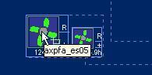

The selected equipment flashes.

On CCM, the Remote Control window appears, you can then view / edit the settings of the selected equipment. For more information on how to edit settings of the equipment, please refer to **Error! Bookmark not defined.**

##### Activate / De-Activate Fire Plan

   Left click on a fire area.

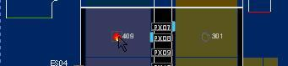

The fire area is highlighted with a light blue border, the activation and deactivation plans appear at the bottom left of the fire diagram.

   Right click on the highlighted fire area.

A context menu appears.

   Click on **Activate** / **De-Activate**.

A window appears to ask for confirmation to retrieve activation / de-activation plans.

   Click on **OK** button.

|  |
| --- |
| Description: c:\_temp\gis\tunnel\plant management control system (pmcs)\fire\Activa33.jpg |
| Figure 246 - Display a context menu for Fire Plan |

The Predefined Plan window appears on the CCM. You can then implement the plan. For more information, please refer to [here](#_Implement_Predefined_Plan).

#### Ventilation and measures

The user profile control the functions the user is authorize to use under Platform Control Mode (PCM) or Fall back Control Mode (FCM). Every user will have one user account that enables the user to login to IW. Every user account belongs to a profile.

|  |  |  |  |  |  |  |
| --- | --- | --- | --- | --- | --- | --- |
| **User profile** | | | | | **Operation mode** | |
| DO | Operator | FC | ITSC | Supervisor | PCM | FCM |
| ✓ | ✓ | ✓ | ✓ | ✓ | ✓ | ✓ |

For Ventilation and measures  in the tunnel, IW GIS has the following features:

•       [Display Ventilation](#_Display_Ventilation)

•       [Remote Control (Jet Fan, Tunnel Section, Visibility Meter only)](#_Remote_Control_(Jet)

•       [Ventilation toolbar](#_Ventilation_toolbar)

##### Display Ventilation

Click the **Ventilation** button  on the toolbar.



The Ventilation Fans diagram and Ventilation toolbar appear.

|  |
| --- |
| Description: c:\_temp\gis\tunnel\plant management control system (pmcs)\ventilation and measures\Displa37.jpg |
| Figure 247 - Ventilation diagram |

##### Remote Control (Jet Fan, Tunnel Section, Visibility Meter only)

Click on an equipment.

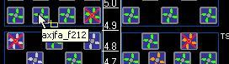

The selected equipment flashes.

On CCM, the Remote Control window appears, you can then view / edit the settings of the selected equipment. For more information on how to edit settings of the equipment, please refer to [here](#_Ventilation).

|  |
| --- |
| **Note** |
| For remote Tunnel Section control, click on the center of Ventilation Level. |

##### Ventilation toolbar

The ventilation toolbar allows you to have different views as well as viewing of Air Quality diagram.

|  |
| --- |
| Description: c:\_temp\gis\tunnel\plant management control system (pmcs)\ventilation and measures\vent_toolbar.JPG |
| |  |  | | --- | --- | | **FANS** | Zoom to full view of Ventilation Fans diagram. | | **NE** | Zoom in northeast region of the tunnel. | | **NW** | Zoom in northwest region of the tunnel. | | **SE** | Zoom in southeast region of the tunnel. | | **SW** | Zoom in southwest region of the tunnel. | | **QUALITY** | Display Air Quality diagram. | |

•         FANS View

Click the **FANS** button  on the toolbar.



The map will zoom to full view of the tunnel.

|  |
| --- |
| Description: c:\_temp\gis\tunnel\plant management control system (pmcs)\ventilation and measures\Ventil13.jpg |
| Figure 248 - Full view of Ventilation Fans diagram |

•         NW View

Click the **NW** button  on the toolbar.



The map will zoom to the northwest region of the tunnel. A more detailed diagram  is shown. Each fan has running hours, direction (+/-), status (Remote/Local/Off) and ID information.

|  |
| --- |
| Description: c:\_temp\gis\tunnel\plant management control system (pmcs)\ventilation and measures\Ventil4.jpg |
| Description: c:\_temp\gis\tunnel\plant management control system (pmcs)\ventilation and measures\Ventil5.jpg |
| Figure 249 - The northwest region of the Tunnel |

•         NE View

Click the **NE** button  on the toolbar.



The map will zoom to the northeast region of the tunnel.

|  |
| --- |
| Description: c:\_temp\gis\tunnel\plant management control system (pmcs)\ventilation and measures\Ventil1.jpg |
| Figure 250 - The northeast region of the Tunnel |

•        SW View

Click the **SW** button  on the toolbar.



The map will zoom to the southwest region of the tunnel.

|  |
| --- |
| Description: c:\_temp\gis\tunnel\plant management control system (pmcs)\ventilation and measures\Ventil12.jpg |
| Figure 251 - The southwest region of the Tunnel |

•         SE View

Click the **SE** button  on the toolbar.



The map will zoom to the southeast region of the tunnel.

|  |
| --- |
| Description: c:\_temp\gis\tunnel\plant management control system (pmcs)\ventilation and measures\Ventil11.jpg |
| Figure 252 - The southwest region of the Tunnel |

•         QUALITY View

Click the **QUALITY** button  on the toolbar.



The Air Quality diagram will show.

|  |
| --- |
| Description: c:\_temp\gis\tunnel\plant management control system (pmcs)\ventilation and measures\Ventil10.jpg |
| Figure 253 - Air Quality diagram |

|  |
| --- |
| **Note** |
| The Air Quality diagram cannot be viewed together with the Ventilation Fans diagram. |

#### Drainage

The user profile control the functions the user is authorize to use under Platform Control Mode (PCM) or Fall back Control Mode (FCM). Every user will have one user account that enables the user to login to IW. Every user account belongs to a profile.

|  |  |  |  |  |  |  |
| --- | --- | --- | --- | --- | --- | --- |
| **User profile** | | | | | **Operation mode** | |
| DO | Operator | FC | ITSC | Supervisor | PCM | FCM |
| ✓ | ✓ | ✓ | ✓ | ✓ | ✓ | ✓ |

For Drainage in the tunnel, IW GIS has the following features:

•       [Display Drainage](#_Display_Drainage)

•       [Remote Control (Pump and Sump only)](#_Remote_Control_(Pump)

•       [Drainage toolbar](#_Drainage_toolbar)

##### Display Drainage

Click the **Drainage** button  on the toolbar.



The Drainage Sump 1 diagram and Drainage toolbar appear. Drainage Sump 1 diagram is shown by default, to view other diagrams, use the Drainage toolbar.

|  |
| --- |
| Description: c:\_temp\gis\tunnel\plant management control system (pmcs)\drainage\Displa51.jpg |
| Figure 254 - Display Drainage Sump 1 diagram |
|  |

|  |  |  |  |
| --- | --- | --- | --- |
| **Symbols** | | | |
| Description: c:\_temp\gis\tunnel\plant management control system (pmcs)\drainage\Displa1.jpg | Pump | Description: c:\_temp\gis\tunnel\plant management control system (pmcs)\drainage\Displa2.jpg | Sump Level |

##### Remote Control (Pump and Sump only)

Click on an equipment.

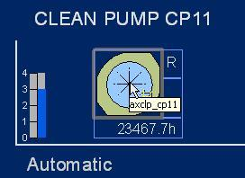

The selected equipment flashes.

On CCM, the Remote Control window appears, you can then view / edit the settings of the selected equipment. For more information on how to edit settings of the equipment, please refer to [here](#_Drainage_3).

|  |
| --- |
| **Note** |
| For remote Sump control, click on the center of Sump Level. |

##### Drainage toolbar

The drainage toolbar allows you to view different drainage diagrams.

|  |
| --- |
| Description: c:\_temp\gis\tunnel\plant management control system (pmcs)\drainage\drain_toolbar.JPG |
| |  |  | | --- | --- | | **SUMP1** | Display Drainage Sump 1 diagram. | | **SUMP2** | Display Drainage Sump 2 diagram. | | **SUMP3** | Display Drainage Sump 3 diagram. | | **SUMP4** | Display Drainage Sump 4 diagram. | | **SUMP5** | Display Drainage Sump 5 diagram. | |

•     View SUMP1 Diagram

Click  the **SUMP1** button on the toolbar.



The map will display the selected SUMP1 diagram.

|  |
| --- |
| Description: c:\_temp\gis\tunnel\plant management control system (pmcs)\drainage\Draina1.jpg |
| Figure 255 - DisplayDrainage Sump 1 diagram |

•     View SUMP2 Diagram

Click  the **SUMP2** button on the toolbar.



The map will display the selected SUMP2 diagram.

|  |
| --- |
| Description: c:\_temp\gis\tunnel\plant management control system (pmcs)\drainage\Draina2.jpg |
| Figure 256 - DisplayDrainage Sump 2 diagram |

•     View SUMP3 Diagram

Click  the **SUMP3** button on the toolbar.



The map will display the selected SUMP3 diagram.

|  |
| --- |
| Description: c:\_temp\gis\tunnel\plant management control system (pmcs)\drainage\Draina3.jpg |
| Figure 257 - DisplayDrainage Sump 3 diagram |

•     View SUMP4 Diagram

Click  the **SUMP4** button on the toolbar.



The map will display the selected SUMP4 diagram.

|  |
| --- |
| Description: c:\_temp\gis\tunnel\plant management control system (pmcs)\drainage\Draina4.jpg |
| Figure 258 - DisplayDrainage Sump 4 diagram |

•     View SUMP5 Diagram

Click  the **SUMP5** button on the toolbar.



The map will display the selected SUMP5 diagram.

|  |
| --- |
| Description: c:\_temp\gis\tunnel\plant management control system (pmcs)\drainage\Draina5.jpg |
| Figure 259 - DisplayDrainage Sump 5 diagram |

|  |
| --- |
| **Note** |
| Only one Sump diagram can be view at a time. |

#### Lighting

The user profile control the functions the user is authorize to use under Platform Control Mode (PCM) or Fall back Control Mode (FCM). Every user will have one user account that enables the user to login to IW. Every user account belongs to a profile.

|  |  |  |  |  |  |  |
| --- | --- | --- | --- | --- | --- | --- |
| **User profile** | | | | | **Operation mode** | |
| DO | Operator | FC | ITSC | Supervisor | PCM | FCM |
| ✓ | ✓ | ✓ | ✓ | ✓ | ✓ | ✓ |

For Lighting in the tunnel, IW GIS has the following features:

•       [Display Lighting](#_Display_Lighting)

•       [Remote Control (Photometer, Boost lighting and Line lighting only)](#_Remote_Control_(Photometer,)

##### Display Lighting

Click the **Lighting** button  on the toolbar.



The Lighting diagram appears.

|  |
| --- |
| Description: c:\_temp\gis\tunnel\plant management control system (pmcs)\lighting\Displa54.jpg |
| Figure 260 - Display the Lighting diagram |

##### Remote Control (Photometer, Boost lighting and Line lighting only)

Click on an equipment.

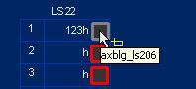

The selected equipment flashes. On CCM, the Remote Control window appears, you can then view / edit the settings of the selected equipment. For more information on how to edit settings of the equipment, please refer to [here](#_Lighting_1).

|  |
| --- |
| **Note** |
| For remote Sump control, click on the center of Sump Level. |

|  |  |  |  |
| --- | --- | --- | --- |
| **Symbols** | | | |
| Description: c:\_temp\gis\tunnel\plant management control system (pmcs)\lighting\Remote1.jpg | Description: c:\_temp\gis\tunnel\plant management control system (pmcs)\lighting\Remote2.jpg | Description: c:\_temp\gis\tunnel\plant management control system (pmcs)\lighting\Remote3.jpg | Description: c:\_temp\gis\tunnel\plant management control system (pmcs)\lighting\Remote4.jpg |
| Photometer | Boost Lighting Switching | Boost Lighting Group | Line Lighting Switching / Line Lighting Control |

#### Air con

The user profile control the functions the user is authorize to use under Platform Control Mode (PCM) or Fall back Control Mode (FCM). Every user will have one user account that enables the user to login to IW. Every user account belongs to a profile.

|  |  |  |  |  |  |  |
| --- | --- | --- | --- | --- | --- | --- |
| **User profile** | | | | | **Operation mode** | |
| DO | Operator | FC | ITSC | Supervisor | PCM | FCM |
| ✓ | ✓ | ✓ | ✓ | ✓ | ✓ | ✓ |

For Air Con in the tunnel, IW GIS has the following features:

•       [Display Air Con](#_Display_Air_Con)

•       [Remote Control](#_Remote_Control)

##### Display Air Con

Click the **Air Con** button  on the toolbar.



The Air Conditioning diagram appears.

|  |
| --- |
| Description: c:\_temp\gis\tunnel\plant management control system (pmcs)\air con\Displa61.jpg |
| Display the Air Conditioning diagram |

##### Remote Control

Click on an Air Con.

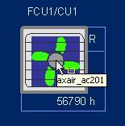

The selected Air con flashes.

On CCM, the Remote Control window appears, you can then view / edit the settings of the selected equipment. For more information on how to edit settings of the equipment, please refer to [here](#_Control_Air_Con).

|  |
| --- |
| **Note** |
| For remote Air Con control, click on the center of Air Con symbol. |

#### Power and measures

The user profile control the functions the user is authorize to use under Platform Control Mode (PCM) or Fall back Control Mode (FCM). Every user will have one user account that enables the user to login to IW. Every user account belongs to a profile.

|  |  |  |  |  |  |  |
| --- | --- | --- | --- | --- | --- | --- |
| **User profile** | | | | | **Operation mode** | |
| DO | Operator | FC | ITSC | Supervisor | PCM | FCM |
| ✓ | ✓ | ✓ | ✓ | ✓ | ✓ | ✓ |

For Power and measures  in the tunnel, IW GIS has the following features:

•       [Display Power](#_Display_Power)

•        [Remote Control (LV MDB Outgoing Feeder and LV Diesel Generator only)](#_Remote_Control_(LV)

•      [Power toolbar](#_Power_toolbar)

##### Display Power

Click the **Power** button  on the toolbar.



The **Power** CB diagram and Power toolbar appear. Power CB diagram is shown by default, to view other diagrams, use the Power toolbar.

|  |
| --- |
| Description: c:\_temp\gis\tunnel\plant management control system (pmcs)\power and measures\Displa63.jpg |
| Figure 261 - Display Power CB Diagram |

##### Remote Control (LV MDB Outgoing Feeder and LV Diesel Generator only)

Click on an equipment.

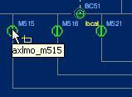

The selected equipment flashes.

On CCM, the Remote Control window appears, you can then view / edit the settings of the selected equipment. For more information on how to edit settings of the equipment, please refer to [here](#_Power_3).

|  |  |  |  |  |  |  |  |  |  |  |  |
| --- | --- | --- | --- | --- | --- | --- | --- | --- | --- | --- | --- |
| **Symbols** | | | | | | | | | | | |
| Description: c:\_temp\gis\tunnel\plant management control system (pmcs)\power and measures\Remote64.jpg | UPS | Description: c:\_temp\gis\tunnel\plant management control system (pmcs)\power and measures\Remote65.jpg | MDB Under Voltage Relay | Description: c:\_temp\gis\tunnel\plant management control system (pmcs)\power and measures\Remote66.jpg | Emergency Panel Under Voltage Relay | Description: c:\_temp\gis\tunnel\plant management control system (pmcs)\power and measures\Remote67.jpg | UPS under Voltage Relay | Description: c:\_temp\gis\tunnel\plant management control system (pmcs)\power and measures\Remote68.jpg | Diesel Generator | Description: c:\_temp\gis\tunnel\plant management control system (pmcs)\power and measures\Remote69.jpg | MDB Outgoing Feeder |

##### Power toolbar

The power toolbar allows you to view different power diagrams as well as Power Measures diagram.

|  |
| --- |
| Description: c:\_temp\gis\tunnel\plant management control system (pmcs)\power and measures\power_toolbar.JPG |
| |  |  | | --- | --- | | **CB** | Display Power CB diagram. | | **FB1** | Display Power FB1 diagram. | | **FB2** | Display Power FB2 diagram. | | **FB3** | Display Power FB3 diagram. | | **FB4** | Display Power FB4 diagram. | | **POWER\_MEASURES** | Display Measures diagram | |  |  | |

•    View Power CB Diagram

Click  the **CB** button on the Power toolbar.



The map will display the selected CB Power diagram.

|  |
| --- |
|  |
| Figure 262 - Display Power CB Diagram |

•    View Power FB1 Diagram

Click  the **FB1** button on the Power toolbar.



The map will display the selected FB1 Power diagram.

|  |
| --- |
|  |
| Figure 263 - Display Power FB1 Diagram |

•     View Power FB2 Diagram

Click  the **FB2** button on the toolbar.



The map will display the selected FB2 Power diagram.

|  |
| --- |
|  |
| Figure 264 - Display Power FB2 Diagram |

•     View Power FB3 Diagram

Click the **FB3** button on the toolbar.



The map will display the selected FB3 Power diagram.

|  |
| --- |
|  |
| Figure 265 - Display Power FB3 Diagram |

•     View Power FB4 Diagram

Click the **FB4** button on the toolbar.



The map will display the selected FB4 Power diagram.

|  |
| --- |
|  |
| Figure 266 - Display Power FB4 Diagram |

•     View Power Measures Diagram

Click the **POWER MEASURES** button on the toolbar.



The map will display the selected Power Measures diagram.

|  |
| --- |
| Description: c:\_temp\gis\tunnel\plant management control system (pmcs)\power and measures\Power 6.jpg |
| Figure 267 - Display Power Measures Diagram |

|  |
| --- |
| **Note** |
| Only one Power diagram can be view at a time. |

## Fort Canning Tunnel

Provide viewing and remote control of FCT Equipment. You can view the status and functioning mode. You can also monitor the maps for defects and alarms.

 Equipment include:

•        LUS

•       VMS and messages (FCT\_TMD, FCT\_AVMS, NES, NLTS)

•       Cameras

•        SOS

•       Fire

•       Lightings (Tunnel Lighting, Air Monitoring System)

•        Ventilation (Jet Fan)

•       COMMS (RBBI, Beacon Light)

•       Power

•      Plant Room

•       ITSC

|  |
| --- |
| Description: c:\_temp\gis\Tunnel80.jpg |
| Figure 268 - FCT Tunnel schematic diagram example |

### Tunnel overview toolbar

Click the **FCT Tunnel** button on the toolbar. The map will zoom to full tunnel view.



The FCT Tunnel toolbar appear on the map. This toolbar allows you to display equipment in the FCT tunnel view.

|  |
| --- |
| Description: c:\_temp\gis\FCT\FCT Overview\overview.JPG |
| |  |  | | --- | --- | | **FCT Tunnel** | Display FCT Tunnel view. | | **LUS** | Display LUS Location and status in the tunnel, refer to [here](#_Lane_Use_Signal_4). | | **VMS** | Display VMS location, status and message, refer to [here](#_Variable_Message_Signs_1). | | **Cameras** | Display cameras location and status, refer to [here](#_Cameras_1). | | **SOS** | Display SOS location, refer to  [here](#_SOS). | | **Fire** | Display FCT fire zones and status, refer to [here](#_Display_Fire_Areas). | | **Lightings** | Display lightings location, status in the tunnel, refer to [here](#_Lighting_2). | | **Ventilation** | Display jet fans location and status in the tunnel, refer to [here](#_Ventilation_1). | | **Security** | Display security doors location and status in the tunnel, refer to [here](#_Security). | | **COMMS** | Display RBBI and Beacon light status in the tunnel, refer to [here](#_COMMS). | | **Power** | Display FCT power equipment status in the tunnel, refer to [here](#_Power_1). | | **Plant Room** | Display plant room location and equipment status in the tunnel, refer to [here](#_Plant_Room). | | **ITSC** | Display ITSC buildings location and equipment status in the tunnel, refer to [here](#_ITSC). | |
| **Note** |
| There are 9 types of equipment you can view in the tunnel view. You can view multiple types together. E.g. if you have turned on LUS layer, you can also turned on VMS layer, to view them together: |

|  |
| --- |
|  |
| Description: c:\_temp\gis\fct\fct overview\overview1.JPG |
| Figure 269 - Display all FCT equipment layers together in Tunnel View |

### Tunnel Overview

The user profile control the functions the user is authorize to use under Platform Control Mode (PCM) or Fall back Control Mode (FCM). Every user will have one user account that enables the user to login to IW. Every user account belongs to a profile.

|  |  |  |  |  |  |  |
| --- | --- | --- | --- | --- | --- | --- |
| **User profile** | | | | | **Operation mode** | |
| DO | Operator | FC | ITSC | Supervisor | PCM | FCM |
| ✓ | ✓ | ✓ | ✓ | ✓ | ✓ | ✓ |

•    Display Tunnel equipment:

•      [Lane Use Signal (LUS)](#_Lane_Use_Signal_4)

•     [Variable Message Signs (VMS)](#_Variable_Message_Signs_1)

•       [Cameras](#_Cameras_1)

•          [SOS](#_SOS)

•          [Fire](#_Display_Fire_Areas)

•         [Ventilation](#_Ventilation_1)

•        [Lightings](#_Lighting_2)

•        [Security](#_Security)

•        [COMMS](#_COMMS)

|  |
| --- |
| **Note** |
| •       You cannot do things like zoom in, zoom out and pan in the tunnel synoptic diagram.  •       At anytime when you want to go to the open road view, click on Description: c:\_temp\gis\Tunnel\Tunnel overview\Tunnel82.jpg button on the toolbar. |

#### ITSC

The user profile control the functions the user is authorize to use under Platform Control Mode (PCM) or Fall back Control Mode (FCM). Every user will have one user account that enables the user to login to IW. Every user account belongs to a profile.

|  |  |  |  |  |  |  |
| --- | --- | --- | --- | --- | --- | --- |
| **User profile** | | | | | **Operation mode** | |
| DO | Operator | FC | ITSC | Supervisor | PCM | FCM |
| ✓ | ✓ | ✓ | ✓ | ✓ | ✓ | ✓ |

•    Display ITSC Lauout

Click the **ITSC** button on the toolbar.

The ITSC room diagram appears.

|  |
| --- |
| Description: c:\_temp\gis\fct\fct overview\itsc_2.JPG |
| Figure 270 - ITSC room diagram |

#### Plant Room

The user profile control the functions the user is authorize to use under Platform Control Mode (PCM) or Fall back Control Mode (FCM). Every user will have one user account that enables the user to login to IW. Every user account belongs to a profile.

|  |  |  |  |  |  |  |
| --- | --- | --- | --- | --- | --- | --- |
| **User profile** | | | | | **Operation mode** | |
| DO | Operator | FC | ITSC | Supervisor | PCM | FCM |
| ✓ | ✓ | ✓ | ✓ | ✓ | ✓ | ✓ |

•    Display Plant Room Lauout

Click the **Plant Room** button  on the toolbar.

The Plant room diagram appears.

|  |
| --- |
| Description: c:\_temp\gis\fct\fct overview\plantroom_2.JPG |
| Figure 271 - Plant room diagram |

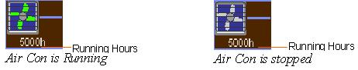

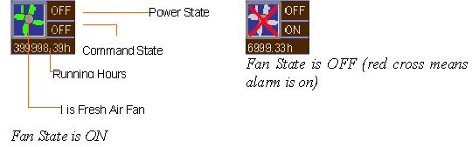

•    Remote Control of Air Con

Click on ACM icon.

The selected ACM flashes. On CCM, the Remote Control window appears, you can then view / edit the settings of the selected ACM. For more information on how to edit settings of ACM, please refer to [here](#_Control_Air_Con_1).

•    Remote Control of Fresh Air Fan

Click on FAF icon.

The selected FAF flashes. On CCM, the Remote Control window appears, you can then view / edit the settings of the selected FAF . For more information on how to edit settings of FAF , please refer to [here](#_Control_Fresh_Air).

#### Power

The user profile control the functions the user is authorize to use under Platform Control Mode (PCM) or Fall back Control Mode (FCM). Every user will have one user account that enables the user to login to IW. Every user account belongs to a profile.

|  |  |  |  |  |  |  |
| --- | --- | --- | --- | --- | --- | --- |
| **User profile** | | | | | **Operation mode** | |
| DO | Operator | FC | ITSC | Supervisor | PCM | FCM |
| ✓ | ✓ | ✓ | ✓ | ✓ | ✓ | ✓ |

•    Display Power Diagram

Click the **Power** button on the toolbar.

The power diagram appears.

|  |
| --- |
| Description: c:\_temp\gis\fct\fct overview\power_2.JPG |
| Figure 272 - Power diagram |

•    Remote Control of Generator

Click on GEN icon .

The selected GEN flashes. On CCM, the Remote Control window appears, you can then view / edit the settings of the selected GEN. For more information on how to edit settings of GEN, please refer to [here](#_Control_Generator).

#### COMMS

The user profile control the functions the user is authorize to use under Platform Control Mode (PCM) or Fall back Control Mode (FCM). Every user will have one user account that enables the user to login to IW. Every user account belongs to a profile.

|  |  |  |  |  |  |  |
| --- | --- | --- | --- | --- | --- | --- |
| **User profile** | | | | | **Operation mode** | |
| DO | Operator | FC | ITSC | Supervisor | PCM | FCM |
| ✓ | ✓ | ✓ | ✓ | ✓ | ✓ | ✓ |

•    Display and Hide RBBI and BEA:

Click the **COMMS** button on the toolbar.

The map refreshes and RBBI and Beacon Light appear on the map.

Click on the **COMMS** button again and the map refreshes and the RBBI and BEA icons will be hidden.

|  |
| --- |
| Description: c:\_temp\gis\fct\fct overview\com_2.JPG |
| Figure 273 - Display Tunnel COMMS |

|  |  |
| --- | --- |
| **Symbols** | |
| Description: c:\_temp\gis\fct\fct overview\comms_symbol.JPG |  |

•    Remote Control of RBBI

Click on RBBI icon .

The selected RBBI flashes. On CCM, the Remote Control window appears, you can then view / edit the settings of the selected RBBI. For more information on how to edit settings of RBBI, please refer to [here](#_Control_RBBI).

•    Remote Control of Beacon Light

Click on BEA icon .

The selected BEA flashes. On CCM, the Remote Control window appears, you can then view / edit the settings of the selected BEA. For more information on how to edit settings of BEA, please refer to [here](#_Control_Beacon_Lighting).

#### Security

The user profile control the functions the user is authorize to use under Platform Control Mode (PCM) or Fall back Control Mode (FCM). Every user will have one user account that enables the user to login to IW. Every user account belongs to a profile.

|  |  |  |  |  |  |  |
| --- | --- | --- | --- | --- | --- | --- |
| **User profile** | | | | | **Operation mode** | |
| DO | Operator | FC | ITSC | Supervisor | PCM | FCM |
| ✓ | ✓ | ✓ | ✓ | ✓ | ✓ | ✓ |

•    Display and Hide Security Door

 Click the **Security** button    on the toolbar.

The map refreshes and Security door appears on the map.

 Click on the **Security** button  again and the map refreshes and the Security icons will be hidden.

|  |
| --- |
| Description: c:\_temp\gis\fct\fct overview\sec-2.JPG |
| Figure 274 - Display FCT Tunnel Security Doors |

#### Ventilation

The user profile control the functions the user is authorize to use under Platform Control Mode (PCM) or Fall back Control Mode (FCM). Every user will have one user account that enables the user to login to IW. Every user account belongs to a profile.

|  |  |  |  |  |  |  |
| --- | --- | --- | --- | --- | --- | --- |
| **User profile** | | | | | **Operation mode** | |
| DO | Operator | FC | ITSC | Supervisor | PCM | FCM |
| ✓ | ✓ | ✓ | ✓ | ✓ | ✓ | ✓ |

•    Display and Hide Jet Fan

 Click the **Ventilation** button    on the toolbar.

The map refreshes and Jet Fans pear on the map.

 Click on the **Ventilation** button again and the map refreshes and the Jet Fan icons will be hidden.

|  |
| --- |
| Description: c:\_temp\gis\fct\fct overview\jetfan_2.JPG |
| Figure 275 - Display FCT Tunnel Jetfans |

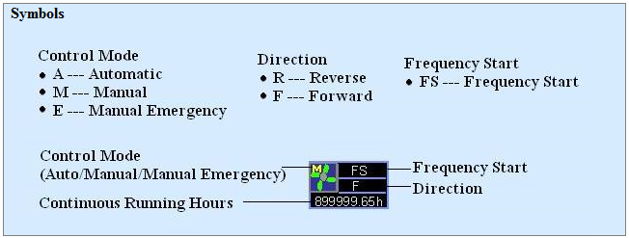

•    Remote Control of Jet Fans

Click on a Jet Fan

The selected jet fan flashes. On CCM, the Remote Control window appears, you can then view / edit the settings of the selected jet fan. For more information on how to edit settings of jet fan, please refer to [here](#_Control_Jet_Fan).

#### Lighting

The user profile control the functions the user is authorize to use under Platform Control Mode (PCM) or Fall back Control Mode (FCM). Every user will have one user account that enables the user to login to IW. Every user account belongs to a profile.

|  |  |  |  |  |  |  |
| --- | --- | --- | --- | --- | --- | --- |
| **User profile** | | | | | **Operation mode** | |
| DO | Operator | FC | ITSC | Supervisor | PCM | FCM |
| ✓ | ✓ | ✓ | ✓ | ✓ | ✓ | ✓ |

•    Dsiplay Lightings

Click the **Lighting** button on the toolbar.

The Lighting diagram appears.

|  |
| --- |
| Description: c:\_temp\gis\fct\fct overview\lighting_1.JPG |
| Figure 276 - Display the Lighting diagram |

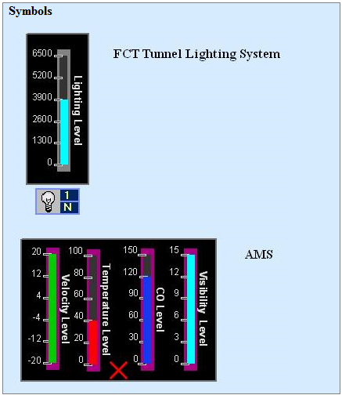

•    Remote Control of Lighting (Tunnel Lighting only)

Click on TLS icon .

The selected TLS flashes. On CCM, the Remote Control window appears, you can then view / edit the settings of the selected TLS. For more information on how to edit settings of TLS, please refer to [here](#_Control_Tunnel_Lighting).

#### Display Fire Areas

Click the **Fire** button 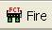on the toolbar.

The Fire Zone diagram appears.

|  |
| --- |
| Description: c:\_temp\gis\fct\fct overview\fire_1.JPG |
| Figure 277 - Display FCT Fire Zone diagram |

|  |  |
| --- | --- |
| **Symbols** | |
| Description: c:\_temp\gis\fct\fct overview\fir_symbol.JPG |  |

#### Activate / De-Activate Fire Plan

   Left click on a fire area.

|  |
| --- |
| Description: c:\_temp\gis\fct\fct overview\fire_plan.JPG |
| Figure 278 - Display a context menu for Fire Plan |

The fire area is highlighted with a light blue border, the activation and deactivation plans appear at the bottom left of the fire diagram.

   Right click on the highlighted fire area.

A context menu appears.

   Click on **Activate** / **De-Activate**.

A window appears to ask for confirmation to retrieve activation / de-activation plans.

   Click on **OK** button.

The Predefined Plan window appears on the CCM. You can then implement the plan. For more information, please refer to [here](#_Implement_Plan).

#### SOS

The user profile control the functions the user is authorize to use under Platform Control Mode (PCM) or Fall back Control Mode (FCM). Every user will have one user account that enables the user to login to IW. Every user account belongs to a profile.

|  |  |  |  |  |  |  |
| --- | --- | --- | --- | --- | --- | --- |
| **User profile** | | | | | **Operation mode** | |
| DO | Operator | FC | ITSC | Supervisor | PCM | FCM |
| ✓ | ✓ | ✓ | ✓ | ✓ | ✓ | ✓ |

•    Display and Hide SOS

1. Click the **FCT\_TUN\_SOS** button   on the toolbar.

The map refreshes and SOS appear on the map.

1. Click on the **FCT\_TUN\_SOS** button again and the map refreshes and the SOS icons will be hidden.

|  |
| --- |
| Description: c:\_temp\gis\fct\fct overview\sos_1.JPG |
| Figure 279 - Display FCT Tunnel SOS |

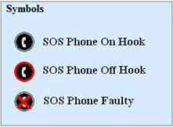

#### Cameras

The user profile control the functions the user is authorize to use under Platform Control Mode (PCM) or Fall back Control Mode (FCM). Every user will have one user account that enables the user to login to IW. Every user account belongs to a profile.

|  |  |  |  |  |  |  |
| --- | --- | --- | --- | --- | --- | --- |
| **User profile** | | | | | **Operation mode** | |
| DO | Operator | FC | ITSC | Supervisor | PCM | FCM |
| ✓ | ✓ | ✓ | ✓ | ✓ | ✓ | ✓ |

•    Display and Hide Cameras

 Click the **Cameras** button on the toolbar.

The map refreshes and cameras (surveillance and detection) appear on the map.

 Click on the **Cameras** button again and the map refreshes and the camera icons will be hidden.

|  |
| --- |
| Description: c:\_temp\gis\fct\fct overview\camera_1.JPG |
| Figure 280 - Display Tunnel Cameras |

|  |  |
| --- | --- |
| **Symbols** | |
| Description: c:\_temp\gis\fct\fct overview\camera_symbolJPG.JPG |  |

#### Variable Message Signs (VMS)

The user profile control the functions the user is authorize to use under Platform Control Mode (PCM) or Fall back Control Mode (FCM). Every user will have one user account that enables the user to login to IW. Every user account belongs to a profile.

|  |  |  |  |  |  |  |
| --- | --- | --- | --- | --- | --- | --- |
| **User profile** | | | | | **Operation mode** | |
| DO | Operator | FC | ITSC | Supervisor | PCM | FCM |
| ✓ | ✓ | ✓ | ✓ | ✓ | ✓ | ✓ |

•    Display and Hide VMS

1. Click the **VMS** button on the toolbar.

    The map refreshes, VMS and their messages appear on the map.

1. Click on the **VMS** button again and the map refreshes and the VMS icons and messages will be hidden.

|  |  |
| --- | --- |
| Description: c:\_temp\gis\fct\fct overview\vms.jpg | |
| Figure 281 - Display VMS and their messages in Tunnel View | |
| Note: | The "\*" character on the VMS equipment means VMS message flash flag. |
|  | |

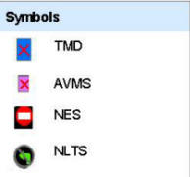

•    Remote Control of VMS on Tunnel Schematic View

Left click on a VMS.

The selected VMS flashes. On CCM, the Remote Control window appears, you can then view / edit the settings of the selected VMS. For more information on how to edit settings of VMS, please refer to [here](#_Variable_Message_Sign).

#### Lane Use Signal (LUS)

The user profile control the functions the user is authorize to use under Platform Control Mode (PCM) or Fall back Control Mode (FCM). Every user will have one user account that enables the user to login to IW. Every user account belongs to a profile.

|  |  |  |  |  |  |  |
| --- | --- | --- | --- | --- | --- | --- |
| **User profile** | | | | | **Operation mode** | |
| DO | Operator | FC | ITSC | Supervisor | PCM | FCM |
| ✓ | ✓ | ✓ | ✓ | ✓ | ✓ | ✓ |

•    Display and Hide LUS

1. Click the **LUS** button 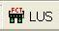on the toolbar.

The map refreshes and LUS appear on the map.

1. Click on the **LUS** button again and the map refreshes and the LUS icons will be hidden.

|  |
| --- |
| Description: c:\_temp\gis\fct\fct overview\lus_layout.JPG |
| Figure 282 - Display LUS in Tunnel View |

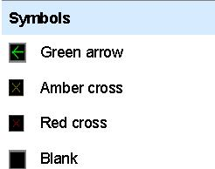

•    Remote Control of LUS on Tunnel Schematic View

Left click on a LUS.

The selected LUS flashes. On CCM, the Remote Control window appears, you can then view / edit the settings of the selected LUS. For more information on how to edit settings of LUS, please refer to [here](#_Lane_Use_Signal_2).

## Woodsville Tunnel

Provide viewing and remote control of WVT Equipment. You can view the status and functioning mode. You can also monitor the maps for defects and alarms.

 Equipment include:

•       LUS

•      VMS and messages (WVT AVMS, WVT EVMS)

•      Cameras

•       SOS

•       Fire

•       Security

•       COMMS

•    Barrier

•       Measure

•       Electrical

•      Power

•       FPS

•       Drainage

•       FB L1

•       FB L2

### Tunnel overview toolbar

Click the **WVT Tunnel** button on the toolbar. The map will zoom to full tunnel view.



The WVT Tunnel toolbar appear on the map. This toolbar allows you to display equipment in the WVT tunnel view.

|  |
| --- |
|  |
| |  |  | | --- | --- | | **WVT Tunnel** | Display WVT Tunnel view. | | **LUS** | Display LUS Location and status in the tunnel, refer to [here](#_Lane_Use_Signal_5). | | **VMS** | Display VMS location, status and message, refer to [here](#_Variable_Message_Signs_2). | | **Cameras** | Display cameras location and status, refer to [here](#_Cameras_2). | | **SOS** | Display SOS location, refer to  [here](#_SOS_1). | | **Fire** | Display WVT fire zones and status, refer to [here](#_Display_Fire_Areas_1). | | **Security** | Display security doors location and status in the tunnel, refer to [here](#_Security_1). | | **COMMS** | Display RBBI and Beacon light status in the tunnel, refer to [here](#_COMMS_1). | | **Barrier** | Display Barrier status in the tunnel, refer to [here](#_Barrier). | | **Measure** | Display measurement in the tunnel, refer to [here](#_Measure). | | **Electrical** | Display the WVT Electrical diagram, refer to [here](#_Electrical). | | **Power** | Display WVT power equipment status in the tunnel, refer to [here](#_Power_2). | | **FPS** | Display WVT fire protection system diagram, refer to [here](#_FPS). | | **FB L1** | Display WVT Facility Building Level 1 location and equipment status, refer to [here](#_FB_L1). | | **FB L2** | Display WVT Facility Building Level 2 location and equipment status, refer to [here](#_FB_L2). | |

### Tunnel Overview

The user profile control the functions the user is authorize to use under Platform Control Mode (PCM) or Fall back Control Mode (FCM). Every user will have one user account that enables the user to login to IW. Every user account belongs to a profile.

|  |  |  |  |  |  |  |
| --- | --- | --- | --- | --- | --- | --- |
| **User profile** | | | | | **Operation mode** | |
| DO | Operator | FC | ITSC | Supervisor | PCM | FCM |
| ✓ | ✓ | ✓ | ✓ | ✓ | ✓ | ✓ |

•    Display Tunnel equipment:

•       [LUS](#_Lane_Use_Signal_5)

•      [VMS and messages (WVT AVMS, WVT EVMS)](#_Variable_Message_Signs_2)

•      [Cameras](#_Cameras_2)

•       [SOS](#_SOS_1)

•       [Fire](#_Display_Fire_Areas_1)

•       [Security](#_Security_1)

•       [COMMS](#_COMMS_1)

•    [Barrier](#_Barrier)

•       [Measure](#_Measure)

•       [Electrical](#_Electrical)

•      [Power](#_Power_2)

•       [FPS](#_FPS)

•       [Drainage](#_Drainage_2)

•       [FB L1](#_FB_L1)

•       [FB L2](#_FB_L2)

#### Lane Use Signal (LUS)

The user profile control the functions the user is authorize to use under Platform Control Mode (PCM) or Fall back Control Mode (FCM). Every user will have one user account that enables the user to login to IW. Every user account belongs to a profile.

|  |  |  |  |  |  |  |
| --- | --- | --- | --- | --- | --- | --- |
| **User profile** | | | | | **Operation mode** | |
| DO | Operator | FC | ITSC | Supervisor | PCM | FCM |
| ✓ | ✓ | ✓ | ✓ | ✓ | ✓ | ✓ |

•    Display and Hide LUS

1. Click the **LUS** button on the toolbar.

The map refreshes and LUS appear on the map.

1. Click on the **LUS** button again and the map refreshes and the LUS icons will be hidden.

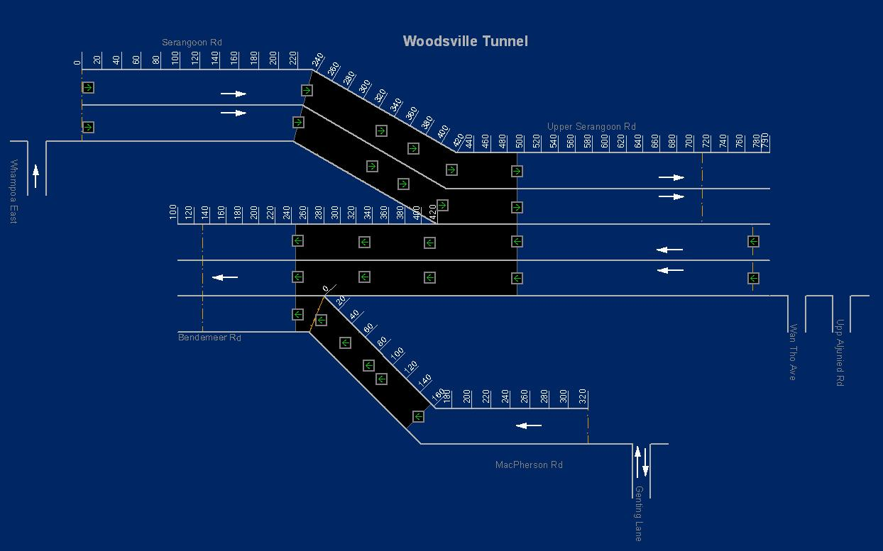

Figure 283 - Display LUS in WVT Tunnel View



•    Remote Control of LUS on Tunnel Schematic View

Left click on a LUS.

The selected LUS flashes. On CCM, the Remote Control window appears, you can then view / edit the settings of the selected LUS. For more information on how to edit settings of LUS, please refer to [here](#_Control_LUS).

#### Variable Message Signs (VMS)

The user profile control the functions the user is authorize to use under Platform Control Mode (PCM) or Fall back Control Mode (FCM). Every user will have one user account that enables the user to login to IW. Every user account belongs to a profile.

|  |  |  |  |  |  |  |
| --- | --- | --- | --- | --- | --- | --- |
| **User profile** | | | | | **Operation mode** | |
| DO | Operator | FC | ITSC | Supervisor | PCM | FCM |
| ✓ | ✓ | ✓ | ✓ | ✓ | ✓ | ✓ |

•    Display and Hide VMS

1. Click the **VMS** button  on the toolbar.

    The map refreshes, VMS and their messages appear on the map.

1. Click on the **VMS** button again and the map refreshes and the VMS icons and messages will be hidden.

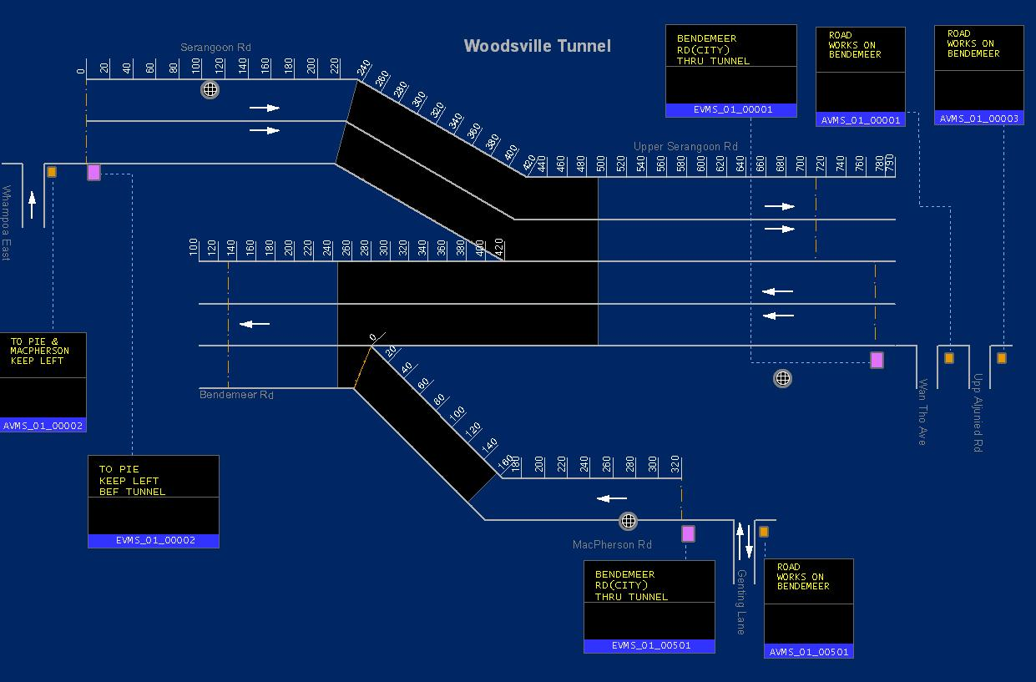

Figure 284 - Display VMS in WVT Tunnel View

•    Remote Control of VMS on Tunnel Schematic View

Left click on a VMS.

The selected VMS flashes. On CCM, the Remote Control window appears, you can then view / edit the settings of the selected VMS. For more information on how to edit settings of VMS, please refer to [here](#_Variable_Message_Sign_2).

#### Cameras

The user profile control the functions the user is authorize to use under Platform Control Mode (PCM) or Fall back Control Mode (FCM). Every user will have one user account that enables the user to login to IW. Every user account belongs to a profile.

|  |  |  |  |  |  |  |
| --- | --- | --- | --- | --- | --- | --- |
| **User profile** | | | | | **Operation mode** | |
| DO | Operator | FC | ITSC | Supervisor | PCM | FCM |
| ✓ | ✓ | ✓ | ✓ | ✓ | ✓ | ✓ |

•    Display and Hide Cameras

 Click the **Cameras** button  on the toolbar.

The map refreshes and cameras (surveillance and detection) appear on the map.

 Click on the **Cameras** button again and the map refreshes and the camera icons will be hidden.

|  |
| --- |
|  |
| Figure 285 - Display Cameras in WVT Tunnel View |

|  |  |
| --- | --- |
| **Symbols** | |
| Description: c:\_temp\gis\fct\fct overview\camera_symbolJPG.JPG |  |

#### SOS

The user profile control the functions the user is authorize to use under Platform Control Mode (PCM) or Fall back Control Mode (FCM). Every user will have one user account that enables the user to login to IW. Every user account belongs to a profile.

|  |  |  |  |  |  |  |
| --- | --- | --- | --- | --- | --- | --- |
| **User profile** | | | | | **Operation mode** | |
| DO | Operator | FC | ITSC | Supervisor | PCM | FCM |
| ✓ | ✓ | ✓ | ✓ | ✓ | ✓ | ✓ |

•    Display and Hide SOS

1. Click the **WVT\_TUN\_SOS** button   on the toolbar.

The map refreshes and SOS appear on the map.

1. Click on the **WVT\_TUN\_SOS** button  again and the map refreshes and the SOS icons will be hidden.

|  |
| --- |
|  |
| Figure 286 - Display SOS in WVT Tunnel view |



#### Display Fire Areas

Click the **Fire** button  on the toolbar.

The Fire Zone diagram appears.

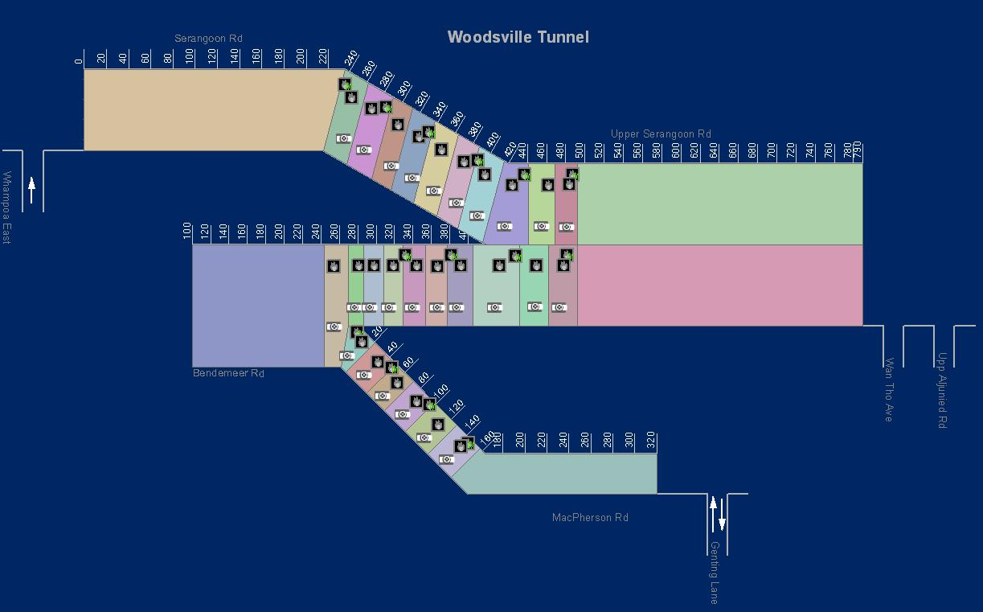



Figure 287 - Display Fire in WVT Tunnel View

|  |  |
| --- | --- |
| **Symbols** | |
| Description: c:\_temp\gis\fct\fct overview\fir_symbol.JPG |  |

#### Activate / De-Activate Fire Plan

   Left click on a fire area.

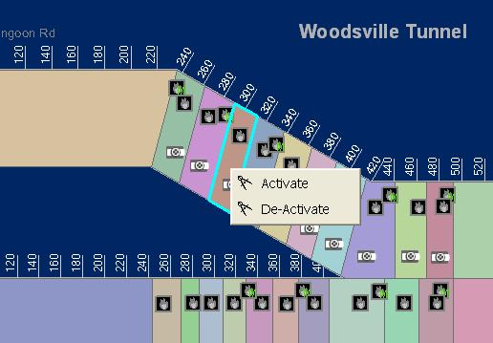

Figure 288 - Display a context menu for Fire Plan

The fire area is highlighted with a light blue border, the activation and deactivation plans appear at the bottom left of the fire diagram.

   Right click on the highlighted fire area.

A context menu appears.

   Click on **Activate** / **De-Activate**.

A window appears to ask for confirmation to retrieve activation / de-activation plans.

   Click on **OK** button.

The Predefined Plan window appears on the CCM. You can then implement the plan. For more information, please refer to [here](#_Implement_Plan).

#### Security

The user profile control the functions the user is authorize to use under Platform Control Mode (PCM) or Fall back Control Mode (FCM). Every user will have one user account that enables the user to login to IW. Every user account belongs to a profile.

|  |  |  |  |  |  |  |
| --- | --- | --- | --- | --- | --- | --- |
| **User profile** | | | | | **Operation mode** | |
| DO | Operator | FC | ITSC | Supervisor | PCM | FCM |
| ✓ | ✓ | ✓ | ✓ | ✓ | ✓ | ✓ |

•    Display and Hide Security Door

 Click the **Security** button  on the toolbar.

The map refreshes and Security door appears on the map.

 Click on the **Security** button again and the map refreshes and the Security icons will be hidden.

|  |
| --- |
|  |
| Figure 289 - Display WVT Tunnel Security Doors |

|  |  |
| --- | --- |
| **Symbols** | |
| Description: c:\_temp\gis\fct\fct overview\sec_symbol.JPG |  |

#### COMMS

The user profile control the functions the user is authorize to use under Platform Control Mode (PCM) or Fall back Control Mode (FCM). Every user will have one user account that enables the user to login to IW. Every user account belongs to a profile.

|  |  |  |  |  |  |  |
| --- | --- | --- | --- | --- | --- | --- |
| **User profile** | | | | | **Operation mode** | |
| DO | Operator | FC | ITSC | Supervisor | PCM | FCM |
| ✓ | ✓ | ✓ | ✓ | ✓ | ✓ | ✓ |

•    Display and Hide COMMS:

Click the **COMMS** button  on the toolbar.

The map refreshes and RBBI and Beacon Light appear on the map.

Click on the **COMMS** button again and the map refreshes and the RBBI and BEA icons will be hidden.

|  |
| --- |
|  |
| Figure 290 - Display Tunnel COMMS |

|  |  |
| --- | --- |
| **Symbols** | |
| Beacon Light  RBIW |  |

•    Remote Control of RBIW

Click on RBIW icon 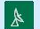.

The selected RBIW flashes. On CCM, the Remote Control window appears, you can then view / edit the settings of the selected RBBI. For more information on how to edit settings of RBIW, please refer to [here](#_Control_RBIW).

•    Remote Control of Beacon Light

Click on BEA icon 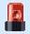.

The selected BEA flashes. On CCM, the Remote Control window appears, you can then view / edit the settings of the selected BEA. For more information on how to edit settings of BEA, please refer to [here](#_Control_Beacon_Lighting_1).

#### Barrier

The user profile control the functions the user is authorize to use under Platform Control Mode (PCM) or Fall back Control Mode (FCM). Every user will have one user account that enables the user to login to IW. Every user account belongs to a profile.

|  |  |  |  |  |  |  |
| --- | --- | --- | --- | --- | --- | --- |
| **User profile** | | | | | **Operation mode** | |
| DO | Operator | FC | ITSC | Supervisor | PCM | FCM |
| ✓ | ✓ | ✓ | ✓ | ✓ | ✓ | ✓ |

•    Display and Hide RBIW and BEA:

Click the **Barrier** button on the toolbar.

The map refreshes and RBBI and Beacon Light appear on the map.

Click on the **Barrier** button  again and the map refreshes and the RBBI and BEA icons will be hidden.

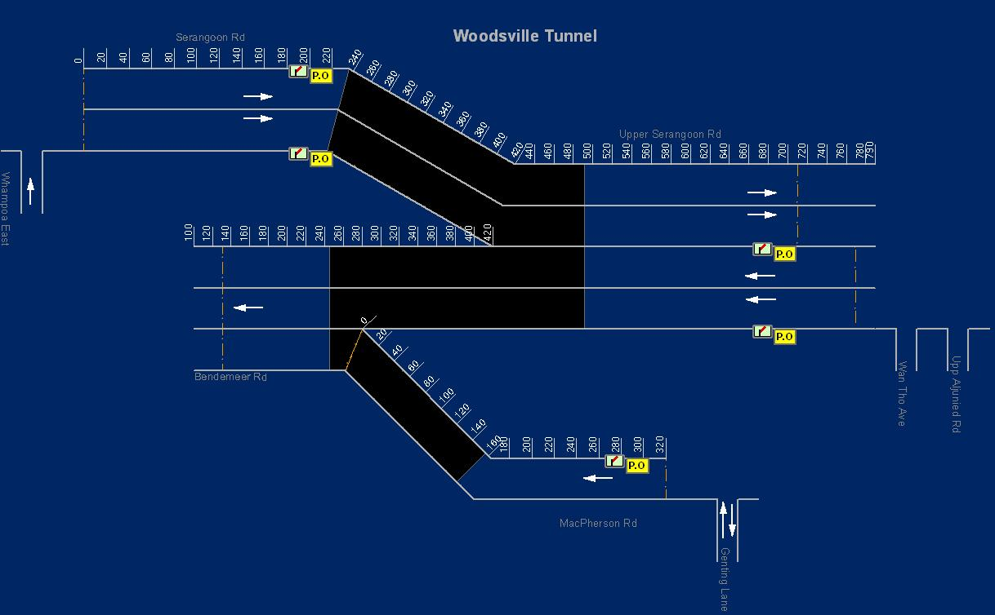

Figure 291 - Display Barrier in WVT Tunnel View

#### Measure

The user profile control the functions the user is authorize to use under Platform Control Mode (PCM) or Fall back Control Mode (FCM). Every user will have one user account that enables the user to login to IW. Every user account belongs to a profile.

|  |  |  |  |  |  |  |
| --- | --- | --- | --- | --- | --- | --- |
| **User profile** | | | | | **Operation mode** | |
| DO | Operator | FC | ITSC | Supervisor | PCM | FCM |
| ✓ | ✓ | ✓ | ✓ | ✓ | ✓ | ✓ |

•    Display Measurement

Click the **Measure** button  on the toolbar.

The Measurement appears.

|  |
| --- |
|  |
| Figure 292 – WVT Measurement |

#### Electrical

The user profile control the functions the user is authorize to use under Platform Control Mode (PCM) or Fall back Control Mode (FCM). Every user will have one user account that enables the user to login to IW. Every user account belongs to a profile.

|  |  |  |  |  |  |  |
| --- | --- | --- | --- | --- | --- | --- |
| **User profile** | | | | | **Operation mode** | |
| DO | Operator | FC | ITSC | Supervisor | PCM | FCM |
| ✓ | ✓ | ✓ | ✓ | ✓ | ✓ | ✓ |

•    Display Electrical layout

Click the **Electrical** button  on the toolbar.

The Electrical layout appears.

|  |
| --- |
|  |
| Figure 293 – WVT Electrical layout |

#### Power

The user profile control the functions the user is authorize to use under Platform Control Mode (PCM) or Fall back Control Mode (FCM). Every user will have one user account that enables the user to login to IW. Every user account belongs to a profile.

|  |  |  |  |  |  |  |
| --- | --- | --- | --- | --- | --- | --- |
| **User profile** | | | | | **Operation mode** | |
| DO | Operator | FC | ITSC | Supervisor | PCM | FCM |
| ✓ | ✓ | ✓ | ✓ | ✓ | ✓ | ✓ |

•    Display Power Layout

Click the **Power** button  on the toolbar.

The WVT Power Measurement appears.

|  |
| --- |
|  |
| Figure 294 - WVT Electrical Measurement |

#### FPS

The user profile control the functions the user is authorize to use under Platform Control Mode (PCM) or Fall back Control Mode (FCM). Every user will have one user account that enables the user to login to IW. Every user account belongs to a profile.

|  |  |  |  |  |  |  |
| --- | --- | --- | --- | --- | --- | --- |
| **User profile** | | | | | **Operation mode** | |
| DO | Operator | FC | ITSC | Supervisor | PCM | FCM |
| ✓ | ✓ | ✓ | ✓ | ✓ | ✓ | ✓ |

•    Display WVT FPS

Click the **FPS** button  on the toolbar.

The WVT FPS appears.

|  |
| --- |
|  |
| Figure 295 – WVT FPS |

#### Drainage

The user profile control the functions the user is authorize to use under Platform Control Mode (PCM) or Fall back Control Mode (FCM). Every user will have one user account that enables the user to login to IW. Every user account belongs to a profile.

|  |  |  |  |  |  |  |
| --- | --- | --- | --- | --- | --- | --- |
| **User profile** | | | | | **Operation mode** | |
| DO | Operator | FC | ITSC | Supervisor | PCM | FCM |
| ✓ | ✓ | ✓ | ✓ | ✓ | ✓ | ✓ |

•    Display WVT Drainage

Click the **Drainage** button  on the toolbar.

The WVT Drainage appears.

|  |
| --- |
|  |
| Figure 296 – WVT Drainage |

#### FB L1

The user profile control the functions the user is authorize to use under Platform Control Mode (PCM) or Fall back Control Mode (FCM). Every user will have one user account that enables the user to login to IW. Every user account belongs to a profile.

|  |  |  |  |  |  |  |
| --- | --- | --- | --- | --- | --- | --- |
| **User profile** | | | | | **Operation mode** | |
| DO | Operator | FC | ITSC | Supervisor | PCM | FCM |
| ✓ | ✓ | ✓ | ✓ | ✓ | ✓ | ✓ |

•    Display WVT FB Level 1 Layout

Click the **FB L1** button  on the toolbar.

The WVT FB Level 1 Layout appears.

|  |
| --- |
|  |
| Figure 297 - WVT FB Level 1 Layout |

#### FB L2

The user profile control the functions the user is authorize to use under Platform Control Mode (PCM) or Fall back Control Mode (FCM). Every user will have one user account that enables the user to login to IW. Every user account belongs to a profile.

|  |  |  |  |  |  |  |
| --- | --- | --- | --- | --- | --- | --- |
| **User profile** | | | | | **Operation mode** | |
| DO | Operator | FC | ITSC | Supervisor | PCM | FCM |
| ✓ | ✓ | ✓ | ✓ | ✓ | ✓ | ✓ |

•    Display WVT FB Level 2 Layout

Click the **FB L2** button  on the toolbar.

The ITSC room diagram appears.

|  |
| --- |
|  |
| Figure 298 - WVT FB Level 1 Layout |

## Sentosa Gateway Tunnel

Provide viewing and remote control of FCT Equipment. You can view the status and functioning mode. You can also monitor the maps for defects and alarms.

 Equipment include:

•        LUS

•       VMS and messages (FCT\_TMD, FCT\_AVMS, NES, NLTS)

•       Cameras

•      SOS

•       Fire

•       Security

•       COMMS (RBBI, Beacon Light)

•       Network

•      Electrical

•       Drainage

•       FPS

•       Measure

•       FB L1 and FP L2

|  |
| --- |
|  |
| Figure 268 - SGT Tunnel schematic diagram |

### Tunnel overview toolbar

Click the **SGT Tunnel** button  on the toolbar. The map will zoom to full tunnel view.



The SGT Tunnel toolbar appear on the map. This toolbar allows you to display equipment in the SGT tunnel view.

|  |  |
| --- | --- |
|  | |
| |  |  | | --- | --- | | **SGT Tunnel** | Display SGT Tunnel view. | | **LUS** | Display LUS Location and status in the tunnel, refer to [here](#_Lane_Use_Signal_6). | | **VMS** | Display VMS location, status and message, refer to [here](#_Variable_Message_Signs_3). | | **Cameras** | Display cameras location and status, refer to [here](#_Cameras_3). | | **SOS** | Display SOS location, refer to  [here](#_SOS_2). | | **Fire** | Display SGT fire zones and status, refer to [here](#_Display_Fire_Areas_2). | | **Security** | Display security doors location and status in the tunnel, refer to [here](#_Security_2). | | **COMMS** | Display RBBI and Beacon light status in the tunnel, refer to [here](#_COMMS_2). | | **Electrical** | Display SGT electrical system diagram, refer to [here](#_Electrical_1). | | **Drainage** | Display plant room location and equipment status in the tunnel, refer to [here](#_Drainage_1). | | **FPS** | Display SGT Fire Protection System diagram, refer to [here](#_FPS). | | **Measure** | Display Tunnel Measurements such as Air Monitoring, Lighting, Jet Fan and LSC, refer to [here](#_Measure_1). | | **FB L1** | Display SGT Facility Building Level 1 location and equipment status, refer to [here](#_FB_L1_1). | | **FB L2** | Display SGT Facility Building Level 2 location and equipment status, refer to [here](#_FB_L2_1). | |
| **Note** |
| There are 9 types of equipment you can view in the tunnel view. You can view multiple types together. E.g. if you have turned on LUS layer, you can also turned on VMS layer, to view them together: |

|  |
| --- |
|  |
|  |
| Figure 269 - Display all SGT equipment layers together in Tunnel View |

### Tunnel Overview

The user profile control the functions the user is authorize to use under Platform Control Mode (PCM) or Fall back Control Mode (FCM). Every user will have one user account that enables the user to login to IW. Every user account belongs to a profile.

|  |  |  |  |  |  |  |
| --- | --- | --- | --- | --- | --- | --- |
| **User profile** | | | | | **Operation mode** | |
| DO | Operator | FC | ITSC | Supervisor | PCM | FCM |
| ✓ | ✓ | ✓ | ✓ | ✓ | ✓ | ✓ |

•    Display Tunnel equipment:

•     [Lane Use Signal (LUS)](#_Lane_Use_Signal_6)

•     [Variable Message Signs (VMS)](#_Variable_Message_Signs_3)

•       [Cameras](#_Cameras_3)

•          [SOS](#_SOS_2)

•          [Fire](#_Display_Fire_Areas_2)

•        [Security](#_Security_2)

•        [COMMS](#_COMMS_2)

•   [Network](#_Network)

•         [Electrical](#_Electrical_1)

•    [Drainage](#_Drainage_1)

•    [Activate / De-Activate Fire Plan](#_Activate_/_De-Activate_1)

•   [Measure](#_Measure_1)

•   [FB L1](#_FB_L1_1)

•   [FB](#_FB_L2_1) L2

|  |
| --- |
| **Note** |
| •       You cannot do things like zoom in, zoom out and pan in the tunnel synoptic diagram.  •       At anytime when you want to go to the open road view, click on Description: c:\_temp\gis\Tunnel\Tunnel overview\Tunnel82.jpg button on the toolbar. |

#### Lane Use Signal (LUS)

The user profile control the functions the user is authorize to use under Platform Control Mode (PCM) or Fall back Control Mode (FCM). Every user will have one user account that enables the user to login to IW. Every user account belongs to a profile.

|  |  |  |  |  |  |  |
| --- | --- | --- | --- | --- | --- | --- |
| **User profile** | | | | | **Operation mode** | |
| DO | Operator | FC | ITSC | Supervisor | PCM | FCM |
| ✓ | ✓ | ✓ | ✓ | ✓ | ✓ | ✓ |

•    Display and Hide LUS

1. Click the **LUS** button on the toolbar.

The map refreshes and LUS appear on the map.

1. Click on the **LUS** button again and the map refreshes and the LUS icons will be hidden.

|  |
| --- |
|  |
| Figure 282 - Display LUS in Tunnel View |



•    Remote Control of LUS on Tunnel Schematic View

Left click on a LUS.

The selected LUS flashes. On CCM, the Remote Control window appears, you can then view / edit the settings of the selected LUS. For more information on how to edit settings of LUS, please refer to [here](#_LUS).

#### Variable Message Signs (VMS)

The user profile control the functions the user is authorize to use under Platform Control Mode (PCM) or Fall back Control Mode (FCM). Every user will have one user account that enables the user to login to IW. Every user account belongs to a profile.

|  |  |  |  |  |  |  |
| --- | --- | --- | --- | --- | --- | --- |
| **User profile** | | | | | **Operation mode** | |
| DO | Operator | FC | ITSC | Supervisor | PCM | FCM |
| ✓ | ✓ | ✓ | ✓ | ✓ | ✓ | ✓ |

•    Display and Hide VMS

1. Click the **VMS** button  on the toolbar.

    The map refreshes, VMS and their messages appear on the map.

1. Click on the **VMS** button again and the map refreshes and the VMS icons and messages will be hidden.

|  |  |
| --- | --- |
|  | |
| Figure 281 - Display VMS in Tunnel View | |
| Note: | The "\*" character on the VMS equipment means VMS message flash flag. |
|  | |

•    Remote Control of VMS on Tunnel Schematic View

Left click on a VMS.

The selected VMS flashes. On CCM, the Remote Control window appears, you can then view / edit the settings of the selected VMS. For more information on how to edit settings of VMS, please refer to [here](#_Variable_Message_Sign_1).

#### Cameras

The user profile control the functions the user is authorize to use under Platform Control Mode (PCM) or Fall back Control Mode (FCM). Every user will have one user account that enables the user to login to IW. Every user account belongs to a profile.

|  |  |  |  |  |  |  |
| --- | --- | --- | --- | --- | --- | --- |
| **User profile** | | | | | **Operation mode** | |
| DO | Operator | FC | ITSC | Supervisor | PCM | FCM |
| ✓ | ✓ | ✓ | ✓ | ✓ | ✓ | ✓ |

•    Display and Hide Cameras

 Click the **Cameras** button  on the toolbar.

The map refreshes and cameras (surveillance and detection) appear on the map.

 Click on the **Cameras** button again and the map refreshes and the camera icons will be hidden.

|  |
| --- |
|  |
| Figure 280 - Display Tunnel Cameras |

|  |  |
| --- | --- |
| **Symbols** | |
| Description: c:\_temp\gis\fct\fct overview\camera_symbolJPG.JPG |  |

•    Remote Control of Cameras (Surveillance Cameras only)

#### SOS

The user profile control the functions the user is authorize to use under Platform Control Mode (PCM) or Fall back Control Mode (FCM). Every user will have one user account that enables the user to login to IW. Every user account belongs to a profile.

|  |  |  |  |  |  |  |
| --- | --- | --- | --- | --- | --- | --- |
| **User profile** | | | | | **Operation mode** | |
| DO | Operator | FC | ITSC | Supervisor | PCM | FCM |
| ✓ | ✓ | ✓ | ✓ | ✓ | ✓ | ✓ |

•    Display and Hide SOS

1. Click the **SGT\_TUN\_SOS** button   on the toolbar.

The map refreshes and SOS appear on the map.

1. Click on the **SGT\_TUN\_SOS** button again and the map refreshes and the SOS icons will be hidden.

|  |
| --- |
|  |
| Figure 279 - Display SGT Tunnel SOS |



#### Security

The user profile control the functions the user is authorize to use under Platform Control Mode (PCM) or Fall back Control Mode (FCM). Every user will have one user account that enables the user to login to IW. Every user account belongs to a profile.

|  |  |  |  |  |  |  |
| --- | --- | --- | --- | --- | --- | --- |
| **User profile** | | | | | **Operation mode** | |
| DO | Operator | FC | ITSC | Supervisor | PCM | FCM |
| ✓ | ✓ | ✓ | ✓ | ✓ | ✓ | ✓ |

•    Display and Hide Security Door

 Click the **Security** button    on the toolbar.

The map refreshes and Security door appears on the map.

 Click on the **Security** button  again and the map refreshes and the Security icons will be hidden.

|  |
| --- |
|  |
| Figure 274 - Display SGT Tunnel Security Doors |

#### COMMS

The user profile control the functions the user is authorize to use under Platform Control Mode (PCM) or Fall back Control Mode (FCM). Every user will have one user account that enables the user to login to IW. Every user account belongs to a profile.

|  |  |  |  |  |  |  |
| --- | --- | --- | --- | --- | --- | --- |
| **User profile** | | | | | **Operation mode** | |
| DO | Operator | FC | ITSC | Supervisor | PCM | FCM |
| ✓ | ✓ | ✓ | ✓ | ✓ | ✓ | ✓ |

•    Display and Hide RBBI and BEA:

Click the **COMMS** button  on the toolbar.

The map refreshes and RBBI and Beacon Light appear on the map.

Click on the **COMMS** button again and the map refreshes and the RBBI and BEA icons will be hidden.

|  |
| --- |
|  |
| Figure 273 - Display Tunnel COMMS |

|  |  |
| --- | --- |
| **Symbols** | |
| Description: c:\_temp\gis\fct\fct overview\comms_symbol.JPG |  |

•    Remote Control of RBBI

Click on RBBI icon .

The selected RBBI flashes. On CCM, the Remote Control window appears, you can then view / edit the settings of the selected RBBI. For more information on how to edit settings of RBBI, please refer to [here](#_Control_RBBI_1).

•    Remote Control of Beacon Light

Click on BEA icon .

The selected BEA flashes. On CCM, the Remote Control window appears, you can then view / edit the settings of the selected BEA. For more information on how to edit settings of BEA, please refer to [here](#_Control_Beacon_Lighting_2).

#### Network

The user profile control the functions the user is authorize to use under Platform Control Mode (PCM) or Fall back Control Mode (FCM). Every user will have one user account that enables the user to login to IW. Every user account belongs to a profile.

|  |  |  |  |  |  |  |
| --- | --- | --- | --- | --- | --- | --- |
| **User profile** | | | | | **Operation mode** | |
| DO | Operator | FC | ITSC | Supervisor | PCM | FCM |
| ✓ | ✓ | ✓ | ✓ | ✓ | ✓ | ✓ |

•    Display Network

Click the **Network** button on the toolbar.

The Network diagram appears.

|  |
| --- |
|  |
| Figure 276 - Display the Network diagram |

#### Electrical

The user profile control the functions the user is authorize to use under Platform Control Mode (PCM) or Fall back Control Mode (FCM). Every user will have one user account that enables the user to login to IW. Every user account belongs to a profile.

|  |  |  |  |  |  |  |
| --- | --- | --- | --- | --- | --- | --- |
| **User profile** | | | | | **Operation mode** | |
| DO | Operator | FC | ITSC | Supervisor | PCM | FCM |
| ✓ | ✓ | ✓ | ✓ | ✓ | ✓ | ✓ |

•    Display Electrical layout

Click the **Electrical** button  on the toolbar.

The Electrical layout appears.

|  |
| --- |
|  |
| Figure 293 – SGT Electrical layout |

#### Drainage

The user profile control the functions the user is authorize to use under Platform Control Mode (PCM) or Fall back Control Mode (FCM). Every user will have one user account that enables the user to login to IW. Every user account belongs to a profile.

|  |  |  |  |  |  |  |
| --- | --- | --- | --- | --- | --- | --- |
| **User profile** | | | | | **Operation mode** | |
| DO | Operator | FC | ITSC | Supervisor | PCM | FCM |
| ✓ | ✓ | ✓ | ✓ | ✓ | ✓ | ✓ |

•    Display and SGT Drainage System diagram

 Click the **Drainage** button    on the toolbar.

The map refreshes and the system diagram appears on the map.

 Click on the **Drainage** button again and the map refreshes and the Jet Fan icons will be hidden.

|  |
| --- |
|  |
| Figure 275 - Display SGT Drainage System diagram |

#### Display Fire Areas

Click the **Fire** button on the toolbar.

The Fire Zone diagram appears.

|  |
| --- |
|  |
| Figure 277 - Display SGT Fire Zone diagram |

#### Activate / De-Activate Fire Plan

   Left click on a fire area.

|  |
| --- |
|  |
| Figure 278 - Display a context menu for Fire Plan |

The fire area is highlighted with a light blue border, the activation and deactivation plans appear at the bottom left of the fire diagram.

   Right click on the highlighted fire area.

A context menu appears.

   Click on **Activate** / **De-Activate**.

A window appears to ask for confirmation to retrieve activation / de-activation plans.

   Click on **OK** button.

The Predefined Plan window appears on the CCM. You can then implement the plan. for more information, please refer to [here](#_Implement_Plan).

#### Measure

The user profile control the functions the user is authorize to use under Platform Control Mode (PCM) or Fall back Control Mode (FCM). Every user will have one user account that enables the user to login to IW. Every user account belongs to a profile.

|  |  |  |  |  |  |  |
| --- | --- | --- | --- | --- | --- | --- |
| **User profile** | | | | | **Operation mode** | |
| DO | Operator | FC | ITSC | Supervisor | PCM | FCM |
| ✓ | ✓ | ✓ | ✓ | ✓ | ✓ | ✓ |

•    Display Measurement

Click the **Measure** button  on the toolbar.

The Measurements appears.

|  |
| --- |
|  |
| Figure 292 – SGT Measurements |

#### FB L1

The user profile control the functions the user is authorize to use under Platform Control Mode (PCM) or Fall back Control Mode (FCM). Every user will have one user account that enables the user to login to IW. Every user account belongs to a profile.

|  |  |  |  |  |  |  |
| --- | --- | --- | --- | --- | --- | --- |
| **User profile** | | | | | **Operation mode** | |
| DO | Operator | FC | ITSC | Supervisor | PCM | FCM |
| ✓ | ✓ | ✓ | ✓ | ✓ | ✓ | ✓ |

•    Display SGT FB Level 1 Layout

Click the **FB L1** button  on the toolbar.

The SGT FB Level 1 Layout appears.

|  |
| --- |
|  |
| Figure 297 - SGT FB Level 1 Layout |

#### FB L2

The user profile control the functions the user is authorize to use under Platform Control Mode (PCM) or Fall back Control Mode (FCM). Every user will have one user account that enables the user to login to IW. Every user account belongs to a profile.

|  |  |  |  |  |  |  |
| --- | --- | --- | --- | --- | --- | --- |
| **User profile** | | | | | **Operation mode** | |
| DO | Operator | FC | ITSC | Supervisor | PCM | FCM |
| ✓ | ✓ | ✓ | ✓ | ✓ | ✓ | ✓ |

•    Display SGT FB Level 2 Layout

Click the **FB L2** button  on the toolbar.

The ITSC room diagram appears.

|  |
| --- |
|  |
| Figure 298 - SGT FB Level 2 Layout |

## KPE

Provide viewing of KPE Tunnel Equipment in map open view and Tunnel layout. You can view the status and functioning mode. You can also monitor the maps for defects and alarms.

 Equipment include:

•       VMS and messages (AVMS, EVMS, TID, TVMS, VSL)

•       TLED and Message

•       AIDC Cameras

•        CCTC Cameras

•       Barriers

•       TFS

•       LUS (only display in tunnel view)

All above equipment will be displayed in open map view and tunnel view as below:

|  |
| --- |
| Description: c:\_temp\gis\kpe\kpe_mapview.jpg |
| Figure 299 - A KPE Boundary map display (with VMS) example |

|  |
| --- |
| Description: c:\_temp\gis\kpe\kpe_tunview.jpg |
| Figure 300 - A KPE tunnel schematic diagram (with VMS) example |

### KPE overview toolbar

Click the **KPE Toolbar** button under Tools menu to toggle the KPE toolbar display.

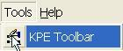

When the KPE toolbar appears on the map, this toolbar allows you to display equipment in the KPE open view and KPE Tunnel view.

|  |  |
| --- | --- |
|  | |
| |  |  | | --- | --- | | **KPE Open view** | Display/hide KPE boundary on open map view. | | **TDS** | Display/hide KPE TDS equipment location, status on open map view, refer to [here](#_Traffic_Display_Sign). | | **AIDC Cameras** | Display/hide AIDC camera location and status on open map view, refer to [here](#_AIDC_Cameras). | | **CCTC Cameras** | Display/hide CCTC camera location and status on open map view, refer to [here](#_CCTC_Cameras). | | **Barrier and TFS** | Display/hide Barrier and TFS equipment location on open map view, refer to [here](#_Traffic_Signal(TFS)_and). | | **Tunnel View1** | Display KPE tunnel view 1, refer to [here](#_Zooming_map_using_1). | | **Tunnel View1 West** | Display KPE tunnel view west part, refer to [here](#_Zooming_map_using_1). | | **Tunnel View1 East** | Display KPE tunnel view east part, refer to [here](#_Zooming_map_using_1). | | **Tunnel View2** | Display KPE tunnel view 2, refer to [here](#_Zooming_map_using_1). | | **Tunnel View3** | Display KPE tunnel view 3, refer to [here](#_Zooming_map_using_1). | | **Tunnel LUS** | Display/hide LUS location and status in the tunnel view, refer to [here](#_Lane_Use_Signal_7). | | **Tunnel VMS** | Display/hide VMS location, status and messages in the tunnel view, refer to [here](#_Variable_Message_Signs_4). | | **Tunnel TLED** | Display/hide TLED location, status and messages in the tunnel view, refer to [here](#_Traffic_LED_Sign(TLED)). | | **Tunnel AIDC** | Display/hide AIDC camera location and status in the tunnel view, refer to [here](#_AIDC_Cameras_1). | | **Tunnel CCTC** | Display/hide CCTC camera location and status in the tunnel view, refer to [here](#_CCTC_Cameras_1). | | **Tunnel Barrier and TFS** | Display/hide Barrier and TFS location in the tunnel view, refer to [here](#_Traffic_Signal(TFS)_and_1). | |

|  |
| --- |
|  |

### KPE Equipment Monitoring and Display

Provide viewing of Traffic and Surveillance Equipment. You can view the status and functioning mode. You can also monitor the maps for defects and alarms.

   equipment include:

•       KPE TDS and messages (AVMS, EVMS, TID, TVMS, TLED, and VSL)

•       AIDC Cameras

•       CCTC Cameras

•       Barriers

•       TFS

   Features:

•      View equipment location

•       Color-code the equipment border to show different status.

    Grey – operational

    Red – not operational

|  |
| --- |
| Description: c:\_temp\gis\kpe\kpe open overview\vms_display.jpg |
| Figure 301 - A map with VMS equipment example |

#### Traffic Display Sign (TDS)

The user profile control the functions the user is authorize to use under Platform Control Mode (PCM) or Fall back Control Mode (FCM). Every user will have one user account that enables the user to login to IW. Every user account belongs to a profile.

|  |  |  |  |  |  |  |
| --- | --- | --- | --- | --- | --- | --- |
| **User profile** | | | | | **Operation mode** | |
| DO | Operator | FC | ITSC | Supervisor | PCM | FCM |
| ✓ | ✓ | ✓ | ✓ | ✓ | ✓ |  |

For KPE TDS Monitoring and Display on  IW GIS, the following features are provided:

•       [Display and Hide TDS](#_Display_and_Hide_10)

•       [Display and hide KPE TDS Message](#_Display_and_hide_11)

##### Display and Hide KPE TDS

  Click the **KPE\_TDS**  button on the toolbar.



The map refreshed and all the KPE TDS (AVMS, EVMS, TID, TVMS, VSL and TLED) icons be displayed on the map.

  Click on the **KPE\_TDS** button again and all the TDS icons will be hidden.

|  |
| --- |
| Description: c:\_temp\gis\kpe\kpe open overview\tds\tds_view.JPG |
| Figure 302 - Display all KPE TDS |

##### Display and hide KPE TDS Message

•     View selective TDS message

  Click the **Monitor** button  on the toolbar.



  Place your mouse over a TDS.

The detail TDS message with the locations will be displayed beside the TDS icon.

|  |  |  |
| --- | --- | --- |
| Description: c:\_temp\gis\kpe\kpe open overview\tds\tid_msg_view.JPG | | |
| Figure 303 - Mouse over TID to display All page's Messages | | |
| Figure 304 - KPE TID Message Details |

•     Display all TDS messages

  Click the **KPE\_TDS\_MSG** button on the toolbar.



The map refreshed and TDS messages for all TDS messages appear on the map.

  Click on the **KPE\_TDS\_MSG** button again and all the TD messages will be hidden.

|  |  |
| --- | --- |
| Description: c:\_temp\gis\kpe\kpe open overview\tds\tds_msg_view.JPG | |
| Figure 305 - Display TDS with Message | |
| Note: | The "M" character on the TDS equipment means TDS messages with multi-pages. |
|  | |

|  |
| --- |
| **Note** |
| The **KPE\_TDS\_MSG** button Description: c:\_temp\gis\kpe\kpe open overview\tds\tds_msg.JPGwill only be enabled if:  •       You have turn on KPE TDS layer.  •       You are currently at level 2 view and below. |

#### AIDC Cameras

The user profile control the functions the user is authorize to use under Platform Control Mode (PCM) or Fall back Control Mode (FCM). Every user will have one user account that enables the user to login to IW. Every user account belongs to a profile.

|  |  |  |  |  |  |  |
| --- | --- | --- | --- | --- | --- | --- |
| **User profile** | | | | | **Operation mode** | |
| DO | Operator | FC | ITSC | Supervisor | PCM | FCM |
| ✓ | ✓ | ✓ | ✓ | ✓ | ✓ | ✓ |

For KPE Expressway AIDC Camera Monitoring and Display on  IW GIS, the following features are provided:

•       [Display and hide KPE AIDC Cameras](#_Display_and_Hide_12)

•       [View KPE AIDC Camera Info](#_View_AIDC_Camera)

##### Display and Hide KPE AIDC Cameras

1.   Click the **KPE\_AIDC** button on the toolbar.



The map refreshes and cameras appear on the map.

2.   Click on the **KPE\_AIDC** button again and the AIDC camera icons will be hidden.

|  |
| --- |
| Description: c:\_temp\gis\kpe\kpe open overview\aidc\aidc_view.JPG |
| Figure 306 - Display AIDC Camera in KPE Expressway |

|  |  |
| --- | --- |
| **Symbols** | |
| Description: c:\_temp\gis\kpe\kpe open overview\aidc\aidc_symbol.JPG |  |

##### View AIDC Camera Info

  Click the **Monitor** button  on the toolbar.



2.  Place your mouse over a AIDC camera.

The camera information shows besides the camera.

|  |
| --- |
| Description: c:\_temp\gis\kpe\kpe open overview\aidc\aidc_info_view.JPG |
| Figure 307 - Mouse over on AIDC Camera Icon |
| Note:  “AIDC\_0028” is the equipment ID.  “SOUTHBOUND CH 1000” is the location description. |

#### CCTC Cameras

The user profile control the functions the user is authorize to use under Platform Control Mode (PCM) or Fall back Control Mode (FCM). Every user will have one user account that enables the user to login to IW. Every user account belongs to a profile.

|  |  |  |  |  |  |  |
| --- | --- | --- | --- | --- | --- | --- |
| **User profile** | | | | | **Operation mode** | |
| DO | Operator | FC | ITSC | Supervisor | PCM | FCM |
| ✓ | ✓ | ✓ | ✓ | ✓ | ✓ | ✓ |

For KPE Expressway CCTC Camera  Monitoring and Display on  IW GIS, the following features are provided:

•       [Display and hide KPE CCTC Cameras](#_Display_and_Hide_13)

•       [View KPE CCTC Camera Info](#_View_CCTC_Camera)

##### Display and Hide KPE CCTC Cameras

1.   Click the **KPE\_CCTC** button on the toolbar.



The map refreshes and cameras appear on the map.

2.   Click on the **KPE\_CCTC** button again and the CCTC camera icons will be hidden.

|  |
| --- |
| Description: c:\_temp\gis\kpe\kpe open overview\cctc\cctc_view.JPG |
| Figure 308 - Display CCTC Camera in KPE Expressway |

|  |  |
| --- | --- |
| **Symbols** | |
| Description: c:\_temp\gis\kpe\kpe open overview\cctc\cctc_symbol.JPG |  |

##### View CCTC Camera Info

  Click the **Monitor** button  on the toolbar.



2.  Place your mouse over a CCTC camera.

The camera information shows besides the camera.

|  |
| --- |
| Description: c:\_temp\gis\kpe\kpe open overview\cctc\cctc_info_view.JPG |
| Figure 309 - Mouse over on CCTC Camera Icon |
| Note:  “CCTC\_0103” is the equipment ID.  “NB CH 390 KM 0.390” is the location description. |

#### Traffic Signal(TFS) and Entrance Ramp Barriers

The user profile control the functions the user is authorize to use under Platform Control Mode (PCM) or Fall back Control Mode (FCM). Every user will have one user account that enables the user to login to IW. Every user account belongs to a profile.

|  |  |  |  |  |  |  |
| --- | --- | --- | --- | --- | --- | --- |
| **User profile** | | | | | **Operation mode** | |
| DO | Operator | FC | ITSC | Supervisor | PCM | FCM |
| ✓ | ✓ | ✓ | ✓ | ✓ | ✓ | ✓ |

For KPE Expressway TFS and Barrier Monitoring and Display on  IW GIS, the following features are provided:

•       [Display and hide KPE TFS and Barriers](#_Display_and_Hide_14)

•       [View KPE TFS and Barrier Info](#_View_TFS_and)

##### Display and Hide KPE TFS and Barriers

1.   Click the **KPE\_BARRIER\_TFS** button on the toolbar.



The map refreshes and cameras appear on the map.

2.   Click on the **KPE\_BARRIER\_TFS** button again and the TFS and Barrier icons will be hidden.

|  |
| --- |
| Description: c:\_temp\gis\kpe\kpe open overview\barriers and tfs\tfs_barrier_view.JPG |
| Figure 310 - Display TFS and Barriers in KPE Expressway |

|  |  |
| --- | --- |
| **Symbols** | |
| Description: c:\_temp\gis\kpe\kpe open overview\barriers and tfs\tfs_barrier_symbol.JPG |  |

##### View TFS and Barrier Info

  Click the **Monitor** button  on the toolbar.



2.  Place your mouse over a TFS or BArrier.

The TFS or Barrier information shows besides the TFS or Barrier.

|  |
| --- |
| Description: c:\_temp\gis\kpe\kpe open overview\barriers and tfs\tfs_barrier_msg.JPG |
| Figure 311 - Mouse over on Barrier Icon |
| Note:  “BAR\_RL11” is the equipment ID.  “AT GRADE L SOUTHBOUND CH 75” is the location description. |

### Tunnel Overview

The user profile control the functions the user is authorize to use under Platform Control Mode (PCM) or Fall back Control Mode (FCM). Every user will have one user account that enables the user to login to IW. Every user account belongs to a profile.

|  |  |  |  |  |  |  |
| --- | --- | --- | --- | --- | --- | --- |
| **User profile** | | | | | **Operation mode** | |
| DO | Operator | FC | ITSC | Supervisor | PCM | FCM |
| ✓ | ✓ | ✓ | ✓ | ✓ | ✓ | ✓ |

•    Display Tunnel 5 pre-defined Views:

•     [Display KPE Tunnel View1](#_Zooming_map_using_1)

•     [Display North West Tunnel View1](#_Zooming_map_using_1)

•     [Display North East Tunnel Box View1](#_Zooming_map_using_1)

•     [Display Tunnel View2](#_Zooming_map_using_1)

•     [Display Tunnel View3](#_Zooming_map_using_1)

•    Display Tunnel equipment:

•        [LUS](#_Lane_Use_Signal_7)

•        [VMS(including AVMS, EVMS, TID, TVMS and VSL)](#_Variable_Message_Signs_4)

•        [TLED](#_Traffic_LED_Sign(TLED))

•          [AIDC Cameras](#_AIDC_Cameras_1)

•          [CCTC Cameras](#_CCTC_Cameras_1)

•          [Barriers and TFS](#_Traffic_Signal(TFS)_and_1)

|  |
| --- |
| **Note** |
| •       You cannot do things like zoom in, zoom out and pan in the tunnel synoptic diagram. There are 5 fixed views available.  •       In each of these five views, you can choose to display the desired tunnel traffic equipment by selecting the appropriate buttons.  •       At anytime when you want to go to the open road view, click on Description: c:\_temp\gis\Tunnel\Tunnel overview\Tunnel82.jpg button on the toolbar. |

#### Zooming map using pre-defined views

There are 5 levels of views available for you to change the overview to region view and vice versa:

1.   Tunnel View1

Click the **Tunnel View1** button on the toolbar. The map will zoom to KPE tunnel view1.



Tunnel view1 diagram is shown as below, and equipment buttons in tunnel view will be enable.

|  |
| --- |
| Description: c:\_temp\gis\kpe\kpe tunnel overview\view1_diagram.jpg |
| Figure 312 - Display Tunnel View1 |

  2.   NW View of Tunnel View1

Click the **Tunnel View1 West** button on the toolbar.



The map will zoom to the northwest box of the tunnel view1.

|  |
| --- |
| Description: c:\_temp\gis\kpe\kpe tunnel overview\view1_west_diagram.jpg |
| Figure 313 - Display  Northwest Box of the Tunnel View1 |

3.   NE View of Tunnel View1

Click the **Tunnel View1 East** button on the toolbar.



The map will zoom to the northeast box of the tunnel view1.

|  |
| --- |
| Description: c:\_temp\gis\kpe\kpe tunnel overview\view1_east_diagram.jpg |
| Figure 314 - Display  Northeast Box of the Tunnel View1 |

 4.   Tunnel View2

Click the **Tunnel View2** button on the toolbar.



The map will zoom to KPE tunnel view2.

|  |
| --- |
| Description: c:\_temp\gis\kpe\kpe tunnel overview\view2_diagram.jpg |
| Figure 315 - Display  Tunnel View2 |

 5.   Tunnel View3

Click the **Tunnel View3** button on the toolbar.



The map will zoom to KPE tunnel view3.

|  |
| --- |
| Description: c:\_temp\gis\kpe\kpe tunnel overview\view3_diagram.jpg |
| Figure 316 - Display  Tunnel View3 |

#### Lane Use Signal (LUS)

The user profile control the functions the user is authorize to use under Platform Control Mode (PCM) or Fall back Control Mode (FCM). Every user will have one user account that enables the user to login to IW. Every user account belongs to a profile.

|  |  |  |  |  |  |  |
| --- | --- | --- | --- | --- | --- | --- |
| **User profile** | | | | | **Operation mode** | |
| DO | Operator | FC | ITSC | Supervisor | PCM | FCM |
| ✓ | ✓ | ✓ | ✓ | ✓ | ✓ | ✓ |

•    Display and Hide LUS

 Click the **KPE\_LUS** button on the toolbar.



The map refreshed and LUS appear on the map.

 Click on the **KPE\_LUS** button again and the map will refresh and LUS icon will be hidden.

|  |
| --- |
| Description: c:\_temp\gis\kpe\kpe tunnel overview\tun_lus_view.jpg |
| Figure 317 - Display LUS in KPE Tunnel View1 |

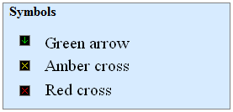

#### Variable Message Signs (VMS)

The user profile control the functions the user is authorize to use under Platform Control Mode (PCM) or Fall back Control Mode (FCM). Every user will have one user account that enables the user to login to IW. Every user account belongs to a profile.

|  |  |  |  |  |  |  |
| --- | --- | --- | --- | --- | --- | --- |
| **User profile** | | | | | **Operation mode** | |
| DO | Operator | FC | ITSC | Supervisor | PCM | FCM |
| ✓ | ✓ | ✓ | ✓ | ✓ | ✓ | ✓ |

•    Display and Hide VMS

Click the **KPE\_TUN\_VMS** button on the toolbar.



The map refreshes, VMS and their messages appear on the map.

Click on the **KPE\_TUN\_VMS** button again and the map refreshes and the VMS icons and messages will be hidden.

|  |
| --- |
| Description: c:\_temp\gis\kpe\kpe tunnel overview\tun_vms_view.jpg |
| Figure 318 - Display VMS and their messages in KPE Tunnel View1 |

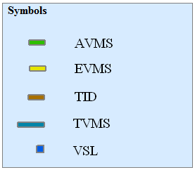

#### Traffic LED Sign(TLED)

The user profile control the functions the user is authorize to use under Platform Control Mode (PCM) or Fall back Control Mode (FCM). Every user will have one user account that enables the user to login to IW. Every user account belongs to a profile.

|  |  |  |  |  |  |  |
| --- | --- | --- | --- | --- | --- | --- |
| **User profile** | | | | | **Operation mode** | |
| DO | Operator | FC | ITSC | Supervisor | PCM | FCM |
| ✓ | ✓ | ✓ | ✓ | ✓ | ✓ | ✓ |

•    Display and Hide TLED

Click the **KPE\_TUN\_TLED** button on the toolbar.



The map refreshes, TLED and their messages appear on the map.

Click on the **KPE\_TUN\_TLED** button again and the map refreshes and the TLED icons and messages will be hidden.

|  |
| --- |
| Description: c:\_temp\gis\kpe\kpe tunnel overview\tun_tled_view.jpg |
| Figure 319 - Display TLED and their messages in KPE Tunnel View1 |
|  |

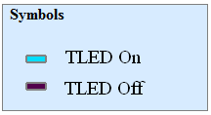

#### AIDC Cameras

The user profile control the functions the user is authorize to use under Platform Control Mode (PCM) or Fall back Control Mode (FCM). Every user will have one user account that enables the user to login to IW. Every user account belongs to a profile.

|  |  |  |  |  |  |  |
| --- | --- | --- | --- | --- | --- | --- |
| **User profile** | | | | | **Operation mode** | |
| DO | Operator | FC | ITSC | Supervisor | PCM | FCM |
| ✓ | ✓ | ✓ | ✓ | ✓ | ✓ | ✓ |

•    Display and Hide AIDC Cameras

Click the **KPE\_TUN\_AIDC** button on the toolbar.



The map refreshes, AIDC cameras and their messages appear on the map.

Click on the **KPE\_TUN\_AIDC** button again and the map refreshes and the AIDC camera icons and messages will be hidden.

|  |
| --- |
| Description: c:\_temp\gis\kpe\kpe tunnel overview\tun_aidc_view.jpg |
| Figure 320 - Display AIDC Cameras in KPE Tunnel View1 |

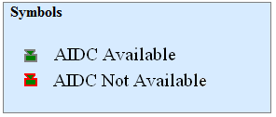

#### CCTC Cameras

The user profile control the functions the user is authorize to use under Platform Control Mode (PCM) or Fall back Control Mode (FCM). Every user will have one user account that enables the user to login to IW. Every user account belongs to a profile.

|  |  |  |  |  |  |  |
| --- | --- | --- | --- | --- | --- | --- |
| **User profile** | | | | | **Operation mode** | |
| DO | Operator | FC | ITSC | Supervisor | PCM | FCM |
| ✓ | ✓ | ✓ | ✓ | ✓ | ✓ | ✓ |

•    Display and Hide CCTC Cameras

Click the **KPE\_TUN\_CCTC** button on the toolbar.



The map refreshes, CCTC cameras and their messages appear on the map.

Click on the **KPE\_TUN\_CCTC** button again and the map refreshes and the CCTC camera icons and messages will be hidden.

|  |
| --- |
| Description: c:\_temp\gis\kpe\kpe tunnel overview\tun_cctc_view.jpg |
| Figure 321 - Display CCTC Cameras in KPE Tunnel View1 |

#### Traffic Signal (TFS) and Entrance Ramp Barriers

The user profile control the functions the user is authorize to use under Platform Control Mode (PCM) or Fall back Control Mode (FCM). Every user will have one user account that enables the user to login to IW. Every user account belongs to a profile.

|  |  |  |  |  |  |  |
| --- | --- | --- | --- | --- | --- | --- |
| **User profile** | | | | | **Operation mode** | |
| DO | Operator | FC | ITSC | Supervisor | PCM | FCM |
| ✓ | ✓ | ✓ | ✓ | ✓ | ✓ | ✓ |

•    Display and Hide TFS and Barriers

Click the **KPE\_TUN\_BARRIER\_TFS** button on the toolbar.



The map refreshes, TFS and Barrier appear on the map.

Click on the **KPE\_TUN\_BARRIER\_TFS** button again and the map refreshes and the TFS and Barrier icons and messages will be hidden.

|  |
| --- |
| Description: c:\_temp\gis\kpe\kpe tunnel overview\tun_barrier_view.jpg |
| Figure 322 - Display TFS and Barriers in KPE Tunnel View1 |

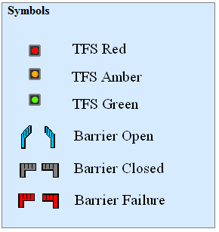

## MCE

Provide viewing of MCE Tunnel Equipment in map open view and Tunnel layout. You can view the status and functioning mode. You can also monitor the maps for defects and alarms.

 Equipment include:

•       VMS and messages (AVMS, EVMS, TID, MVMS, VSL)

•       TCL

•       AIDC Cameras

•        CCTC Cameras

•       Barriers

•       TFS

•       LUS (only display in tunnel view)

All above equipment will be displayed in open map view and tunnel view as below:

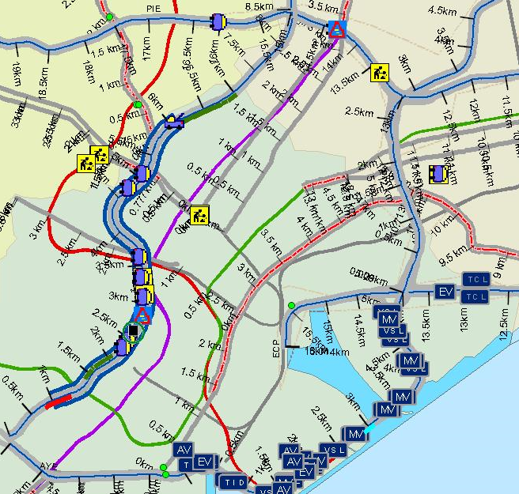

Figure 323 - A MCE Boundary map display (with VMS) example

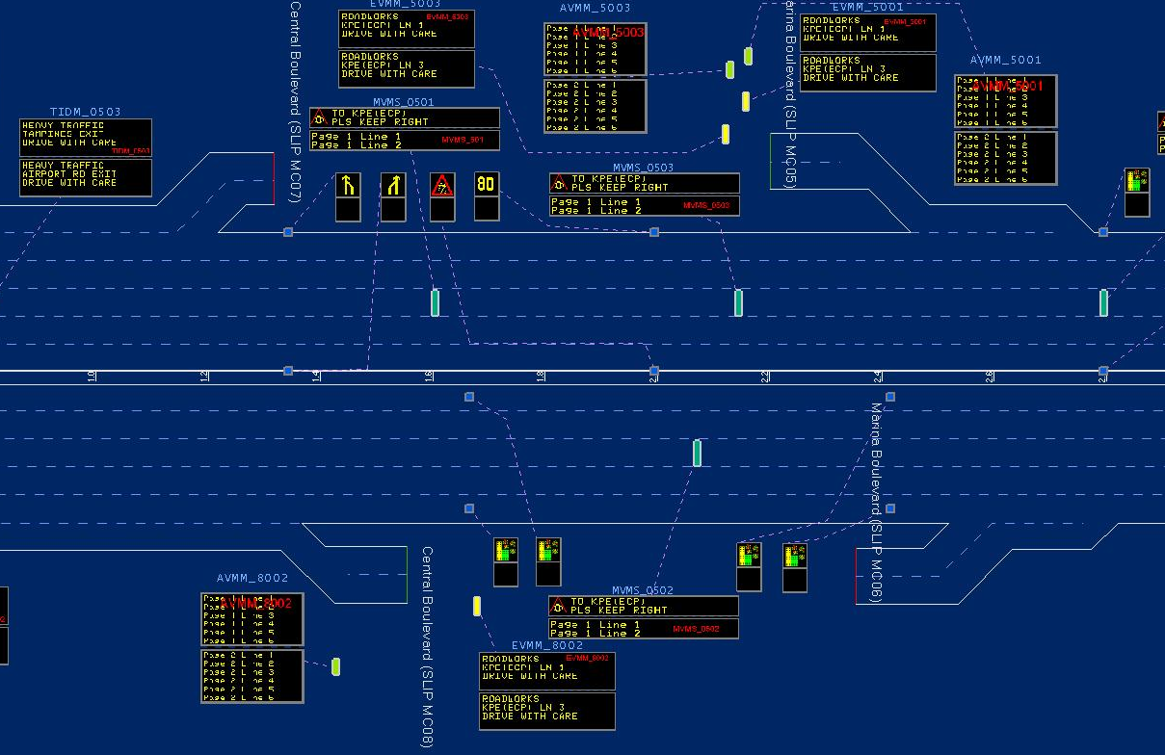

Figure 324 - A MCE tunnel schematic diagram (with VMS) example

### MCE overview toolbar

Click the **MCE Toolbar** button under Tools menu to toggle the MCE toolbar display.

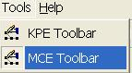

When the MCE toolbar appears on the map, this toolbar allows you to display equipment in the MCE open view and MCE Tunnel view.



|  |  |
| --- | --- |
| **MCE Open view** | Display/hide MCE boundary on open map view. |
| **TDS** | Display/hide MCE TDS equipment location, status on open map view, refer to [here](#_Traffic_Display_Sign_1). |
| **AIDC Cameras** | Display/hide AIDC camera location and status on open map view, refer to [here](#_AIDC_Cameras_2). |
| **CCTC Cameras** | Display/hide CCTC camera location and status on open map view, refer to [here](#_CCTC_Cameras_2). |
| **Barrier and TFS** | Display/hide Barrier and TFS equipment location on open map view, refer to [here](#_Traffic_Signal(TFS)_and_2). |
| **Tunnel View1** | Display MCE tunnel view 1, refer to [here](#_Zooming_map_using_2). |
| **Tunnel View1 West** | Display MCE tunnel view west part, refer to [here](#_Zooming_map_using_2). |
| **Tunnel View1 East** | Display MCE tunnel view east part, refer to [here](#_Zooming_map_using_2). |
| **Tunnel View2** | Display MCE tunnel view 2, refer to [here](#_Zooming_map_using_2). |
| **Tunnel LUS** | Display/hide LUS location and status in the tunnel view, refer to [here](#_Lane_Use_Signal_8). |
| **Tunnel VMS** | Display/hide VMS location, status and messages in the tunnel view, refer to [here](#_Variable_Message_Signs_5). |
| **Tunnel TLC** | Display/hide TLC location, status and messages in the tunnel view, refer to [here](#_Traffic_LED_Sign(TLED)). |
| **Tunnel AIDC** | Display/hide AIDC camera location and status in the tunnel view, refer to [here](#_AIDC_Cameras_3). |
| **Tunnel CCTC** | Display/hide CCTC camera location and status in the tunnel view, refer to [here](#_CCTC_Cameras_3). |
| **Tunnel Barrier and TFS** | Display/hide Barrier and TFS location in the tunnel view, refer to [here](#_Traffic_Signal(TFS)_and_3). |

### MCE Equipment Monitoring and Display

Provide viewing of Traffic and Surveillance Equipment. You can view the status and functioning mode. You can also monitor the maps for defects and alarms.

   equipment include:

•       MCE TDS and messages (AVMS, EVMS, TID, MVMS, and VSL)

•       AIDC Cameras

•       CCTC Cameras

•       Barriers

•       TFS

   Features:

•      View equipment location

•       Color-code the equipment border to show different status.

    Grey – operational

    Red – not operational

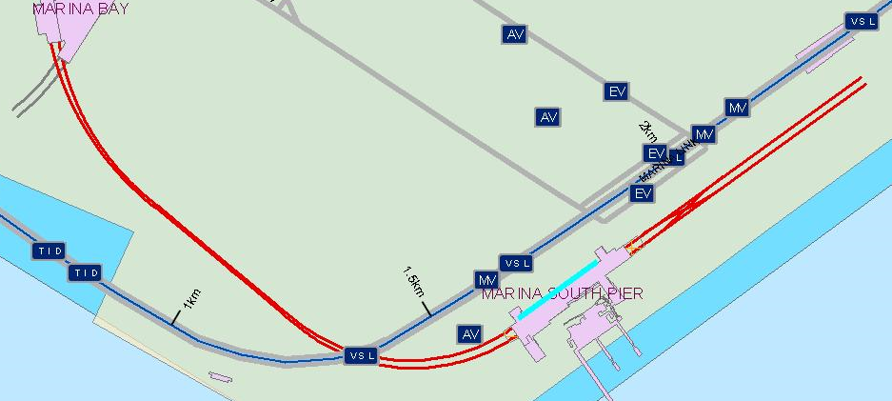

Figure 325 - A map with VMS equipment example

#### Traffic Display Sign (TDS)

The user profile control the functions the user is authorize to use under Platform Control Mode (PCM) or Fall back Control Mode (FCM). Every user will have one user account that enables the user to login to IW. Every user account belongs to a profile.

|  |  |  |  |  |  |  |
| --- | --- | --- | --- | --- | --- | --- |
| **User profile** | | | | | **Operation mode** | |
| DO | Operator | FC | ITSC | Supervisor | PCM | FCM |
| ✓ | ✓ | ✓ | ✓ | ✓ | ✓ |  |

For MCE TDS Monitoring and Display on  IW GIS, the following features are provided:

•       [Display and Hide TDS](#_Display_and_Hide_15)

•       [Display and hide MCE TDS Message](#_Display_and_hide_16)

##### Display and Hide MCE TDS

  Click the **MCE\_TDS**  button on the toolbar.



The map refreshed and all the MCE TDS (AVMS, EVMS, TID, MVMS, VSL and TCL) icons be displayed on the map.

  Click on the **MCE\_TDS** button again and all the TDS icons will be hidden.

|  |
| --- |
|  |
| Figure 326 - Display all MCE TDS |

##### Display and hide MCE TDS Message

•     View selective TDS message

  Click the **Monitor** button  on the toolbar.

  Place your mouse over a TDS.

The detail TDS message with the locations will be displayed beside the TDS icon.

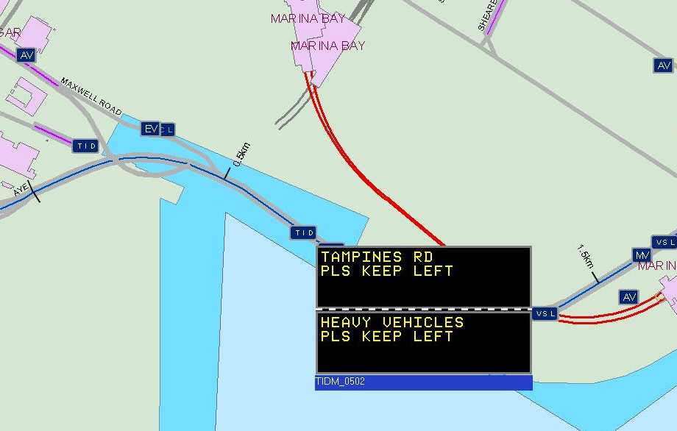

Figure 327 - Mouse over TID to display All page's Messages

•     Display all TDS messages

  Click the **MCE\_TDS\_MSG** button on the toolbar.



The map refreshed and TDS messages for all TDS messages appear on the map.

  Click on the **MCE\_TDS\_MSG** button again and all the TD messages will be hidden.

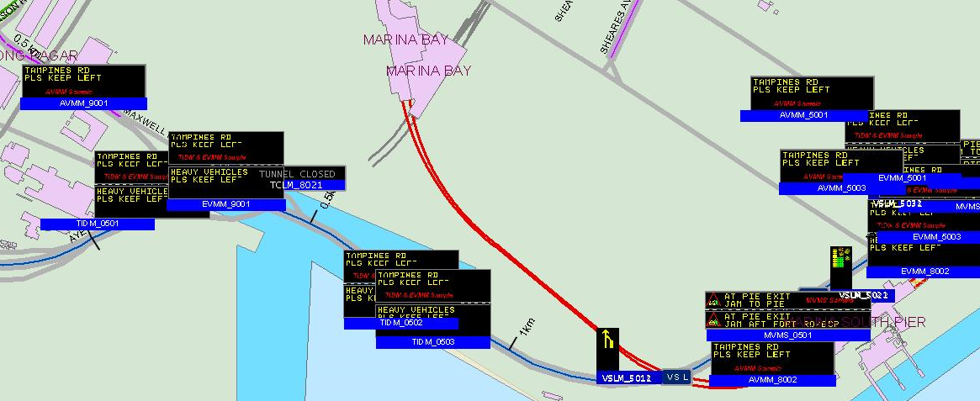

Figure 328 - Display TDS with Message

|  |
| --- |
| **Note** |
| The **MCE\_TDS\_MSG** button Description: c:\_temp\gis\kpe\kpe open overview\tds\tds_msg.JPGwill only be enabled if:  •       You have turn on MCE TDS layer.  •       You are currently at open view level 2 view and below. |

#### AIDC Cameras

The user profile control the functions the user is authorize to use under Platform Control Mode (PCM) or Fall back Control Mode (FCM). Every user will have one user account that enables the user to login to IW. Every user account belongs to a profile.

|  |  |  |  |  |  |  |
| --- | --- | --- | --- | --- | --- | --- |
| **User profile** | | | | | **Operation mode** | |
| DO | Operator | FC | ITSC | Supervisor | PCM | FCM |
| ✓ | ✓ | ✓ | ✓ | ✓ | ✓ | ✓ |

For MCE Expressway AIDC Camera Monitoring and Display on  IW GIS, the following features are provided:

•       [Display and hide MCE AIDC Cameras](#_Display_and_Hide_17)

•       [View MCE AIDC Camera Info](#_View_AIDC_Camera_1)

##### Display and Hide MCE AIDC Cameras

1.   Click the **MCE\_AIDC** button on the toolbar.



The map refreshes and cameras appear on the map.

2.   Click on the **MCE\_AIDC** button again and the AIDC camera icons will be hidden.

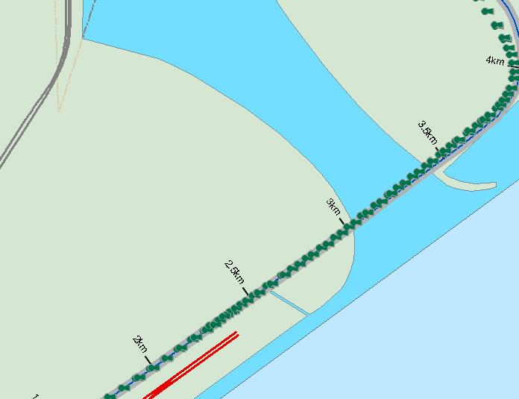

Figure 329 - Display AIDC Camera in MCE Expressway

|  |  |
| --- | --- |
| **Symbols** | |
| Description: c:\_temp\gis\kpe\kpe open overview\aidc\aidc_symbol.JPG |  |

##### View AIDC Camera Info

  Click the **Monitor** button  on the toolbar.



2.  Place your mouse over a AIDC camera.

The camera information shows besides the camera.

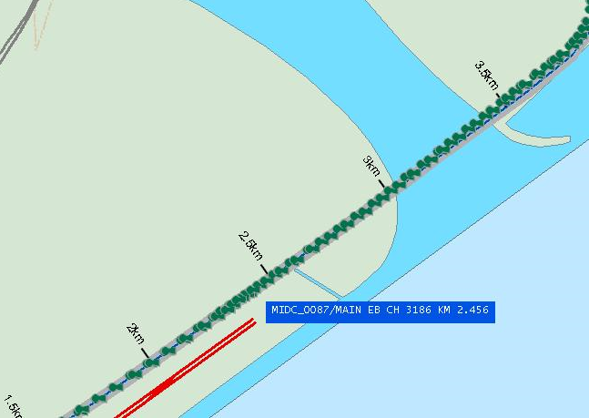

Figure 330 - Mouse over on AIDC Camera Icon

Note:

“MIDC\_0087” is the equipment ID.

“MAIN EB CH 3186 KM 2.456” is the location description.

#### CCTC Cameras

The user profile control the functions the user is authorize to use under Platform Control Mode (PCM) or Fall back Control Mode (FCM). Every user will have one user account that enables the user to login to IW. Every user account belongs to a profile.

|  |  |  |  |  |  |  |
| --- | --- | --- | --- | --- | --- | --- |
| **User profile** | | | | | **Operation mode** | |
| DO | Operator | FC | ITSC | Supervisor | PCM | FCM |
| ✓ | ✓ | ✓ | ✓ | ✓ | ✓ | ✓ |

For MCE Expressway CCTC Camera Monitoring and Display on  IW GIS, the following features are provided:

•       [Display and hide MCE CCTC Cameras](#_Display_and_Hide_18)

•       [View MCE CCTC Camera Info](#_View_CCTC_Camera_1)

##### Display and Hide MCE CCTC Cameras

1.   Click the **MCE\_CCTC** button on the toolbar.



The map refreshes and cameras appear on the map.

2.   Click on the **MCE\_CCTC** button again and the CCTC camera icons will be hidden.

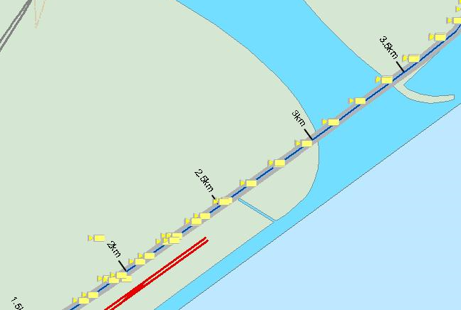

Figure 331 - Display CCTC Camera in MCE Expressway

|  |  |
| --- | --- |
| **Symbols** | |
| Description: c:\_temp\gis\kpe\kpe open overview\cctc\cctc_symbol.JPG |  |

##### View CCTC Camera Info

  Click the **Monitor** button  on the toolbar.



2.  Place your mouse over a CCTC camera.

The camera information shows besides the camera.

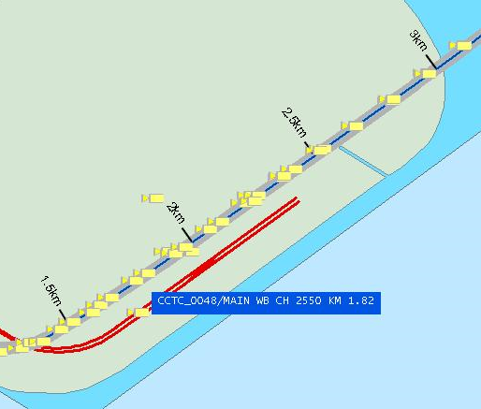

Figure 332 - Mouse over on CCTC Camera Icon

Note:

“CCTC\_0048” is the equipment ID.

“MAIN WB CH 2550 KM 1.82” is the location description.

#### Traffic Signal(TFS) and Entrance Ramp Barriers

The user profile control the functions the user is authorize to use under Platform Control Mode (PCM) or Fall back Control Mode (FCM). Every user will have one user account that enables the user to login to IW. Every user account belongs to a profile.

|  |  |  |  |  |  |  |
| --- | --- | --- | --- | --- | --- | --- |
| **User profile** | | | | | **Operation mode** | |
| DO | Operator | FC | ITSC | Supervisor | PCM | FCM |
| ✓ | ✓ | ✓ | ✓ | ✓ | ✓ | ✓ |

For MCE Expressway TFS and Barrier Monitoring and Display on  IW GIS, the following features are provided:

•       [Display and hide MCE TFS and Barriers](#_Display_and_Hide_14)

•       [View MCE TFS and Barrier Info](#_View_TFS_and_1)

##### Display and Hide MCE TFS and Barriers

1.   Click the **MCE\_BARRIER\_TFS** button on the toolbar.



The map refreshes and cameras appear on the map.

2.   Click on the **MCE\_BARRIER\_TFS** button again and the TFS and Barrier icons will be hidden.

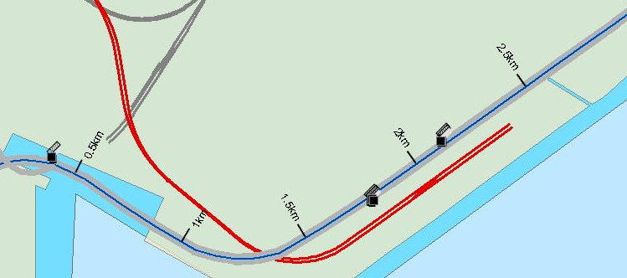

Figure 333 - Display TFS and Barriers in MCE Expressway

|  |  |
| --- | --- |
| **Symbols** | |
| Description: c:\_temp\gis\kpe\kpe open overview\barriers and tfs\tfs_barrier_symbol.JPG |  |

##### View TFS and Barrier Info

  Click the **Monitor** button  on the toolbar.



2.  Place your mouse over a TFS or Barrier.

The TFS or Barrier information shows besides the TFS or Barrier.

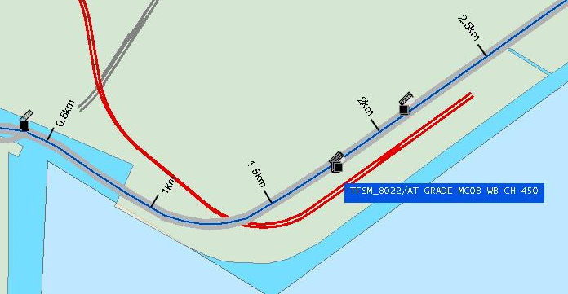

Figure 334 - Mouse over on Barrier Icon

Note:

“TFSM\_8022” is the equipment ID.

“AT GRADE MC08 WB CH 450” is the location description.

### Tunnel Overview

The user profile control the functions the user is authorize to use under Platform Control Mode (PCM) or Fall back Control Mode (FCM). Every user will have one user account that enables the user to login to IW. Every user account belongs to a profile.

|  |  |  |  |  |  |  |
| --- | --- | --- | --- | --- | --- | --- |
| **User profile** | | | | | **Operation mode** | |
| DO | Operator | FC | ITSC | Supervisor | PCM | FCM |
| ✓ | ✓ | ✓ | ✓ | ✓ | ✓ | ✓ |

•    Display Tunnel 4 pre-defined Views:

•     Display MCE Tunnel View1

•     Display MCE Tunnel View2

•     Display MCE Tunnel View3

•     Display MCE Tunnel View4

•    Display Tunnel equipment:

•        LUS

•        VMS(including AVMS, EVMS, TID, MVMS and VSL)

•        TCL

•          AIDC Cameras

•          CCTC Cameras

•          Barriers and TFS

|  |
| --- |
| **Note** |
| •       You cannot do things like zoom in, zoom out and pan in the tunnel synoptic diagram. There are 4 fixed views available.  •       In each of these four views, you can choose to display the desired tunnel traffic equipment by selecting the appropriate buttons.  •       At anytime when you want to go to the open road view, click on Description: c:\_temp\gis\Tunnel\Tunnel overview\Tunnel82.jpg button on the toolbar. |

#### Zooming map using pre-defined views

There are 4 levels of views available for you to change the overview to region view and vice versa:

1.   Tunnel View1

Click the **Tunnel View1** button on the toolbar. The map will zoom to MCE tunnel view1.



Tunnel view1 diagram is shown as below, and equipment buttons in tunnel view will be enable.

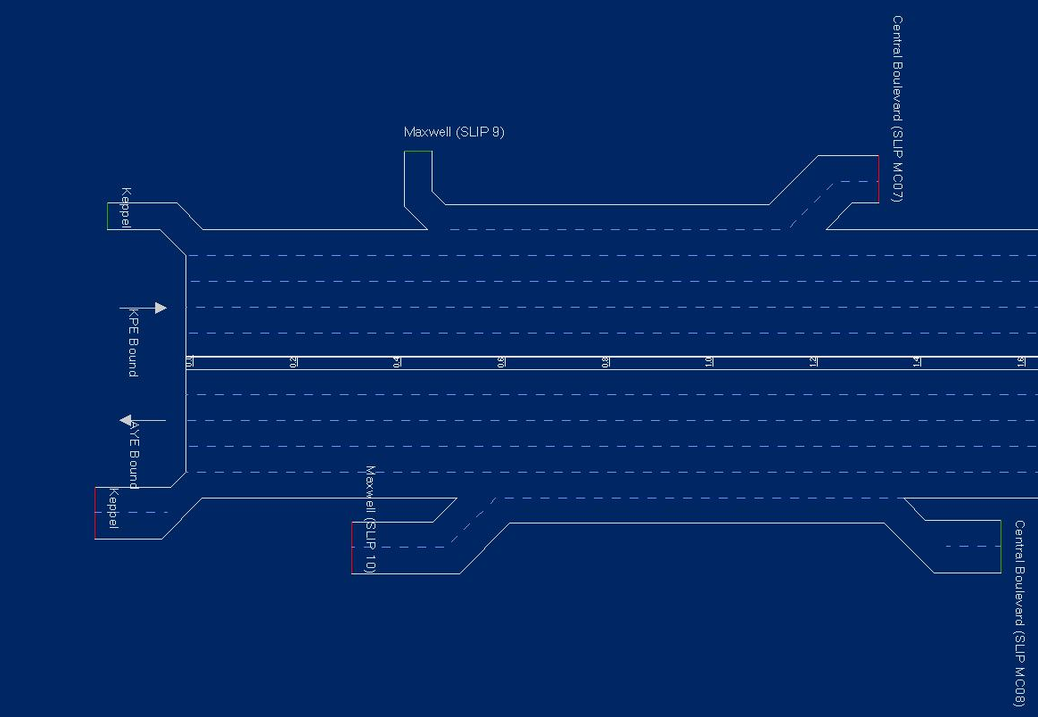

Figure 335 - Display Tunnel View1

2.   Tunnel View2

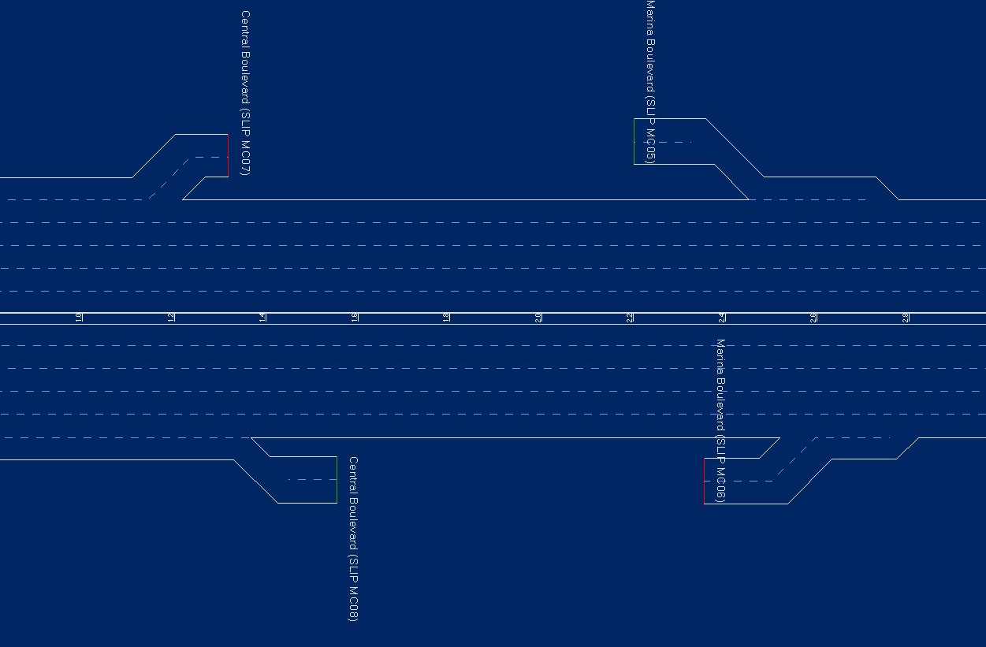

Figure 336 - Display Tunnel View2

3.   Tunnel View3

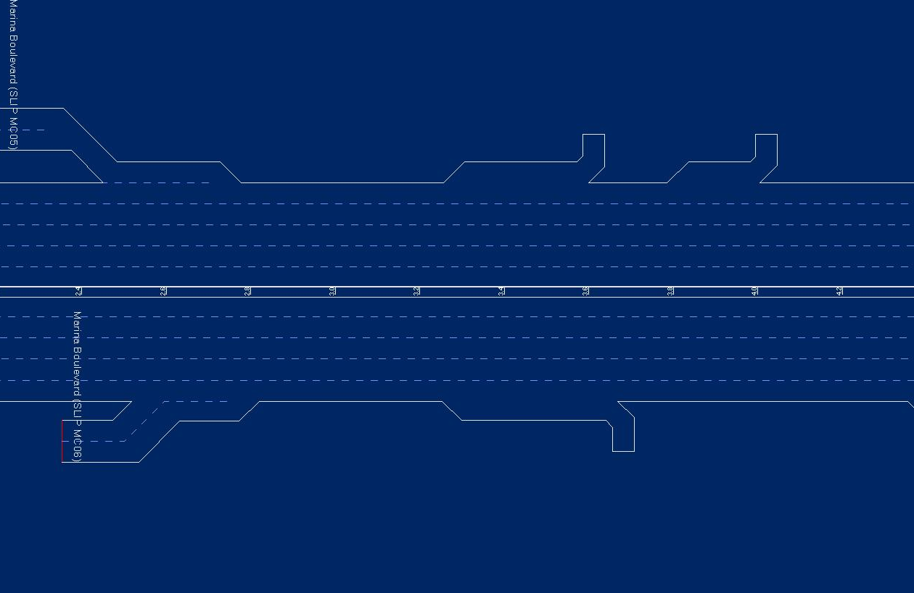

Figure 337 - Display Tunnel View3

4.   Tunnel View4

**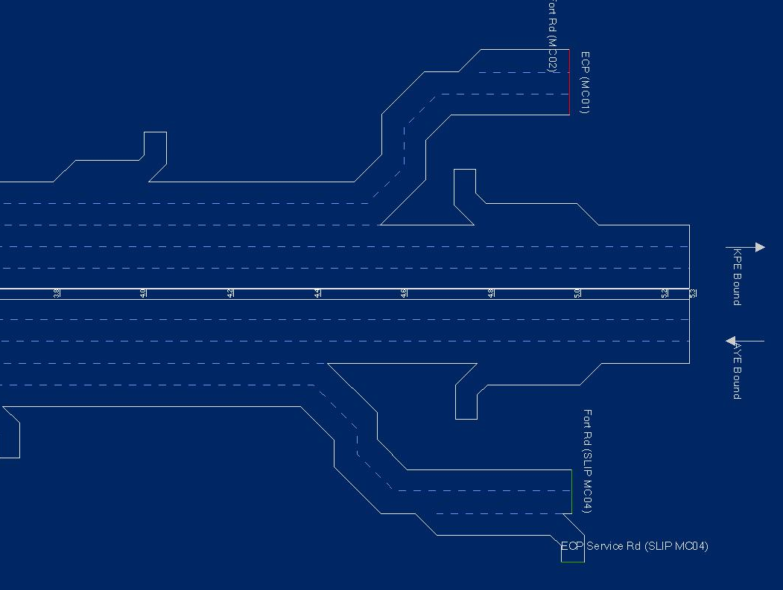**

Figure 338 - Display Tunnel View4

#### Lane Use Signal (LUS)

The user profile control the functions the user is authorize to use under Platform Control Mode (PCM) or Fall back Control Mode (FCM). Every user will have one user account that enables the user to login to IW. Every user account belongs to a profile.

|  |  |  |  |  |  |  |
| --- | --- | --- | --- | --- | --- | --- |
| **User profile** | | | | | **Operation mode** | |
| DO | Operator | FC | ITSC | Supervisor | PCM | FCM |
| ✓ | ✓ | ✓ | ✓ | ✓ | ✓ | ✓ |

•    Display and Hide LUS

 Click the **MCE\_LUS** button on the toolbar.



The map refreshed and LUS appear on the map.

 Click on the **MCE\_LUS** button again and the map will refresh and LUS icon will be hidden.

**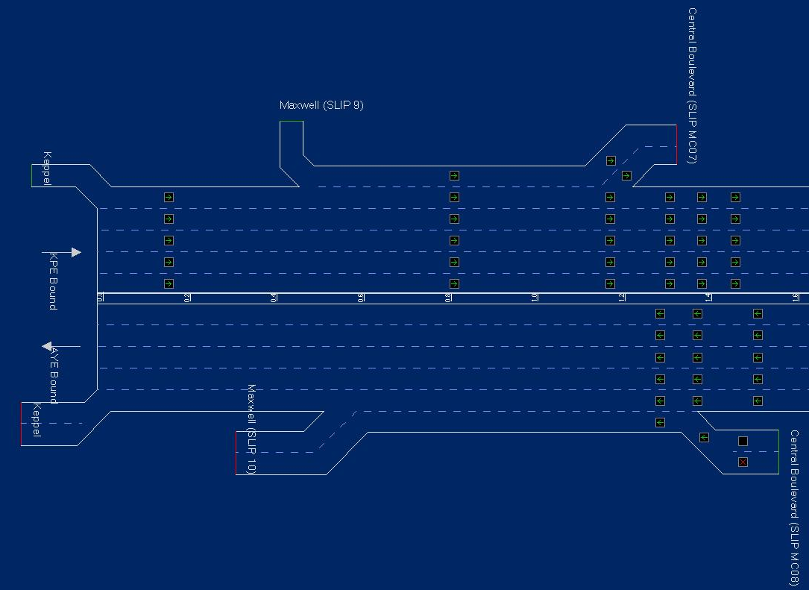**

Figure 339 - Display LUS in MCE Tunnel View1



#### Variable Message Signs (VMS)

The user profile control the functions the user is authorize to use under Platform Control Mode (PCM) or Fall back Control Mode (FCM). Every user will have one user account that enables the user to login to IW. Every user account belongs to a profile.

|  |  |  |  |  |  |  |
| --- | --- | --- | --- | --- | --- | --- |
| **User profile** | | | | | **Operation mode** | |
| DO | Operator | FC | ITSC | Supervisor | PCM | FCM |
| ✓ | ✓ | ✓ | ✓ | ✓ | ✓ | ✓ |

•    Display and Hide VMS

Click the **MCE\_TUNNEL\_VMS** button on the toolbar.



The map refreshes, VMS and their messages appear on the map.

Click on the **MCE\_TUNNEL\_VMS** button again and the map refreshes and the VMS icons and messages will be hidden.

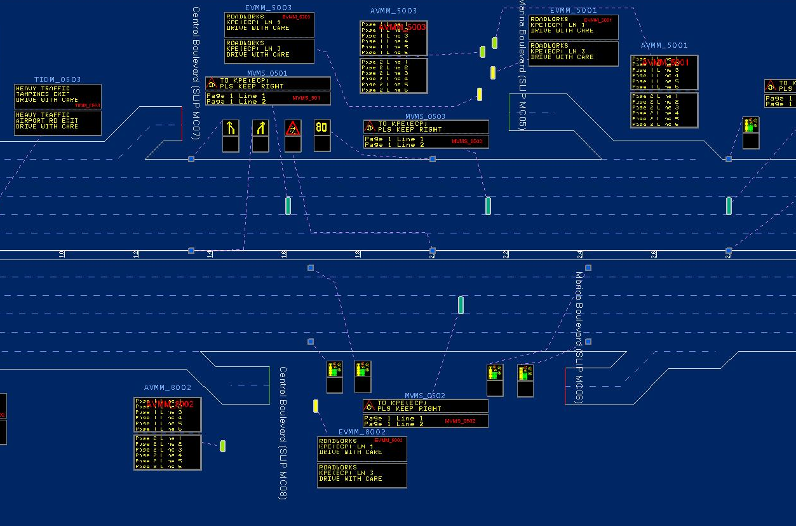

Figure 340 - Display VMS and their messages in MCE Tunnel View2

#### TCL

The user profile control the functions the user is authorize to use under Platform Control Mode (PCM) or Fall back Control Mode (FCM). Every user will have one user account that enables the user to login to IW. Every user account belongs to a profile.

|  |  |  |  |  |  |  |
| --- | --- | --- | --- | --- | --- | --- |
| **User profile** | | | | | **Operation mode** | |
| DO | Operator | FC | ITSC | Supervisor | PCM | FCM |
| ✓ | ✓ | ✓ | ✓ | ✓ | ✓ | ✓ |

•    Display and Hide TLED

Click the **MCE\_TUN\_TCL** button  on the toolbar.



The map refreshes, TCL and their messages appear on the map.

Click on the **MCE\_TUN\_TCL** button again and the map refreshes and the TLED icons and messages will be hidden.

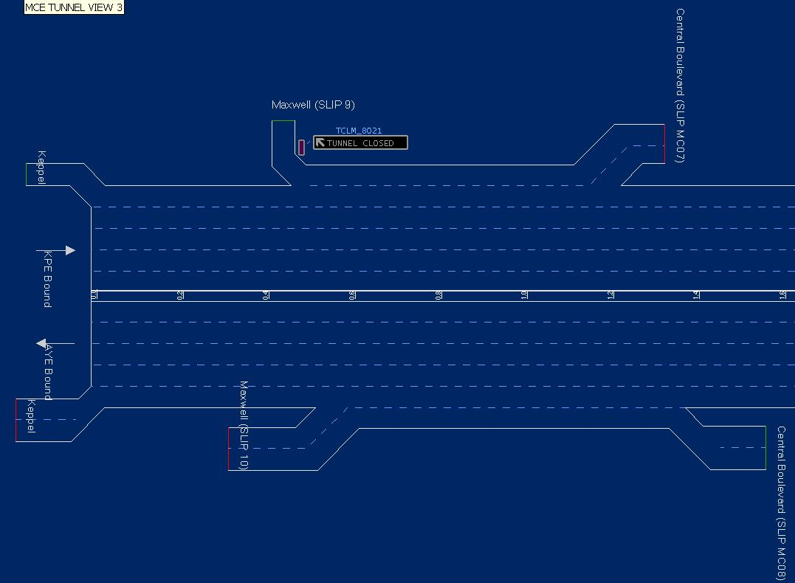

Figure 341 - Display TCL in MCE tunnel view 1

#### AIDC Cameras

The user profile control the functions the user is authorize to use under Platform Control Mode (PCM) or Fall back Control Mode (FCM). Every user will have one user account that enables the user to login to IW. Every user account belongs to a profile.

|  |  |  |  |  |  |  |
| --- | --- | --- | --- | --- | --- | --- |
| **User profile** | | | | | **Operation mode** | |
| DO | Operator | FC | ITSC | Supervisor | PCM | FCM |
| ✓ | ✓ | ✓ | ✓ | ✓ | ✓ | ✓ |

•    Display and Hide AIDC Cameras

Click the **MCE\_TUN\_AIDC** button on the toolbar.



The map refreshes, AIDC cameras and their messages appear on the map.

Click on the **MCE\_TUN\_AIDC** button again and the map refreshes and the AIDC camera icons and messages will be hidden.

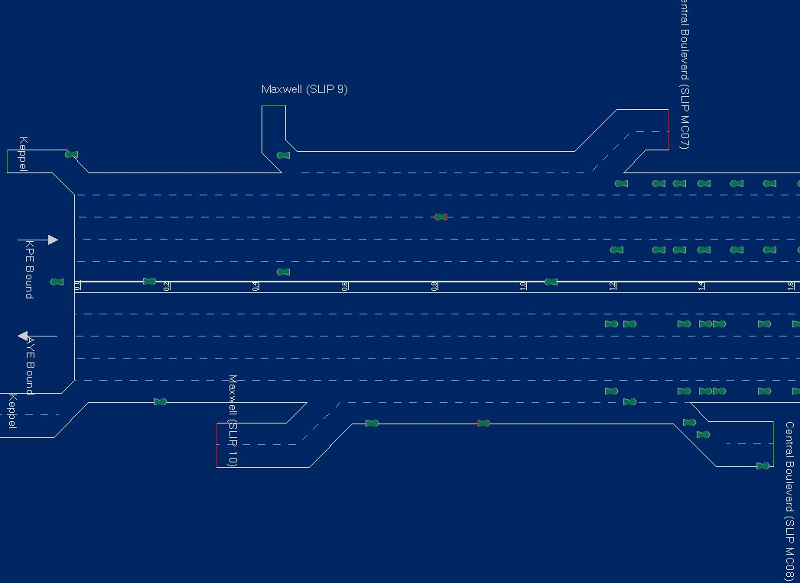

Figure 342 - Display AIDC in MCE tunnel view 1

#### CCTC Cameras

The user profile control the functions the user is authorize to use under Platform Control Mode (PCM) or Fall back Control Mode (FCM). Every user will have one user account that enables the user to login to IW. Every user account belongs to a profile.

|  |  |  |  |  |  |  |
| --- | --- | --- | --- | --- | --- | --- |
| **User profile** | | | | | **Operation mode** | |
| DO | Operator | FC | ITSC | Supervisor | PCM | FCM |
| ✓ | ✓ | ✓ | ✓ | ✓ | ✓ | ✓ |

•    Display and Hide CCTC Cameras

Click the **MCE\_TUN\_CCTC** button on the toolbar.



The map refreshes, CCTC cameras and their messages appear on the map.

Click on the **MCE\_TUN\_CCTC** button again and the map refreshes and the CCTC camera icons and messages will be hidden.

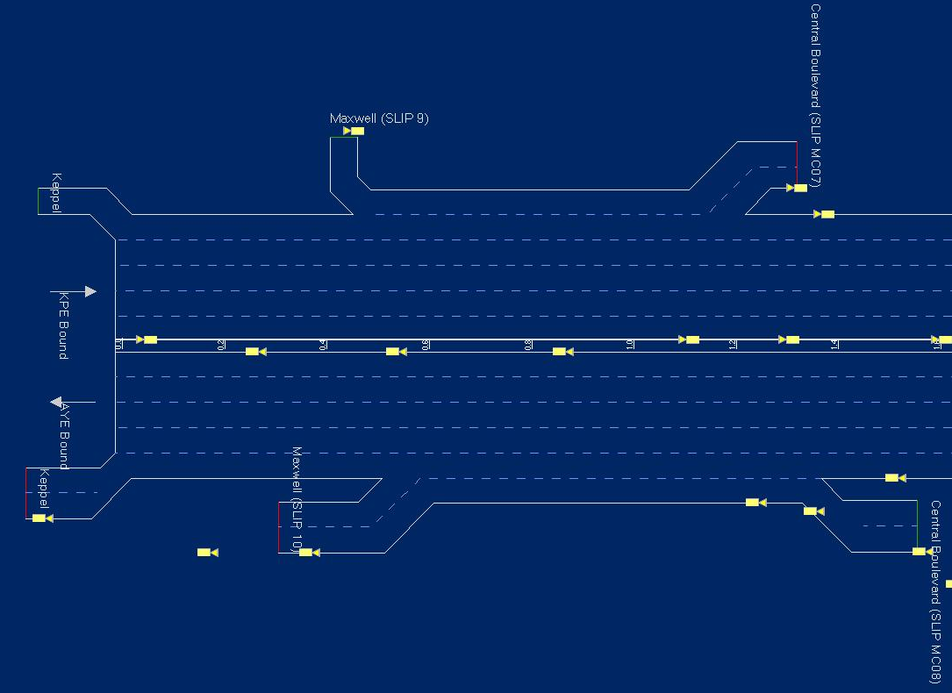

Figure 343 - Display CCTC in MCE tunnel view 1

#### Traffic Signal(TFS) and Entrance Ramp Barriers

The user profile control the functions the user is authorize to use under Platform Control Mode (PCM) or Fall back Control Mode (FCM). Every user will have one user account that enables the user to login to IW. Every user account belongs to a profile.

|  |  |  |  |  |  |  |
| --- | --- | --- | --- | --- | --- | --- |
| **User profile** | | | | | **Operation mode** | |
| DO | Operator | FC | ITSC | Supervisor | PCM | FCM |
| ✓ | ✓ | ✓ | ✓ | ✓ | ✓ | ✓ |

•    Display and Hide TFS and Barriers

Click the **MCE\_TUN\_BARRIER\_TFS** button on the toolbar.



The map refreshes, TFS and Barrier appear on the map.

Click on the **MCE\_TUN\_BARRIER\_TFS** button again and the map refreshes and the TFS and Barrier icons and messages will be hidden.

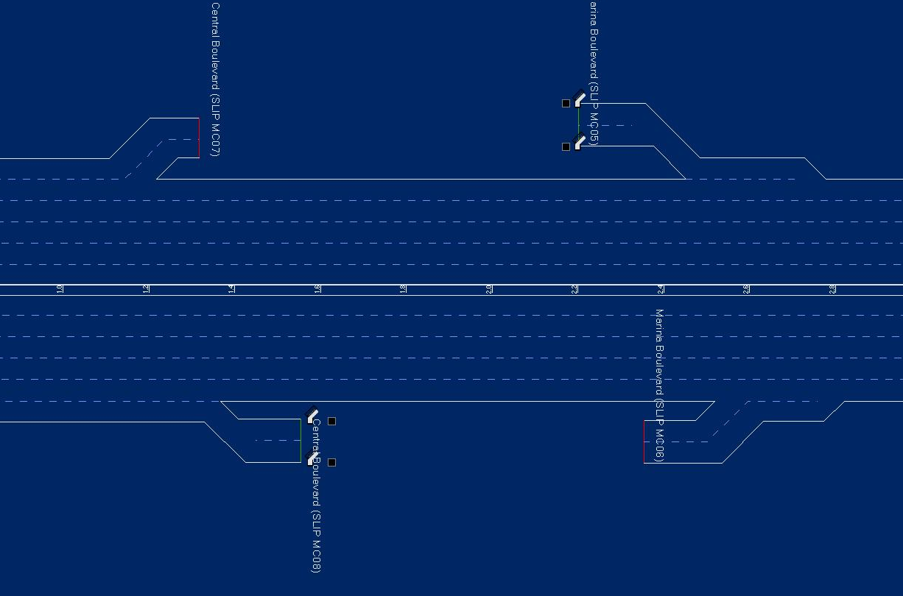

Figure 344 - Display TFS in MCE tunnel view 2

## Incident Record (IR) Creation

You can right click mouse on GIS to create Expressway, EAC Corridor, tunnel or arterial road IR or use menu on CCM (refer to [here](#_Incident_Record_(IR))). The types and icons of IR in GIS are as follows:

•    Accident 

•     Road works 

•     Unattended vehicle 

•     Vehicle breakdown 

•     Obstacle 

•     Road block 

•     Diversion 

•     Miscellaneous 

•     Slow Traffic 

•     Weather 

There are 5 phases for IR handling (refer to [here](#_Incident_Record_(IR)) ):

•    Detection

•    Verification

•    Creation

•    Monitoring & event handling

•    Closing

### Expressway, EAC, and Arterial road IR

The user profile control the functions the user is authorize to use under Platform Control Mode (PCM) or Fall back Control Mode (FCM). Every user will have one user account that enables the user to login to IW. Every user account belongs to a profile.

|  |  |  |  |  |  |  |
| --- | --- | --- | --- | --- | --- | --- |
| **User profile** | | | | | **Operation mode** | |
| DO | Operator | FC | ITSC | Supervisor | PCM | FCM |
| ✓ | ✓ | ✓ | ✓ | ✓ | ✓ | ✓ \* |

For a expressway and arterial road IR event, you can right click mouse on GIS to create:

•     [New IR by types](#_Create_IR)

•    [IR Start Point](#_Create_Start_Point)

•     [IR End Point](#_Create_End_Point)

•     [IR Congestion End Point](#_Create_Congestion_End)

Note:

No arterial IR creation, modification, or handling during fallback mode

#### Create IR

   If you are currently in tunnel view, click on **Open View** button  to go back to expressways and arterial roads map.



  Click the **Monitor** button  on the toolbar.



  Navigate the map to a view where IR creation function is enabled (3 TIP view and below) and IR location can be clearly seen.

   Right click on left / right side of the road to indicate IR location.

The nearest road to the click point will be highlighted in light blue and the context menu appears. This road will be used as reference to update certain information in the next step. If this road is not what you want, click **Cancel** and repeat this step.

|  |
| --- |
| Description: c:\_temp\gis\incident record (ir) creation\expressway and arterial road ir\ir_creat.JPG |
| Figure 345 - Show IR Creation context menu |

   Select the Type of IR in the context menu.

The IR window appears on CCM. Road Name, Location Code, Direction and Start Point will be automatically updated (for Expressway IR).

|  |
| --- |
| Description: c:\_temp\gis\incident record (ir) creation\expressway and arterial road ir\ir_type.JPG |
| Figure 346 - Create an Accident IR |

   Create End Point.

•        If the end point is in open expressways / arterials roads, please refer to [here](#_Create_End_Point) for Expressway and arterial road IR - Create End Point.

•        If the end point is in tunnel, please refer to [here](#_Create_End_Point_1) for Tunnel IR -Create End Point.

   You must enter the rest of the required information and finish the IR creation on CCM.

For more information on how to create the rest of the information, please refer to [here](#_Create_Expressway/EA/ST_IR) for Expressway IR or [here](#_Create_Arterial_Road) for Arterial Road IR.

|  |
| --- |
| **Note** |
| When you click on a point on the map, the system automatically detects if the IR is for Expressway, EAC Corridor, or Arterial road and pop up an appropriate IR window on CCM. |

#### Create Start Point

  Click the **Monitor** button  on the toolbar.



   Navigate the map to the location where IR start point will be created.

   Skip this step if IR is for Arterial road. Click on Start Point textbox on the IR window on CCM, refer to [here](#_Accident).

   Right click on left / right side of the road to indicate the start point.

     The nearest road to the click point will be highlighted in light blue and the context menu appears. This road will be used as reference to update certain information in the next step. If this road is not what you want, click Cancel and repeat this step.

|  |
| --- |
| Description: c:\_temp\gis\incident record (ir) creation\expressway and arterial road ir\Create76.jpg |
| Figure 347 - Show IR Creation context menu |

   Select **Start Point** in the context menu.

     Road Name, Location Code, Direction and Start Point will be automatically updated (for Expressway IR).

     Up Site Id, Up Node Distance, Road Name and Up Node will be automatically updated (for Arterial road IR).

     You must go on and create end point.

#### Create End Point

  Click the **Monitor** button  on the toolbar.



  Navigate the map to the location where IR end point will be created.

  Skip this step if IR is for Arterial road. Click on End Point textbox on the IR window on CCM, refer to [here](#_Accident).

  Right click on left / right side of the road to indicate the end point.

The nearest road to the click point will be highlighted in light blue and the context menu appears. This road will be used as reference to update certain information in the next step. If this road is not what you want, click **Cancel** and repeat this step.

|  |
| --- |
| Description: c:\_temp\gis\incident record (ir) creation\expressway and arterial road ir\Create78.jpg |
| Figure 348 - Show IR Creation context menu |

  Select **End Point** in the context menu.

  Select **End Point** in the context menu.

End Point will be automatically updated (for Expressway IR).

Down Site Id and Down Node will be automatically updated (for Arterial road IR).

  There are new equipment faults, measurement exceeding threshold values and fire alarms that require immediate attention, acknowledgement and action.

For more information on how to create the rest of the information, please refer to [here](#_Create_Expressway/EA/ST_IR) about Expressway IR or [here](#_Create_Arterial_Road) about Arterial Road IR.

#### Create Congestion End Point

  Click the **Monitor** button  on the toolbar.



  Navigate the map to the location where Congestion end point will be created.

    Click on Congestion End Point textbox on the IR window on CCM, refer to [here](#_Update_Monitor).

    Right click on left / right side of the road to indicate the end point.

|  |
| --- |
| Description: c:\_temp\gis\incident record (ir) creation\expressway and arterial road ir\Create80.jpg |
| Figure 349 - The context menu for IR Creation |

The nearest road to the click point will be highlighted in light blue and the context menu appears. This road will be used as reference to update certain information in the next step. If this road is not what you want, click **Cancel** and repeat this step.

    Select **Congestion End Point** in the context menu.

Congestion End Point will be automatically updated on the IR window.

    You must save the IR.

### Tunnel IR

The user profile control the functions the user is authorize to use under Platform Control Mode (PCM) or Fall back Control Mode (FCM). Every user will have one user account that enables the user to login to IW. Every user account belongs to a profile.

|  |  |  |  |  |  |  |
| --- | --- | --- | --- | --- | --- | --- |
| **User profile** | | | | | **Operation mode** | |
| DO | Operator | FC | ITSC | Supervisor | PCM | FCM |
| ✓ | ✓ \* | ✓ | ✓ | ✓ | ✓ | ✓ |

For a Tunnel IR event, you can right click mouse on GIS to create:

•       [New Tunnel IR by types](#_Create_IR_1)

•       [Tunnel IR Start Point](#_Create_Start_Point_1)

•       [Tunnel IR End Point](#_Create_End_Point_1)

•        [Tunnel IR Congestion End Point](#_Create_Congestion_End_1)

Note:

Tunnel or Zone1 operator only.

#### Create IR

   If you are currently in expressways and arterial roads map, click on **Tunnel Overview** button  on the toolbar to go to tunnel view.



   Click on **LUS** button  to turn on LUS layer.



     The LUS layer will appear.

   Zoom into NW / NE / SW / SE tunnel box by clicking on the button.

    The map will zoom to the selected tunnel. It is always advisable to zoom in to individual tunnel boxes to create IR. This is to ensure the start point km is more accurate.

   Navigate the map to a view where IR location can be clearly seen.

   Right click on the road to indicate IR location.

    The affected LUS on the nearest road to the click point will be highlighted in light blue colour and the context menu appears. This road will be used as reference to update certain information in the next step. If this road is not what you want, click **Cancel** and repeat this step.

|  |
| --- |
| Description: c:\_temp\gis\incident record (ir) creation\tunnel ir\Create83.jpg |
| Figure 350 - Tunnel IR Creation context menu |

  Select the Type of IR in the context menu.

     The IR window appears on CCM.

     Road Name, Location Code, Direction and Start Point will be automatically updated (for Expressway IR).

    Up Site Id, Up Node Distance, Road Name and Up Node will be automatically updated (for Arterial road IR).

   Create End Point.

     If the end point is in tunnel, please refer to [here](#_Create_End_Point_1) for Tunnel IR -Create End Point. If the end point is in open expressways / arterials roads, please refer to [here](#_Create_End_Point) for Expressway and arterial road IR - Create End Point.

   For more information on how to create the rest of the information, please refer to [here](#_Create_Expressway/EA/ST_IR) for Expressway IR or [here](#_Create_Arterial_Road) for Arterial Road IR.

#### Create Start Point

   Click on **LUS** button  to turn on LUS layer.



   Zoom into NW / NE / SW / SE tunnel box by clicking on the button.

    The map will zoom to the selected tunnel. It is always advisable to zoom in to individual tunnel boxes to create IR. This is to ensure the start point is more accurate.

   Skip this step if IR is for Arterial road. Click on Start Point textbox on the IR window on CCM, refer to [here](#_Accident).

   Right click on left / right side of the road to indicate the start point.

    The affected LUS on the nearest road to the click point will be highlighted in light blue colour and the context menu appears. This road will be used as reference to update certain information in the next step. If this road is not what you want, click **Cancel** and repeat this step.

|  |
| --- |
| Description: c:\_temp\gis\incident record (ir) creation\tunnel ir\Create85.jpg |
| Tunnel IR Creation context menu |

    Select **Start Point** in the context menu.

     Road Name, Location Code, Direction and Start Point will be automatically updated (for Expressway IR).

     Up Site Id, Up Node Distance, Road Name and Up Node will be automatically updated (for Arterial road IR).

     You must go on and create end point.

|  |
| --- |
| **Note** |
| LUS layer must be enabled to create tunnel IR. |

#### Create End Point

   Click on **LUS** button  to turn on LUS layer.

The LUS layer will appear.

    Zoom into NW / NE / SW / SE tunnel box by clicking on the button.

     The map will zoom to the selected tunnel. It is always advisable to zoom in to individual tunnel boxes to create IR. This is to ensure the start point is more accurate.

   Skip this step if IR is for Arterial road. Click on End Point textbox on the IR window on CCM., refer to [here](#_Create_Arterial_Road).

    Right click on left / right side of the road to indicate the end point.

     The affected LUS on the nearest road to the click point will be highlighted in light blue color and the context menu appears. This road will be used as reference to update certain information in the next step. If this road is not what you want, click **Cancel** and repeat this step.

|  |
| --- |
| Description: c:\_temp\gis\incident record (ir) creation\tunnel ir\Create87.jpg |
| Figure 351 - FCT IR Creation context menu |

    Select **End Point** in the context menu.

     End Point will be automatically updated (for Expressway IR).

     Down Site Id and Down Node will be automatically updated (for Arterial road IR).

   You must enter the rest of the required information and finish the IR creation on CCM.

     For more information on how to create the rest of the information, please refer to [here](#_Create_Expressway/EA/ST_IR) about Expressway IR

|  |
| --- |
| **Note** |
| LUS layer must be enabled to create tunnel IR |

#### Create Congestion End Point

   Navigate the map to the location where Congestion end point will be created.

  Click on Congestion End Point textbox on the IR window on CCM, refer to [here](#_Update_Monitor).

   Right click on left / right side of the road to indicate the end point.

     The affected LUS on the nearest road to the click point will be highlighted in light blue colour and the context menu appears. This road will be used as reference to update certain information in the next step. If this road is not what you want, click **Cancel** and repeat this step.

|  |
| --- |
| Description: c:\_temp\gis\incident record (ir) creation\tunnel ir\Create88.jpg |
| Figure 352 - Tunnel IR Creation context menu |

   Select **Congestion End Point** in the context menu.

    Congestion End Point will be automatically updated on the IR window.

  You must save the IR

|  |
| --- |
| **Note** |
| LUS layer must be enabled to create tunnel IR. |

### FCT IR

The user profile control the functions the user is authorize to use under Platform Control Mode (PCM) or Fall back Control Mode (FCM). Every user will have one user account that enables the user to login to IW. Every user account belongs to a profile.

|  |  |  |  |  |  |  |
| --- | --- | --- | --- | --- | --- | --- |
| **User profile** | | | | | **Operation mode** | |
| DO | Operator | FC | ITSC | Supervisor | PCM | FCM |
| ✓ | ✓ \* | ✓ | ✓ | ✓ | ✓ | ✓ |

For a Tunnel IR event, you can right click mouse on GIS to create:

•       [New FCT IR by types](#_Create_IR_2)

•       [FCT IR Start Point](#_Create_Start_Point_2)

•       [FCT IR End Point](#_Create_End_Point_2)

•       [FCT IR Congestion End Point](#_Create_Congestion_End_2)

Note:

FCT or Zone1 operator only.

#### Create Congestion End Point

   Navigate the map to the location where Congestion end point will be created.

  Click on Congestion End Point textbox on the IR window on CCM, refer to [here](#_Update_Monitor).

   Right click on left / right side of the road to indicate the end point.

     The affected LUS on the nearest road to the click point will be highlighted in light blue colour and the context menu appears. This road will be used as reference to update certain information in the next step. If this road is not what you want, click **Cancel** and repeat this step.

|  |
| --- |
| Description: c:\_temp\gis\incident record (ir) creation\fct ir\congest.JPG |
| Figure 353 - FCT IR Creation context menu |

   Select **Congestion End Point** in the context menu.

    Congestion End Point will be automatically updated on the IR window.

  You must save the IR

|  |
| --- |
| **Note** |
| LUS layer must be enabled to create tunnel IR. |

#### Create End Point

   Click on **LUS** button  to turn on LUS layer.

The LUS layer will appear.

    Right click on left / right side of the road to indicate the end point.

     The affected LUS on the nearest road to the click point will be highlighted in light blue color and the context menu appears. This road will be used as reference to update certain information in the next step. If this road is not what you want, click **Cancel** and repeat this step.

|  |
| --- |
| Description: c:\_temp\gis\incident record (ir) creation\fct ir\end.JPG |
| Figure 354 - FCT IR Creation context menu |

    Select **End Point** in the context menu.

     End Point will be automatically updated

   You must enter the rest of the required information and finish the IR creation on CCM.

     For more information on how to create the rest of the information, please refer to [here](#_Create_Expressway/EA/ST_IR) about FCT IR

|  |
| --- |
| **Note** |
| LUS layer must be enabled to create tunnel IR |

#### Create Start Point

   Click on **LUS** button  to turn on LUS layer

   Right click on left / right side of the road to indicate the start point.

    The affected LUS on the nearest road to the click point will be highlighted in light blue colour and the context menu appears. This road will be used as reference to update certain information in the next step. If this road is not what you want, click **Cancel** and repeat this step.

|  |
| --- |
| Description: c:\_temp\gis\incident record (ir) creation\fct ir\start.JPG |
| Figure 355 - FCT IR Creation context menu |

    Select **Start Point** in the context menu.

     Road Name, Location Code, Direction and Start Point will be automatically updated.

     You must go on and create end point.

|  |
| --- |
| **Note** |
| LUS layer must be enabled to create tunnel IR. |

#### Create IR

   If you are currently in expressways and arterial roads map, click on **FCT Overview** button on the toolbar to go to FCT tunnel view.

   Click on **LUS** button   to turn on LUS layer.

     The LUS layer will appear.

   Right click on the lane to indicate IR location.

    The affected LUS on the nearest road to the click point will be highlighted in light blue colour and the context menu appears. This lane will be used as reference to update certain information in the next step. If this lane is not what you want, click **Cancel** and repeat this step.

|  |
| --- |
| Description: c:\_temp\gis\incident record (ir) creation\fct ir\create.JPG |
| Figure 356 - Tunnel IR Creation context menu |

  Select the Type of IR in the context menu.

     The IR window appears on CCM.

     Road Name, Location Code, Direction and Start Point will be automatically updated.

   Create End Point.

     If the end point is in tunnel, please refer to [here](#_Create_End_Point_1) for Tunnel IR -Create End Point.

   For more information on how to create the rest of the information, please refer to [here](#_Create_Expressway/EA/ST_IR) about FCT IR.

### WVT IR

The user profile control the functions the user is authorize to use under Platform Control Mode (PCM) or Fall back Control Mode (FCM). Every user will have one user account that enables the user to login to IW. Every user account belongs to a profile.

|  |  |  |  |  |  |  |
| --- | --- | --- | --- | --- | --- | --- |
| **User profile** | | | | | **Operation mode** | |
| DO | Operator | FC | ITSC | Supervisor | PCM | FCM |
| ✓ | ✓ \* | ✓ | ✓ | ✓ | ✓ | ✓ |

For a Tunnel IR event, you can right click mouse on GIS to create:

•       [New WVT IR by types](#_Create_IR_3)

•       [WVT IR Start Point](#_Create_Start_Point_3)

•       [WVT IR End Point](#_Create_End_Point_3)

•        [WVT IR Congestion End Point](#_Create_Congestion_End_3)

Note:

WVT or Zone1 operator only.

#### Create Congestion End Point

   Navigate the map to the location where Congestion end point will be created.

  Click on Congestion End Point textbox on the IR window on CCM, refer to [here](#_Update_Monitor).

   Right click on left / right side of the road to indicate the end point.

     The affected LUS on the nearest road to the click point will be highlighted in light blue colour and the context menu appears. This road will be used as reference to update certain information in the next step. If this road is not what you want, click **Cancel** and repeat this step.

|  |
| --- |
|  |
| Figure 357 - WVT IR Creation context menu – Start Point |

   Select **Congestion End Point** in the context menu.

    Congestion End Point will be automatically updated on the IR window.

  You must save the IR

|  |
| --- |
| **Note** |
| LUS layer must be enabled to create tunnel IR. |

#### Create End Point

   Click on **LUS** button  to turn on LUS layer.

The LUS layer will appear.

    Right click on left / right side of the road to indicate the end point.

     The affected LUS on the nearest road to the click point will be highlighted in light blue color and the context menu appears. This road will be used as reference to update certain information in the next step. If this road is not what you want, click **Cancel** and repeat this step.

|  |
| --- |
|  |
| Figure 358 - WVT IR Creation context menu – End Point |

    Select **End Point** in the context menu.

     End Point will be automatically updated

   You must enter the rest of the required information and finish the IR creation on CCM.

     For more information on how to create the rest of the information, please refer to [here](#_Create_Expressway/EA/ST_IR) about ST IR

|  |
| --- |
| **Note** |
| LUS layer must be enabled to create tunnel IR |

#### Create Start Point

   Click on **LUS** button  to turn on LUS layer

   Right click on left / right side of the road to indicate the start point.

    The affected LUS on the nearest road to the click point will be highlighted in light blue colour and the context menu appears. This road will be used as reference to update certain information in the next step. If this road is not what you want, click **Cancel** and repeat this step.

|  |
| --- |
|  |
| Figure 359 - WVT IR Creation context menu – Start Point |

    Select **Start Point** in the context menu.

     Road Name, Location Code, Direction and Start Point will be automatically updated.

     You must go on and create end point.

|  |
| --- |
| **Note** |
| LUS layer must be enabled to create tunnel IR. |

#### Create IR

   If you are currently in expressways and arterial roads map, click on **WVT Overview** button on the toolbar to go to FCT tunnel view.

   Click on **LUS** button   to turn on LUS layer.

     The LUS layer will appear.

   Right click on the lane to indicate IR location.

    The affected LUS on the nearest road to the click point will be highlighted in light blue colour and the context menu appears. This lane will be used as reference to update certain information in the next step. If this lane is not what you want, click **Cancel** and repeat this step.

|  |
| --- |
|  |
| Figure 360 - Tunnel IR Creation context menu – WVT IR Creation |

  Select the Type of IR in the context menu.

     The IR window appears on CCM.

     Road Name, Location Code, Direction and Start Point will be automatically updated.

   Create End Point.

     If the end point is in tunnel, please refer to [here](#_Create_End_Point_3) for WVT IR -Create End Point.

### SGT IR

The user profile control the functions the user is authorize to use under Platform Control Mode (PCM) or Fall back Control Mode (FCM). Every user will have one user account that enables the user to login to IW. Every user account belongs to a profile.

|  |  |  |  |  |  |  |
| --- | --- | --- | --- | --- | --- | --- |
| **User profile** | | | | | **Operation mode** | |
| DO | Operator | FC | ITSC | Supervisor | PCM | FCM |
| ✓ | ✓ \* | ✓ | ✓ | ✓ | ✓ | ✓ |

For a Tunnel IR event, you can right click mouse on GIS to create:

•       [New SGT IR by types](#_Create_IR_4)

•       [SGT IR Start Point](#_Create_Start_Point_4)

•       [SGT IR End Point](#_Create_End_Point_4)

•       [SGT IR Congestion End Point](#_Create_Congestion_End_4)

Note:

SGT or Zone1 operator only.

#### Create Congestion End Point

   Navigate the map to the location where Congestion end point will be created.

  Click on Congestion End Point textbox on the IR window on CCM, refer to [here](#_Update_Monitor).

   Right click on left / right side of the road to indicate the end point.

     The affected LUS on the nearest road to the click point will be highlighted in light blue colour and the context menu appears. This road will be used as reference to update certain information in the next step. If this road is not what you want, click **Cancel** and repeat this step.

|  |
| --- |
|  |
| Figure 353 - SGT IR Creation context menu |

   Select **Congestion End Point** in the context menu.

    Congestion End Point will be automatically updated on the IR window.

  You must save the IR

|  |
| --- |
| **Note** |
| LUS layer must be enabled to create tunnel IR. |

#### Create End Point

   Click on **LUS** button  to turn on LUS layer.

The LUS layer will appear.

    Right click on left / right side of the road to indicate the end point.

     The affected LUS on the nearest road to the click point will be highlighted in light blue color and the context menu appears. This road will be used as reference to update certain information in the next step. If this road is not what you want, click **Cancel** and repeat this step.

|  |
| --- |
|  |
| Figure 354 - SGT IR Creation context menu |

    Select **End Point** in the context menu.

     End Point will be automatically updated

   You must enter the rest of the required information and finish the IR creation on CCM.

     For more information on how to create the rest of the information, please refer to [here](#_Create_Expressway/EA/ST_IR) about ST IR

|  |
| --- |
| **Note** |
| LUS layer must be enabled to create tunnel IR |

#### Create Start Point

   Click on **LUS** button  to turn on LUS layer

   Right click on left / right side of the road to indicate the start point.

    The affected LUS on the nearest road to the click point will be highlighted in light blue colour and the context menu appears. This road will be used as reference to update certain information in the next step. If this road is not what you want, click **Cancel** and repeat this step.

|  |
| --- |
|  |
| Figure 355 - SGT IR Creation context menu |

    Select **Start Point** in the context menu.

     Road Name, Location Code, Direction and Start Point will be automatically updated.

     You must go on and create end point.

|  |
| --- |
| **Note** |
| LUS layer must be enabled to create tunnel IR. |

#### Create IR

   If you are currently in expressways and arterial roads map, click on **FCT Overview** button on the toolbar to go to SGT tunnel view.

   Click on **LUS** button   to turn on LUS layer.

     The LUS layer will appear.

   Right click on the lane to indicate IR location.

    The affected LUS on the nearest road to the click point will be highlighted in light blue colour and the context menu appears. This lane will be used as reference to update certain information in the next step. If this lane is not what you want, click **Cancel** and repeat this step.

|  |
| --- |
|  |
| Figure 356 - SGT IR Creation context menu |

  Select the Type of IR in the context menu.

     The IR window appears on CCM.

     Road Name, Location Code, Direction and Start Point will be automatically updated.

   Create End Point.

     If the end point is in tunnel, please refer to [here](#_Create_End_Point_1) for Tunnel IR -Create End Point.

   For more information on how to create the rest of the information, please refer to [here](#_Create_Expressway/EA/ST_IR) about ST IR.

### Traffic Alert

The user profile control the functions the user is authorize to use under Platform Control Mode (PCM) or Fall back Control Mode (FCM). Every user will have one user account that enables the user to login to IW. Every user account belongs to a profile.

|  |  |  |  |  |  |  |
| --- | --- | --- | --- | --- | --- | --- |
| **User profile** | | | | | **Operation mode** | |
| DO | Operator | FC | ITSC | Supervisor | PCM | FCM |
| ✓ | ✓ | ✓ | ✓ | ✓ | ✓ | ✓ |

Display Traffic Alert

Click the **Traffic Alert** button  on the toolbar.



The map refreshes and Traffic alerts appear on the map.

|  |
| --- |
| Description: c:\_temp\gis\traffic alert\Displa92.jpg |
| Figure 361 - Display Traffic Alerts |

|  |  |  |  |
| --- | --- | --- | --- |
| **Symbols** | | | |
| Description: c:\_temp\gis\traffic alert\Displa1.jpg | UCD / Automatic Incident Detection (AID) traffic alerts | Description: c:\_temp\gis\traffic alert\Displa2.jpg | SOS / Detection Camera traffic alerts |

## Traffic Condition Monitoring

You can monitor the traffic condition on the map. These measures are updated every 2 minutes and are displayed in the form of color-coded segments on the roads:

•      Speed - the real-time road speed information in kilometer per hour.

•        Level Of Service (LOS) – the real-time LOS information, based on calculation of speed, volume and no. of lane(s) information. The following is LOS classes:

|  |  |
| --- | --- |
| **Class** | **Description** |
| A | Free flow, low volume, high speed |
| B | Stable flow, operating speed slightly restricted |
| C | Stable flow, speed and manoeuvrability restricted |
| D | Approaching unstable flow, freedom to manoeuvre restricted |
| E | Unstable maximum flow at capacity, no freedom to manoeuvre |
| F | Forced flow, frequent stopping and queuing |

•      Estimated Speed – both the real-time and estimated speed information in kilometer per hour.

|  |
| --- |
|  |
| Figure 362 – Roads colour-coded by speed. |

### Speed

The user profile control the functions the user is authorize to use under Platform Control Mode (PCM) or Fall back Control Mode (FCM). Every user will have one user account that enables the user to login to IW. Every user account belongs to a profile.

|  |  |  |  |  |  |  |
| --- | --- | --- | --- | --- | --- | --- |
| **User profile** | | | | | **Operation mode** | |
| DO | Operator | FC | ITSC | Supervisor | PCM | FCM |
| ✓ | ✓ | ✓ | ✓ | ✓ | ✓ | ✓ |

Display Speed Information:

Click the **Speed** button  on the toolbar.



The map refreshed and speed information appears on the map.

|  |
| --- |
| **Symbols** |
| Expressway:    Other: |

### Level Of Service (LOS)

The user profile control the functions the user is authorize to use under Platform Control Mode (PCM) or Fall back Control Mode (FCM). Every user will have one user account that enables the user to login to IW. Every user account belongs to a profile.

|  |  |  |  |  |  |  |
| --- | --- | --- | --- | --- | --- | --- |
| **User profile** | | | | | **Operation mode** | |
| DO | Operator | FC | ITSC | Supervisor | PCM | FCM |
| ✓ | ✓ | ✓ | ✓ | ✓ | ✓ | ✓ |

Display LOS Information:

Click the **LOS** button  on the toolbar.



The map refreshed and LOS information appears on the map.

|  |
| --- |
| **Symbols** |
| Description: c:\_temp\gis\traffic condition monitoring\los_color.JPG |

### Estimated speed

The user profile control the functions the user is authorize to use under Platform Control Mode (PCM) or Fall back Control Mode (FCM). Every user will have one user account that enables the user to login to IW. Every user account belongs to a profile.

|  |  |  |  |  |  |  |
| --- | --- | --- | --- | --- | --- | --- |
| **User profile** | | | | | **Operation mode** | |
| DO | Operator | FC | ITSC | Supervisor | PCM | FCM |
| ✓ | ✓ | ✓ | ✓ | ✓ | ✓ | ✓ |

Display Estimated Speed Information:

Click the **Estimated Speed** button  on the toolbar.



The map refreshed and estimated speed information appears on the map.

|  |
| --- |
| **Symbols** |
| Expressway:    Other: |

### Predicted Speed

The user profile control the functions the user is authorize to use under Platform Control Mode (PCM) or Fall back Control Mode (FCM). Every user will have one user account that enables the user to login to IW. Every user account belongs to a profile.

|  |  |  |  |  |  |  |
| --- | --- | --- | --- | --- | --- | --- |
| **User profile** | | | | | **Operation mode** | |
| DO | Operator | FC | ITSC | Supervisor | PCM | FCM |
| ✓ | ✓ | ✓ | ✓ | ✓ | ✓ | ✓ |

When the Simulation Module (SIM) is running, predicted traffic speed 15 or 30 minutes ahead of time can be displayed. The exact time interval which the users can view ahead of time is a configuration set by the i-transport SIM maintenance team. To display predict speed information:

Click the **Predict Speed** button  on the toolbar.



The map refreshed and estimated speed information appears on the map.

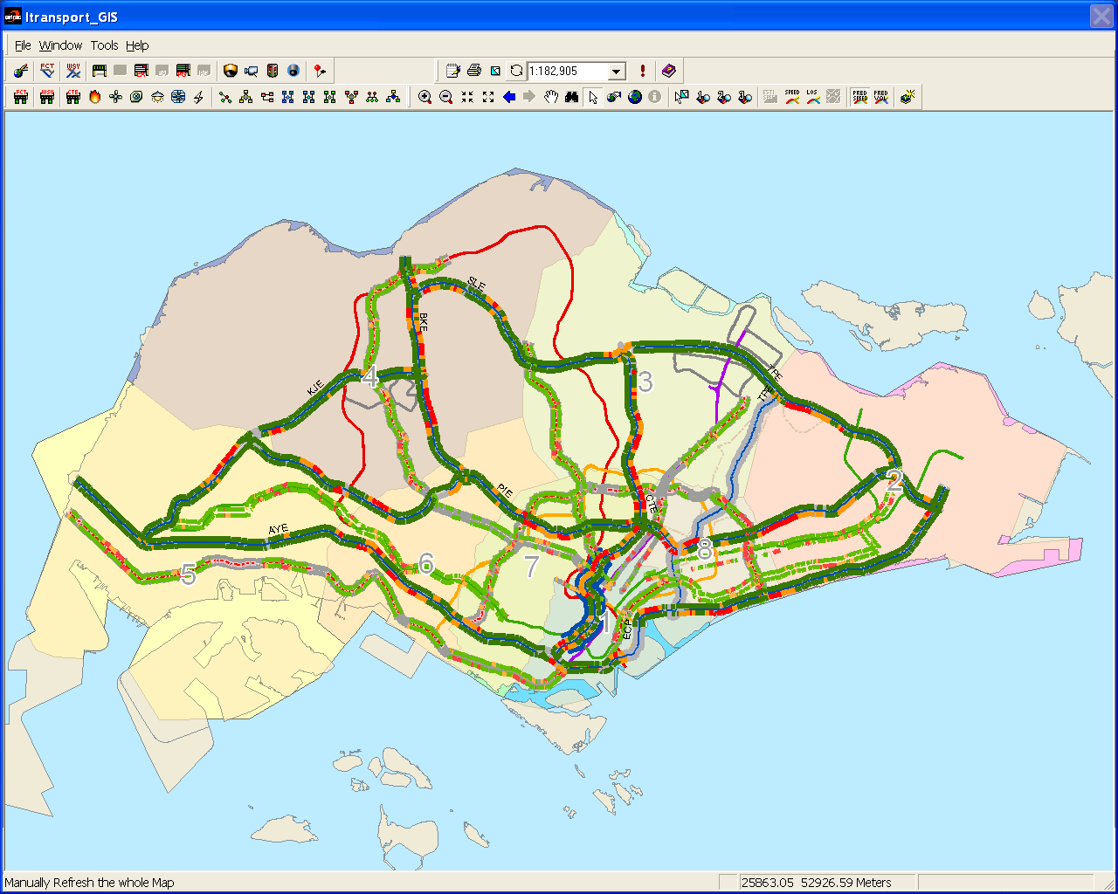

|  |
| --- |
| **Symbols** |
| Expressway:    Other: |

Note: The Predicted Speed feature is only enabled when the simulation module is running.

### Predicted Volume

The user profile control the functions the user is authorize to use under Platform Control Mode (PCM) or Fall back Control Mode (FCM). Every user will have one user account that enables the user to login to IW. Every user account belongs to a profile.

|  |  |  |  |  |  |  |
| --- | --- | --- | --- | --- | --- | --- |
| **User profile** | | | | | **Operation mode** | |
| DO | Operator | FC | ITSC | Supervisor | PCM | FCM |
| ✓ | ✓ | ✓ | ✓ | ✓ | ✓ | ✓ |

When the Simulation Module (SIM) is running, predicted traffic volume 15 or 30 minutes ahead of time can be displayed. The exact time interval which the users can view ahead of time is a configuration set by the i-transport SIM maintenance team. To display predict volume information:

Click the **Predict Volume** button  on the toolbar.



The map refreshed and estimated speed information appears on the map.

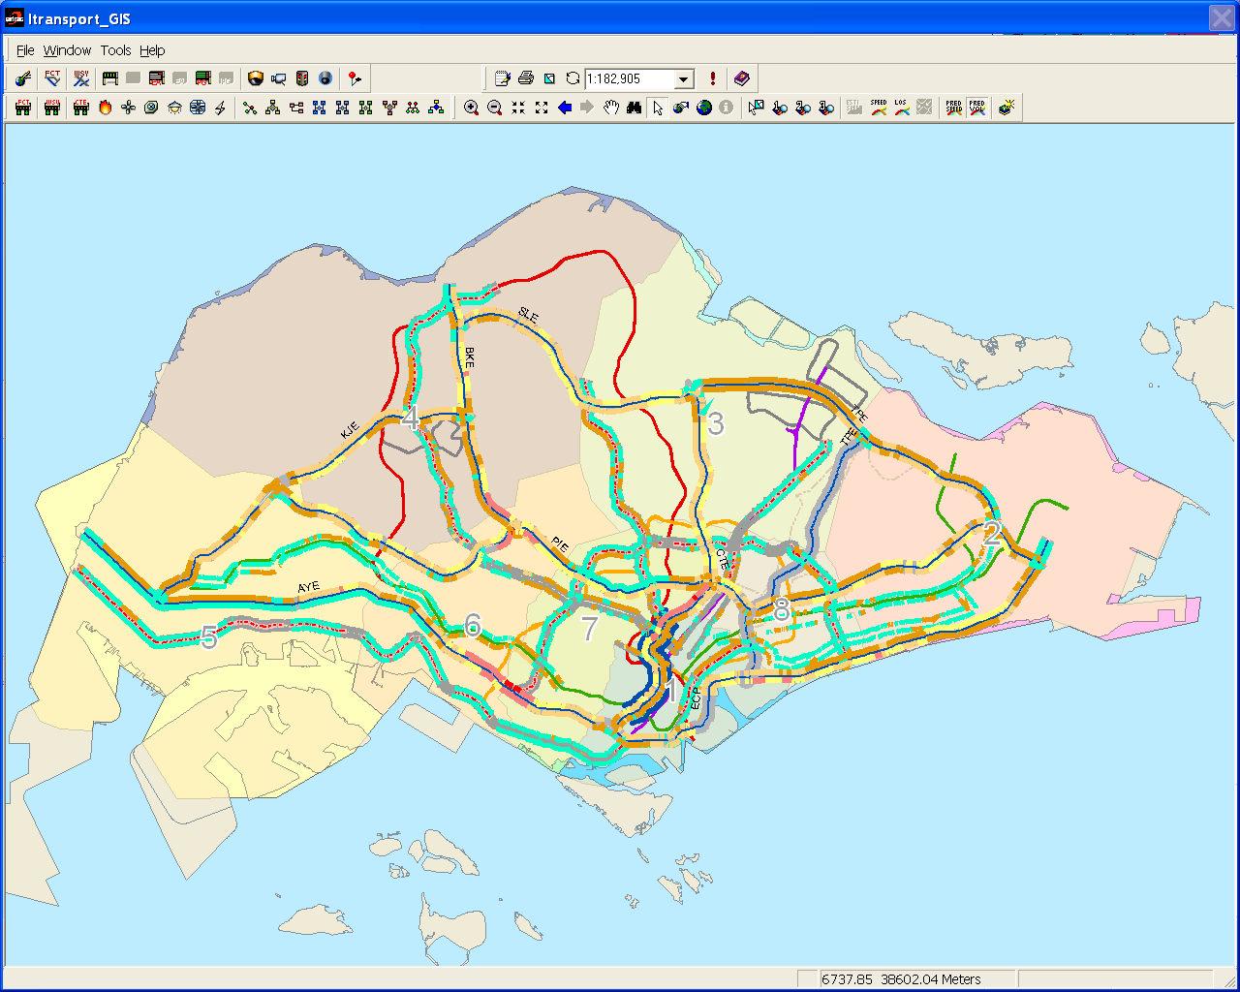

|  |
| --- |
| **Symbols** |
| Traffic Volume (unit/hr):  predict_volume_colorcode |

Note: The Predicted Speed feature is only enabled when the simulation module is running

### Realtime Road Works

The user profile control the functions the user is authorize to use under Platform Control Mode (PCM) or Fall back Control Mode (FCM). Every user will have one user account that enables the user to login to IW. Every user account belongs to a profile.

|  |  |  |  |  |  |  |
| --- | --- | --- | --- | --- | --- | --- |
| **User profile** | | | | | **Operation mode** | |
| DO | Operator | FC | ITSC | Supervisor | PCM | FCM |
| ✓ | ✓ | ✓ | ✓ | ✓ | ✓ | ✓ |

Realtime Road Works information is provided by a third-party source, not to be confused with the Roadworks IR. For Realtime Road Works Display on IW GIS, the following features are provided:

•       [Display and hide Realtime Road Works](#_Display_and_Hide_19)

•      [View Detection Realtime Road Works Info](#_View_Realtime_Road)

#### Display and Hide Realtime Road Works

  Click the **Realtime Road Works** button  on the toolbar.



The map refreshes and roadworks appear on the map.

|  |
| --- |
|  |
| Figure 379 – Realtime Roadworks Icons enabled |
|  |

  Click on the **Realtime Road Works** button again and the Road Works icons will be hidden.

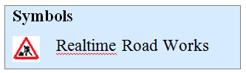

#### View Realtime Road Works info

  Click the **Monitor** button  on the toolbar.



  Place your mouse over a road works symbol.

The Realtime Road Works information shows besides the Realtime Road Works.

|  |
| --- |
|  |
| Figure 380 - Mouse Over on Realtime Roadworks Icon |
|  |

## System Status Monitoring

You can monitor the system status diagrams:

•      System health status - view system health status of EMAS, Glide, J-Eyes, and i-transport main modules, refer to [here](#_System_health_status).

•       EMAS health status, refer to [here](#_EMAS_health_status). 

•       Junction Eyes health status, refer to [here](#_Junction_Eyes_health). 

•       EA health status, refer to [here](#_EA_health_status).

•       FELS health status, refer to [here](#_FELS_health_status).

•       Short Tunnel health status, refer to [here](#_Short_Tunnel_ITPMS).

•       FCT health status, refer to [here](#_FCT_Health_Status).

•       WVT health status, refer to [here](#_WVT_Health_Status).

•      SGT health status, refer to [here](#_SGT_Health_Status).

### System health status

The user profile control the functions the user is authorize to use under Platform Control Mode (PCM) or Fall back Control Mode (FCM). Every user will have one user account that enables the user to login to IW. Every user account belongs to a profile.

|  |  |  |  |  |  |  |
| --- | --- | --- | --- | --- | --- | --- |
| **User profile** | | | | | **Operation mode** | |
| DO | Operator | FC | ITSC | Supervisor | PCM | FCM |
| ✓ | ✓ | ✓ | ✓ | ✓ | ✓ | ✓ |

Display System Health Status

Click the **System Health** button  on the toolbar.



The System Health Status diagram appears.

|  |
| --- |
|  |
| Figure 363 - Display System Health Status diagram |

|  |  |  |  |
| --- | --- | --- | --- |
| **Symbols** | | | |
| Description: c:\_temp\gis\system status monitoring\server.JPG  Description: c:\_temp\gis\system status monitoring\db.JPG | I-transport modules    Database |  |  |
| Description: c:\_temp\gis\system status monitoring\machine.JPG | Interface / External system / IW |  |  |

### EMAS health status

The user profile control the functions the user is authorize to use under Platform Control Mode (PCM) or Fall back Control Mode (FCM). Every user will have one user account that enables the user to login to IW. Every user account belongs to a profile.

|  |  |  |  |  |  |  |
| --- | --- | --- | --- | --- | --- | --- |
| **User profile** | | | | | **Operation mode** | |
| DO | Operator | FC | ITSC | Supervisor | PCM | FCM |
| ✓ | ✓ | ✓ | ✓ | ✓ | ✓ | ✓ |

Display EMAS Health Status

Click the **EMAS Health** button  on the toolbar.



The EMAS Health Status diagram appears.

|  |
| --- |
| EMAS |
| Figure 364 - Display EMAS Health Status diagram |

|  |  |
| --- | --- |
| **Symbols** | |
| Description: c:\_temp\gis\system status monitoring\EMAS h4.jpg | External system |
| Description: c:\_temp\gis\system status monitoring\EMAS h5.jpg | Application, background color is black for System OK and red for System Error. |
| Description: c:\_temp\gis\system status monitoring\EMAS h5.jpg | FELS, background color is black for System OK and red for System Error. |
| Description: c:\_temp\gis\system status monitoring\EMAS h5.jpg | Process, background color is black for System OK and red for System Error. |
| Description: c:\_temp\gis\system status monitoring\EMAS h10.jpg | Admin Workstation, background color is black for System OK and red for System Error. |
| Description: c:\_temp\gis\system status monitoring\EMAS h10.jpg | EMAS Clock, background color is black for System OK and red for System Error |

### Junction Eyes health status

The user profile control the functions the user is authorize to use under Platform Control Mode (PCM) or Fall back Control Mode (FCM). Every user will have one user account that enables the user to login to IW. Every user account belongs to a profile.

|  |  |  |  |  |  |  |
| --- | --- | --- | --- | --- | --- | --- |
| **User profile** | | | | | **Operation mode** | |
| DO | Operator | FC | ITSC | Supervisor | PCM | FCM |
| ✓ | ✓ | ✓ | ✓ | ✓ | ✓ | ✓ |

Display Junction Eyes Health Status

Click the **JEYE\_HEALTH\_STATUS** button  on the toolbar.



The Junction Eyes Health Status diagram appears.

|  |
| --- |
|  |
| Figure 365 - Display Junction Eye Health Status diagram |

|  |  |  |  |
| --- | --- | --- | --- |
| **Symbols** | | | |
| Description: c:\_temp\gis\system status monitoring\machine.JPG  Description: c:\_temp\gis\system status monitoring\server.JPG  Description: c:\_temp\gis\system status monitoring\je_conc.JPG | Client User Workstation    J-Eyes modules  Concentrator | Description: c:\_temp\gis\system status monitoring\je_rsw.JPG  Description: c:\_temp\gis\system status monitoring\je_dvr.JPG  Description: c:\_temp\gis\system status monitoring\je_nsw.JPG | Router Switch    Digital Video Recorder  Network Switch |
| Description: c:\_temp\gis\system status monitoring\je_ups.JPG | UPS | Description: c:\_temp\gis\system status monitoring\je_itransport.JPG | i-Transport system |

### EA health status

The user profile control the functions the user is authorize to use under Platform Control Mode (PCM) or Fall back Control Mode (FCM). Every user will have one user account that enables the user to login to IW. Every user account belongs to a profile.

|  |  |  |  |  |  |  |
| --- | --- | --- | --- | --- | --- | --- |
| **User profile** | | | | | **Operation mode** | |
| DO | Operator | FC | ITSC | Supervisor | PCM | FCM |
| ✓ | ✓ | ✓ | ✓ | ✓ | ✓ | ✓ |

Display EA Health Status

Click the **EA Health** button  on the toolbar.



The EA Health Status diagram appears.

|  |
| --- |
|  |
| Figure 366 - Display EA Health Status diagram |

### FELS health status

The user profile control the functions the user is authorize to use under Platform Control Mode (PCM) or Fall back Control Mode (FCM). Every user will have one user account that enables the user to login to IW. Every user account belongs to a profile.

|  |  |  |  |  |  |  |
| --- | --- | --- | --- | --- | --- | --- |
| **User profile** | | | | | **Operation mode** | |
| DO | Operator | FC | ITSC | Supervisor | PCM | FCM |
| ✓ | ✓ | ✓ | ✓ | ✓ | ✓ | ✓ |

Display FELS Health Status

Click the **FELS Health** button  on the toolbar.



The FELS Health Status diagram appears.

|  |
| --- |
|  |
| Figure 367 - Display FELS Health Status diagram |

### Short Tunnel ITPMS Health Status

The user profile control the functions the user is authorize to use under Platform Control Mode (PCM) or Fall back Control Mode (FCM). Every user will have one user account that enables the user to login to IW. Every user account belongs to a profile.

|  |  |  |  |  |  |  |
| --- | --- | --- | --- | --- | --- | --- |
| **User profile** | | | | | **Operation mode** | |
| DO | Operator | FC | ITSC | Supervisor | PCM | FCM |
| ✓ | ✓ | ✓ | ✓ | ✓ | ✓ | ✓ |

Display Short Tunnel System Health Status

Click the **Short Tunnel System Health** button  on the toolbar.



The System Health Status diagram appears.

|  |
| --- |
|  |
| Figure 368 - Display Short Tunnel Health Status diagram |

### FCT Health Status

The user profile control the functions the user is authorize to use under Platform Control Mode (PCM) or Fall back Control Mode (FCM). Every user will have one user account that enables the user to login to IW. Every user account belongs to a profile.

|  |  |  |  |  |  |  |
| --- | --- | --- | --- | --- | --- | --- |
| **User profile** | | | | | **Operation mode** | |
| DO | Operator | FC | ITSC | Supervisor | PCM | FCM |
| ✓ | ✓ | ✓ | ✓ | ✓ | ✓ | ✓ |

Display FCT System Health Status

Click the **FCT System Health** button  on the toolbar.



The System Health Status diagram appears.

|  |
| --- |
|  |
| Figure 369 - Display FCT Health Status diagram |

### WVT Health Status

The user profile control the functions the user is authorize to use under Platform Control Mode (PCM) or Fall back Control Mode (FCM). Every user will have one user account that enables the user to login to IW. Every user account belongs to a profile.

|  |  |  |  |  |  |  |
| --- | --- | --- | --- | --- | --- | --- |
| **User profile** | | | | | **Operation mode** | |
| DO | Operator | FC | ITSC | Supervisor | PCM | FCM |
| ✓ | ✓ | ✓ | ✓ | ✓ | ✓ | ✓ |

Display WVT System Health Status

Click the **WVT System Health** button  on the toolbar.



The System Health Status diagram appears.

|  |
| --- |
|  |
| Figure 370 – Display WVT Health Status diagram |

### SGT Health Status

The user profile control the functions the user is authorize to use under Platform Control Mode (PCM) or Fall back Control Mode (FCM). Every user will have one user account that enables the user to login to IW. Every user account belongs to a profile.

|  |  |  |  |  |  |  |
| --- | --- | --- | --- | --- | --- | --- |
| **User profile** | | | | | **Operation mode** | |
| DO | Operator | FC | ITSC | Supervisor | PCM | FCM |
| ✓ | ✓ | ✓ | ✓ | ✓ | ✓ | ✓ |

Display SGT System Health Status

Click the **SGT System Health** button  on the toolbar.



The System Health Status diagram appears.

|  |
| --- |
|  |
| Figure 370 – Display SGT Health Status diagram |

## Search

The user profile control the functions the user is authorize to use under Platform Control Mode (PCM) or Fall back Control Mode (FCM). Every user will have one user account that enables the user to login to IW. Every user account belongs to a profile.

|  |  |  |  |  |  |  |
| --- | --- | --- | --- | --- | --- | --- |
| **User profile** | | | | | **Operation mode** | |
| DO | Operator | FC | ITSC | Supervisor | PCM | FCM |
| ✓ | ✓ | ✓ | ✓ | ✓ | ✓ | ✓ |

You can search for information and view them on the map.

•      [Roads](#_Search_Roads)

•      Expressways e.g. AYE

•      Arterial road e.g Bukit Timah Road

•      [Junctions](#_Search_Junctions)

•       Sites e.g. ID 101

•      Control boxes e.g. ID 355

•      Junction cameras e.g. ID 100401

•      [Traffic Equipment](#_Search_Equipment)

•       VMS

•      Cameras

•      SOS phones

•      [Incident Record (IR)](#_Search_IR)

### Search Roads

  Click the **Search** button  on the toolbar.



The Search window appears.

  Click on **Road** tab if you are on other tabs.

•     By Expressway

  Click on **Expressway** radio button.

The expressways will appear in the Name dropdown box, and the KM textbox appears.

  Click on **Name** dropdown arrow, and click an expressway name.

3.  Type kilometer in the **KM** textbox.

|  |
| --- |
|  |
| Figure 371 - Road tab in Search Dialog |

4.  Click on **Search** button.

The result list appears at the bottom.

5.  Click on a link.

The selected link is highlighted in blue.

|  |
| --- |
|  |
| Figure 372 - Result for searching Expressway by kilometer mark |

6.  Click on **Map Display** button.

The selected link is highlighted in light blue on the map.

•     By Arterial Road

  Click on **Arterial Road** radio button.

The Name textbox appears.

  Type road name in part or full in the **Name** textbox.

3.  Click on Search button.

The result list appears at the bottom.

|  |
| --- |
|  |
| Figure 373 - Result for searching Arterial Road |

4.    Click on a road.

The selected road is highlighted in blue.

5.  Click on **Map Display** button.

The selected road is highlighted in light blue on the map.

### Search Junctions

  Click the **Search** button  on the toolbar.



The Search window appears.

  Click on **Junction** tab if you are on other tabs.

|  |
| --- |
| Description: c:\_temp\gis\search\search.JPG |
| Figure 374 - Junction tab in Search Dialog |

•    By Site ID

  Click on **Site ID** radio button.

2.  Type site ID no. in the **ID No.** textbox.

3.  Click on **Search** button.

The result list appears at the bottom.

  Click on a site.

The selected site is highlighted in blue.

5.   Click on **Map Display** button.

The selected site is highlighted in light blue on the map.

|  |
| --- |
| Description: c:\_temp\gis\search\Search13.jpg |
| Figure 375 - Result for searching Junction by Site ID |

•    By Control Box ID

  Click on **Control Box ID** radio button.

2.  Type control box ID no. in the **ID No.** textbox.

3.  Click on **Search** button.

The result list appears at the bottom.

  Click on a control box.

The selected control box is highlighted in blue.

  Click on **Map Display** button.

The selected control box is highlighted in light blue on the map.

|  |
| --- |
| Description: c:\_temp\gis\search\by_cbox.JPG |
| Figure 376 - Result for searching Junction by Control Box ID |

•    By Junction Camera ID

   Click on **Junction Camera ID** radio button.

2.  Type junction camera ID no. in the **ID No.** textbox.

3.  Click on **Search** button.

The result list appears at the bottom.

4.  Click on a camera.

The selected camera is highlighted in blue.

5.  Click on **Map Display** button.

The selected camera is highlighted in light blue on the map.

|  |
| --- |
| Description: c:\_temp\gis\search\by_jcam.JPG |
| Figure 377 - Result for searching Junction by Camera ID |

|  |  |  |
| --- | --- | --- |
| **Error** | | |
| Message | Cause | Possible solution |
| Please enable Junctions. | Junctions layer is not turned on for searching. | Turn on the layer so that Search function can be enabled. Please refer to [here](#_Display_and_hide_3) on how to display Junctions. |

### Search Equipment

  Click the **Search** button  on the toolbar.



The Search window appears.

  Click on **Equipment** tab if you are on other tabs.

3.  Click on **Road Name** dropdown arrow, and click a road.

4.  Click on **Type** dropdown arrow, and click a type.

|  |
| --- |
|  |
| Figure 378 - Equipment tab in Search Dialog |

5.   Type equipment id in the **Equipment ID** textbox. (optional)

6.   Click on **Search** button.

The results appear in the result list below.

7.   Click on an equipment in the list.

The selected equipment is highlighted in blue.

|  |
| --- |
|  |
| Figure 379 - Results for searching all TIP on PIE |

8.  Click on **Map Display** button.

The map refreshes to show the equipment, and the equipment is highlighted in light blue.

### Search IR

  Click the **Search** button  on the toolbar.



The Search window appears.

  Click on **Incident** tab if you are on other tabs.

   Click on **Type** dropdown arrow, and click a type.

|  |
| --- |
| Description: c:\_temp\gis\search\ir_search.JPG |
| Figure 380 - Incident tab in Search Dialog |

  Type IR ID in the **IR ID** textbox. (optional)

  Set the Start Time and End Time, click on the **Clock** button to set time as the current time. To manually set date and time, click on the textbox, a Date and Time window will appear. (optional)

  Click on **Search** button.

The results appear in the result list below.

  Click on an IR in the list.

The selected IR is highlighted in blue.

|  |
| --- |
| Description: c:\_temp\gis\search\Search17.jpg |
| Figure 381 - Results for searching all Accident IR |

  Click on **Map Display** button.

The map refreshes to show the IR, and the IR is highlighted in light blue.

## Others

There are other functions that you can use on GIS.

•       [Print map](#_Print_map)

•       [Clear map selection](#_Clear_map_selection)

•       [Refresh map](#_Refresh_map)

•       [Online help](#_Online_help)

•       [Legend  help](#_Legend_help)

### Print map

The user profile control the functions the user is authorize to use under Platform Control Mode (PCM) or Fall back Control Mode (FCM). Every user will have one user account that enables the user to login to IW. Every user account belongs to a profile.

|  |  |  |  |  |  |  |
| --- | --- | --- | --- | --- | --- | --- |
| **User profile** | | | | | **Operation mode** | |
| DO | Operator | FC | ITSC | Supervisor | PCM | FCM |
| ✓ | ✓ | ✓ | ✓ | ✓ | ✓ | ✓ |

Print Current Map

Click the **Print** button  on the toolbar.



A Print dialog will appear. Choose the desired settings and click **OK** button to start printing.

|  |
| --- |
| Description: c:\_temp\gis\others\Print 19.jpg |
| Figure 382 - GIS Map Print Dialog |

### Clear map selection

The user profile control the functions the user is authorize to use under Platform Control Mode (PCM) or Fall back Control Mode (FCM). Every user will have one user account that enables the user to login to IW. Every user account belongs to a profile.

|  |  |  |  |  |  |  |
| --- | --- | --- | --- | --- | --- | --- |
| **User profile** | | | | | **Operation mode** | |
| DO | Operator | FC | ITSC | Supervisor | PCM | FCM |
| ✓ | ✓ | ✓ | ✓ | ✓ | ✓ | ✓ |

Clear Map Selection

Click the **Clear** button  on the toolbar.



The map refreshes and all existing selection on the map will be cleared.

|  |
| --- |
| **Note** |
| Clearing map selection will improve the performance of the map. Since the map does not need to re-highlight the selected equipment/roads on the map, each time it is being refreshes. |

### Refresh map

The user profile control the functions the user is authorize to use under Platform Control Mode (PCM) or Fall back Control Mode (FCM). Every user will have one user account that enables the user to login to IW. Every user account belongs to a profile.

|  |  |  |  |  |  |  |
| --- | --- | --- | --- | --- | --- | --- |
| **User profile** | | | | | **Operation mode** | |
| DO | Operator | FC | ITSC | Supervisor | PCM | FCM |
| ✓ | ✓ | ✓ | ✓ | ✓ | ✓ | ✓ |

Refresh Current Map

Click the **Refresh** button  on the toolbar.



The map refreshes.

### Online help

The user profile control the functions the user is authorize to use under Platform Control Mode (PCM) or Fall back Control Mode (FCM). Every user will have one user account that enables the user to login to IW. Every user account belongs to a profile.

|  |  |  |  |  |  |  |
| --- | --- | --- | --- | --- | --- | --- |
| **User profile** | | | | | **Operation mode** | |
| DO | Operator | FC | ITSC | Supervisor | PCM | FCM |
| ✓ | ✓ | ✓ | ✓ | ✓ | ✓ | ✓ |

Display Online Help

Click the **IW Help** button    on the toolbar.



A help window appears.

|  |
| --- |
| Description: c:\_temp\gis\others\Online3.jpg |
| Figure 383 - IW GIS Online Help Window |

### Legend help

The user profile control the functions the user is authorize to use under Platform Control Mode (PCM) or Fall back Control Mode (FCM). Every user will have one user account that enables the user to login to IW. Every user account belongs to a profile.

|  |  |  |  |  |  |  |
| --- | --- | --- | --- | --- | --- | --- |
| **User profile** | | | | | **Operation mode** | |
| DO | Operator | FC | ITSC | Supervisor | PCM | FCM |
| ✓ | ✓ | ✓ | ✓ | ✓ | ✓ | ✓ |

Display IW GIS Legend Help

Click the **Legend Help** button  on the toolbar.



A help window appears.

|  |
| --- |
| Description: c:\_temp\gis\others\Legend2.jpg |
| Figure 384 - IW GIS Legend Help Window |